传输报文：

{

"interface_num":"MOBSCMD0005",

"serial_no":"123456789",

"source_system":"SCM",

"request_time":"2022-04-24 10:10:10",

"bus_key":"WGEC",

"bus_type":"001",

"bus_data":{

    "enumCode":"BAREROCK_DEMAND_STATUS,DEMAND_ITEM_STATUS"//枚举值获取参考下图

}

}

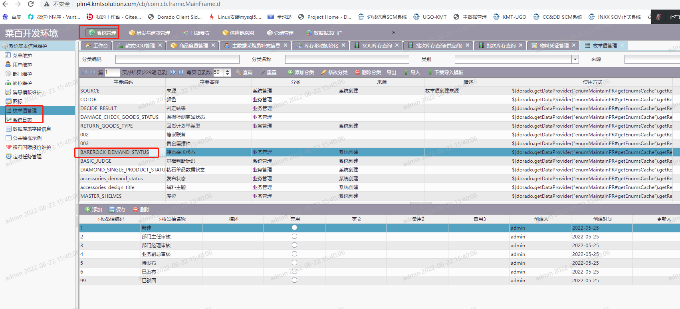

返回报文：

{

    "code": "200",

    "msg": "success",

    "data": [

        {

            "id": "2c92804b80f9db0c0180fa4f778b0001",

            "category": "",

            "source": "",

            "code": "1",

            "name": "新建",

            "parentCode": "2c92804b80f9db0c0180fa4b19420000",

            "description": "",

            "materialTypeCode": "",

            "materialTypeName": "",

            "deleted": **false**,

            "createBy": "admin",

            "createDate": 1653466953000,

            "updateBy": "",

            "updateDate": **null**,

            "attribute1": "",

            "attribute2": "",

            "attribute3": "",

            "attribute4": "",

            "attribute5": ""

        },

        {

            "id": "2c92804b80f9db0c0180fa4f783e0002",

            "category": "",

            "source": "",

            "code": "2",

            "name": "部门主任审核",

            "parentCode": "2c92804b80f9db0c0180fa4b19420000",

            "description": "",

            "materialTypeCode": "",

            "materialTypeName": "",

            "deleted": **false**,

            "createBy": "admin",

            "createDate": 1653466953000,

            "updateBy": "",

            "updateDate": **null**,

            "attribute1": "",

            "attribute2": "",

            "attribute3": "",

            "attribute4": "",

            "attribute5": ""

        },

        {

            "id": "2c92804b80f9db0c0180fa4f78ea0003",

            "category": "",

            "source": "",

            "code": "3",

            "name": "部门经理审核",

            "parentCode": "2c92804b80f9db0c0180fa4b19420000",

            "description": "",

            "materialTypeCode": "",

            "materialTypeName": "",

            "deleted": **false**,

            "createBy": "admin",

            "createDate": 1653466953000,

            "updateBy": "",

            "updateDate": **null**,

            "attribute1": "",

            "attribute2": "",

            "attribute3": "",

            "attribute4": "",

            "attribute5": ""

        },

        {

            "id": "2c92804b80f9db0c0180fa4f799f0004",

            "category": "",

            "source": "",

            "code": "4",

            "name": "业务副总审核",

            "parentCode": "2c92804b80f9db0c0180fa4b19420000",

            "description": "",

            "materialTypeCode": "",

            "materialTypeName": "",

            "deleted": **false**,

            "createBy": "admin",

            "createDate": 1653466954000,

            "updateBy": "",

            "updateDate": **null**,

            "attribute1": "",

            "attribute2": "",

            "attribute3": "",

            "attribute4": "",

            "attribute5": ""

        },

        {

            "id": "2c92804b80f9db0c0180fa4f7a4b0005",

            "category": "",

            "source": "",

            "code": "5",

            "name": "待发布",

            "parentCode": "2c92804b80f9db0c0180fa4b19420000",

            "description": "",

            "materialTypeCode": "",

            "materialTypeName": "",

            "deleted": **false**,

            "createBy": "admin",

            "createDate": 1653466954000,

            "updateBy": "",

            "updateDate": **null**,

            "attribute1": "",

            "attribute2": "",

            "attribute3": "",

            "attribute4": "",

            "attribute5": ""

        },

        {

            "id": "2c92804b80f9db0c0180fa4f7af40006",

            "category": "",

            "source": "",

            "code": "6",

            "name": "已发布",

            "parentCode": "2c92804b80f9db0c0180fa4b19420000",

            "description": "",

            "materialTypeCode": "",

            "materialTypeName": "",

            "deleted": **false**,

            "createBy": "admin",

            "createDate": 1653466954000,

            "updateBy": "",

            "updateDate": **null**,

            "attribute1": "",

            "attribute2": "",

            "attribute3": "",

            "attribute4": "",

            "attribute5": ""

        },

        {

            "id": "2c92804b80f9db0c0180fa4f7ba00007",

            "category": "",

            "source": "",

            "code": "99",

            "name": "已驳回",

            "parentCode": "2c92804b80f9db0c0180fa4b19420000",

            "description": "",

            "materialTypeCode": "",

            "materialTypeName": "",

            "deleted": **false**,

            "createBy": "admin",

            "createDate": 1653466954000,

            "updateBy": "",

            "updateDate": **null**,

            "attribute1": "",

            "attribute2": "",

            "attribute3": "",

            "attribute4": "",

            "attribute5": ""

        }

    ]

}