**Human Breast Numerical Model Genration based on Deep Learning for Photoacoustic Image**

*Yaxin Ma, Caiwen Jiang*

1. Introduction

Photoacoustic (PA) imaging is an emerging imaging technology with non-invasive and non-ionizing advantages. PA imaging detects ultrasonic signals generated by tissue which is excited by pulsed laser. During the imaging process, the tissue undergoes thermal expansion after laser irradiation, forming an initial sound field inside the tissue. The propagating sound waves, i.e. PA waves, outwards from the tissue are received by the ultrasonic transducers. After that, the initial sound field is reconstructed by the received PA signals and proper reconstruction algorithm to obtain the optical absorption distribution of the tissue.

PA imaging combines the optical absorption contrast and ultrasonic resolution in deep scattering tissue, which can provide functional information, such as blood oxygenation, beyond anatomical imaging done by traditional methods. So that it can better help cancer diagnostics, e.g. early-stage breast cancer.

However, as an emerging biomedical imaging technology, PA imaging is still in preclinical stage, and lacks clinical data, resulting in insufficient open source dataset for PA imaging research. To solve this problem, some researchers develop models comprised of simple objects. However, the model they proposed ignores a lot of crucial information, and unable to represent the real human breast information. Some recent studies have reported more realistic breast models, such as three realistic numerical breast phantoms, which however is manually generated suffering huge time consumption and insufficiency. In this paper, we propose to automatically generate PA numerical model datasets of human breast based on deep learning, which conforms to both anatomical and pathological features, and can reflect both optical and acoustic properties of the breast tissue. To the best of our knowledge, this is the first time applying deep learning algorithm to numerical model generation for PA imaging.

2. Problem statement

The objective is to design and implement the algorithm for automatically generating photoacoustic numerical models from mammography dataset. Firstly, different tissues of breast are extracted by convolutional neural network. Subsequently, new images are synthesized with the extracted tissues by mathematical set operation. Finally, different tissues in new image modes are assigned with photoacoustic parameters based on their specific optical and acoustic properties.

The CBIS-DDSM (Curated Breast Imaging Subset of DDSM) dataset is an upgraded version of DDSM (Digital Database for Screening Mammography), which contains 10,239 processed mammography. In order to implement the algorithm better, we preprocess the dataset by data augmentation. In particular, manual cropping was performed to process the tissue, which is the input of convolutional neural network based on the guidance of clinicians.

The breast can be mainly divided into four types of tissues: skin, fat, fibroglandular, and tumor. We use the EfficientNet to extract fibroglandular. EfficientNet is a new type of convolutional neural network based on a new model scaling method proposed by Google. The performance measurement indexes include loss, Iou score and *f1* score.

We use Dice loss and Focal loss function to evaluate fibroglandular segmentation performance, which is defined as:

$$L=L\left(precision,recall\right)+ L\left(gr,pr\right) (1)$$

The Dice loss is defined as:

$L\left(precision,recall\right)=1-\left(1-b^{2}\right)\frac{precision×rcall}{b^{2}×precision+recall }$（2）

Wherein, $b$ represents the coefficient for precision and recall balance.

The Focal loss is defined as:

*L*(*gt*,*pr*)=-*gt****a***(1-*pr*)g log(*pr*)-(1-*gt*)***a****pr*g log(1-*pr*) (3)

Among them, *gt* represents ground truth, *pr* represents prediction, *a* is weighting factor, *g* represents focusing parameter.

3. Technical Approach

3.1. Dataset Processing

For ease of processing, the dataset is firstly converted from a Dicom medical image format to BMP format image, and then resized to 320×600 pixels. In order to obtain a better segmentation performance, the input image is subjected to data enhancement operations, such as smoothing, histogram equalization, and binarization.

In particular, we manually label the different tissues region on the CBIS-DDSM breast image as the input training sample of the deep learning model. The output of the deep learning model is the result of automatically segmented tissues region. In order to expand the volume of training examples, data augmentation is applied including horizontal flipping, vertical flipping, rotation, contrast adjustment, which is shown in Fig. 1.

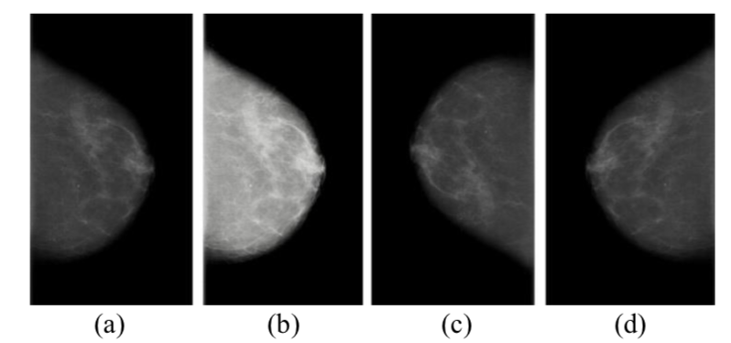

Fig.1. The operation of data augmentation. They are (*a*) original image, (*b*) contrast adjustment, (*c*) rotation, (*d*) horizontal flipping.

3.2. Transfer learning

Although the data is augmentaed, the data used to train the network is still insufficient, Transfer learning that transfers the pre-trained parameters on the ImageNet dataset is employed to tackle the problem of small samples.

4. Intermediate/Preliminary Results

Deep learning is applied to extract fibroglandular tissues of breast. EfficientNet model is exploited with 1,400 preprocessed datasets. Adam optimizer is used to optimize the model, and Sigmoid function is utilized as classification function. The learning rate is set to 0.0001, epoch is 100, and the batch size is 8. This experiment was implemented on a server with four NVIDIA GTX1080Ti installed.

The segmentation result of the model is shown in Figure 3, and the performance measurement including loss, Iou score, f1 score are shown in Table 1. It can be clearly seen that the segmented images based on the deep learning model is quite similar to ground truth.

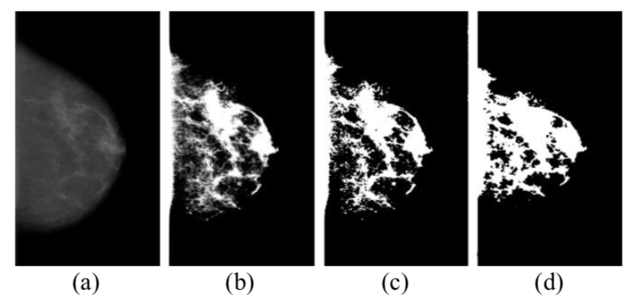

Fig.4 The comparison between ground truth and output of deep learning model for breast firboglandular tissue segmentation. They are (*a*) the original image, (*b*) ground truth, (*c*) ground truth after binarization, (*d*) output of deep learning model.

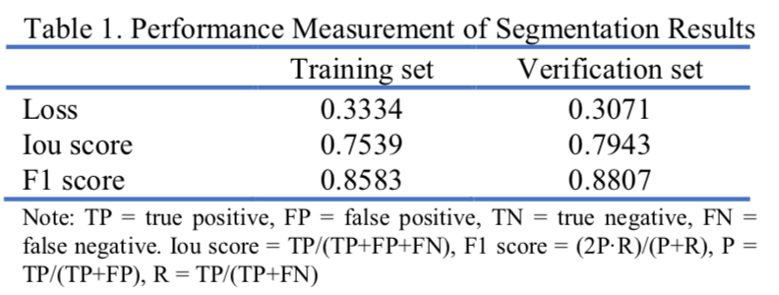

Note: TP = true positive, FP = false positive, TN = true negative, FN = false negative. Iou score = TP/(TP+FP+FN), F1 score = (2P·R)/(P+R), P = TP/(TP+FP), R = TP/(TP+FN)