**Human Breast Numerical Model Genration based on Deep Learning for Photoacoustic Image**

*Yaxin Ma, Caiwen Jiang*

1. Abstract

Photoacoustic imaging which combines high contrast of optical imaging and high resolution of ultrasound imaging, can provide functional information, potentially playing a crucial role in the study of breast cancer diagnostics. However, open source dataset for PA imaging research is insufficient on account of lacking clinical data. To tackle this problem, we propose a method to automatically generate breast numerical model for photoacoustic imaging. The different type of tissues is automatically extracted first by employing deep learning and other methods from mammography. And then the tissues are combined by mathematical set operation to generate a new breast image after being assigned optical and acoustic parameters. Finally, breast numerical model with proper optical and acoustic properties are generated, which are specifically suitable for PA imaging studies, and the experiment results indicate that our method is feasible with high efficiency.

***Index Terms***— photoacoustic image, photoacoustic data automatic generation, deep learning, breast numerical model

2. Introduction

Photoacoustic (PA) imaging is an emerging imaging technology with non-invasive and non-ionizing advantages. PA imaging detects ultrasonic signals generated by tissue which is excited by pulsed laser. During the imaging process, the tissue undergoes thermal expansion after laser irradiation, forming an initial sound field inside the tissue. The propagating sound waves, i.e. PA waves, outwards from the tissue are received by the ultrasonic transducers. After that, the initial sound field is reconstructed by the received PA signals and proper reconstruction algorithm to obtain the optical absorption distribution of the tissue.

PA imaging combines the optical absorption contrast and ultrasonic resolution in deep scattering tissue, which can provide functional information, such as blood oxygenation, beyond anatomical imaging done by traditional methods. So that it can better help cancer diagnostics, e.g. early-stage breast cancer.

However, as an emerging biomedical imaging technology, PA imaging is still in preclinical stage, and lacks clinical data, resulting in insufficient open source dataset for PA imaging research. To solve this problem, some researchers develop models comprised of simple objects. However, the model they proposed ignores a lot of crucial information, and unable to represent the real human breast information. Some recent studies have reported more realistic breast models, such as three realistic numerical breast phantoms, which however is manually generated suffering huge time consumption and insufficiency. In this paper, we propose to automatically generate PA numerical model datasets of human breast based on deep learning, which conforms to both anatomical and pathological features, and can reflect both optical and acoustic properties of the breast tissue. To the best of our knowledge, this is the first time applying deep learning algorithm to numerical model generation for PA imaging.

2. Method

The objective is to design and implement the algorithm for automatically generating photoacoustic numerical models from mammography dataset. The steps of the algorithm are shown in below flowchart in Fig. 1. Firstly, different tissues of breast are extracted by convolutional neural network. Subsequently, new images are synthesized with the extracted tissues by mathematical set operation. Finally, different tissues in new image modes are assigned with photoacoustic parameters based on their specific optical and acoustic properties.

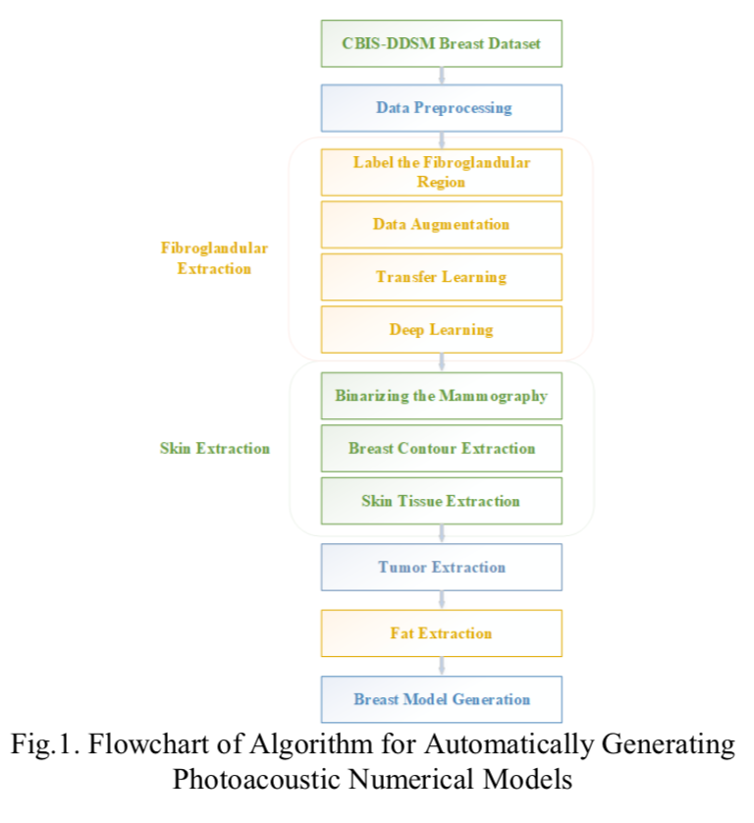The CBIS-DDSM (Curated Breast Imaging Subset of DDSM) dataset is an upgraded version of DDSM (Digital Database for Screening Mammography), which contains 10,239 processed mammography. In order to implement the algorithm better, we preprocess the dataset by data augmentation. In particular, manual cropping was performed to process the tissue, which is the input of convolutional neural network based on the guidance of clinicians.

The breast can be mainly divided into four types of tissues: skin, fat, fibroglandular, and tumor. Different algorithms are utilized when extracting different types of tissues. Among them, extracting fibroglandular is the most crucial and difficult task in this paper, which is the key to the implementation of automatic generation of photoacoustic numerical model dataset. The feature extraction of fibroglandular is complicated, because its shape is irregular and has no clear boundary, so that even manual labeling is very troublesome. Deep learning provides an effective automatic extraction method, which has been widely used in the field of medical image segmentation. In this paper, we use the Unet to extract fibroglandular. We make some improvement on Unet, and replace the encoder part of a with EfficientNet to achieve better feature extraction. EfficientNet is a new type of convolutional neural network based on a new model scaling method proposed by Google. The performance measurement indexes include loss, Iou score and f1 score.

We use Dice loss and Focal loss function to evaluate fibroglandular segmentation performance, which is defined as:

$$L=L\left(precision,recall\right)+ L\left(gr,pr\right) (1)$$

The Dice loss is defined as:

$L\left(precision,recall\right)=1-\left(1-b^{2}\right)\frac{precision×rcall}{b^{2}×precision+recall }$（2）

Wherein, $b$ represents the coefficient for precision and recall balance.

The Focal loss is defined as:

*L*(*gt*,*pr*)=-*gt****a***(1-*pr*)g log(*pr*)-(1-*gt*)***a****pr*g log(1-*pr*) (3)

Among them, *gt* represents ground truth, *pr* represents prediction, *a* is weighting factor, *g* represents focusing parameter.

3. Experiments

3.1. Dataset Processing

For ease of processing, the dataset is firstly converted from a Dicom medical image format to BMP format image, and then resized to 320×600 pixels. In order to obtain a better segmentation performance, the input image is subjected to data enhancement operations, such as smoothing, histogram equalization, and binarization.

In particular, for fibroglandular extraction, we manually label the fibroglandular region on the CBIS-DDSM breast image as the input training sample of the deep learning model. The output of the

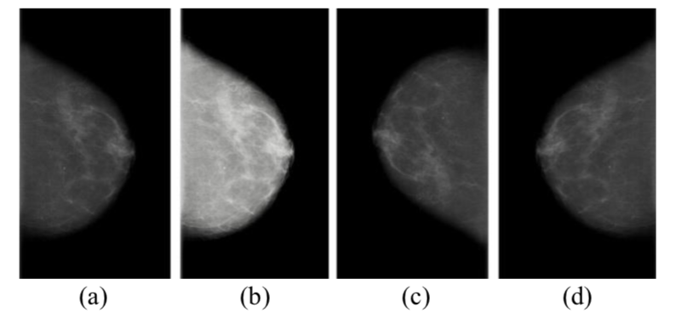

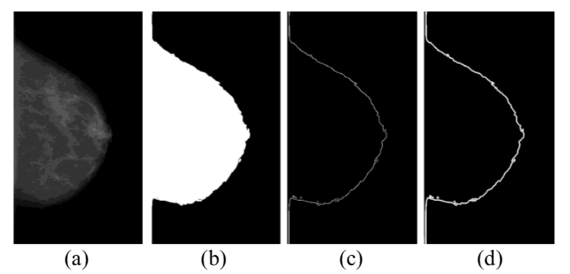Fig.2. The operation of data augmentation. They are (a) original image, (b) contrast adjustment, (c) rotation, (d) horizontal flipping.

Fig.3. The operation of skin extraction. They are (a)original image, (b)binarization, (c)edge extraction algorithm, (d)morphological processing such as expansion and corrosion

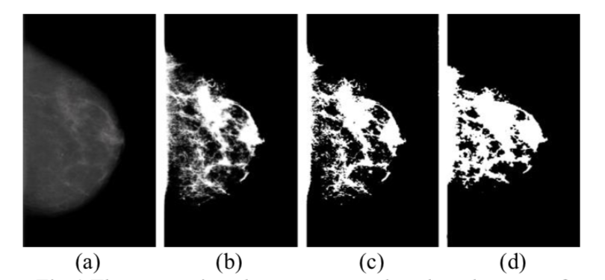

Fig.4 The comparison between ground truth and output of deep learning model for breast firboglandular tissue segmentation. They are (a)the original image, (b)ground truth, (c)ground truth after binarization, (d)output of deep learning model.

deep learning model is the result of automatically segmented fibroglandular region. In order to expand the volume of training examples, data augmentation is applied including horizontal flipping, vertical flipping, rotation, contrast adjustment, which is shown in Fig. 2. Finally, a total number of 1,400 extracted fibroglandular datasets were produced, which were divided into three parts: training set, verification set and test set according to the ratio of 6:2:2.

3.2. Extraction of different type of tissues

The skin tissue is obtained by extracting the outline of breast shown in Fig. 3. Firstly, the mammography is binarized shown in Fig. 3(b). And then the edge extraction algorithm using the canny operator is applied to segment the outline of breast shown in Fig. 3(c). Finally, we utilize morphological processing such as expansion and corrosion to generate skin model (shown in Fig. 3(d)) in accordance with real breast skin data.

Deep learning is applied to extract fibroglandular tissues of breast. EfficientNet model is exploited with 1,400 preprocessed datasets. Transfer learning that transfers the pre-trained parameters on the ImageNet dataset is also employed to tackle the problem of small samples. Adam optimizer is used to optimize the model, and Sigmoid function is utilized as classification function. The learning rate is set to 0.0001, epoch is 100, and the batch size is 8. This experiment was implemented on a server with four NVIDIA GTX1080Ti installed. The segmentation result of the model is shown in Figure 4.

The performance measurement including loss, Iou score, f1 score are shown in Table 1. It can be clearly seen that the segmented images based on the deep learning model is quite similar to ground truth. We also tried to use different networks to replace EfficentNet as the encoder in Unet, the results are shown in Table 2.

A union operation is executed on the extracted skin, fibroglandular, and tumor tissues, then the fat tissue is obtained by subtracting the union from the original mammography.

After dividing the various tissues of the breast, these tissues are employed to synthesize new breast numerical models. From bottom to top, is the new model includes four layers: fat, skin, fibroglandular, and tumor. Index are exploited to

Table 1. Performance Measurement of Segmentation Results

|  |  |  |
| --- | --- | --- |
|  | Training set | Verification set |
| Loss | 0.3334 | 0.3071 |
| Iou_score | 0.7539 | 0.7943 |
| F1-score | 0.8583 | 0.8807 |

Note: TP = true positive, FP = false positive, TN = true negative, FN = false negative. Iou score = TP/(TP+FP+FN), F1 score = (2P·R)/(P+R), P = TP/(TP+FP), R = TP/(TP+FN)

Table 2. Performance Measurement of different model

|  |  |  |  |
| --- | --- | --- | --- |
| Model | Loss | Iou_score | F1-score |
| VGG16 | 0.36569 | 0.76083 | 0.86149 |
| Resnet50 | 0.30757 | 0.79495 | 0.88355 |
| Densenet121 | 0.30046 | 0.80163 | 0.88802 |
| inceptionV3 | 0.33961 | 0.33961 | 0.87534 |

represent different tissues in the synthesized numerical models. The Index corresponding to fat, skin, fibroglandular, and tumors are represented as 1, 2, 3, and 4.

The manually segmented breast slice result in and the automatically generated breast numerical image models in this paper are shown in Fig. 5 for comparison. It can be seen that the automatically generated image is very similar to the manually extracted breast slice image, proving the feasibility and accuracy of our proposed algorithm.

Finally, because different tissues have their specific optical and acoustic parameters, the synthesized numerical image model is further assigned with different values shown in Table 3. After doing that, the automatic generation of breast numerical image data is completed for photoacoustic imaging.

4. Disscussion and Conclusions

In this paper, we automatically generated

batches of breast numerical model images with proper optical and acoustic characteristics, which can be used for PA imaging research. The crucial step is to extract fibroglandular tissue, which is achieved by deep learning and transfer learning. The results show that deep learning method demonstrates good performance in breast fibroglandular tissue segmentation, thereby eliminating manual cropping used in previous literatures, and significantly improving efficiency.

In short, in order to solve the problem of insufficient photoacoustic image dataset, we propose a method to automatically generate photoacoustic image dataset by extracting, synthesizing and assigning parameters to clinically obtained breast tissues from mammography. Our future research will focus on improving segmentation algorithm performance, adding breast vascular tissue in the breast images, and automatically generating 3D PA numerical image data.

Table 3. Optical and Acoustic Parameters of Tissues

|  |  |  |  |  |
| --- | --- | --- | --- | --- |
| Tissue type | Index | $m_{a}({cm}^{-1}）$ | $m_{s}({cm}^{-1}）$ | $v(m/s)$ |
| Fat | 1 | 0.05 | 159 | 1470 |
| Skin | 2 | 0.08 | 500 | 1650 |
| Fibroglandular | 3 | 0.04 | 133 | 1515 |
| Tumor | 4 | 0.07 | 16 | 1548 |

Note: $m_{a}$ indicates optical absorption coefficient, $m_{s}$ indicates optical scattering coefficient, v indicates sound speed.

