Bowen Jiang (NUID: 001582174)

INFO 6205

Program Structures & Algorithms

Fall 2020

Assignment 4

Task: Your task is

We mentioned two alternatives for implementing Union-Find:

1. For weighted quick union, store the depth rather than the size;
2. For weighted quick union with path compression, do two loops, so that all intermediate nodes point to the root, not just the alternates.

For both of these, code the alternative and benchmark it against the implementation in the repository. You have all of that available from a previous assignment.

If you can explain why alternative #1 is unnecessary to be benchmarked, you may skip benchmarking that one.

Usual submission rules apply. 40 points only for this one.

**Output**

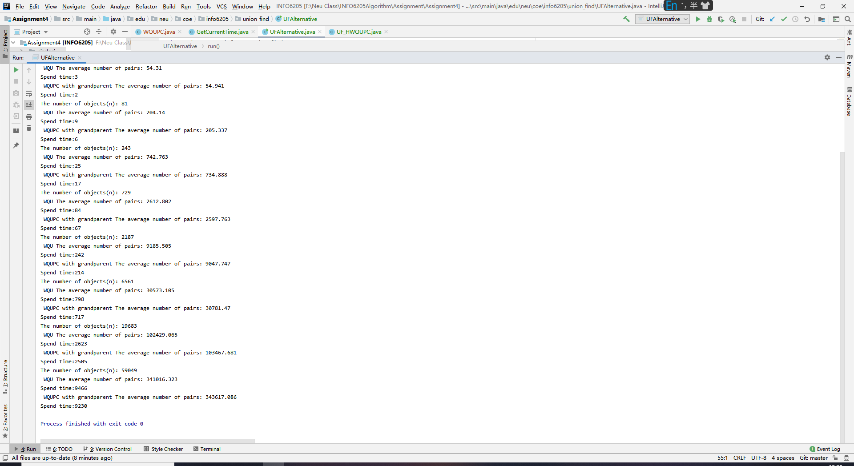

**Relationship Conclusion**

Conclusion: The performance of Weighted Quick Union with depth is better than Weighted Quick Union With Path Compression(GrandParent). The time difference between the two experiments is very close.

**Evidence to support relationship**

This Table shows the experimental data.

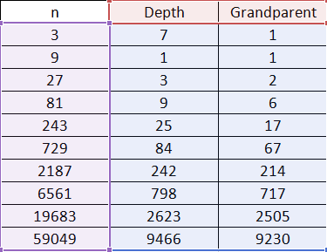

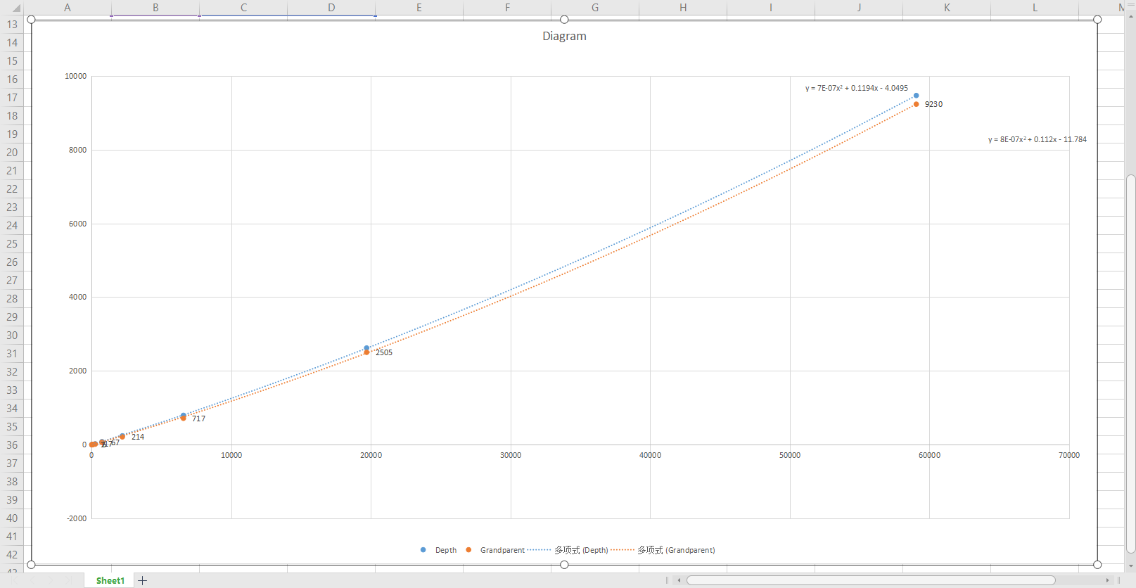

**Screenshot of Unit test passing**

UF_HWQUPC_Test.java

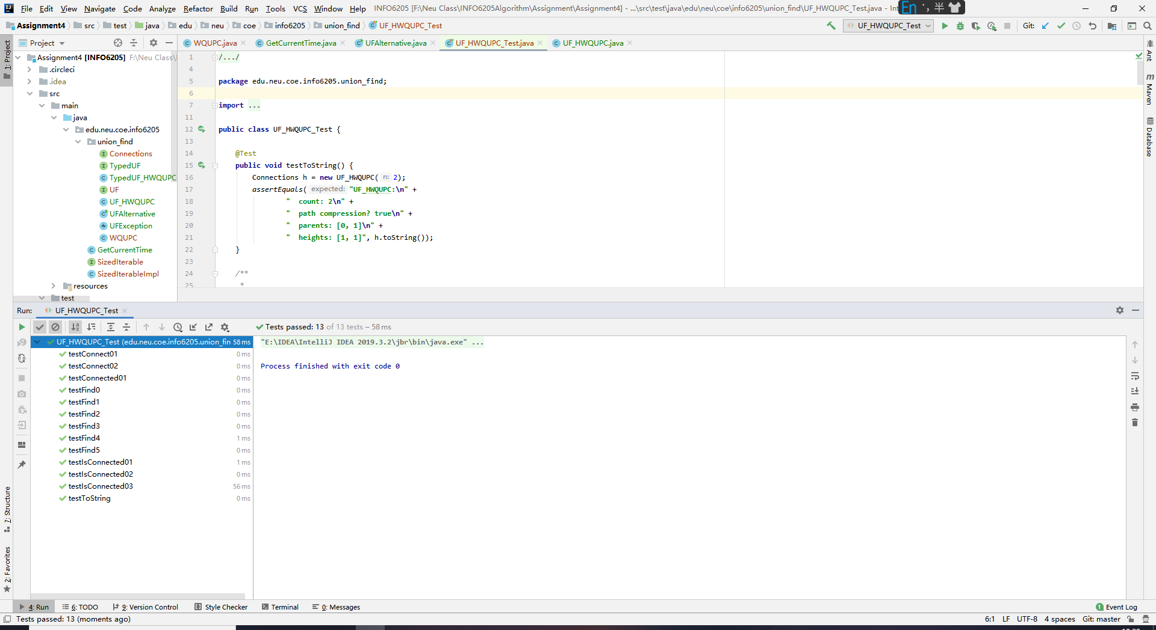

WQUPCTest.java

