introduction
This template allows using PlantUML directly from MS Word 2010 without need to alter document templates or edit VBA macro's. MS Word Versions 2007 and 2013 might work, but are not tested.

Example

@startuml
actor User
participant Word
participant PlantUML
User-->Word: Type text\nstartuml…enduml

User-->Word: Click [Add-ins:Uml]
activate Word
Word-->PlantUML: Generate pictures
activate PlantUML
PlantUML--//Word: Done
deactivate PlantUML
deactivate Word
User->User: ;-) pictures!
@enduml
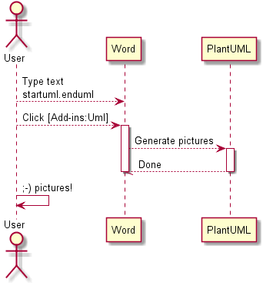

Installation
First time:
- install this template in Word
  - copy this (docm) file in to %appdata%\Microsoft\Word\STARTUP
- install Plantuml.jar in %appdata%
- install GraphViz
  - http://www.graphviz.org/Download_windows.php
    - use installer if you have rights to install applications; this will install graphviz in your program files (x86)
    - use zip for portable installation
      - extract in %appdata%
      - (executable is then in %appdata%\release\bin\dot.exe)
  - if alternative portable installation, please set GRAPHVIZ_DOT to location of DOT.EXE
restart Word. You now should have a PlantUML menu!

@startuml
actor User
participant Word
participant PlantUML
User-->Word: Type text\nstartuml…enduml

User-->Word: Click [Add-ins:Uml]
activate Word
Word-->PlantUML: Generate pictures
activate PlantUML
PlantUML--//Word: Done
deactivate PlantUML
deactivate Word
User->User: ;-) pictures!
@enduml

Installation
First time:
- install this template in Word
  - copy this (dotm) file in to %appdata%\Microsoft\Word\STARTUP
  - note: .dotm = Word Doc Template (office 2007/2010) with Macro's enabled
- install Plantuml.jar in %appdata%
- install GraphViz
  - http://www.graphviz.org/Download_windows.php
    - use installer if you have rights to install applications; this will install graphviz in your program files (x86)
    - use zip for portable installation
      - extract in %appdata%
      - (executable is then in %appdata%\release\bin\dot.exe)
  - if alternative portable installation, please set GRAPHVIZ_DOT to location of DOT.EXE
- restart Word. You now should have a PlantUML menu!

Using
Once installed, a special menu (PlantUML) should be availabe in Word.
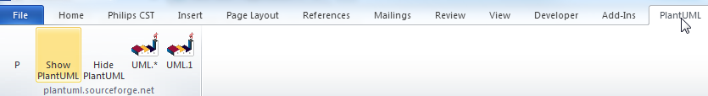
P =  : show paragraph marks
Show PlantUML: reveal (green text) of PlantUML image sources (for editing)
Hide PlantUML : hide source, just show generated pictures (before releasing a document for review/UCC)
UML.1 : Generate current diagram (cursor in green PlantUML definition)
UML.* : Generate all (note: this may take seconds up to a minute for 100+ pictures). Press Ctrl-Break to abort.

About word template
This document contains VBA scripts (based on plantuml007.bas).
Improvements made by Adriaan van den Brand:
- Easy distribution and integration (as a word.docm)
- performance (no new documents created, direct writing of text files)
- fixed issue of images at wrong locations
- better sync with plantuml java (by using ShellandWait module)
- no unnecessary delays
- can be aborted with ctrl-breai
Known issues:
- autoformat (automatic bullets/arrows) are not compatible with plantuml
- formatting plantuml can be improved
- add-ins from previous version are still created (so 2 methods of invoking plantuml after first Uml.* run)
Contact:adriaan.plantuml@gmail.com

I appreciate feedback and improved versions.
@startuml
left to right direction
class WordTemplate {
by Adriaan van den Brand
+PlantUML.bas
+ShellAndWait.bas
---
UML.1()
UML.*()
ShowPlantUML()
HidePlantUML()
}

class PlantUML.jar {
}
class GraphViz.DOT

WordTemplate --|> PlantUML.jar
PlantUML.jar --|> GraphViz.DOT

@enduml
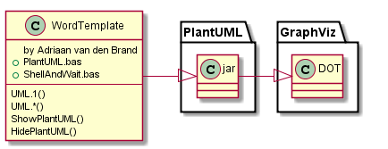

Version info plantUML
The following picture should be updated when you select PlantUML (menu) UML.1 or UML.*
@startuml
version
@enduml
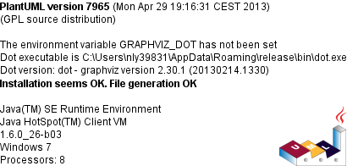

Check for uppdates
@startuml
checkversion
@enduml
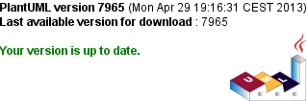

License information
For license information of PlantUML, please check out http://plantuml.sourceforge.net/
The code below will generate a copyright image (if correctly installed)
@startuml
license
@enduml
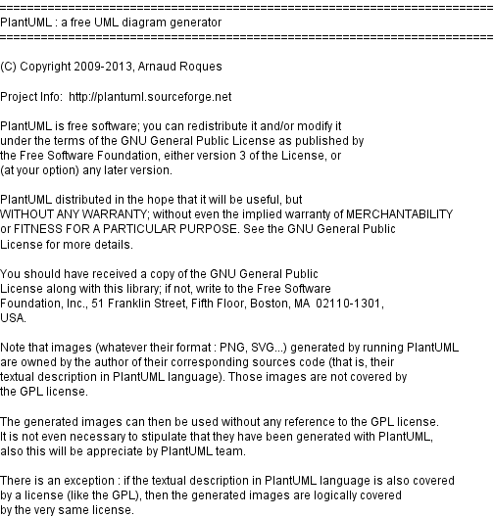

VBA code Shellandwait
' By Chip Pearson, chip@cpearson.com, www.cpearson.com
' This page on the web site: www.cpearson.com/Excel/ShellAndWait.aspx
' 9-September-2008

(Public domain)

Examples
See http://plantuml.sourceforge.net for more information and examples

Basic sequence diagram

@startuml

title <u>Simple</u> communication example\non several lines

Alice -> Bob: Authentication Request
Bob -> Alice: Authentication Response

@enduml
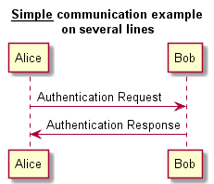

Class example

@startuml
skinparam classAttributeIconSize 0
class Dummy {
-field1
#field2
~method1()
+method2()
}

@enduml
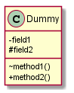

Activity (parallel)
@startuml

start

if (multiprocessor?) then (yes)
fork
:Treatment 1;
fork again
:Treatment 2;
end fork
else (monoproc)
:Treatment 1;
:Treatment 2;
endif

@enduml
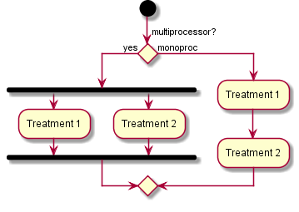

Components
@startuml

package "Some Group" {
HTTP - [First Component]
[Another Component]
}

node "Other Groups" {
FTP - [Second Component]
[First Component] --> FTP
}

cloud {
[Example 1]
}

database "MySql" {
folder "This is my folder" {
[Folder 3]
}
frame "Foo" {
[Frame 4]
}
}
@enduml
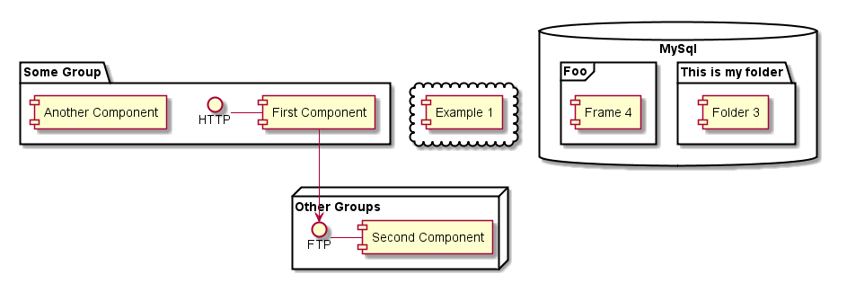

Statechart
@startuml
scale 350 width
[*] --> NotShooting

state NotShooting {
[*] --> Idle
Idle --> Configuring : EvConfig
Configuring --> Idle : EvConfig
}

state Configuring {
[*] --> NewValueSelection
NewValueSelection --> NewValuePreview : EvNewValue
NewValuePreview --> NewValueSelection : EvNewValueRejected
NewValuePreview --> NewValueSelection : EvNewValueSaved

state NewValuePreview {
State1 -> State2
}

}
@enduml
