1. 首页
2. <Http://localhost/cardList> get请求

数据类型：

[

{

"listId": "今日计划",

"target": [

{

"id": 2132,

"name": "the first",

"status": false,

"isDelete": false,

"completeDate": "",

"chooseList": 0,

"mouseOver": false

},

{

"id": 487,

"name": "the second",

"status": false,

"isDelete": false,

"completeDate": "",

"chooseList": 0,

"mouseOver": false

}

]

1. <http://localhost/cardList/add> post 请求 (我传listId)
2. http://localhost/cardList/edit post请求 （我传listId 和 id）

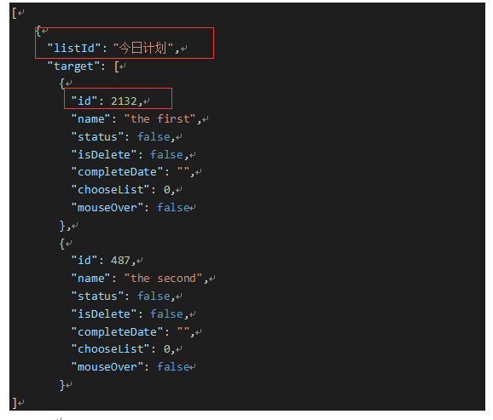

1. <http://localhost/cardList/delete> post请求 （我传listId 和 id）
2. 查看已完成任务列表

<http://localhost/alreadyList> get 请求 （查看所有已经完成的项目列表）

返回数据结构：

[

{

"date": 1324354657, //该值对应 completeDate

"name": "登录模块功能" //对应 name参数

},{

"date": 13243513657, //该值对应 completeDate

"name": "完成xmind设计"

}

]

