Installing Python, Pip, Django
- Install Python
To work with Django, we need to install python. Django is a Python web framework, it relies on python code and interpreter. To install Python, follow the steps below. NOTE: the version of Python you are installing may be different from that shown in the figure below.
Go to https://python.org/downloads and click on downloads to download the latest version of Python 3 (we will use the latest version).
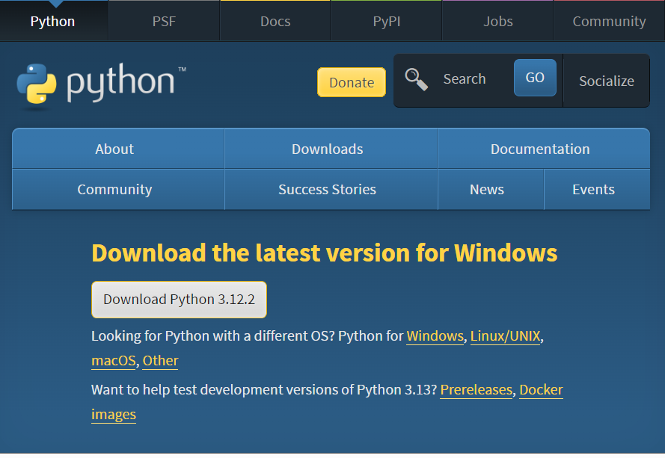

After downloading Python, you need to install it on your computer. After starting the installer, choose install now in the screen shown below
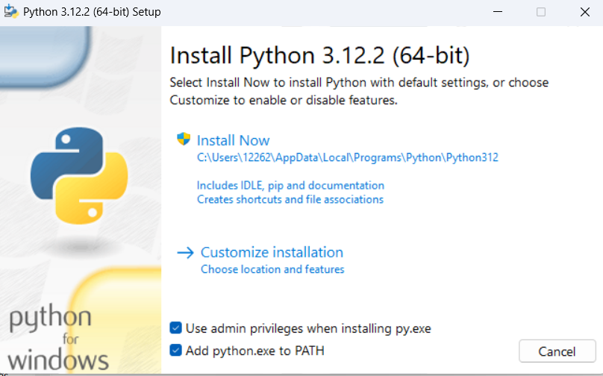
Important Note: you should check the box Add python.exe to PATH in the above screen. Then go through the installation process

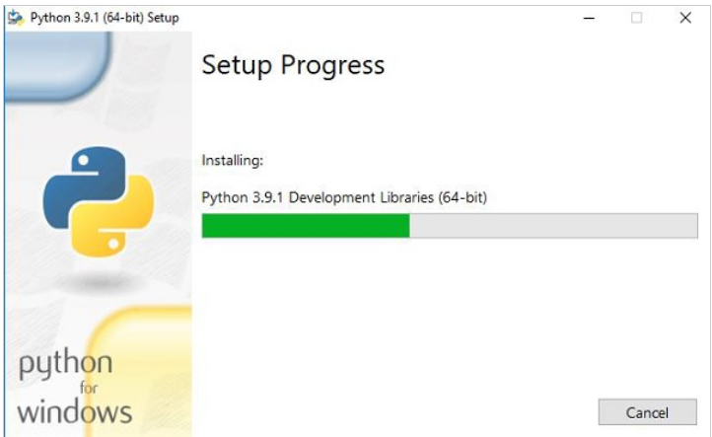

Now when you open the cmd, type python and it will bring you to python interpreter. If you want to exit python, type exit()
Type python --version at cmd prompt to check the version of python that is installed.
You can use Python either using python command or python shell (IDLE or Python GUI) as seen below:
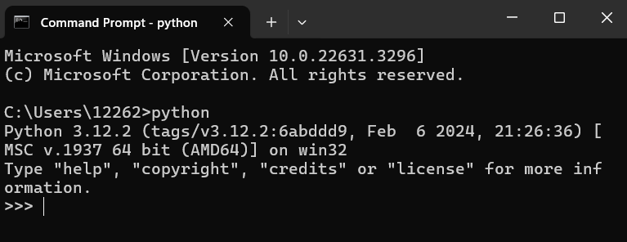

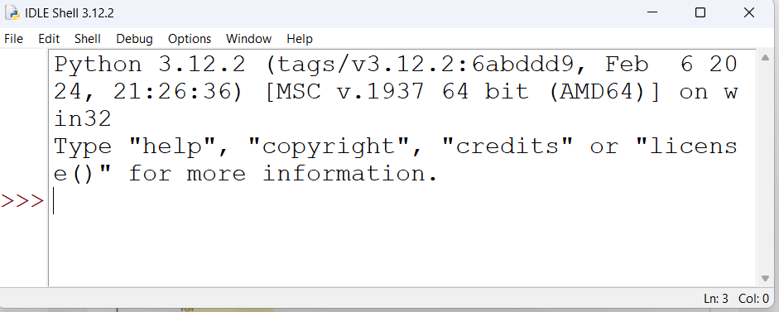

- Install Django
a) Uninstall any previous version of Django (if needed). To do this, simply remove appropriate dir. This step is not needed if Django was installed using pip.
b) Type pip install Django at cmd prompt OR
c) Type pip install –U Django to upgrade to a newer version (if you already had an older version installed)
NOTE: If you get an error message such “as Fatal error in launcher: Unable to create process using …” Try python -m pip install Django
d) Check that Django is installed correctly and also check the version by typing the following sequence of commands at command prompt:
>python
>>>import django
>>>django.VERSION

Your cmd window should show something like this (we will use version 5.2):
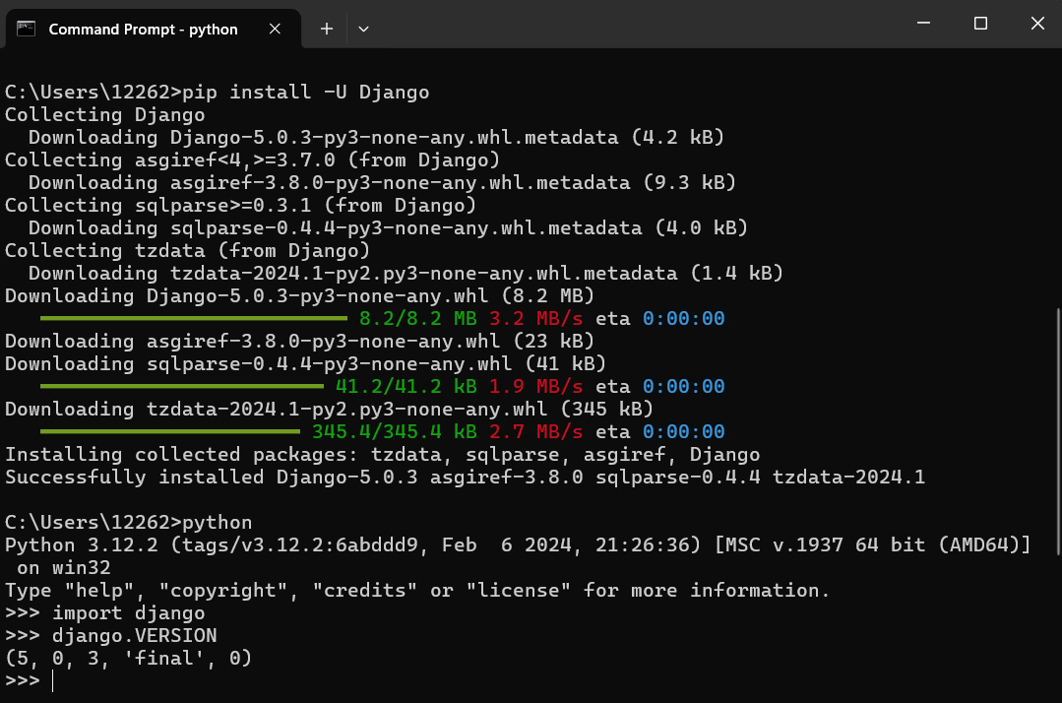

- Install PyCharm
- Go to https://account.jetbrains.com/login and register for a JetBrains account. Make sure you use you uwindsor email to register for the account.
- Go to: https://www.jetbrains.com/student/ and click "APPLY NOW".
- You will be redirected to the application form. On this form, select “I’m a student”, enter your first and last name and your uwindsor email, then click”APPLY FOR FREE PRODUCTS”
- You should receive an email asking you to Confirm Request by clicking on a link. Click the link and follow any instructions.
- You should receive another email asking you to Activate Educational License by clicking on a link. Click the link and follow any instructions.
- Go to https://www.jetbrains.com/pycharm/ to download PyCharm. Remember, you need the Professional version, NOT the Community version.

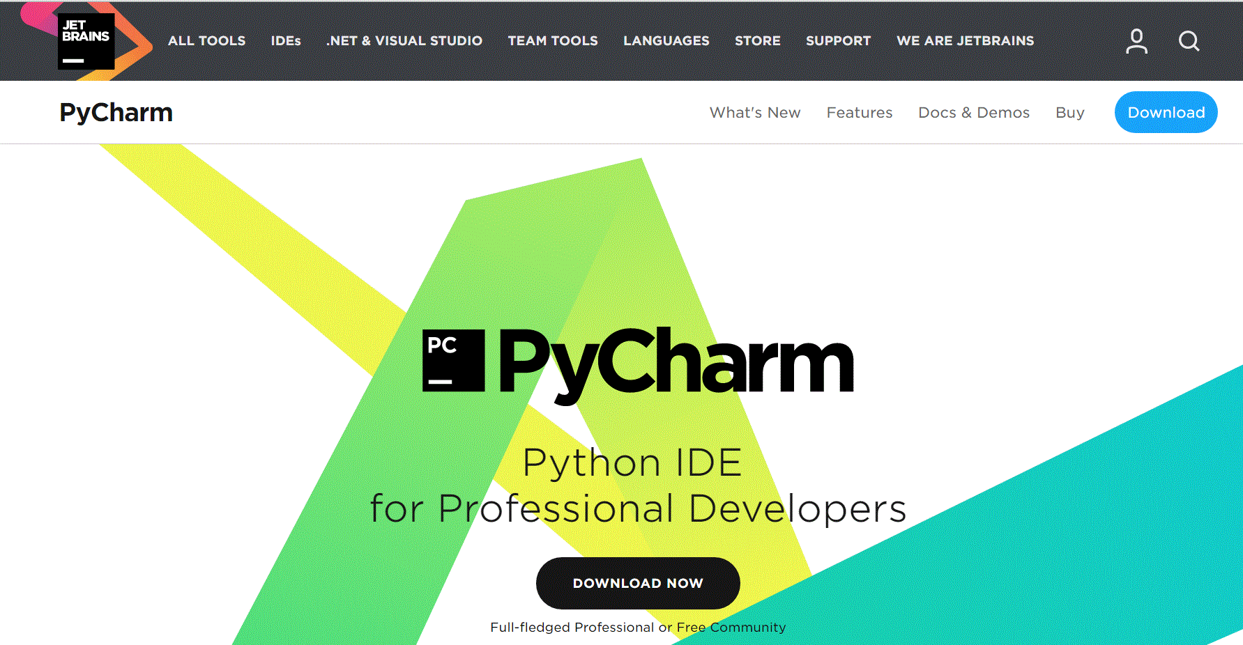

After downloading PyCharm click on the downloaded exe file and follow the installation steps:
Launch PyCharm and activate your account by selecting the JetBrains Account option and entering your email and password (created in step 4a)
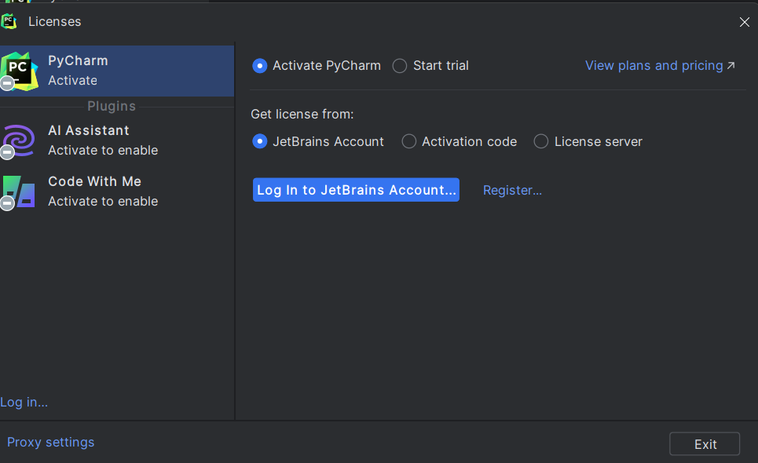
Once your login has been authenticated, click the blue “Activate” button.

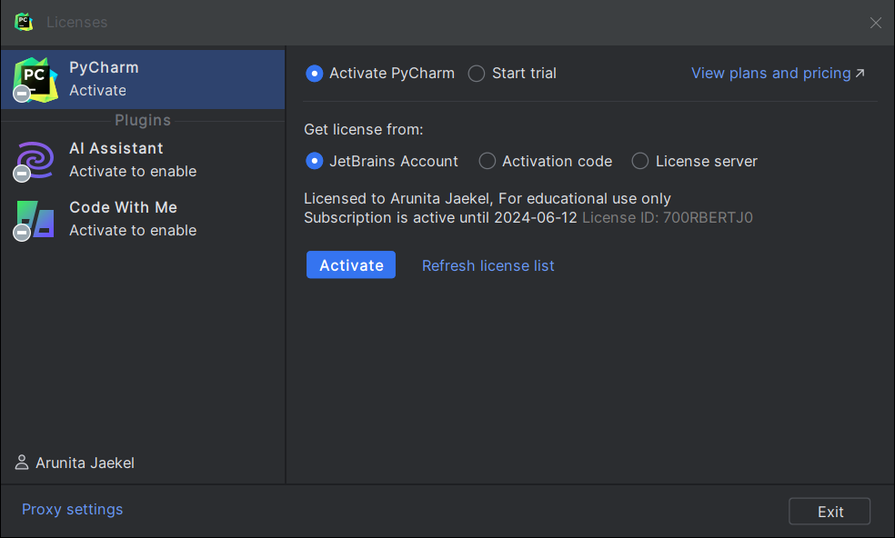

Select Create New Project and create a new pure python project called lab1
