COMP 8347 — Lab #4 Report
Query Section (Part 2.6 and Part 3)
Project: Django 6.0.5, app myapp. All queries reproducible via:
python manage.py shell < queries.py

Part 2.6 — Basic queries
import django
from myapp.models import Publisher, Book, Member, Order

Screenshot — full shell output (a–d)
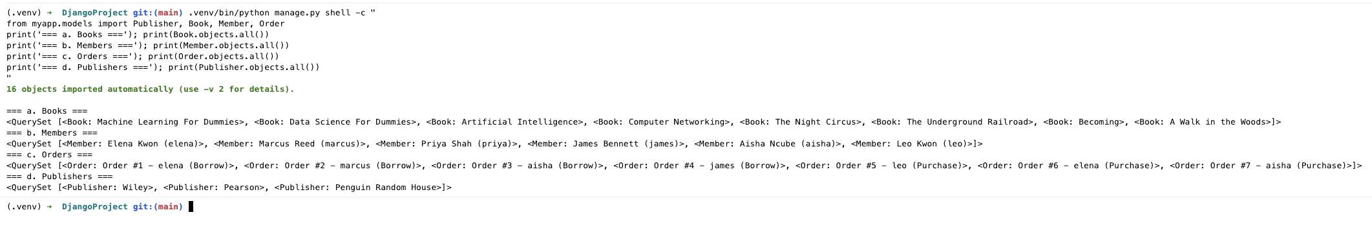

a. List all the books in the db
Book.objects.all()
Result: Machine Learning For Dummies, Data Science For Dummies, Artificial Intelligence, Computer Networking, The Night Circus, The Underground Railroad, Becoming, A Walk in the Woods

b. List all the members in the db
Member.objects.all()
Result: Elena Kwon, Marcus Reed, Priya Shah, James Bennett, Aisha Ncube, Leo Kwon

c. List all the orders in the db
Order.objects.all()
Result: 7 orders — #1 elena Borrow, #2 marcus Borrow, #3 aisha Borrow, #4 james Borrow, #5 leo Purchase, #6 elena Purchase, #7 aisha Purchase

d. List all the publishers in the db
Publisher.objects.all()
Result: Wiley, Pearson, Penguin Random House

Part 3 — Query practice

Screenshot — full shell output (a–o)
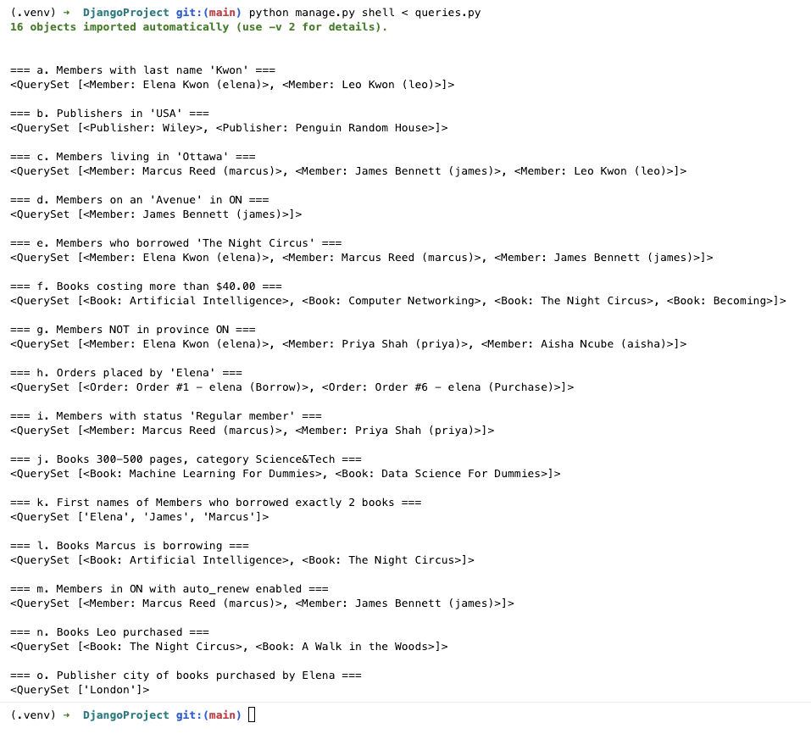

a. Members whose last name is 'Kwon'
Member.objects.filter(last_name='Kwon')
Result: Elena Kwon, Leo Kwon

b. Publishers with headquarters in 'USA'
Publisher.objects.filter(country='USA')
Result: Wiley, Penguin Random House

c. Members that live in 'Ottawa'
Member.objects.filter(city='Ottawa')
Result: Marcus Reed, James Bennett, Leo Kwon

d. Members that live on an 'Avenue' and live in ON province
Member.objects.filter(address__icontains='Avenue', province='ON')
Result: James Bennett
Elena also lives on an Avenue but in BC, so correctly excluded.

e. Members that have borrowed the book 'The Night Circus'
Member.objects.filter(borrowed_books__title='The Night Circus')
Result: Elena Kwon, Marcus Reed, James Bennett

f. Books that cost more than $40.00
Book.objects.filter(price__gt=40.00)
Result: Artificial Intelligence ($197.32), Computer Networking ($143.99), The Night Circus ($41.00), Becoming ($45.00)

g. Members that do NOT live in province ON
Member.objects.exclude(province='ON')
Result: Elena Kwon (BC), Priya Shah (SK), Aisha Ncube (MB)

h. Orders placed by a client whose first_name is 'Elena'
Order.objects.filter(member__first_name='Elena')
Result: Order #1 (Borrow), Order #6 (Purchase)

i. Members whose status are 'Regular Member'
Member.objects.filter(status=1)
Result: Marcus Reed, Priya Shah

j. Books with 300–500 pages (inclusive) in category 'Science&Tech'
Book.objects.filter(num_pages__range=(300, 500), category='S')
Result: Machine Learning For Dummies (464p), Data Science For Dummies (432p)

k. First name of Members who have borrowed exactly 2 books
from django.db.models import Count
Member.objects.annotate(n=Count('borrowed_books')).filter(n=2).values_list('first_name', flat=True)
Result: Elena, James, Marcus

l. Books that Member with username 'Marcus' is currently borrowing
Book.objects.filter(member__username='marcus')
Result: Artificial Intelligence, The Night Circus

m. Members who live in ON and have auto_renew enabled
Member.objects.filter(province='ON', auto_renew=True)
Result: Marcus Reed, James Bennett

n. Books that 'Leo' has purchased
Book.objects.filter(order__member__username='leo', order__order_type=0)
Result: The Night Circus, A Walk in the Woods
order_type 0 = Purchase.

o. City where the headquarters of the publisher of the book purchased by 'Elena' is located
Publisher.objects.filter(
books__order__member__first_name='Elena',
books__order__order_type=0,
).values_list('city', flat=True).distinct()
Result: London
Elena purchased 'Artificial Intelligence' → published by Pearson → headquartered in London.

