COMP8677 — Lab 4 Report

1. Packet Construction with Scapy

1.1 Constructing an IP Header
Using the IP() function, a default IP header was created with custom source and destination addresses. The command ls(iph) was used to view the header fields:
>>> from scapy.all import *
>>> ls(IP())
>>> iph = IP(src="10.0.2.4", dst="10.10.10.10")
>>> ls(iph)
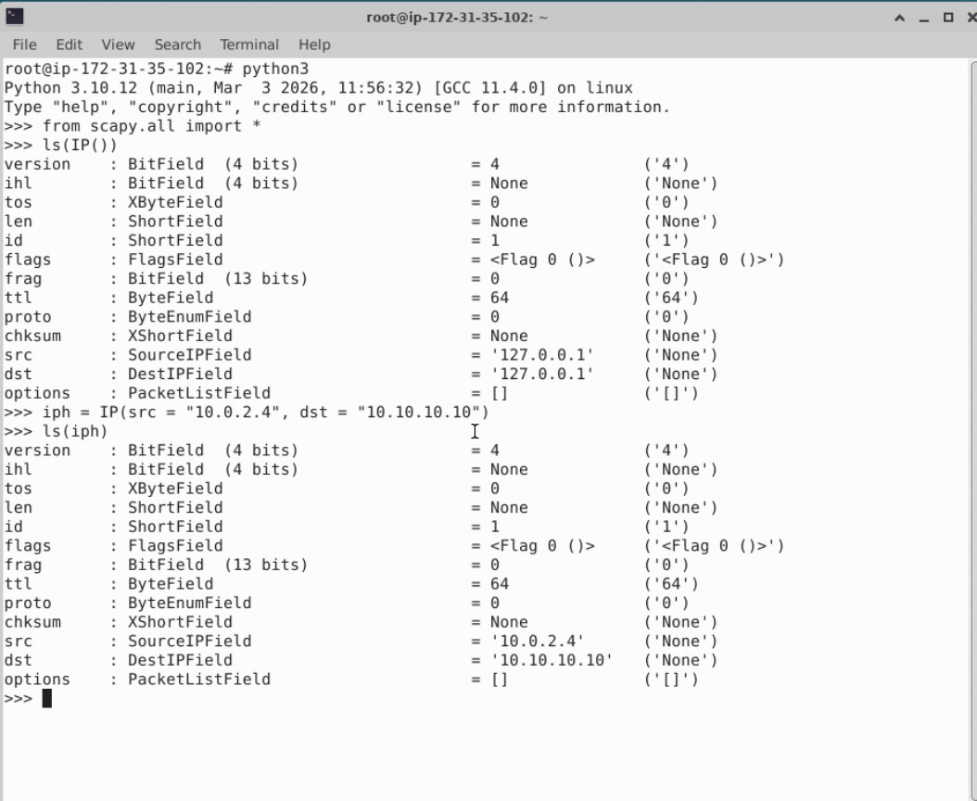
Figure 1.1 — Default IP header and customized IP header with src=10.0.2.4, dst=10.10.10.10
From the output, the source field was successfully changed to 10.0.2.4 and the destination field to 10.10.10.10, while other fields (version=4, ttl=64, etc.) retained their default values.

1.2 Constructing a UDP Segment
A UDP segment was created with source port 5000, destination port 5300, and the payload "hello". The show2() function was used to display the result:
>>> udp = UDP(sport=5000, dport=5300) / Raw(load="hello")
>>> udp.show2()
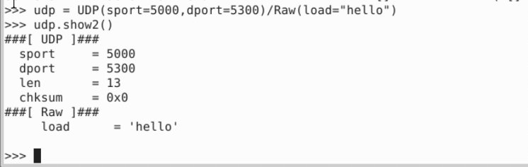
Figure 1.2 — UDP segment with sport=5000, dport=5300, payload="hello"
The output shows the UDP header with sport=5000, dport=5300, len=13 (8-byte UDP header + 5-byte payload), and the Raw layer carrying the string "hello".

1.3 Constructing a Ping Packet and a UDP/IP Packet
First, a ping packet (IP/ICMP) was built using the VM IP (172.31.35.102) as source and 10.10.10.10 as destination:
>>> ping_pkt = IP(src="172.31.35.102", dst="10.10.10.10") / ICMP()
>>> ping_pkt.show2()
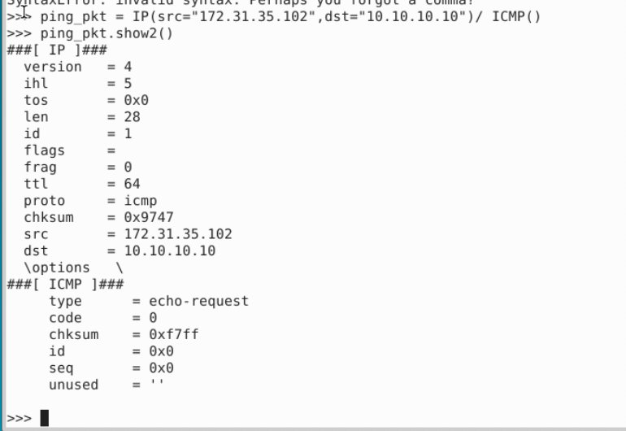
Figure 1.3a — Ping packet (IP/ICMP, type=echo-request)
Next, an IP packet was created with the same source/destination but carrying the UDP segment from 1.2 as its payload:
>>> ping_udp_pkt = IP(src="172.31.35.102", dst="10.10.10.10") / UDP(sport=5000, dport=5300) / Raw(load="hello")
>>> ping_udp_pkt.show2()
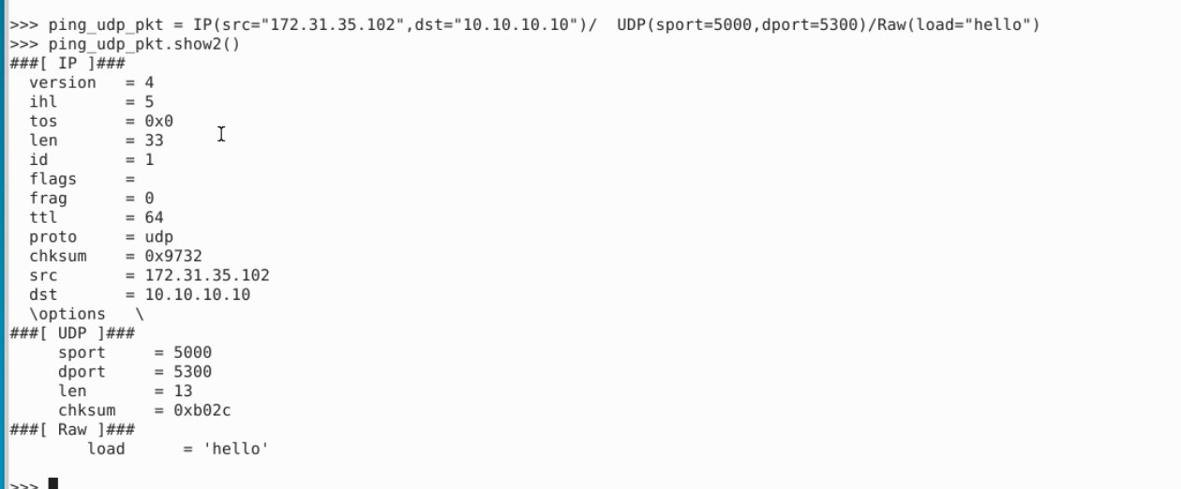
Figure 1.3b — IP packet carrying the UDP segment as payload
The output confirms the complete encapsulation: the IP layer (proto=udp), UDP layer (sport=5000, dport=5300), and the Raw payload "hello".

1.4 Extracting the UDP Segment
Using pkt[UDP] indexing, the UDP segment was extracted from the IP datagram constructed in 1.3:
>>> ping_udp_pkt[UDP].show2()
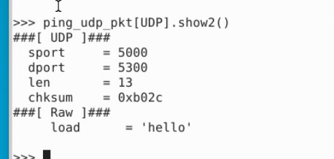
Figure 1.4 — UDP segment extracted from the IP datagram
The output displays only the UDP and Raw layers (the IP header is stripped), which confirms that Scapy can access individual layers by indexing with the protocol class.

2. Sniffing Packets

Task A — Running the Sniffer with and without Root Privilege
The sample sniffer program was implemented as follows. The interface ens5 corresponds to the active network interface on the VM:
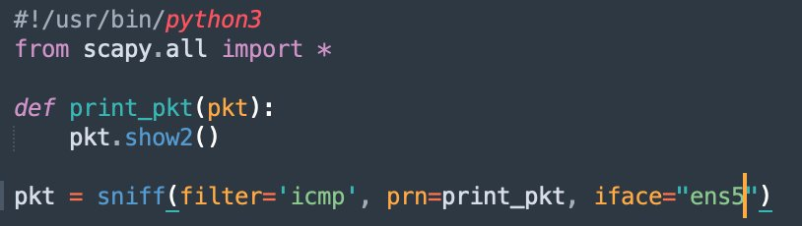
Figure 2.1 — sniffer.py source code

Running with root privilege (sudo)
The program was first executed with sudo python3 sniffer.py. ICMP packets were successfully captured and displayed:
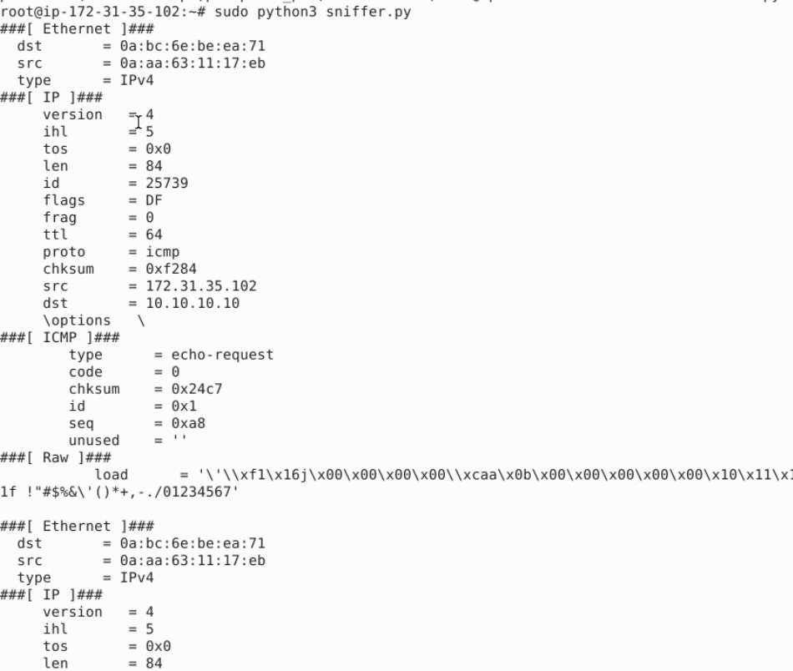
Figure 2.2 — Sniffer output when run as root (sudo)

Running without sudo (still as root user)
The program was then run again with python3 sniffer.py (without sudo). Since the current login user is already root, raw socket access is allowed and packets were still captured successfully:
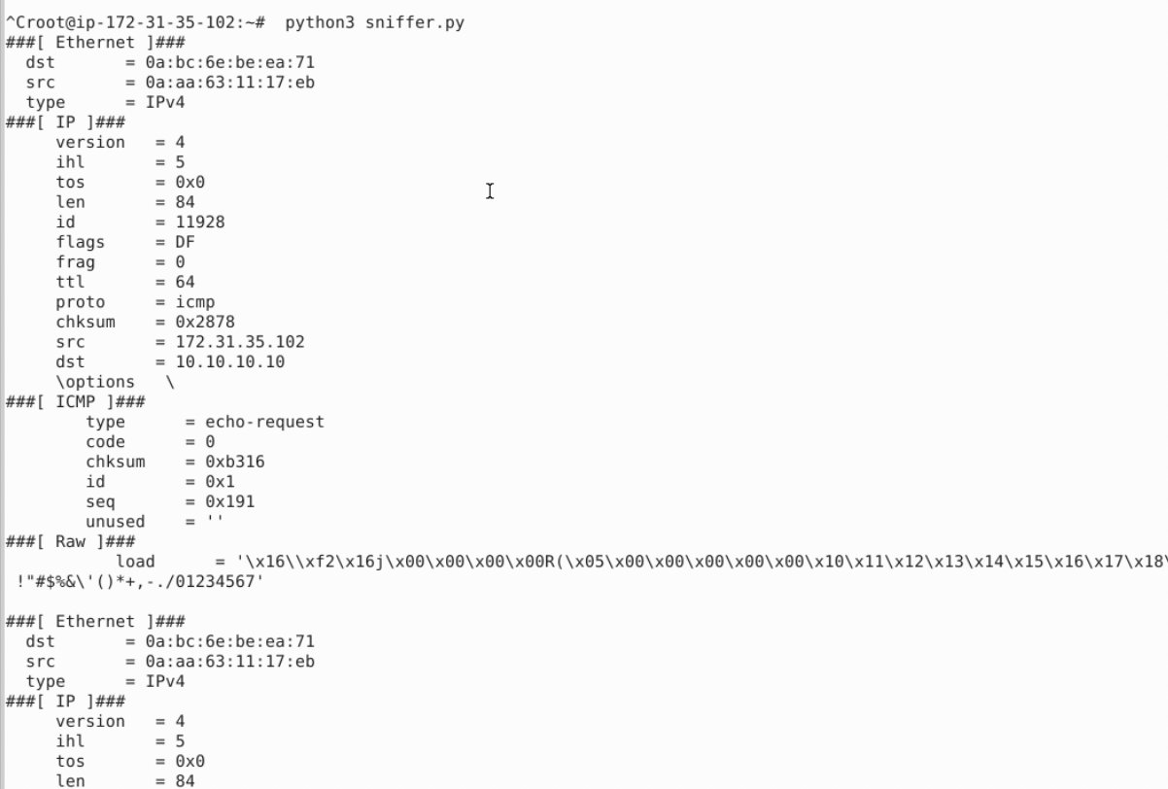
Figure 2.3 — Sniffer output when run without sudo (but still as root user)

Task B — Sniffing and Spoofing ICMP Packets
The program was modified to (1) sniff only ICMP packets whose source IP is 10.10.10.10, and (2) for each captured packet, swap the source and destination IPs, set the ICMP type to 8 (echo-request), set the payload to "COMP8677-KunLan", and send the modified packet. Source code:
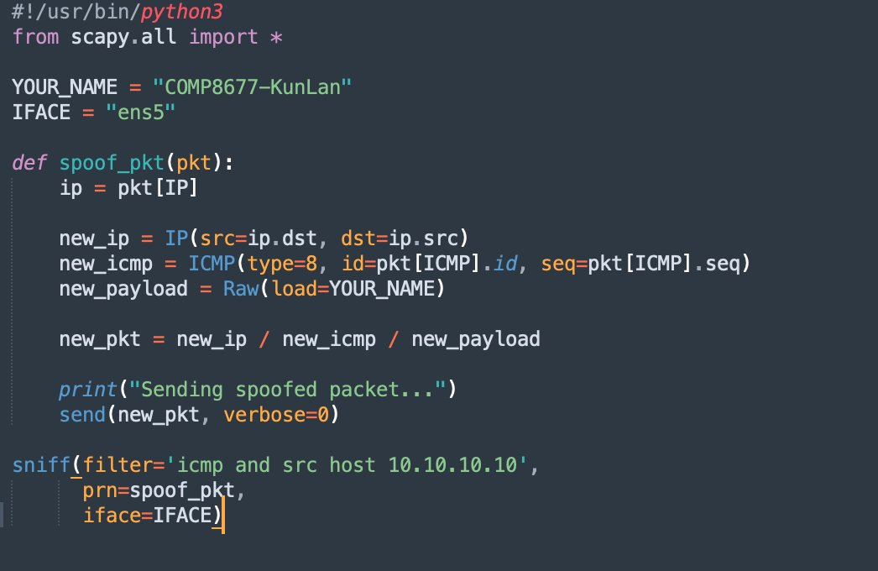
Figure 2.4 — Sniff-and-spoof program for Task B
After running the program and issuing ping 10.10.10.10 from another terminal, Wireshark was used to verify that 10.10.10.10 replied to our spoofed packet. The captured ICMP echo-request shows the modified data field containing "COMP8677-KunLan":
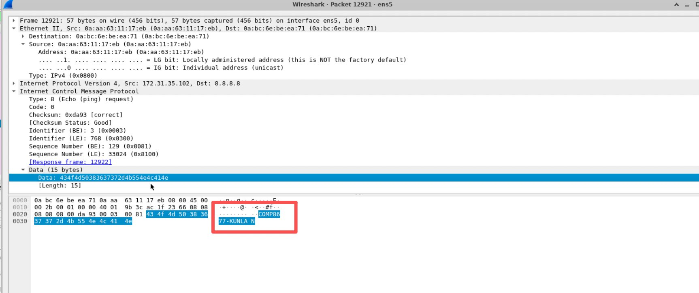
Figure 2.5 — Wireshark capture showing the spoofed ICMP packet with data field "COMP8677-KunLan"
The Data field hex 434f4d50383637372d4b756e4c616e decodes to the ASCII string "COMP8677-KunLan", confirming that the modified packet was successfully transmitted and accepted by the remote host.

Task C — BPF Filter Practice

(a) Capture TCP packets from www.example.com to the VM subnet
A curl request to http://www.example.com was issued from one terminal to generate TCP traffic. In another terminal, Scapy was used to capture matching packets:
>>> pkts = sniff(filter="tcp and src host www.example.com and dst net 172.31.0.0/16", count=5, iface="ens5")
>>> pkts[0].show2()
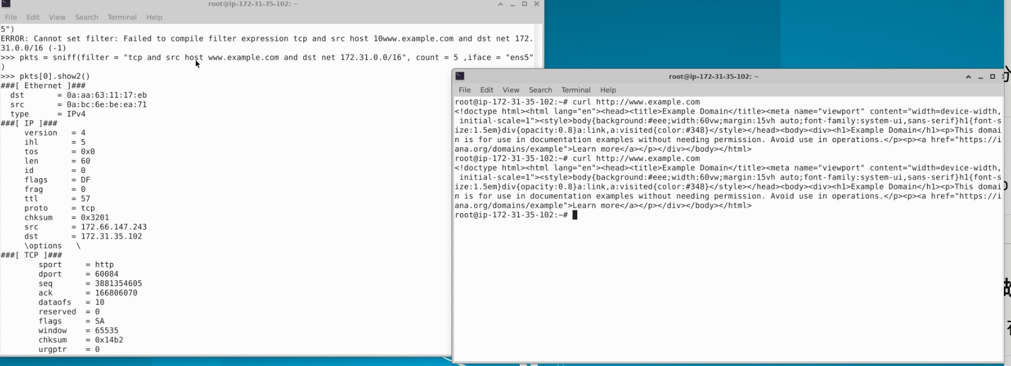
Figure 2.6 — TCP packet captured from www.example.com (src=172.66.147.243, dst=172.31.35.102)
The captured packet shows proto=tcp, src=172.66.147.243 (one of the IPs of example.com), and dst=172.31.35.102 (the VM, within the 172.31.0.0/16 subnet), with sport=http(80). This confirms the BPF filter works correctly.

(b) Capture packets from source port 53 in a specified subnet
A DNS query was issued using dig @8.8.8.8 www.mit.edu to generate DNS response traffic from the 8.8.0.0/16 subnet. The BPF filter captured the response:
>>> pkts = sniff(filter="src port 53 and src net 8.8.0.0/16", count=3, iface="ens5")
>>> pkts[0].show2()
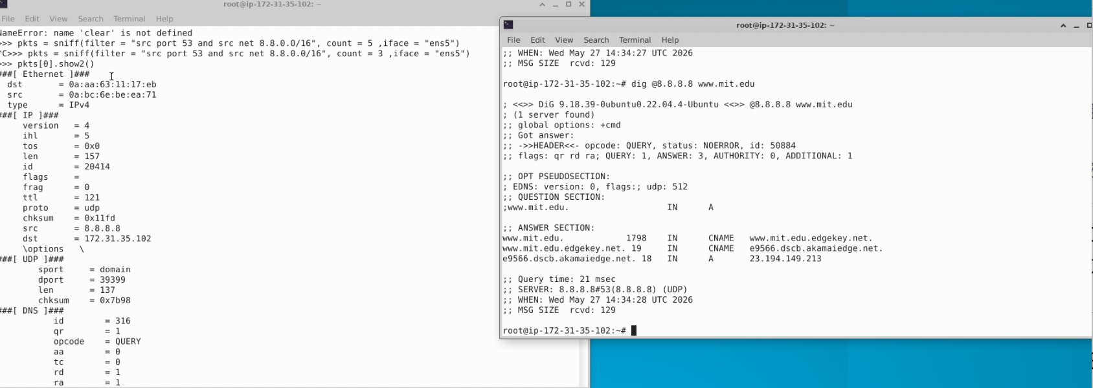
Figure 2.7 — DNS response packet from 8.8.8.8 (src port 53)
The captured packet shows proto=udp, src=8.8.8.8 (within 8.8.0.0/16), sport=domain (53), and a DNS response payload — confirming that the BPF filter correctly matched only packets originating from port 53 in the specified subnet.

3. ARP Cache Poisoning Attack

3.1 Completed Attack Program
The completed Python program (arp_attack.py) is shown below:
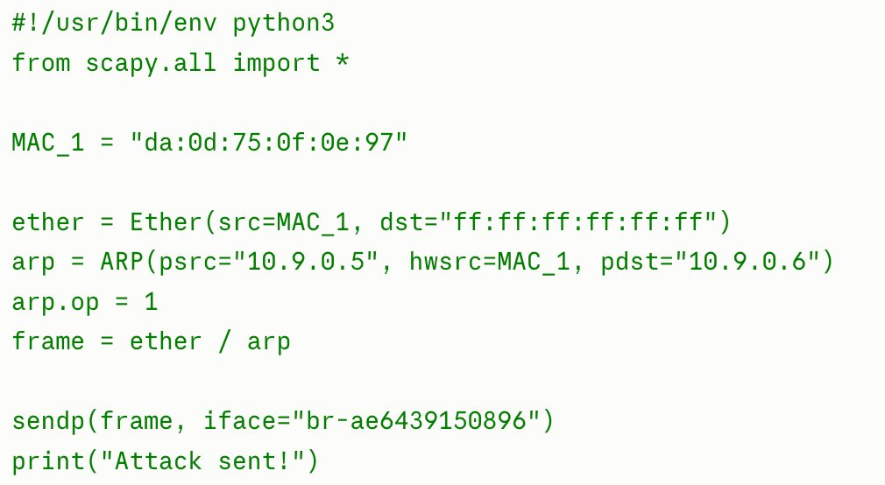
Figure 3.1 — Completed ARP cache poisoning code
Key fields:
- Ether layer: src = MAC_1 (attacker's MAC da:0d:75:0f:0e:97), dst = ff:ff:ff:ff:ff:ff (broadcast).
- ARP layer: psrc = 10.9.0.5 (spoofed sender IP), hwsrc = MAC_1, pdst = 10.9.0.6 (victim), op = 1 (ARP request).
- sendp(frame, iface="br-ae6439150896") sends the link-layer frame on the bridge interface of the 10.9.0.0/24 subnet.

3.2 Verifying the Poisoned ARP Cache on 10.9.0.6
The attack program was executed on the attacker container:
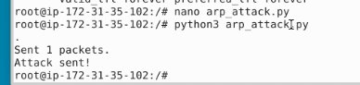
Figure 3.2 — Running the attack program (Attack sent!)
Inside the victim container 10.9.0.6, the ARP table was inspected before and after the attack:
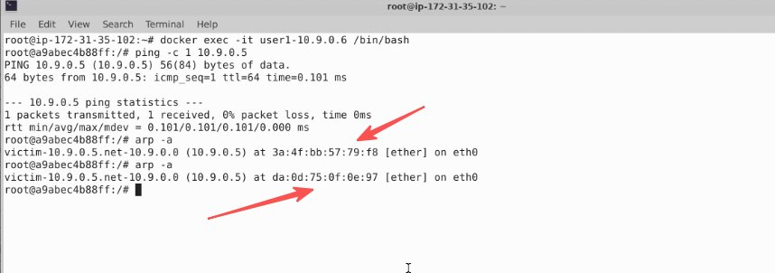
Figure 3.3 — ARP table on 10.9.0.6 before and after the attack
Before the attack, ping 10.9.0.5 forced the victim to learn the legitimate ARP mapping 10.9.0.5 → 3a:4f:bb:57:79:f8. After our forged ARP query was sent, the same arp -a command shows the entry has been overwritten to 10.9.0.5 → da:0d:75:0f:0e:97, which is the attacker's MAC (MAC_1). The poisoning was successful.

3.3 Explanation of How the Attack Works
ARP has no authentication — any host on the LAN can claim ownership of any IP, and others will believe it. Moreover, when a host receives an ARP request, it caches the (sender IP, sender MAC) pair from the request before replying, on the assumption that it will need to reply soon. The attack exploits this behavior:
- The attacker crafts an ARP request with a forged sender: psrc = 10.9.0.5, hwsrc = MAC_1 (attacker's own MAC), pdst = 10.9.0.6. The Ethernet destination is set to the broadcast address so the victim is guaranteed to receive it.
- Upon receiving the request, victim 10.9.0.6 caches (10.9.0.5 → MAC_1) into its ARP table without any verification.
- From this point on, any packet 10.9.0.6 sends to 10.9.0.5 is silently delivered to the attacker instead, enabling a man-in-the-middle attack.

