Q0
import socket
import time
# Server configuration
HOST = '' # Empty string means listen on all network interfaces
PORT = 4000 # Port to listen on
TIMEOUT = 15 # Client command timeout in seconds
BUFFER_SIZE = 1024 # Receive buffer size
# Create welcome socket
ss = socket.socket(socket.AF_INET, socket.SOCK_STREAM)
# Allow port reuse to avoid "Address already in use" errors when restarting quickly
ss.setsockopt(socket.SOL_SOCKET, socket.SO_REUSEADDR, 1)
# Bind the socket to the address and port, and start listening
ss.bind((HOST, PORT))
ss.listen(1)
print(f"Server is listening on port {PORT}...\n")
# Flag: controls whether the server continues to run
server_running = True
while server_running:
print("Waiting for a new connection...\n")
# Accept a new connection, returning a new socket and the client address (IP, port)
new_sock, addr = ss.accept()
client_ip, client_port = addr
print(f"Connected by {client_ip}:{client_port}\n")
# Step 1: Tell the client its own IP address and port
welcome_msg = f"Your IP address is {client_ip}, your port number is {client_port}\n"
new_sock.send(welcome_msg.encode())
# Set 15 seconds timeout
new_sock.settimeout(TIMEOUT)
# Enter command processing loop
while True:
try:
data = new_sock.recv(BUFFER_SIZE)
# If the client actively closes the connection, recv returns an empty byte string
if len(data) == 0:
print("Client closed the connection.\n")
break
# Decode and strip whitespace (remove newlines, etc.)
command = data.decode().strip()
print(f"Received command: {command}\n")
# Process commands
if command == "TIME":
# Return current time string
current_time = time.ctime()
new_sock.send(current_time.encode() +"\n".encode())
elif command == "EXIT":
# Exit: respond to client, then shutdown the server
new_sock.send("Server is shutting down.\n".encode())
server_running = False
break
else:
# Invalid command
new_sock.send("Invalid command!\n".encode())
except socket.timeout:
# No command received within 15 seconds
print("Connection timed out (no command in 15 seconds).\n")
break
except ConnectionResetError:
# Client connection disconnected unexpectedly
print("Client connection was reset.\n")
break
# Close current client socket, prepare to accept the next client
new_sock.close()
print("Current client socket closed.\n")
# Close welcome socket, server fully shuts down
ss.close()
print("Welcome socket closed. Server has shut down.\n")

Q1
a. Source and Destination IP
- Source Address: 172.31.45.91 (my VM)
- Destination Address: 23.185.0.1 (www.utoronto.ca)
b. Upper Layer Protocol
- Protocol: ICMP (1)
c. IP Header Length
- Header Length: 20 bytes (5 × 4)
d. Payload Length
- Total Length = 84
- Header Length = 20
- Payload Length = 84 − 20 = 64 bytes
e. TTL Value and Meaning
- TTL = 64
- Meaning: Every time the packet passes through a router, the TTL value is decremented by 1. When TTL reaches 0, the packet is discarded. This prevents packets from looping in the network indefinitely due to routing loops.
f. Field Indicating IPv4 or IPv6
- The Version field indicates the IP format. In the screenshot it shows 0100 .... = Version: 4, meaning IPv4 (a value of 6 would indicate IPv6).
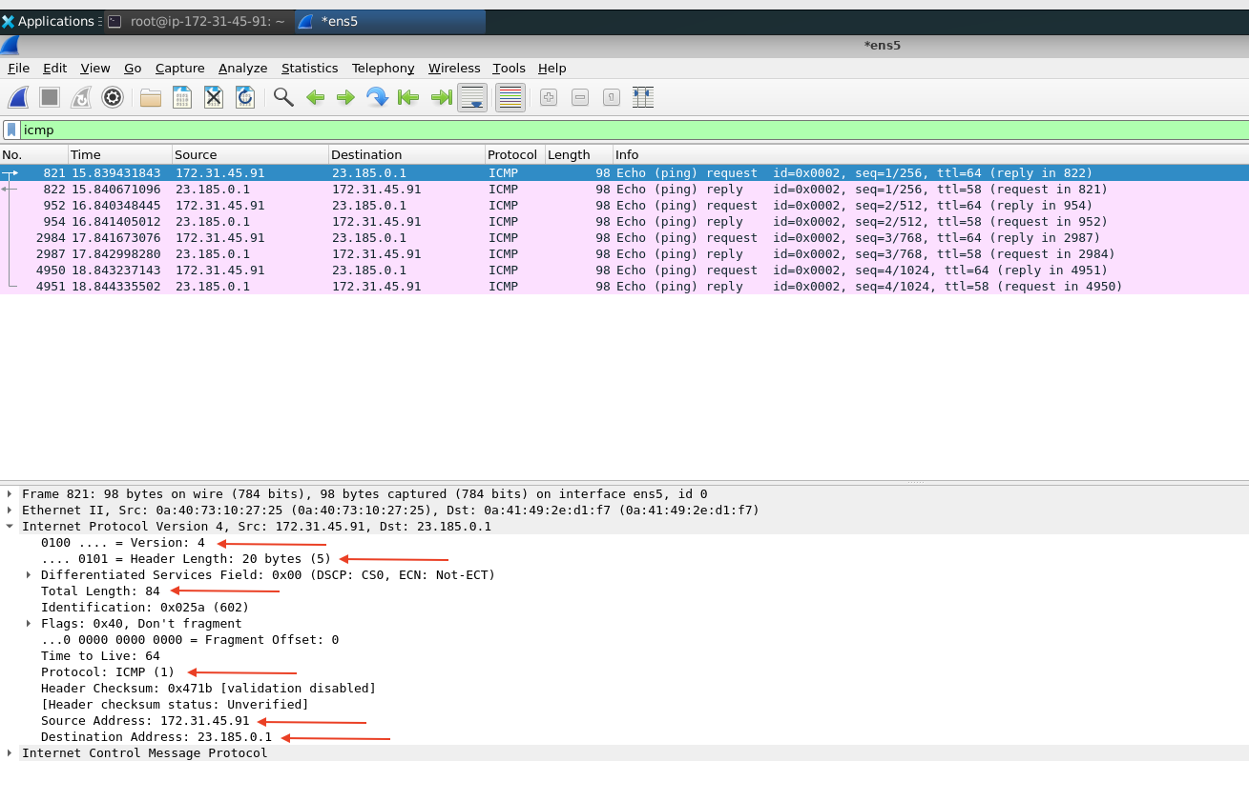
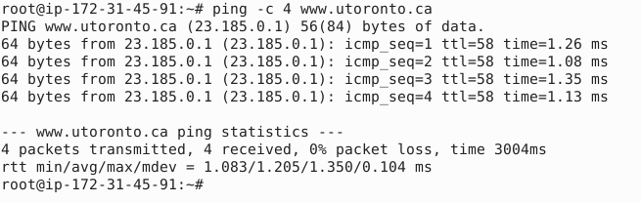

Q2
a. Transport Layer Protocol of DHCP
From the DHCP Discover packet (No. 982), the transport layer header shows that DHCP uses UDP (User Datagram Protocol) — Source Port 68, Destination Port 67.
Reason it is not TCP: TCP requires a three-way handshake to establish a connection before exchanging data. However, when DHCP runs, the client does not yet have an IP address (Source IP = 0.0.0.0) and must broadcast to 255.255.255.255 to find a DHCP server. A TCP connection cannot be established without a valid IP address and a known server address, so DHCP uses connectionless UDP instead.
b. DHCP Offer — Configuration Information
From the DHCP Offer packet (No. 983), the following configuration information is provided to the client:
Field | Value
DHCP Server IP | 172.31.32.1 (Option 54: DHCP Server Identifier)
Subnet Mask | 255.255.240.0 (Option 1: Subnet Mask)
Router IP | 172.31.32.1 (Option 3: Router)
DNS Server IP | 172.31.0.2 (Option 6: Domain Name Server)
In addition, the offered client IP address is 172.31.45.91.
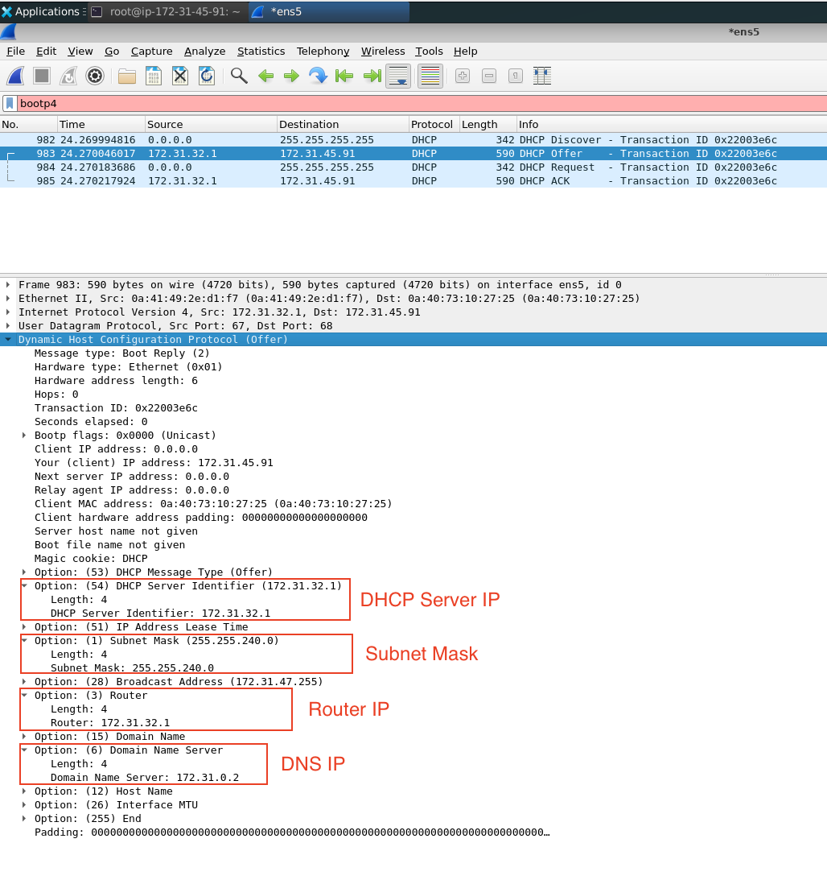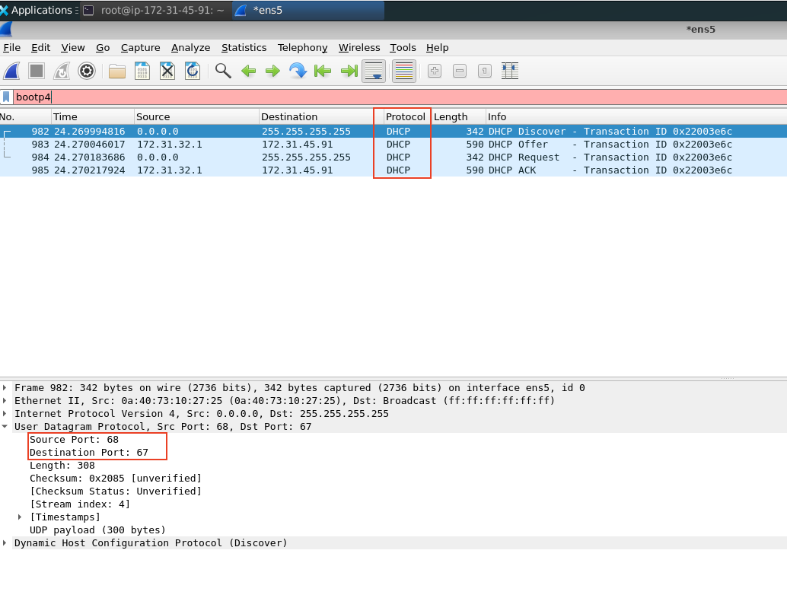
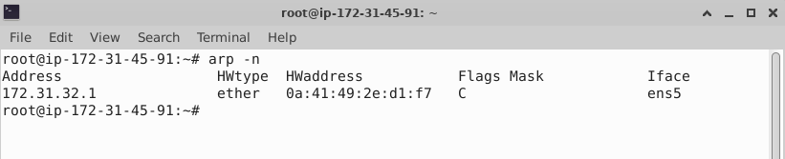

Q3
a. ARP Broadcast Request (Packet No. 807)
- Upper layer protocol in the link-layer header: Type: ARP (0x0806). The Ethernet II Type field value 0x0806 indicates that the upper layer protocol is ARP.
- Broadcast MAC address: ff:ff:ff:ff:ff:ff (the Destination MAC in the Ethernet II header).
- Target IP address (the IP being resolved): 172.31.32.1 (the router).
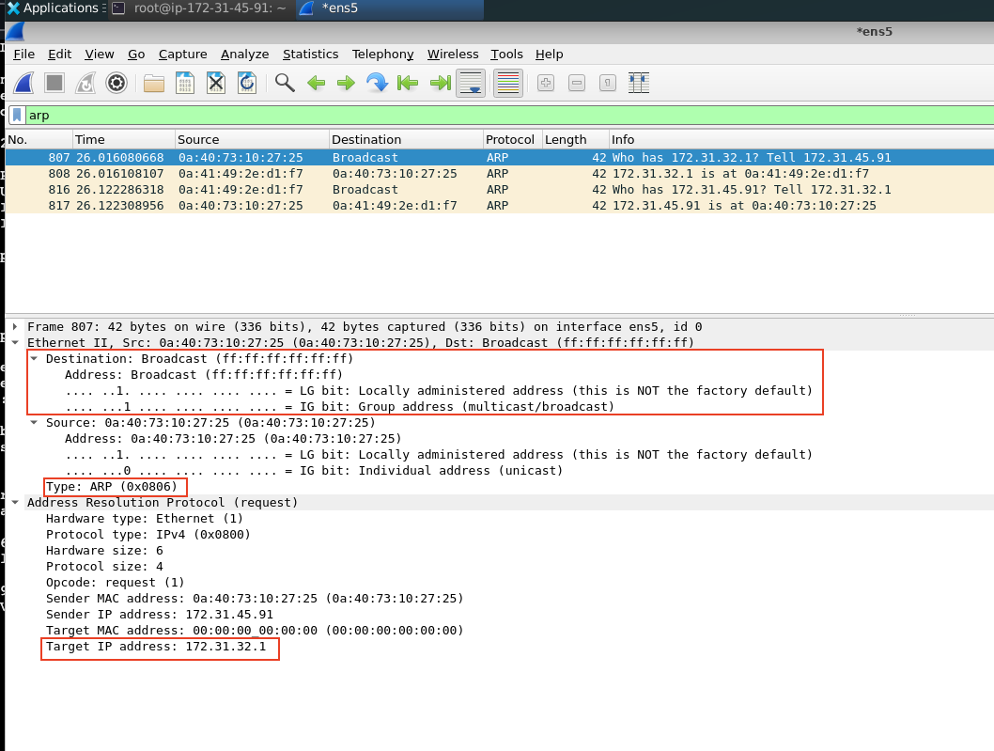
b. ARP Reply (Packet No. 808)
- Sender IP address: 172.31.32.1
- Sender MAC address: 0a:41:49:2e:d1:f7
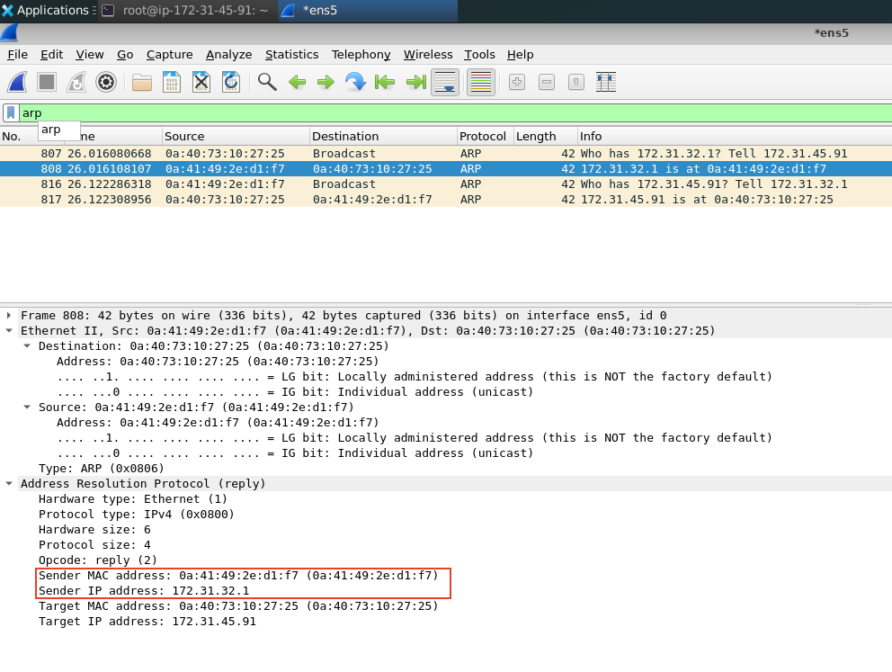

Q4
a. Source and Destination MAC of the HTTP Request
From the HTTP GET request packet (No. 1159) sent to 172.66.147.243 (www.example.com), the Ethernet II header shows:
- Source MAC address: 0a:40:73:10:27:25 (the MAC address of my VM)
- Destination MAC address: 0a:41:49:2e:d1:f7
b. Does the Destination MAC belong to 172.66.147.243?
No. Running the arp -n command on the VM gives the following output:
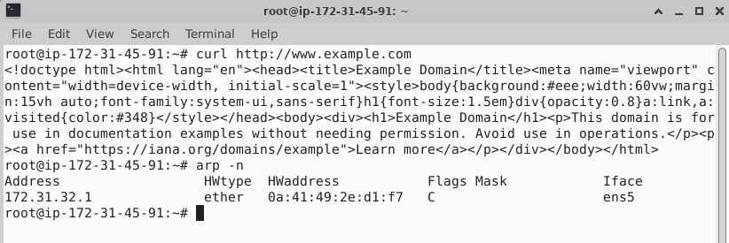
The destination MAC 0a:41:49:2e:d1:f7 is listed in the ARP table, and it belongs to the router at IP 172.31.32.1, not to the web server at 172.66.147.243.
This is expected behaviour: the web server is on a remote network, so the VM cannot directly address it at the link layer (MAC addresses are only meaningful within the local network). The HTTP packet is therefore sent at the link layer to the default gateway (router), which then forwards it toward the actual destination 172.66.147.243.
c. Upper Protocol Field in the Link-Layer Header
In the Ethernet II header of the HTTP request packet, the Type field has the value 0x0800, which represents the IPv4 protocol. This indicates that the payload encapsulated within the Ethernet frame is an IPv4 packet.
