**触摸事件30%，其他按键50%，错误停止，延时200**

1. adb shell monkey -p com.example.shoujiedemo --throttle 200 --pct-touch 30 --pct-anyevent 50 -v -v 100次 运行100次不报错
2. adb shell monkey -p com.example.shoujiedemo --throttle 200 --pct-touch 30 --pct-anyevent 50 -v -v 1000次 报错

Caused by: android.view.InflateException: Binary XML file line #134: Error inflating class <unknown> 构造方法出错

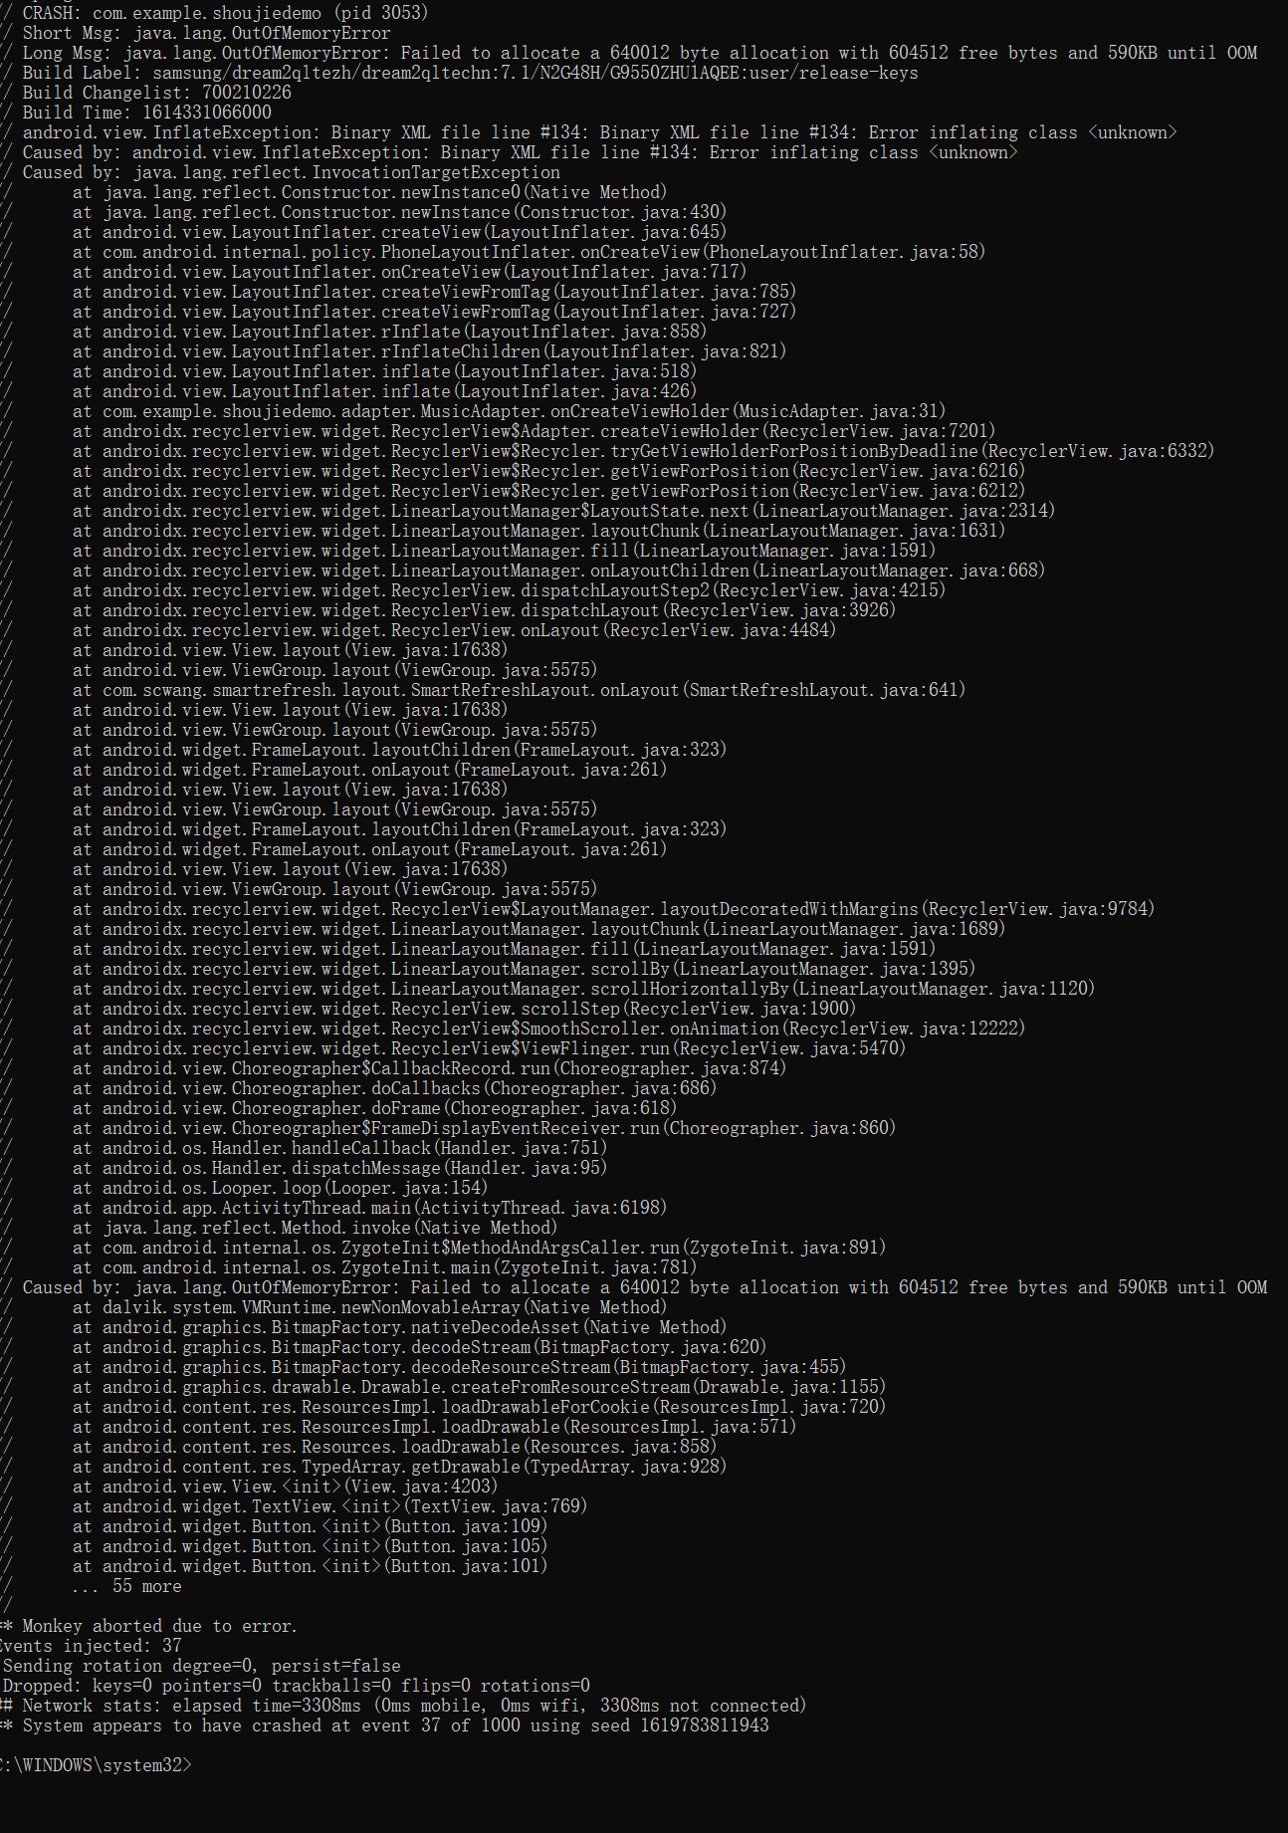

强制转换异常 java.lang.ClassCastException: android.graphics.drawable.ColorDrawable cannot be cast to android.graphics.drawable.BitmapDrawable

// at com.example.shoujiedemo.util.CircleImageView.onDraw(CircleImageView.java:53)

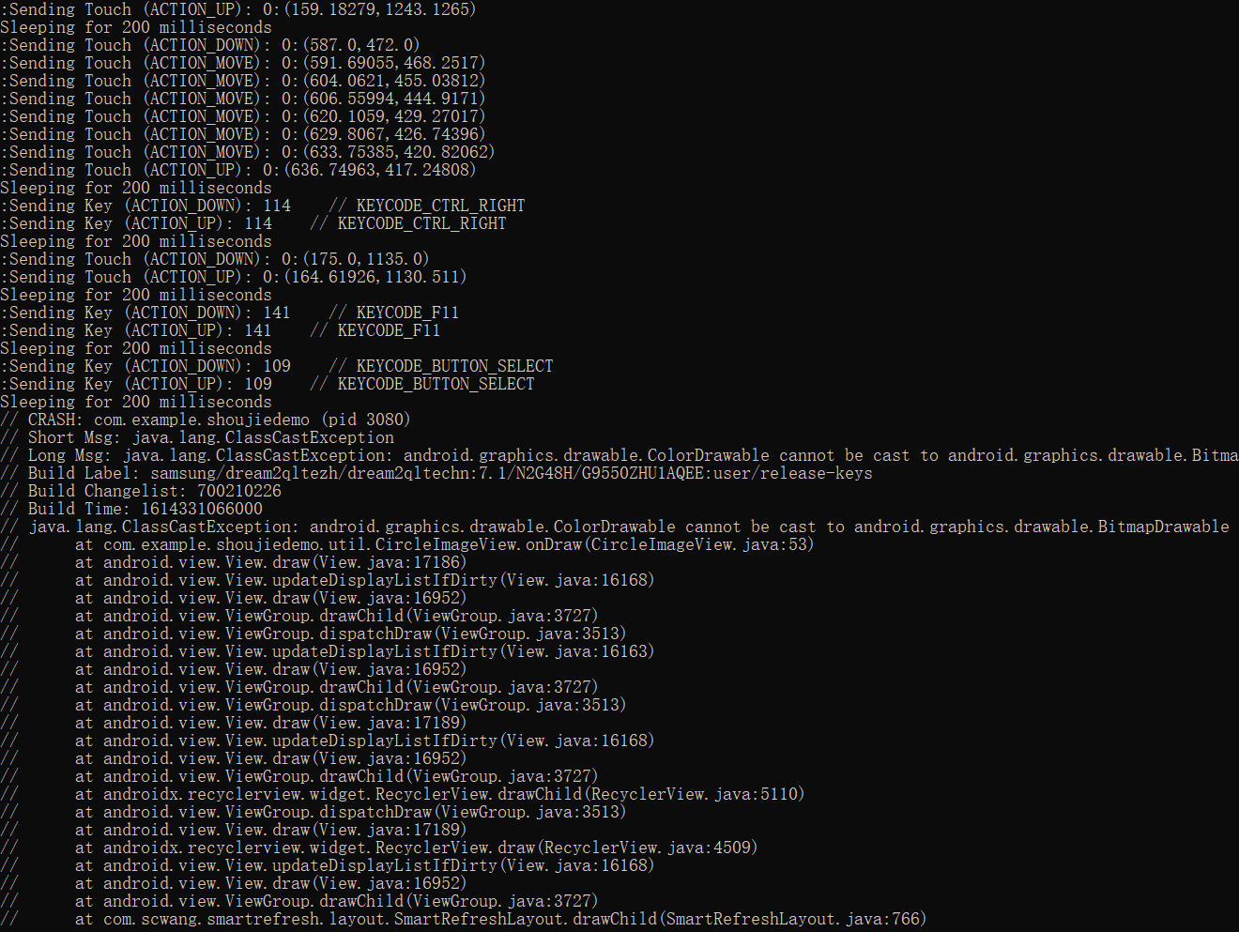

1. adb shell monkey -p com.example.shoujiedemo --throttle 200 --pct-touch 30 --pct-anyevent 50 -v -v 10000 运行10000次 报内存溢出的错误

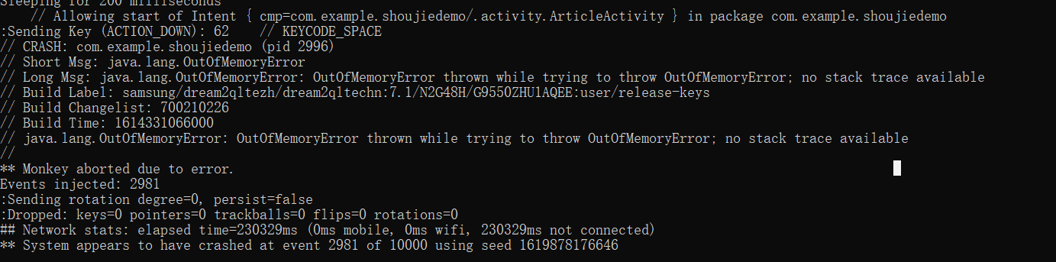

1. adb shell monkey -p com.example.shoujiedemo --throttle 200 --pct-touch 40 --pct-motion 20 --pct-anyevent 20 --pct-appswitch 10  -v -v 1000 报错 Unable to start activity ComponentInfo{com.example.shoujiedemo/com.example.shoujiedemo.myCenter.mySpace.view.activity.fragment.activity.MyArticleActivity}: 无法打开MyArticleActivity

|  |
| --- |
| // Allowing start of Intent { cmp=com.example.shoujiedemo/.myCenter.mySpace.view.activity.fragment.activity.MyArticleActivity } in package com.example.shoujiedemo  // CRASH: com.example.shoujiedemo (pid 3691)  // Short Msg: java.lang.OutOfMemoryError  // Long Msg: java.lang.OutOfMemoryError: Failed to allocate a 8785308 byte allocation with 4345328 free bytes and 4MB until OOM  // Build Label: samsung/dream2qltezh/dream2qltechn:7.1/N2G48H/G9550ZHU1AQEE:user/release-keys  // Build Changelist: 700210226  // Build Time: 1614331066000  java.lang.RuntimeException: Unable to start activity ComponentInfo{com.example.shoujiedemo/com.example.shoujiedemo.myCenter.mySpace.view.activity.fragment.activity.MyArticleActivity}:  android.view.InflateException: Binary XML file line #17: Binary XML file line #17: Error inflating class <unknown>  // at android.app.ActivityThread.performLaunchActivity(ActivityThread.java:2668)  // at android.app.ActivityThread.handleLaunchActivity(ActivityThread.java:2729)  // at android.app.ActivityThread.-wrap12(ActivityThread.java)  // at android.app.ActivityThread$H.handleMessage(ActivityThread.java:1480)  // at android.os.Handler.dispatchMessage(Handler.java:102)  // at android.os.Looper.loop(Looper.java:154)  // at android.app.ActivityThread.main(ActivityThread.java:6198)  // at java.lang.reflect.Method.invoke(Native Method)  // at com.android.internal.os.ZygoteInit$MethodAndArgsCaller.run(ZygoteInit.java:891)  // at com.android.internal.os.ZygoteInit.main(ZygoteInit.java:781)  // Caused by: android.view.InflateException: Binary XML file line #17: Binary XML file line #17: Error inflating class <unknown>  // Caused by: android.view.InflateException: Binary XML file line #17: Error inflating class <unknown>  // Caused by: java.lang.reflect.InvocationTargetException |

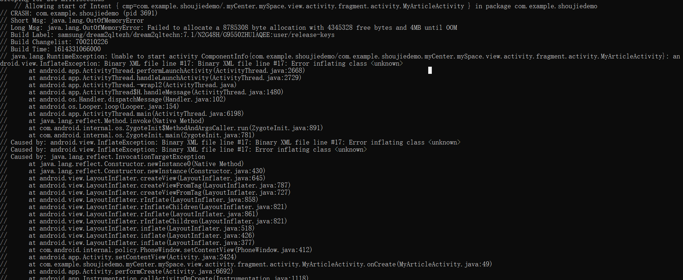

1. adb shell monkey -p com.example.shoujiedemo --throttle 200 --pct-touch 40 --pct-motion 30 --pct-anyevent 20 --pct-appswitch 10  -v -v 1000 报错 java.lang.RuntimeException: Unable to start activity ComponentInfo{com.example.shoujiedemo/com.example.shoujiedemo.activity.MusicActivity}: 无法打开MusicActivity

|  |
| --- |
| // CRASH: com.example.shoujiedemo (pid 4280)  // Short Msg: java.lang.OutOfMemoryError  // Long Msg: java.lang.OutOfMemoryError: Failed to allocate a 32490012 byte allocation with 6268288 free bytes and 5MB until OOM  // Build Label: samsung/dream2qltezh/dream2qltechn:7.1/N2G48H/G9550ZHU1AQEE:user/release-keys  // Build Changelist: 700210226  // Build Time: 1614331066000  // java.lang.RuntimeException: Unable to start activity ComponentInfo{com.example.shoujiedemo/com.example.shoujiedemo.activity.MusicActivity}: android.view.InflateException: Binary XML file line #115: Binary XML file line #115: Error inflating class <unknown>  // at android.app.ActivityThread.performLaunchActivity(ActivityThread.java:2668)  // at android.app.ActivityThread.handleLaunchActivity(ActivityThread.java:2729)  // at android.app.ActivityThread.-wrap12(ActivityThread.java)  // at android.app.ActivityThread$H.handleMessage(ActivityThread.java:1480)  // at android.os.Handler.dispatchMessage(Handler.java:102)  // at android.os.Looper.loop(Looper.java:154)  // at android.app.ActivityThread.main(ActivityThread.java:6198)  // at java.lang.reflect.Method.invoke(Native Method)  // at com.android.internal.os.ZygoteInit$MethodAndArgsCaller.run(ZygoteInit.java:891)  // at com.android.internal.os.ZygoteInit.main(ZygoteInit.java:781)  // Caused by: android.view.InflateException: Binary XML file line #115: Binary XML file line #115: Error inflating class <unknown>  // Caused by: android.view.InflateException: Binary XML file line #115: Error inflating class <unknown>  // Caused by: java.lang.reflect.InvocationTargetException  // at java.lang.reflect.Constructor.newInstance0(Native Method)  // at java.lang.reflect.Constructor.newInstance(Constructor.java:430)  // at android.view.LayoutInflater.createView(LayoutInflater.java:645)  // at android.view.LayoutInflater.createViewFromTag(LayoutInflater.java:787)  // at android.view.LayoutInflater.createViewFromTag(LayoutInflater.java:727)  // at android.view.LayoutInflater.rInflate(LayoutInflater.java:858) |

