Prefix-scan evaluation

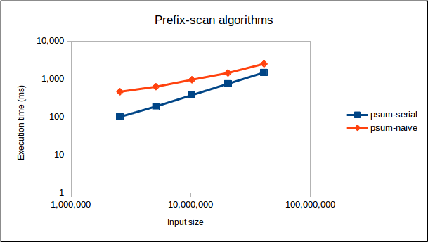

The above graph shows the performance of the two prefix-scan implementations I wrote. The serial CPU implementation, indicated by psum-serial, simply computes prefix-sums in place on an input array. It performs a single addition for each element. Thus, psum-serial has a complexity of of O(n), where n is the length of the input. On the other hand, the naive parallel GPU implementation, indicated by psum-naive, is a little more complex. It traverses the input like a tree, computing partial sums one “level” at a time. It performs n-2^l additions on each level, where l is current level’s index. Furthermore, there are log_2(n) levels in total. As such, psum-naive has a complexity of O(n*log_2(n)).
However, as the input size doubles, the lines on the graph start to converge. Although psum-naive has a higher complexity than psum-serial, the GPU’s architecture allows it to spawn millions of threads and have thousands executing in parallel at any given point in time. Furthermore, for any given thread that is blocked on I/O, there are millions of other threads that could be execute while it waits. Since psum-naive scales the number of threads to the input size, then, its performance slowly catches up to psum-serial as the input size grows. This “latency hiding” is a significant part of what makes GPUs so powerful.

