DEliverable 1 report
Group 46 Team 26 – ADC Subteam
Authors: Leo Jiang and Caleb Vaillancourt

Introduction and System Context
The goal of this project develop the software for an automated dispensing cabinet (ADC) and medicine monitoring system used in hospital. This report will focus on the ADC’s firmware component. The ADC is a safety-critical, software-controlled dispensing device, that needs to manage the dispensing of medication. It must ensure that only qualified individuals are able to access the cabinet, and must interface with the management system to ensure that hospital admins have up-to-date information on system status, inventory, and system logs.

Functional Requirements
Requirement ID | Requirement | Description
FR-AUT-01 | Authentication | The cabinet must require successful staff authentication (eg. Password, staff card to scan) before access to the cabinet is granted
FR-INV-01 | Inventory Management | The cabinet must log each medicine within the cabinet information portal, including medication name, quantity, location, etc.
FR-INV-02 | Inventory Management | The cabinet must notify the monitoring system when restocking is needed
FR-DIS-01 | Dispensing | The cabinet must open the drawer containing the medicine selected by the authenticated user
FR-EVE-01 | Event Logging | The cabinet shall record dispensing, authentication, access, and restocking information and display them on the UI
FR-FAU-01 | Fault Detection | The cabinet shall detect 3 consecutive unsuccessful authentication attempts and send a notification to IT
FR-FAU-02 | Fault Detection | The cabinet must detect if any drawer has been left open for longer than 3 minutes, notify the monitoring system, and automatically close the cabinet
FR-FAU-03 | Fault Detection | The cabinet shall detect a failure of the automatic drawer-opening or closing mechanism and notify the monitoring system
FR-OPE-01 | Operational Modes | The device must feature a standby mode, dispensing mode, locked mode, and emergency shutdown mode
FR-EXT-01 | External Communication | The cabinet shall send medication dispensing, inventory, and fault detection information to the monitoring system

Non-Functional Requirements
Requirement ID | Requirement | Description
NFR-SEC-01 | Security | The cabinet shall prevent unauthenticated users from accessing medications
NFR-SEC-02 | Security | The cabinet shall not allow the user to access the cabinet after 3 consecutive unsuccessful authentication attempts
NFR-REL-01 | Reliability | The cabinet shall accurately monitor inventory levels and identify low-stock conditions with 99% accuracy
NFR-REL-02 | Reliability | Fewer than 1 unplanned shutdown per 10,000 hours of cabinet operation
NFR-AVA-01 | Availability | The cabinet shall maintain at least 99.9% operational availability during scheduled hospital operating periods
NFR-PER-01 | Performance | The cabinet shall dispense the selected medication within 5 seconds of user selection and touchscreen confirmation
NFR-TRA-01 | Traceability/Auditability | All medication dispensing events shall be traceable to the authenticated user, medication, quantity dispensed, and time of dispensing
NFR-USE-01 | Useability | The cabinet shall allow all routine medication-dispensing operations to be completed using one hand without assistance
NFR-USE-02 | Useability | The cabinet UI workflow must be intuitive and require minimal training to learn how it works

User Stories
Stakeholder | Stakeholder Type | User Story ID | User Story | Acceptance Criteria
Nurse getting medicine from the cabinet | Direct | US-DIS-01 | “As a nurse getting medicine from the cabinet, I want the cabinet open the drawer containing the exact medicine I want.” | GIVEN a medicine extraction scenario, WHEN the nurse specifies the medication, THEN the drawer containing the correct medication opens up for the nurse or cabinet user.
Nurse getting medicine from the cabinet | Direct | US-PER-01 | “As a nurse getting medicine from the cabinet, I want the process to be quick to ensure I can deliver medicine to patients on time.” | GIVEN a medicine extraction scenario, WHEN the nurse selects the medication on the screen, THEN the medication should dispense quickly to ensure on-time delivery to patients.
Nurse getting medicine from the cabinet | Direct | US-USE-01 | As a nurse getting medicine from the cabinet, I want the ADC’s UI and workflow to be intuitive, so I do not need extended training and will make less operational errors. | GIVEN a medicine extraction scenario, WHEN the nurse uses the screen, THEN its UI and workflow should be intuitive and not require extended training.
Nurse getting medicine from the cabinet | Direct | US-EVE-01 | As a nurse getting medicine from the cabinet, I want to know which cabinet has the medicine I need, so I do not waste time looking through different cabinets. | GIVEN a nurse needs medicine, WHEN a nurse needs to know which cabinets have which medicine, THEN there should be a feature that allows the nurse to know which medications are in each cabinet so they do not need to waste time looking for the correct medication.
Nurse getting medicine from the cabinet | Direct | US-USE-02 | As a nurse getting medicine from the cabinet, I want to be able to operate the cabinet with one hand, so that I can use the cabinet while holding medicine in the other hand  I want to be able to access the cabinets with multiple methods in case one method fails” | GIVEN a medicine extraction scenario, WHEN the nurse attempts to use the screen with one hand, THEN it should be possible to operate with one hand and not require the use of a second hand.
Nurse getting medicine from the cabinet | Direct | US-REL-01 | “As a nurse getting medicine from the cabinet, I want the cabinet to be available at all times of the day with minimal unplanned shutdowns per year.” | GIVEN a nurse getting medicine from the cabinet, WHEN a nurse needs medicine, THEN the cabinet should be available at all times of the day with minimal yearly shutdowns.
Nurse restocking the cabinet | Direct | US-USE-03 | As a nurse restocking the cabinet, I want to be able to operate the cabinet during the restocking process with one hand, so I can operate the cabinet while holding medicine in my other hand" | GIVEN a cabinet restocking scenario, WHEN the nurse restocks the cabinet and has one hand taken away with medicine in it, THEN the nurse should be able to use the screen and cabinet with their other free hand.
Doctor | Indirect | US-INV-01 | “As a doctor, I want to be able to see what medicines are in which cabinets, so I know if the medicines I want are in stock and which cabinets they are in” | GIVEN a doctor wants to see which medicines are in which cabinet, WHEN a doctor checks the stock of a cabinet, THEN the UI should correctly and quickly display the stock of the cabinet to the doctor.
Hospital Admin | Indirect | US-SEC-01 | “As a hospital admin, I want to ensure only authorized individuals are allowed to access the cabinet, so I can ensure medication does not get stolen/misused. | GIVEN an authorized user attempts to access the cabinet, WHEN they enter their login information or scan their staff card, THEN they should be allowed access into the cabinet.
Hospital Admin | Indirect | US-FAU-01 | As a hospital admin, I want to be able to constantly monitor the operating state of the ADC, so I can ask someone to repair the ADC the moment a fault occurs. | GIVEN a fault occurs on the ADC such as a drawer being jammed, WHEN the fault occurs, THEN the administrator using the monitoring system should be able to see the fault being reported immediately.
Hospital Admin | Indirect | US-EXT-01 | As a hospital admin, I want to be able to check the inventory and know when to ask a nurse to restock each cabinet, so I can make sure the cabinets are never overstocked or understocked. | GIVEN any dispensing/restocking event, WHEN a change in inventory (medicine dispensed/added), THEN the monitoring system should update and reflect that change in their system
Hospital Admin | Indirect | US-EVE-02 | As a hospital admin, I want to be able to check system logs of each ADC, so I can keep track of all the transactions. | GIVEN any past dispensing/restocking event, WHEN using the monitoring system to check system logs, THEN the time, the user, and action taken should be displayed.
Hospital Admin | Indirect | US-SEC-02 | As a hospital admin, I want the cabinet to automatically block the user from accessing the cabinet after 3 consecutive unsuccessful authentication attempts. | GIVEN 2 unsuccessful log in attempts, WHEN the user fails their third attempt, THEN the system will disallow additional log in attempts
Maintenance Worker | Direct | US-FAU-02 | As a maintenance worker, I want direct access to system logs, fault flags, and internal data so I can diagnose and repair malfunctions with the ADC quickly and restore it to a functional state | GIVEN a successful technician log in, WHEN that user interacts with the graphical interface, THEN additional options should appear to allow inspection of certain system logs, and the option to clear errors.

High-Level Architecture Diagram
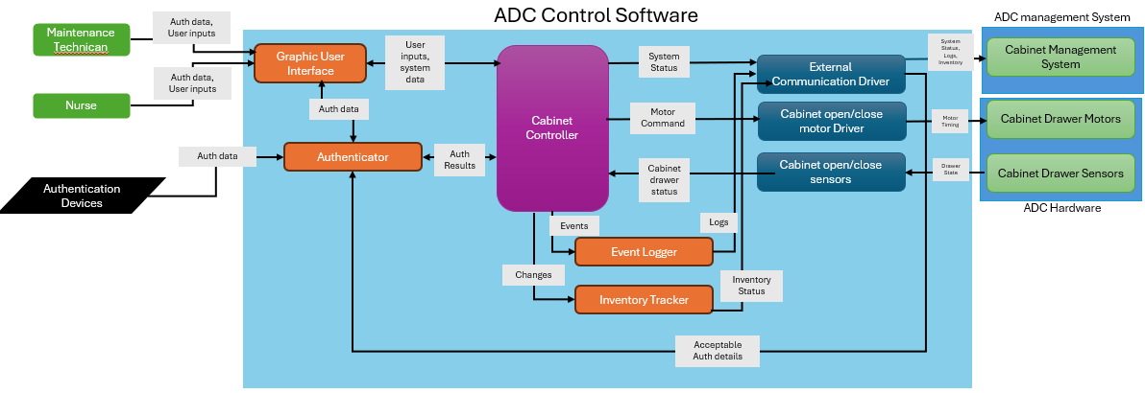

UML Models — Structure and Behaviour
  - Use Case Diagram
  - 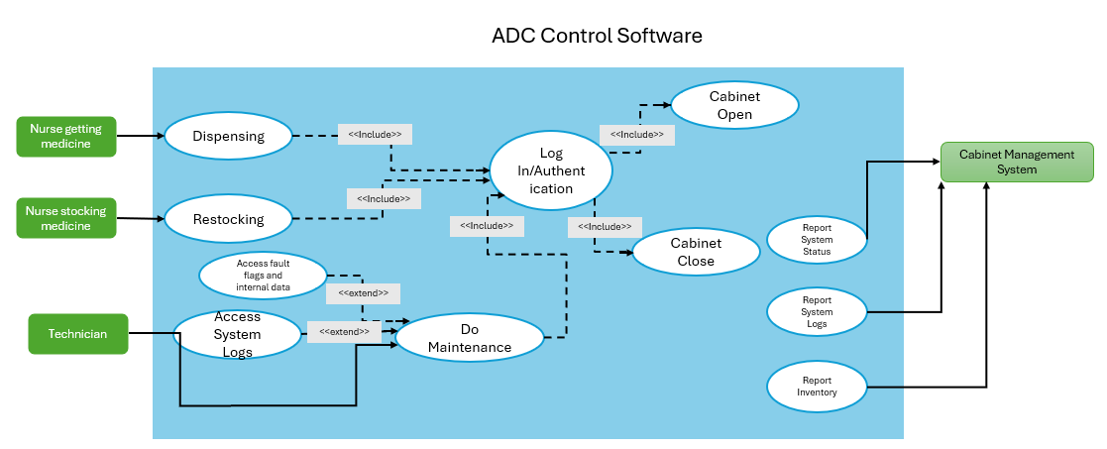

  - Activity Diagram
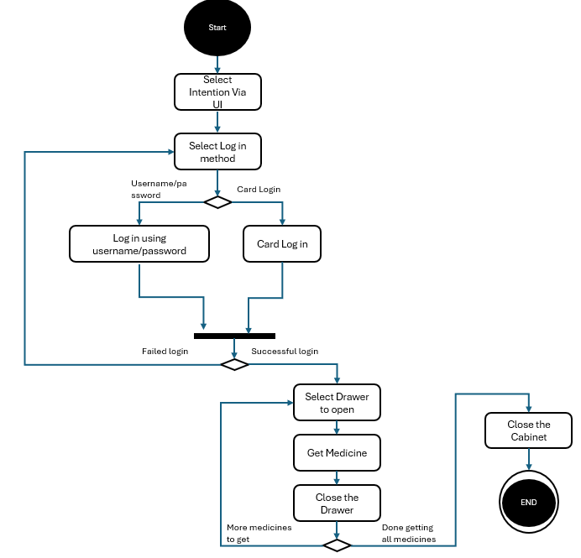

  - State Diagrams
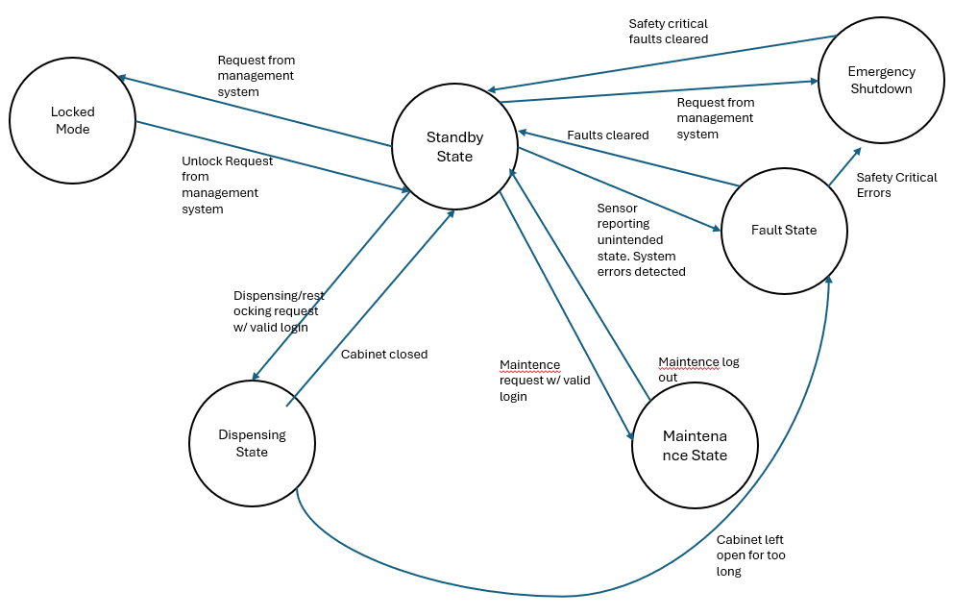

UML Domain Diagram
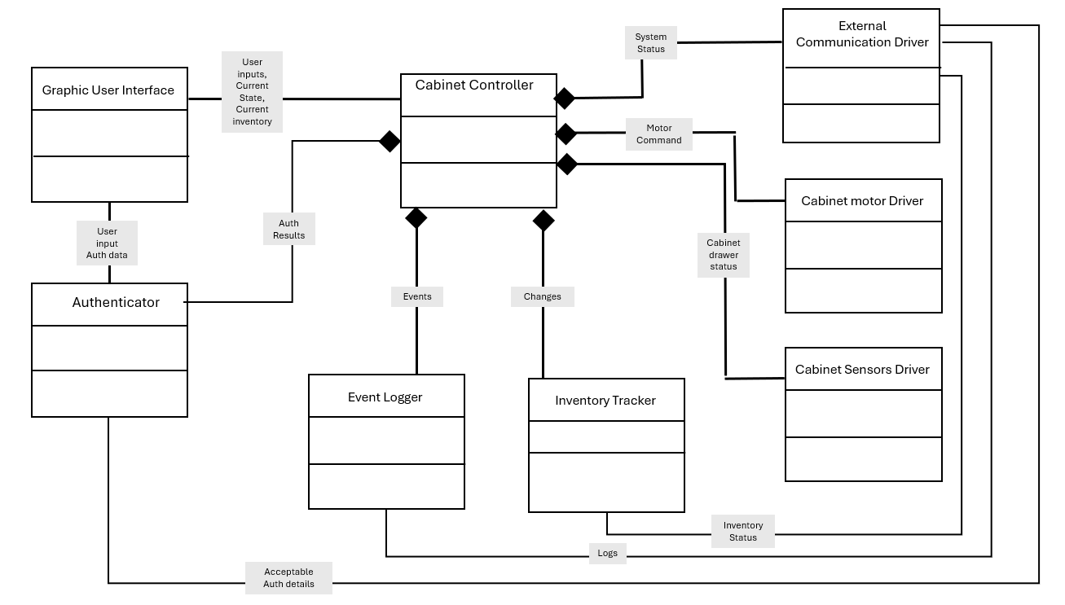

Traceability Table
Req ID | Description | Story | Component | Stakeholder/source
FR-AUT-01 | The cabinet must require successful staff authentication (eg. Password, staff card to scan) before access to the cabinet is granted | US-SEC-01 | Authentication system, cabinet door locking system | Hospital Admin
FR-INV-01 | The cabinet must log each medicine within the cabinet information portal, including medication name, quantity, location, etc. | US-INV-01, US-EXT-01 | Logging system, UI design | Doctor, Hospital Admin
FR-INV-02 | The cabinet must notify the monitoring system when restocking is needed | US-INV-01 | Restocking notification, communication system, cabinet controller | Nurses restocking the cabinet
FR-DIS-01 | The cabinet must dispense the medication and quantity selected by the authenticated user | US-DIS-01 | UI design, cabinet controller, cabinet open/close door motor driver, cabinet drawer sensors/motors | Nurses getting medicine from cabinet
FR-EVE-01 | The cabinet shall record dispensing, authentication, access, and restocking information and display them on the UI | US-EVE-01, US-EVE-02 | UI design, logging system, cabinet notifications | Nurses getting medicine from the cabinet, hospital admin
FR-FAU-01 | The cabinet shall detect 3 consecutive unsuccessful authentication attempts and send a notification to IT | US-SEC-02 | Authentication system, cabinet controller, UI design, external communication driver | Hospital Admin
FR-FAU-02 | The cabinet must detect if doors have been left open for longer than 3 minutes, notify the monitoring system, and automatically close the cabinet | US-SEC-01 | Authentication system, cabinet door locking system, cabinet door open/close motor control, cabinet notifications, monitoring system | Hospital Admin
FR-FAU-03 | The cabinet shall detect a failure of the automatic door-opening or closing mechanism and notify the monitoring system | US-FAU-01 | cabinet door open/close motor control, cabinet notifications, monitoring system, fault detection | Hospital Admin
FR-OPE-01 | The device must feature a standby mode, dispensing mode, locked mode, and emergency shutdown mode | US-SEC-01 | Standby mode, dispensing system, cabinet locking system, emergency shutdown procedures | Hospital Admin
FR-EXT-01 | The cabinet shall send medication dispensing, inventory, and fault detection information to the monitoring system | US-EXT-01 | Cabinet notification system | Hospital Admin
NFR-SEC-01 | The cabinet shall prevent unauthenticated users from accessing medications | US-SEC-01 | Authentication system, cabinet door locking system | Hospital Admin
NFR-SEC-02 | The cabinet shall not allow the user to access the cabinet after 3 consecutive unsuccessful authentication attempts | US-SEC-02 | Authentication system, cabinet controller, UI design, external communication driver | Hospital Admin
NFR-REL-01 | The cabinet shall accurately monitor inventory levels and identify low-stock conditions with 99% accuracy | US-EXT-01 | Inventory monitoring system, restocking monitoring notification system | Hospital Admin
NFR-REL-02 | Fewer than 1 unplanned shutdown per 10,000 hours of cabinet operation | US-REL-01 | Cabinet controller, motor and communication drivers, UI reliability | Nurse getting medicine from cabinet
NFR-AVA-01 | The cabinet shall maintain at least 99.9% operational availability during scheduled hospital operating periods | US-REL-01 | Cabinet controller, motor and communication drivers, UI reliability | Nurse getting medicine from cabinet
NFR-PER-01 | The cabinet shall dispense the selected medication within 5 seconds of user selection and touchscreen confirmation | US-PER-01 | Cabinet open/close motor driver, cabinet controller | Nurse getting medicine from cabinet
NFR-TRA-01 | All medication dispensing events shall be traceable to the authenticated user, medication, quantity dispensed, and time of dispensing | US-EVE-02 | Event logging system, inventory status | Hospital Admin
NFR-USE-01 | The cabinet shall allow all routine medication-dispensing operations to be completed using one hand without assistance | US-USE-02, US-USE-03 | UI design | Nurse getting medicine from cabinet, Nurse restocking the cabinet
NFR-USE-02 | The cabinet UI workflow must be intuitive and require minimal training to learn how it works. | US-USE-01 | UI design | Nurse getting medicine from cabinet

Assumptions and Decisions
Assumption | Consideration | Decision
The Cabinet contains multiple drawers that stores medicine, whose access can be controlled by motors built into the ADC | Operational | Decided to have a dedicated motor driver class that helps the Cabinet controller interface with the motors that manages physical access
The Cabinet has a touch screen that the User can engage a graphic user interface through | Operational | Decided to primarily use the graphical User interface for user inputs and information display
The Cabinet has wired connection to the management system that communication can be conducted through | Operational | Decided to have an external communication module which will report all data relevant to the management system, and also receive information the management system sends to the ADC such as requests, latest authentication details.
The Cabinet includes an employee card reader that allows quick identification verification | Operational | Decided to have architecture allow for card based authentication as an alternative to username/password log in via the GUI
Only authorized individuals should be allowed to access the cabinet | Controlled Access | Decided to have different physical and informational access levels between Nurse, technician, and remote monitoring system
Nurses may need to be able to operate the ADC with only one hand | Accessibility | Decided to create requirement for one handed operation
System logs regarding which user accessed which medicine drawer should be hidden from nurses/technicians to ensure information which can be used to deduce patient medical condition remains controlled. | Patient Privacy | Decided to give nurse users no access to system logs, and technicians access to only system logs which may aid them in problem diagnosis. Only Management system users can see the full logs
The software will be audited, and must conform to medical software standards | Auditability | Decided to enforce a strict access level system. Separated out modules such as authentication and external communication modules which may be under higher scrutiny
There may be future requirements and hardware upgrades planned that the software must be designed to easily support | Scalability | Decided on a modularized architecture that allows future additions

