1.系统名称：智能健身房管理系统
核心需求：
会员管理：支持会员注册、信息修改、类型管理（普通会员/VIP会员）。VIP会员享有课程折扣和优先预约权限。
员工管理：管理员工信息（如前台、清洁人员），教练需额外记录专业领域和资格证书。
课程管理：创建健身课程（如瑜伽、动感单车），指定教练、时间、最大参与人数。
预约管理：会员可预约/取消课程，系统需检查课程名额并限制重复预约。
设备借用：会员可借用设备（如哑铃、跳绳），记录借用与归还时间，普通会员最多借3天。
2.
- E/R图
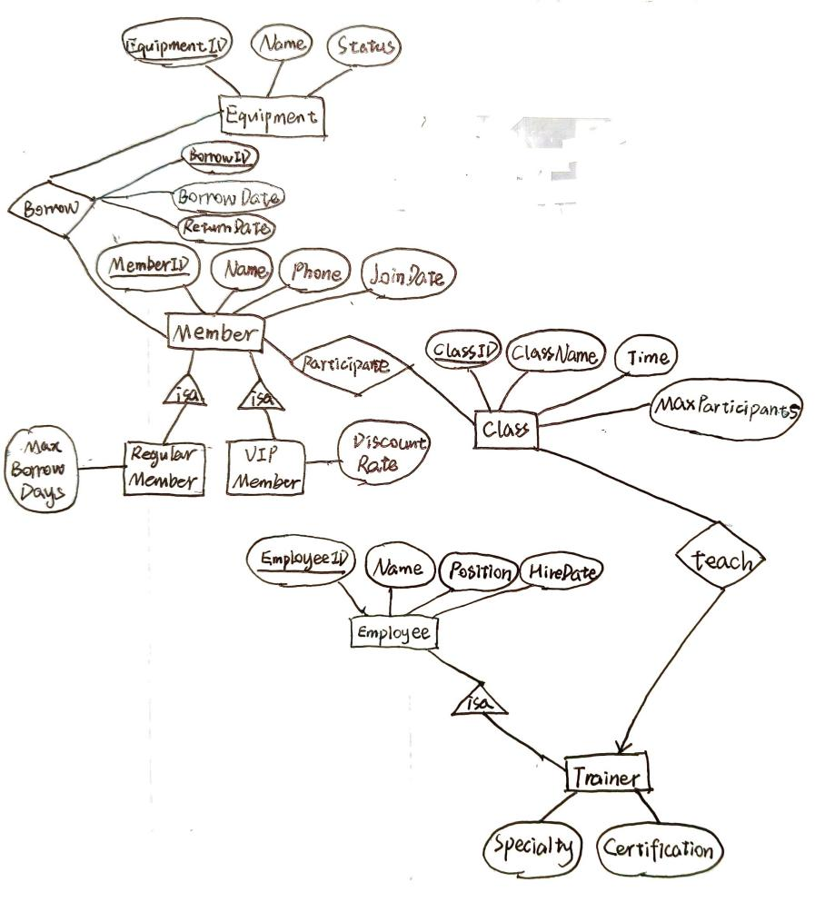
b) 转换成关系模式
●Member(MemberID,Name,Phone,JoinDate)
RegularMenber(MemberID,MaxBorrowDays)
VIPMember(MemberID,DiscountRate)
●Class(ClassID,ClassName,Time,MaxParticipants)
●Employee(EmployeeID,Name,Position,HireDate)
Trainer(EmployeeID,Specialty,Certification)
●Equipment(EquipmentID,Name,Status)

■participate(MemberID,ClassID)
■teach(EmployeeID,ClassID)
■borrow(BorrowID,MemberID,EquipmentID,BorrowDate,ReturnDate)

c) 用SQL语句创建上述关系模式
-- 创建会员表（父表）
CREATE TABLE Member (
MemberID INT PRIMARY KEY,
Name VARCHAR(50) NOT NULL,
Phone VARCHAR(20),
JoinDate DATE NOT NULL
);

-- 创建普通会员子表（继承Member）
CREATE TABLE RegularMember (
MemberID INT PRIMARY KEY,
MaxBorrowDays INT DEFAULT 3,
FOREIGN KEY (MemberID) REFERENCES Member(MemberID)
ON DELETE CASCADE
);

-- 创建VIP会员子表（继承Member）
CREATE TABLE VIPMember (
MemberID INT PRIMARY KEY,
DiscountRate DECIMAL(5,2) CHECK (DiscountRate BETWEEN 0 AND 1),
FOREIGN KEY (MemberID) REFERENCES Member(MemberID)
ON DELETE CASCADE
);

-- 创建课程表
CREATE TABLE Class (
ClassID INT PRIMARY KEY,
ClassName VARCHAR(100) NOT NULL,
Time DATETIME,
MaxParticipants INT CHECK (MaxParticipants > 0)
);

-- 创建员工表（父表）
CREATE TABLE Employee (
EmployeeID INT PRIMARY KEY,
Name VARCHAR(50) NOT NULL,
Position VARCHAR(50) CHECK (Position IN ('Front Desk', 'Cleaner', 'Trainer')),
HireDate DATE NOT NULL
);

-- 创建教练子表（继承Employee）
CREATE TABLE Trainer (
EmployeeID INT PRIMARY KEY,
Specialty VARCHAR(50) NOT NULL,
Certification VARCHAR(100),
FOREIGN KEY (EmployeeID) REFERENCES Employee(EmployeeID)
ON DELETE CASCADE
);

-- 创建设备表
CREATE TABLE Equipment (
EquipmentID INT PRIMARY KEY,
Name VARCHAR(50) NOT NULL,
Status VARCHAR(20) DEFAULT 'Available'
CHECK (Status IN ('Available', 'Borrowed', 'Under Maintenance'))
);

-- 创建课程参与关系表（多对多）
CREATE TABLE participate (
MemberID INT,
ClassID INT,
PRIMARY KEY (MemberID, ClassID),
FOREIGN KEY (MemberID) REFERENCES Member(MemberID),
FOREIGN KEY (ClassID) REFERENCES Class(ClassID)
);

-- 创建教学关系表（一对多：一个教练可教多门课程，一门课程由一个教练教）
CREATE TABLE teach (
EmployeeID INT,
ClassID INT,
PRIMARY KEY (EmployeeID, ClassID),
FOREIGN KEY (EmployeeID) REFERENCES Employee(EmployeeID),
FOREIGN KEY (ClassID) REFERENCES Class(ClassID)
);

-- 创建设备借用记录表
CREATE TABLE borrow (
BorrowID INT PRIMARY KEY,
MemberID INT NOT NULL,
EquipmentID INT NOT NULL,
BorrowDate DATE NOT NULL,
ReturnDate DATE,
FOREIGN KEY (MemberID) REFERENCES Member(MemberID),
FOREIGN KEY (EquipmentID) REFERENCES Equipment(EquipmentID)
);

d) 查询语句
①单表查询：查询所有手机号以555开头的会员的ID号和姓名
SELETE MemberID, Name
FROM Member
WHERE Phone LIKE ‘555%’;
②多表连接查询：查询所有参加瑜伽课的会员的手机号
SELETE Phone
FROM Member, Class, participate
WHERE ClassName = ‘Yoga’ AND Member.MemberID = participate.MemberID
AND Class.ClassID = participate.ClassID;
③多表嵌套查询：查询职工号为123456的教练教的所有课程名称
SELECT ClassName
FROM Class
WHERE ClassID IN (SELECT ClassID FROM teach WHERE EmployeeID = 123456);
④EXISTS查询：查询只教一门课（ClassID唯一）的教练的名字
SELECT Name
FROM Employee, teach t1
WHERE Employee.EmployeeID = teach.EmployeeID AND
NOT EXIST (SELECT * FROM teach WHERE EmployeeID = t1.EmployeeID
AND ClassID <> t1.ClassID);
⑤聚合查询：查询借设备次数超过5次的会员的ID和借设备次数
SELECT MemberID, COUNT(BorrowID)
FROM borrow
GROUP BY MemberID
HAVING COUNT(BorrowID) > 5;
3.
a) 使用PowerDesigner画E/R图
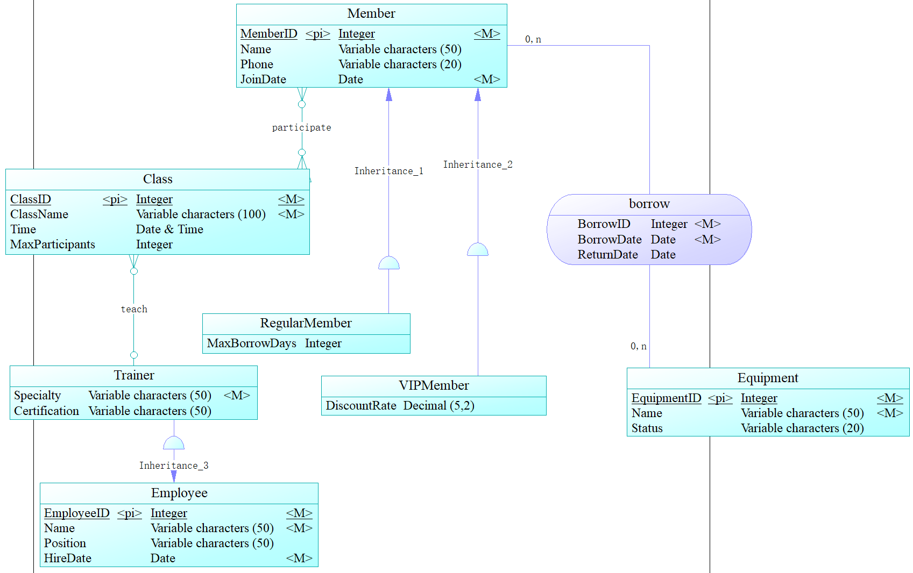
b) 转为关系模型图
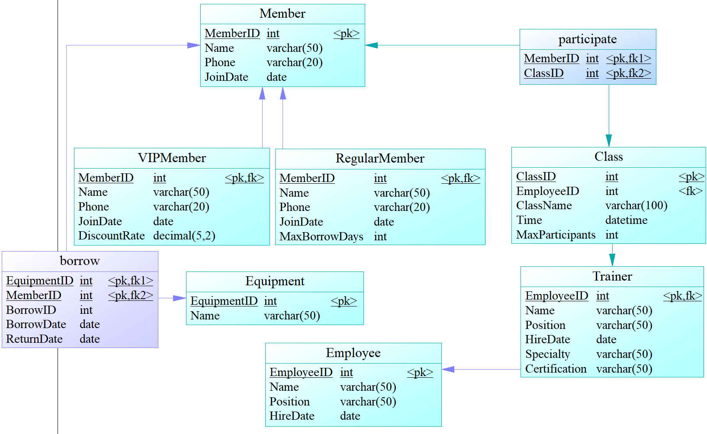
c) 自动生成的SQL语句
/*==============================================================*/
/* DBMS name: MySQL 5.0 */
/* Created on: 2025/4/14 3:00:40 */
/*==============================================================*/

drop table if exists Class;

drop table if exists Employee;

drop table if exists Equipment;

drop table if exists Member;

drop table if exists RegularMember;

drop table if exists Trainer;

drop table if exists VIPMember;

drop table if exists borrow;

drop table if exists participate;

/*==============================================================*/
/* Table: Class */
/*==============================================================*/
create table Class
(
ClassID int not null,
EmployeeID int,
ClassName varchar(100) not null,
Time datetime,
MaxParticipants int,
primary key (ClassID)
);

/*==============================================================*/
/* Table: Employee */
/*==============================================================*/
create table Employee
(
EmployeeID int not null,
Name varchar(50) not null,
Position varchar(50),
HireDate date not null,
primary key (EmployeeID)
);

/*==============================================================*/
/* Table: Equipment */
/*==============================================================*/
create table Equipment
(
EquipmentID int not null,
Name varchar(50) not null,
Status varchar(20),
primary key (EquipmentID)
);

/*==============================================================*/
/* Table: Member */
/*==============================================================*/
create table Member
(
MemberID int not null,
Name varchar(50),
Phone varchar(20),
JoinDate date not null,
primary key (MemberID)
);

/*==============================================================*/
/* Table: RegularMember */
/*==============================================================*/
create table RegularMember
(
MemberID int not null,
Name varchar(50),
Phone varchar(20),
JoinDate date not null,
MaxBorrowDays int not null,
primary key (MemberID)
);

/*==============================================================*/
/* Table: Trainer */
/*==============================================================*/
create table Trainer
(
EmployeeID int not null,
Name varchar(50) not null,
Position varchar(50),
HireDate date not null,
Specialty varchar(50) not null,
Certification varchar(50),
primary key (EmployeeID)
);

/*==============================================================*/
/* Table: VIPMember */
/*==============================================================*/
create table VIPMember
(
MemberID int not null,
Name varchar(50),
Phone varchar(20),
JoinDate date not null,
DiscountRate decimal(5,2),
primary key (MemberID)
);

/*==============================================================*/
/* Table: borrow */
/*==============================================================*/
create table borrow
(
EquipmentID int not null,
MemberID int not null,
BorrowID int not null,
BorrowDate date not null,
ReturnDate date,
primary key (EquipmentID, MemberID)
);

/*==============================================================*/
/* Table: participate */
/*==============================================================*/
create table participate
(
MemberID int not null,
ClassID int not null,
primary key (MemberID, ClassID)
);

alter table Class add constraint FK_teach foreign key (EmployeeID)
references Trainer (EmployeeID);

alter table RegularMember add constraint FK_Inheritance_2 foreign key (MemberID)
references Member (MemberID);

alter table Trainer add constraint FK_Inheritance_1 foreign key (EmployeeID)
references Employee (EmployeeID);

alter table VIPMember add constraint FK_Inheritance_3 foreign key (MemberID)
references Member (MemberID);

alter table borrow add constraint FK_borrow foreign key (EquipmentID)
references Equipment (EquipmentID);

alter table borrow add constraint FK_borrow2 foreign key (MemberID)
references Member (MemberID);

alter table participate add constraint FK_participate foreign key (MemberID)
references Member (MemberID);

alter table participate add constraint FK_participate2 foreign key (ClassID)
references Class (ClassID);
4.
a) 存在差异，PowerDesigner处理子类实体时采用面向对象方法。后期创建表的SQL语句行数会更多一些。
b)
（1）特点
1.标准化结构
注释规范：包含表名、创建时间、DBMS 版本等信息，便于追溯和维护。
格式统一：表名和字段名采用首字母大写（如 ClassID），符合常见命名规范。
2.显式主键定义
每个表的主键通过 primary key 明确声明（如 Class.ClassID）。
3.外键分离定义
外键约束（foreign key）不内联在 CREATE TABLE 中，而是通过后续的 ALTER TABLE 单独添加。
原因：避免表创建顺序依赖（如先创建主表，再创建从表），降低执行失败风险。
4.继承关系实现
子表（如 RegularMember、VIPMember）通过外键关联到父表（Member），但 子表冗余存储了父表字段（如 Name, Phone）。
5.多对多关系处理
使用独立的关系表（如 participate、borrow），并通过复合主键（MemberID + ClassID）实现多对多关联。
（2）附加语句的作用
1.外键约束（ALTER TABLE ... ADD CONSTRAINT）
作用：确保引用完整性（Referential Integrity），防止无效数据插入。
2.继承关系绑定（FK_Inheritance_*）
作用：强制子表（如 RegularMember）的 MemberID 必须存在于父表（Member）中。

