PCA Analysis

Strictly MFCC (no DC term)

10 feature points – 0.3771

20 feature points – 0.2684

25 feature points – 0.2564

50 feature points – 0.2656

75 feature points – 0.3011

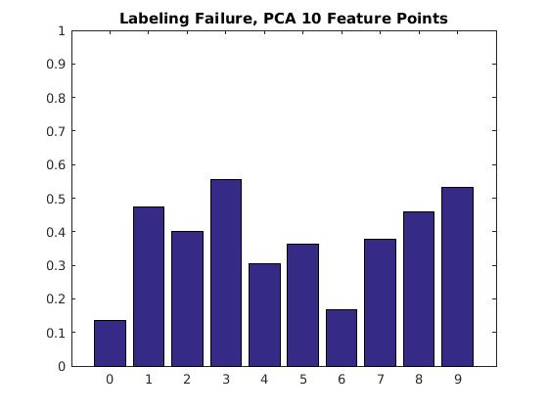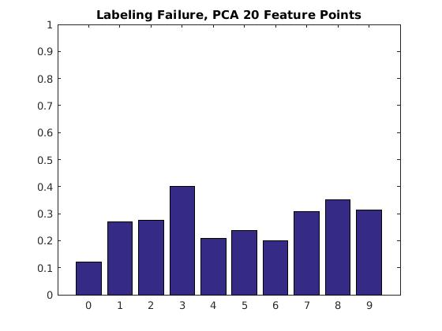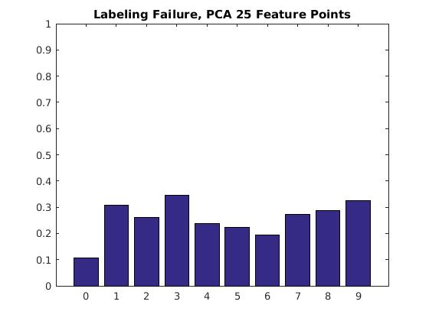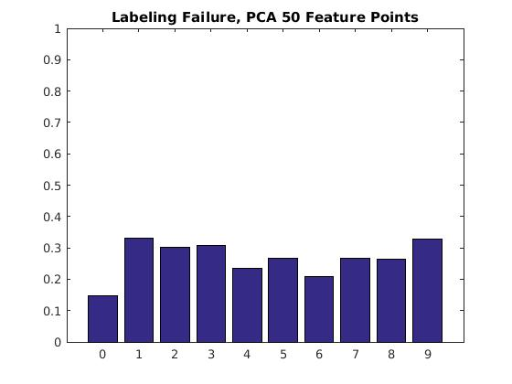

Feature point selection (30 feature points)

Only MFCC raw values – 0.2564

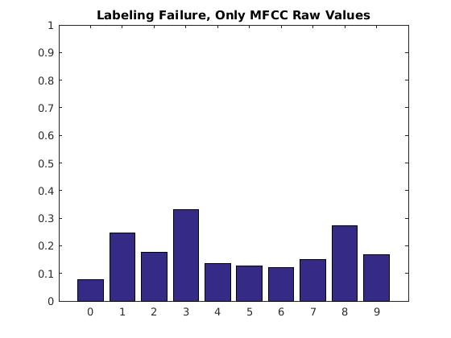

Letters

Set differentiation

Set classification – 0.14

No Set differentiation – 0.44

With Set differentiation (sets 100% correct)

With Set differentiation (sets predicted) – 0.39

