Java Coding Assignment System

Submitted By
Jianguo Guo (jianguo.java@gmail.com)

10/14/2016

Table of Contents

Introduction
Overview
We'd like you to create a RESTful web service in Java. Please read the instruction below carefully. The service you develop should be deployable by a standard WAR file.
Requirements
- The service has two endpoints.
  - One is to take a Unicode string as a parameter and register it in the service.
  - The other is to take a string id and return all registered strings that match with the string id.
- String id is a number calculated as follows:
  - String id is a sum of each character's id.
  - A character id is a sum of the current and previous character's Unicode code point.
  - The character id of the first character in the string is the character's Unicode code point.
  - If the current and previous characters are the same, the character id is the current character's Unicode code point.
  - String id must be calculated without using a loop.
- Example:
  - "abc" => 97 + (97 + 98) + (98 + 99)
  - "abbc" => 97 + (97 + 98) + (98) + (98 + 99)
- The registered strings must be persisted so that the strings are still available after a reboot.
  - Use a file for the persistent medium.
  - For easier troubleshooting, the file must be a text file.
- The REST APIs accept and produce JSON.
- The service doesn't have to be designed to work reliably in the clustered environment, but it must be reliable as a single node service.
- The code must be thoroughly tested by unit tests
Deliverables
- Source code
- Build and deployment instruction REST API documentation
- If you have a github account, you can create a repo there. Otherwise send us your deliverables in a zip file.
- We expect a production grade code, not a throw-away test code

Planning

Members: 1

Total days (2 day/member): 2 days
- Project requirements and design documents (diagrams, UI mockup): 1 days
- Implementation and testing: 1 days

Software Development Methodology: Agile Scrum

System design

UI:
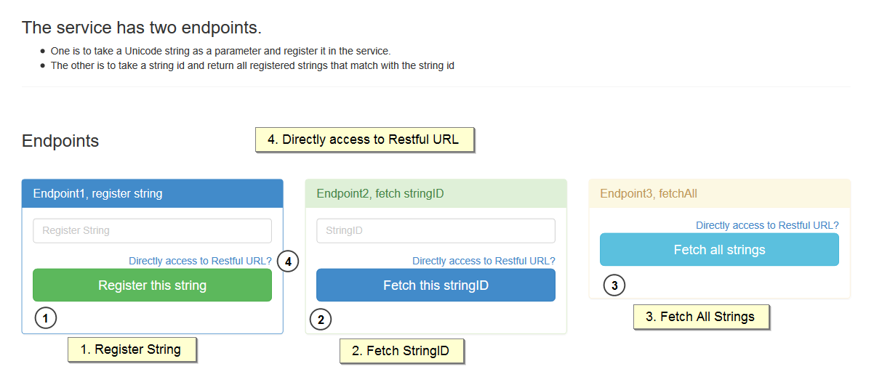

Implementation

UI mockup:

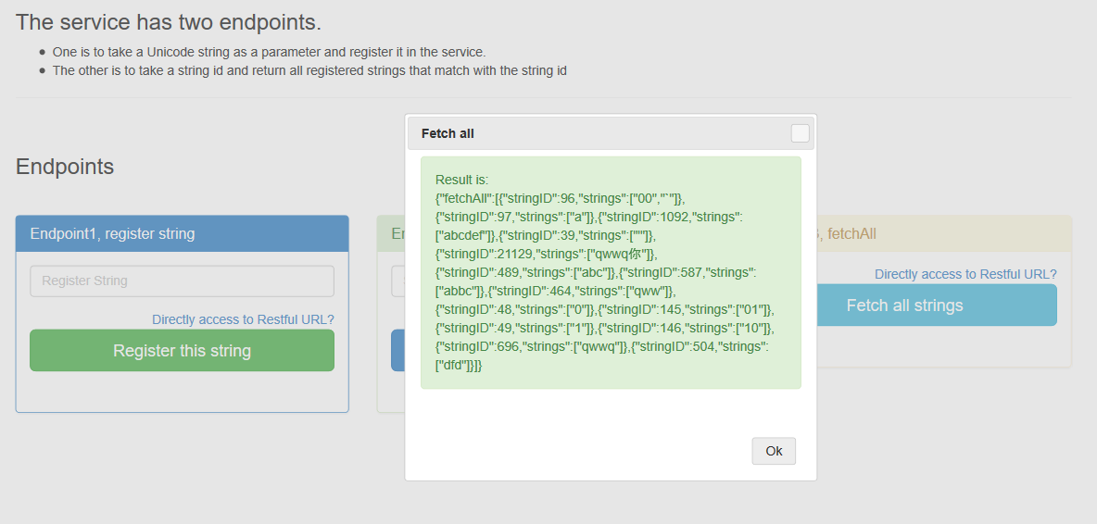

Source code
Source code for this project can be found in Github at address:

Main Method
Java: restfulService\src\main\java\com\paypal\project\service\impl\ServiceImpl.java
Lines:32~53
NO loop
// recursive
private int getStringID(UnicodeString domain, int first, int second) {
String unicodeStr = domain.getUnicodeStr();
if (unicodeStr == null || unicodeStr.length() == 0) {
return 0;
}
if (first == 0) {
domain.setStringID(domain.getStringID() + unicodeStr.charAt(first));
}
if (second >= unicodeStr.length()) {
return domain.getStringID();
}
if (unicodeStr.charAt(first) == unicodeStr.charAt(second)) {
domain.setStringID(domain.getStringID() + unicodeStr.charAt(second));
} else {
domain.setStringID(domain.getStringID() + unicodeStr.charAt(first));
domain.setStringID(domain.getStringID() + unicodeStr.charAt(second));
}
first++;
second++;
getStringID(domain, first, second);
return domain.getStringID();
}

Team member responsibilities
Here is summary list
Team member | Task
Jianguo Guo
 | Restful Services (1. Register, 2. Fetch ID, 3. Fetch all)
 | UI and Test Cases
 | Worked on Design documents

API

Register (GET or POST):

http://localhost:8080/restfulService/services/register/abc

Fetch (GET or POST):

http://localhost:8080/restfulService/services/fetch/489

Fetch all (GET or POST):

http://localhost:8080/restfulService/services/fetchall

Note:
Source code Notation:
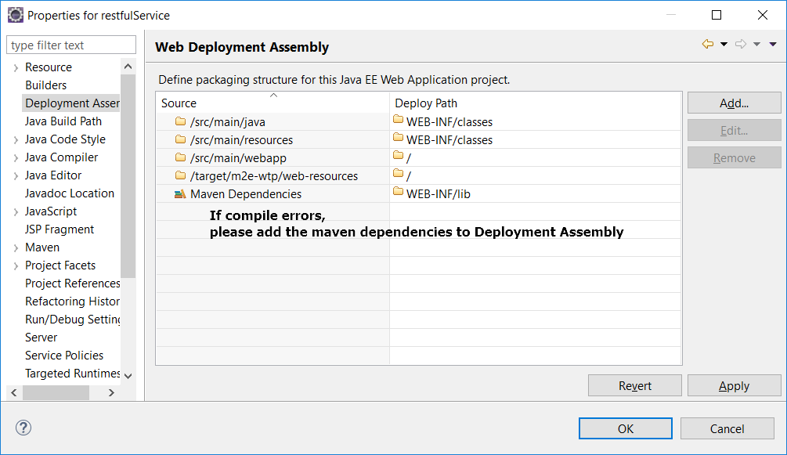

Project Introduction:
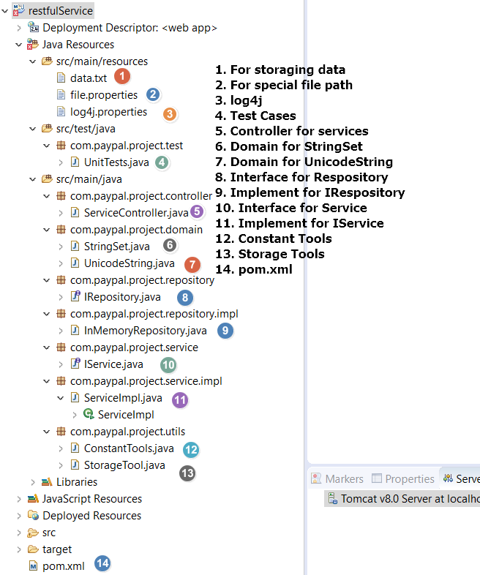

Test Cases:
