ShardingSphere

1.简介
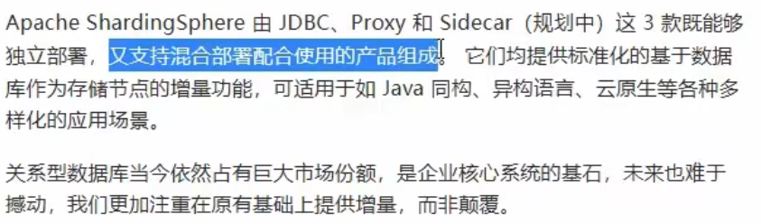

2. ShardingSphere-JDBC
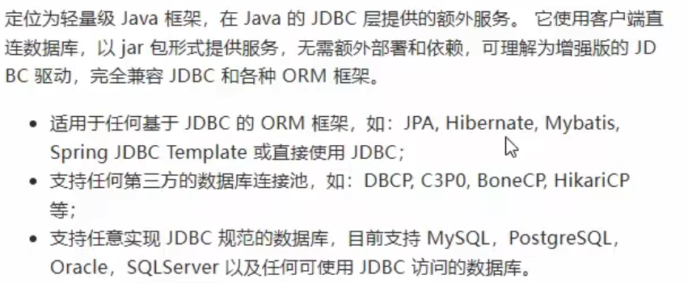
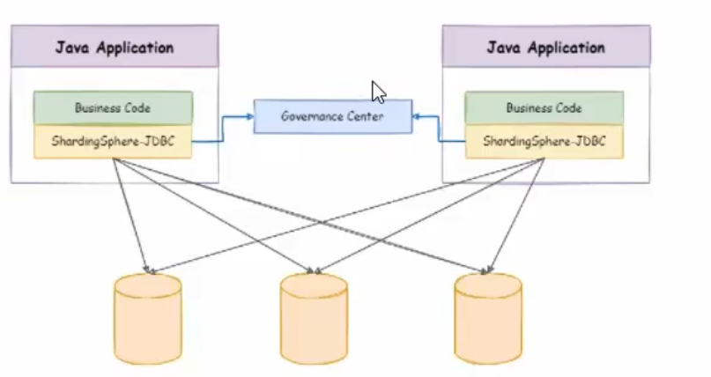

3. ShardingSphere-Proxy
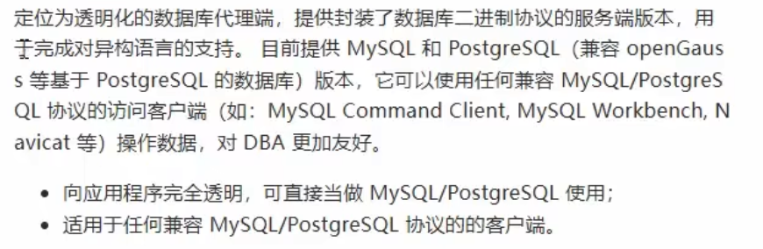
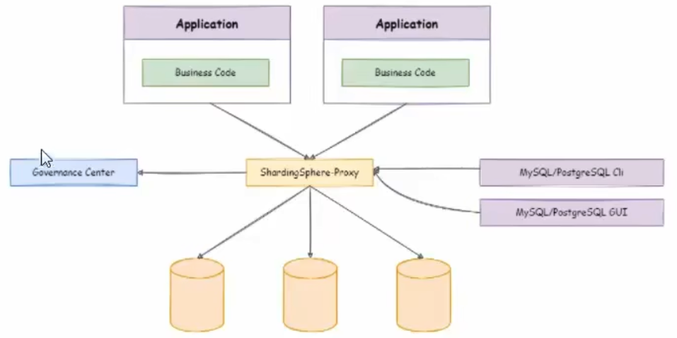
官网-快速入门
https://shardingsphere.apache.org/document/current/cn/quick-start/

