|  |  |  |  |  |  |  |  |  |  |
| --- | --- | --- | --- | --- | --- | --- | --- | --- | --- |
| BIOS：EG6.25.09 | 需要对默认项进行检查 |  |  |  |  |  |  |  |  |
|  |  |  |  |  |  |  |  |
|  |  |  |  |  |  |  |  |  |  |
| **功能** | **推荐相关参数（供参考，具体功能实现各自和美团对接）** | **BHS平台** | **结果** | **是否默认** | **路径** |  |  |  |  |
| 要求睿频，关闭节能 | Mwaite/Monitor | Mwaite/Monitor | Disabled | 是 | Socket Configuration->Advanced Power Management Configuration->CPU C State Control->Enable Monitor MWAIT--[Disable] |  |  |  |  |
|  | CPU C6 report | ACPI C6 Enumeration | Disabled | 是 | Socket Configuration->Advanced Power Management Configuration->CPU C State Control->CPU C6 report--[Disable] |  |  |  |  |
|  | Enhanced Halt State (C1E) | ACPI C1 Enumeration | Disabled | 是 | Socket Configuration->Advanced Power Management Configuration->CPU C State Control->Enhanced Halt State（C1E）--[Disable] |  |  |  |  |
|  | CPU C State | 无 | Disabled | 无该选项 |  |  |  |  |  |
|  | Package C State | Package C State | C0/C1 state | 是 | Socket Configuration->Advanced Power Management Configuration->Package C State Control--[C0/C1 state] |  |  |  |  |
|  | EIST（P-State） | SpeedStep (PStates) | Enabled | 是 | Socket Configuration->Advanced Power Management Configuration->CPU P State Control->SpeedStep（Pstates）--[Enable] |  |  |  |  |
|  | Hardware P-State | Hardware P-State | Native Mode | 是 | Socket Configuration->Advanced Power Management Configuration->Hardware PM State Control->Hardware P-States--[Native Mode] |  |  |  |  |
|  | Turbo Mode | Turbo Mode | Enabled | 是 | Socket Configuration->Advanced Power Management Configuration->CPU P State Control->Turbo Mode--[Enable] |  |  |  |  |
|  | Power Performance Tuning | Power Performance Tuning | BIOS Control | 是 | Socket Configuration->Advanced Power Management Configuration->CPU - Advanced PM Tuning->Energy Perf BIAS->Power Performance Turning--[BIOS Controls EPB] |  |  |  |  |
|  | Power Policy Select | ENERGY_PERF_BIAS_CFG mode | PERF | 是 | Socket Configuration->Advanced Power Management Configuration->System Profile--[Custom] |  |  |  |  |
|  | Power Supply Mode | 无 | PERF | 无该选项 |  |  |  |  |  |
|  | OS ACPI Cx | 无 | ACPI C2 | 是 | Socket Configuration->Advanced Power Management Configuration->CPU C State Control->OS ACPI Cx--[ACPI C2] |  |  |  |  |
| 打开超线程 | HT | Enable LP [Global] | Enabled | 是 | Socket Configuration->Processor Configuration->Enable LP[Global]--[ALL LPs] |  |  |  |  |

## 一、开机按delete进入bios调整参数，进行高性能优化。

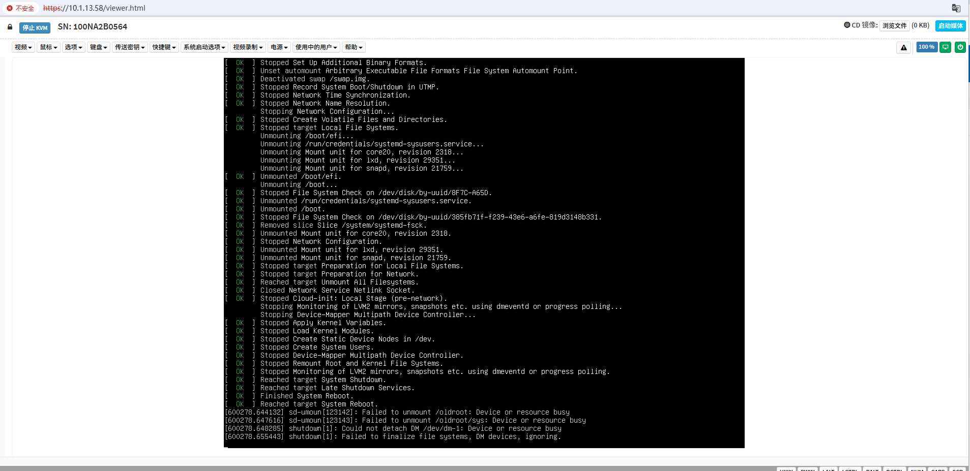

进入bios后按右边的ctrl键+F3，进入专家模式

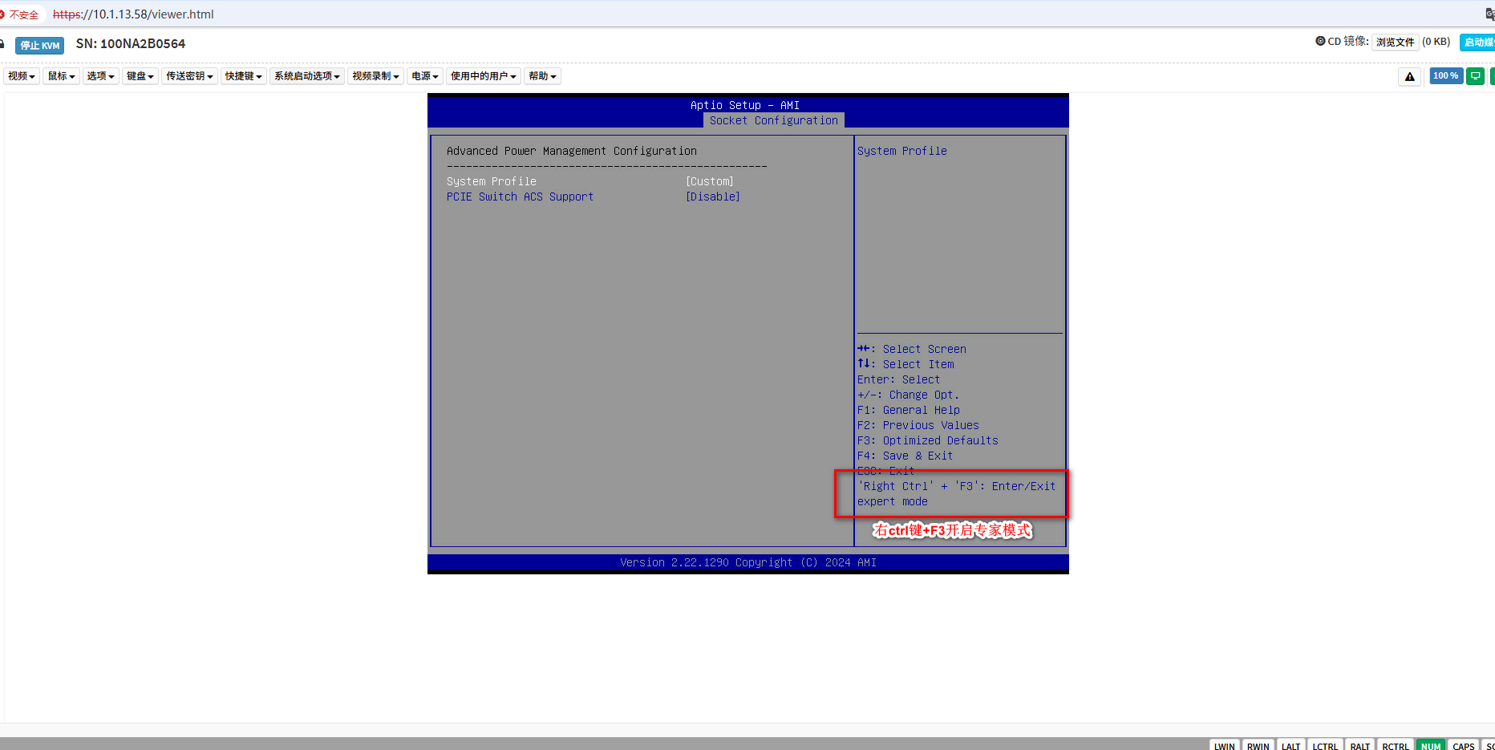

其他选项默认开启，只需要调整如下两个参数即可：

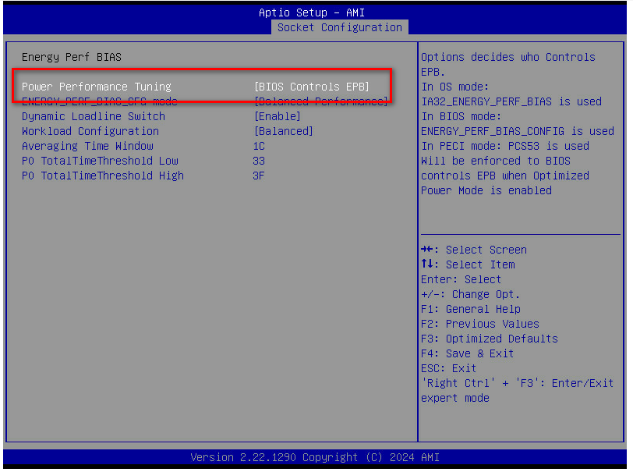

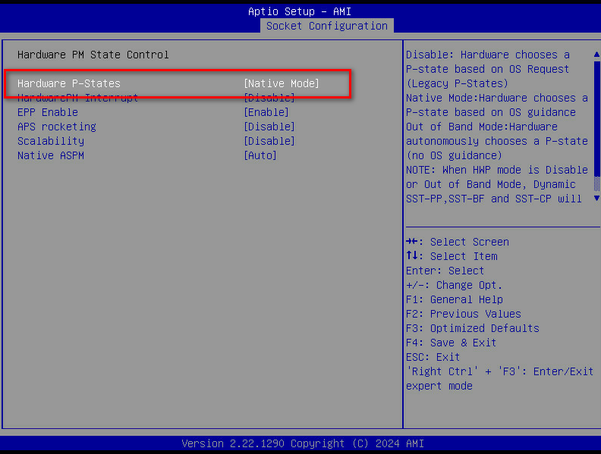

其他可以忽略

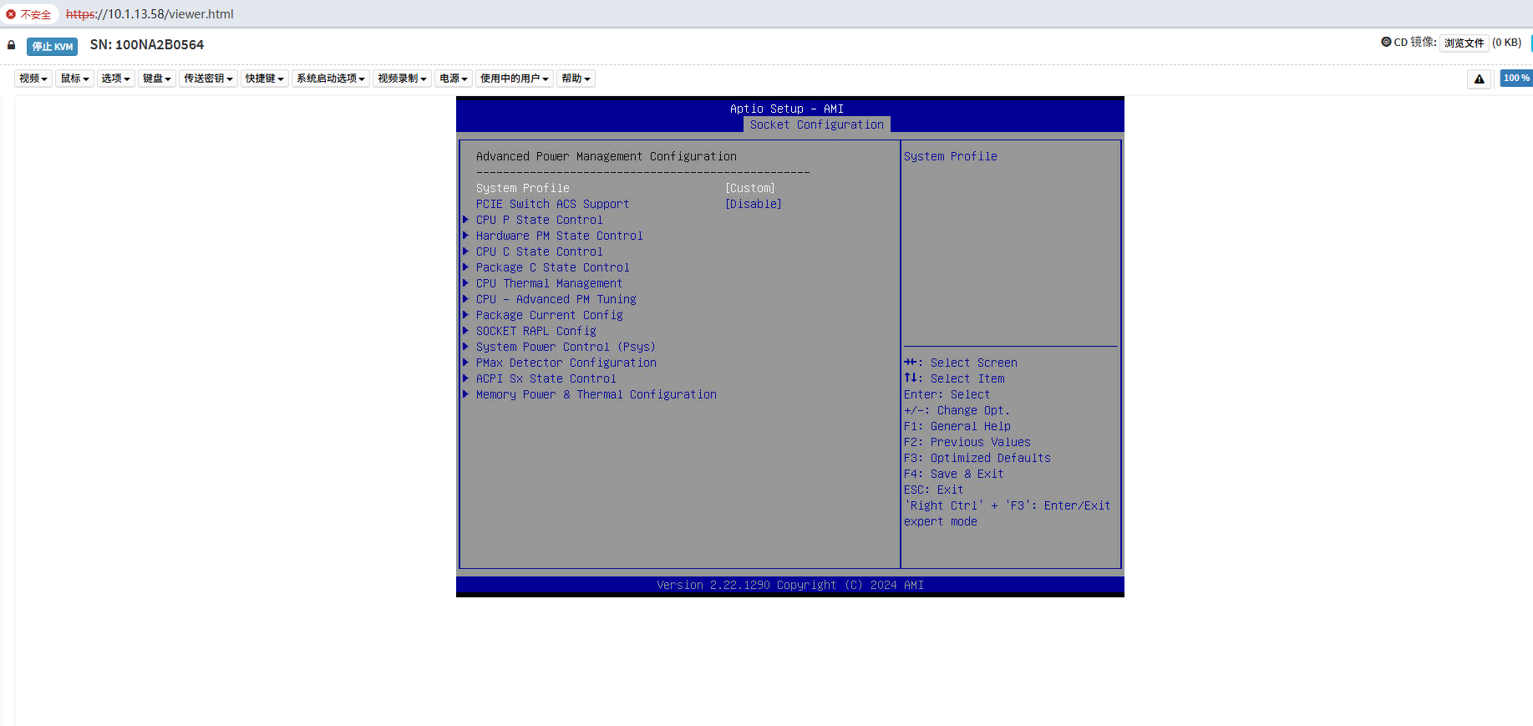

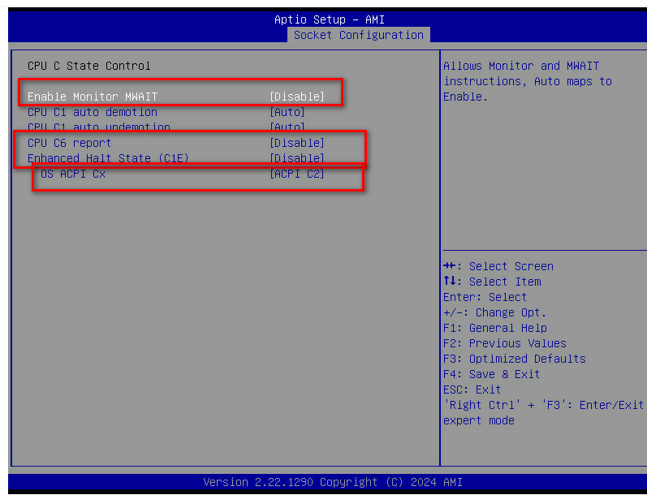

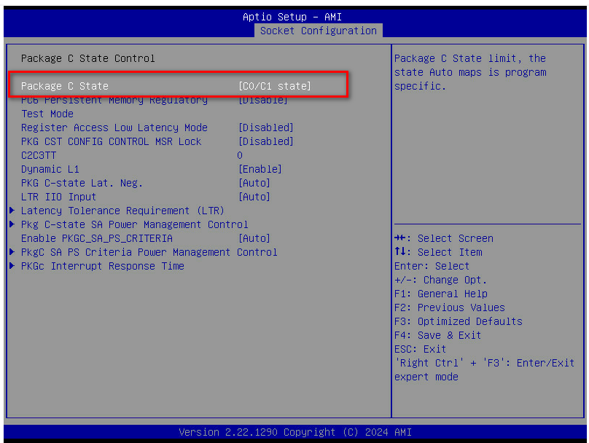

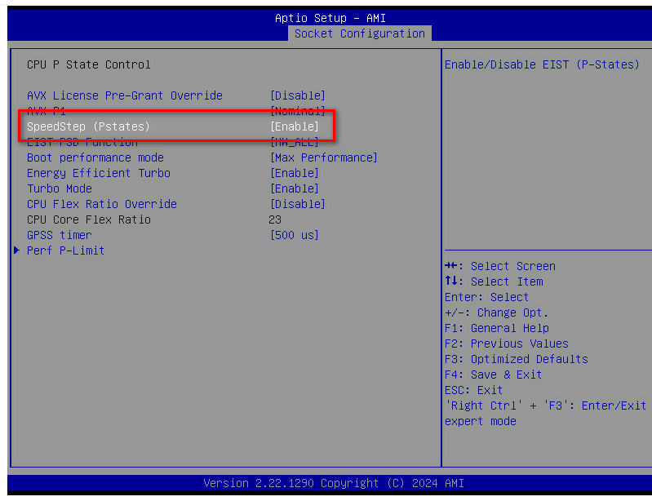

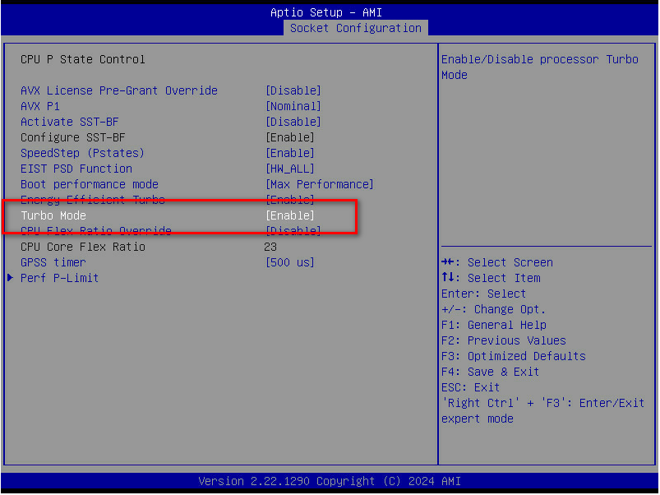

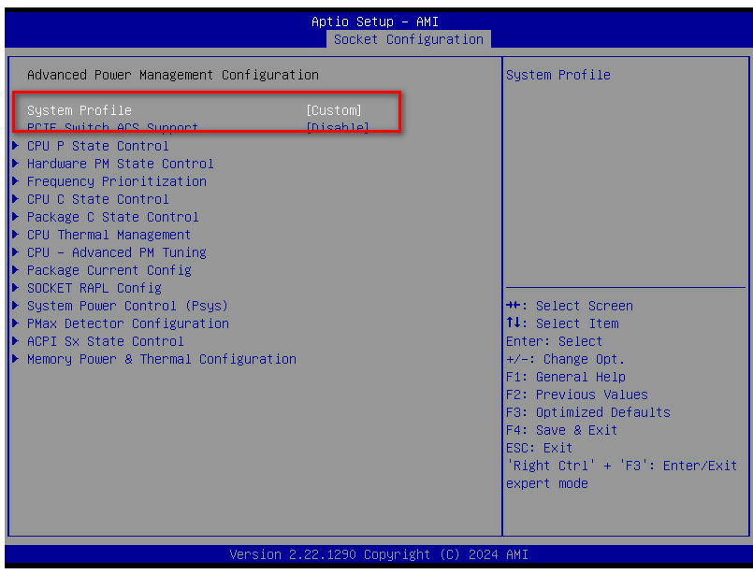

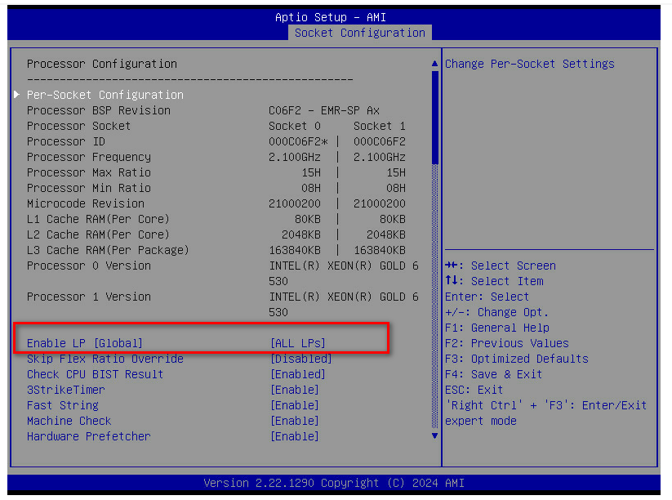

## 二、BIOS设置锁定CPU核数，达到睿频4.0Ghz

|  |
| --- |
| CPU0设置C65ABA2600000000 |
| CPU1设置591BCA6300000000 |

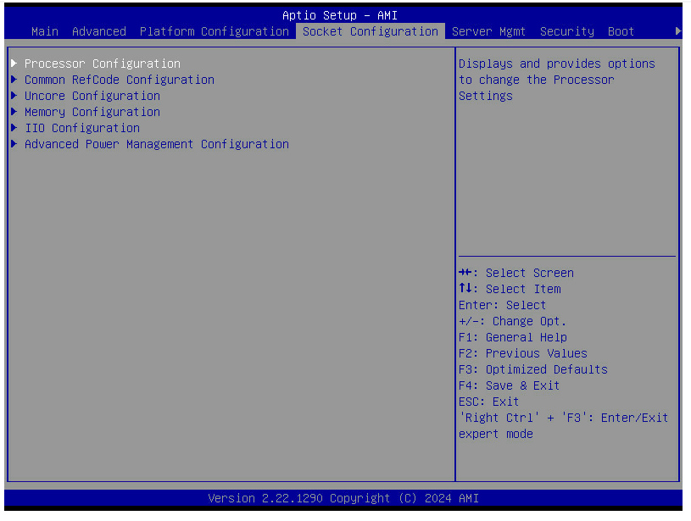

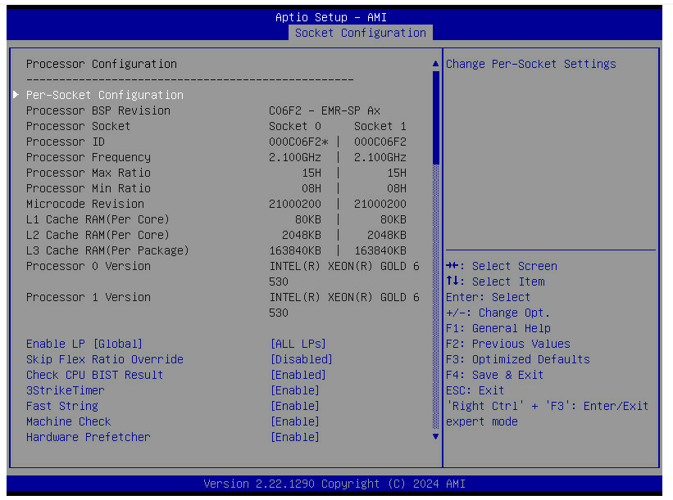

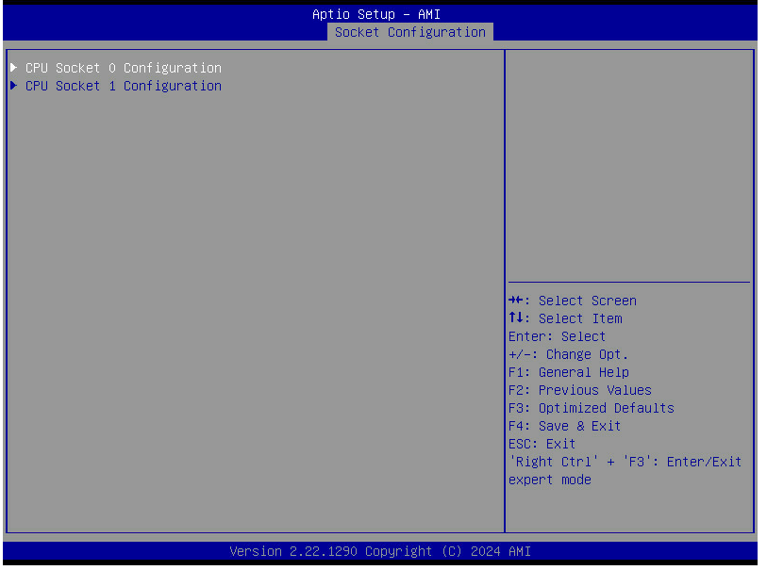

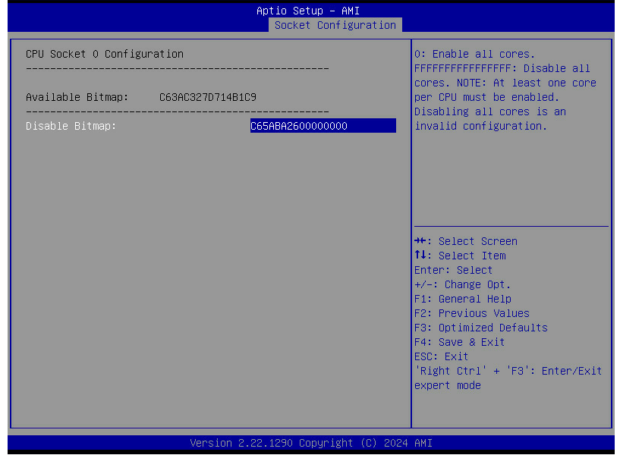

Cpu1配置相应参数，F4保存即可。

## 三、系统下配置锁定睿频

1、修改镜像源

sudo sed -i s/security.ubuntu.com/mirrors.aliyun.com/g /etc/apt/sources.list

sudo sed -i s/archive.ubuntu.com/mirrors.aliyun.com/g /etc/apt/sources.list

apt update

2、安装工具包

sudo apt-get install python3-nacl python3-paramiko

sudo apt install cpufrequtils

sudo apt install linux-tools-common

sudo apt install linux-tools-5.15.0-140-generic linux-cloud-tools-5.15.0-140-generic

3、查看支持的睿频频率：

user@admin:~$ cpufreq-info

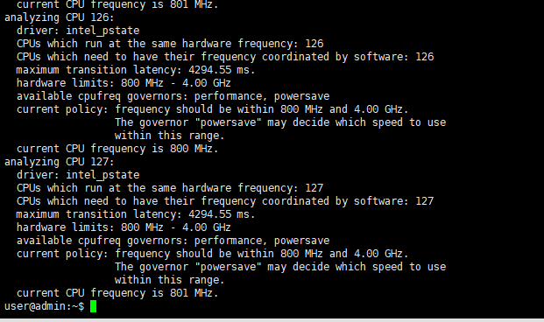

~~You may need to install the following packages for this specific kernel:~~

~~linux-tools-5.15.0-140-generic~~

~~linux-cloud-tools-5.15.0-140-generic~~

查看CPU实时频率，目前没有以最大频率运行

user@admin:~$ watch -n 1 sudo cpupower monitor

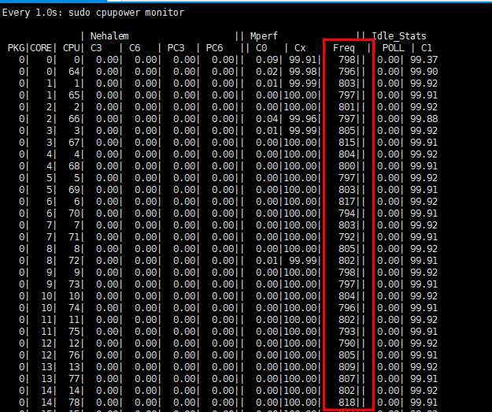

设置CPU最大频率运行

cpupower frequency-set -g performance命令的主要功能是将CPU设置为高性能模式。在这种模式下，CPU会以最高频率运行，从而提供最大的处理能力，但可能会增加功耗和发热量‌12。

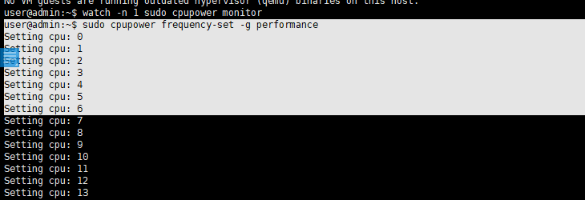

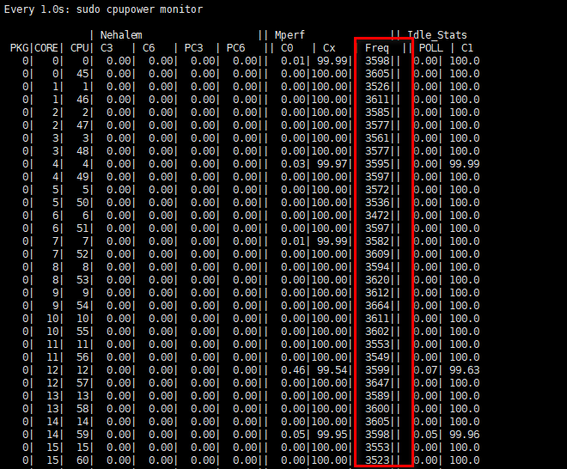

## 四、设置开启动配置最大频率运行

1. 修改启动脚本：您还可以编辑启动脚本来设置 CPU 频率锁定。编辑 /etc/rc.local 文件，并将以下命令添加到文件末尾ubuntu默认没有，创建一个即可：

cpupower frequency-set --governor performance

1. 保存并关闭文件后，确保该文件可执行：

sudo chmod +x /etc/rc.d/rc.local

1. 在下一次系统引导时，这个脚本将会执行，将 CPU 频率锁定在最高性能状态。