**Tourism Data from 2005 to 2014 in China (How many foreign tourists come to China over the past decade? How about them and where are they from?)**

**Task:** Visualize the tourism data of China with D3.js and JQuery

**About:**

Our group selected several views of past China including xxx, xxx, xxx, and tourism, and I take the tourism part. In this topic, I chose to do foreign tourist data visualization and I further picked out three typical aspects of that, namely the amount of tourists of *different age groups*, from *different countries*, and from *different areas*.

The reason why I choose to do visualization with d3.js is that programming’s flexibility can enable me to achieve my diagram design and interaction design.

I self-design and write a visualization tool for the data of my part. “Tag Cloud” and combined bar and line chart are adopted as the main visualization elements, and the dynamic data interactions are achieved with D3.js transition animation and JQuery event.

**Design details:**

***Tag cloud:***

The index page shows tag clouds of the three selected aspects, the text sizes are corresponding to the ten years average data, the text color contains no information because they are randomly generated.

When the mouse hover the orange topic title, the corresponding tag cloud will be generated and come out with a animation, every time when the tag cloud is regenerated its layout will be updated. Click the index title and the index page will change to another three detailed diagrams.

***Coordinate system:***

In the combined chart, I draw two symmetric spaces above or below the ‘x’ axis to make full use of the screen to display more information. The two ‘y’ axis are reversed and axisymmetric.

***Line chart:***

The line charts are displayed in the ‘above space’(above the x axis), showing the data trends over the past ten years. The line shows all the properties’(age or area) trends by dynamically change from the current property’s line chart to another one. Besides there is also a wider and static line in the above space which shows the average data and this line will stay there all the time after first drawing. To keep the monotony on ‘y’ axis, the ‘monotone’ function is selected on the line chart and I also draw dots on every key point of the line.

***Bar chart:***

Initially, all the bar charts are draw in the below space, each year’s bars are overlapped but will not hide each other totally. The data have been ordered descendingly so the shorter bar will draw on other longer ones. I deploy the bars in that way trying to make up the missing proportion information. I also want to draw many pie charts of every year but failed to do that properly.

***Color:***

Two contrasting colors of the color wheel are selected as the start color and end color to amplify the overall color contrast. The medium colors are interpolated between them. The color also contains amount information of the data.

***Interaction:***

When the mouse hover the legends on top of the chart, the whole diagram’s layout will change: the line chart will reshape to show the right data and the corresponding bar chart will move up to the above space, there is also an icon on top-right to show the current data. When the mouse move out the bar chart will slide back to the original space. Besides, when the mouse hover the line dots or the bars the corresponding value tip will show up.

**Data analyzation:**

1. ***Index page***

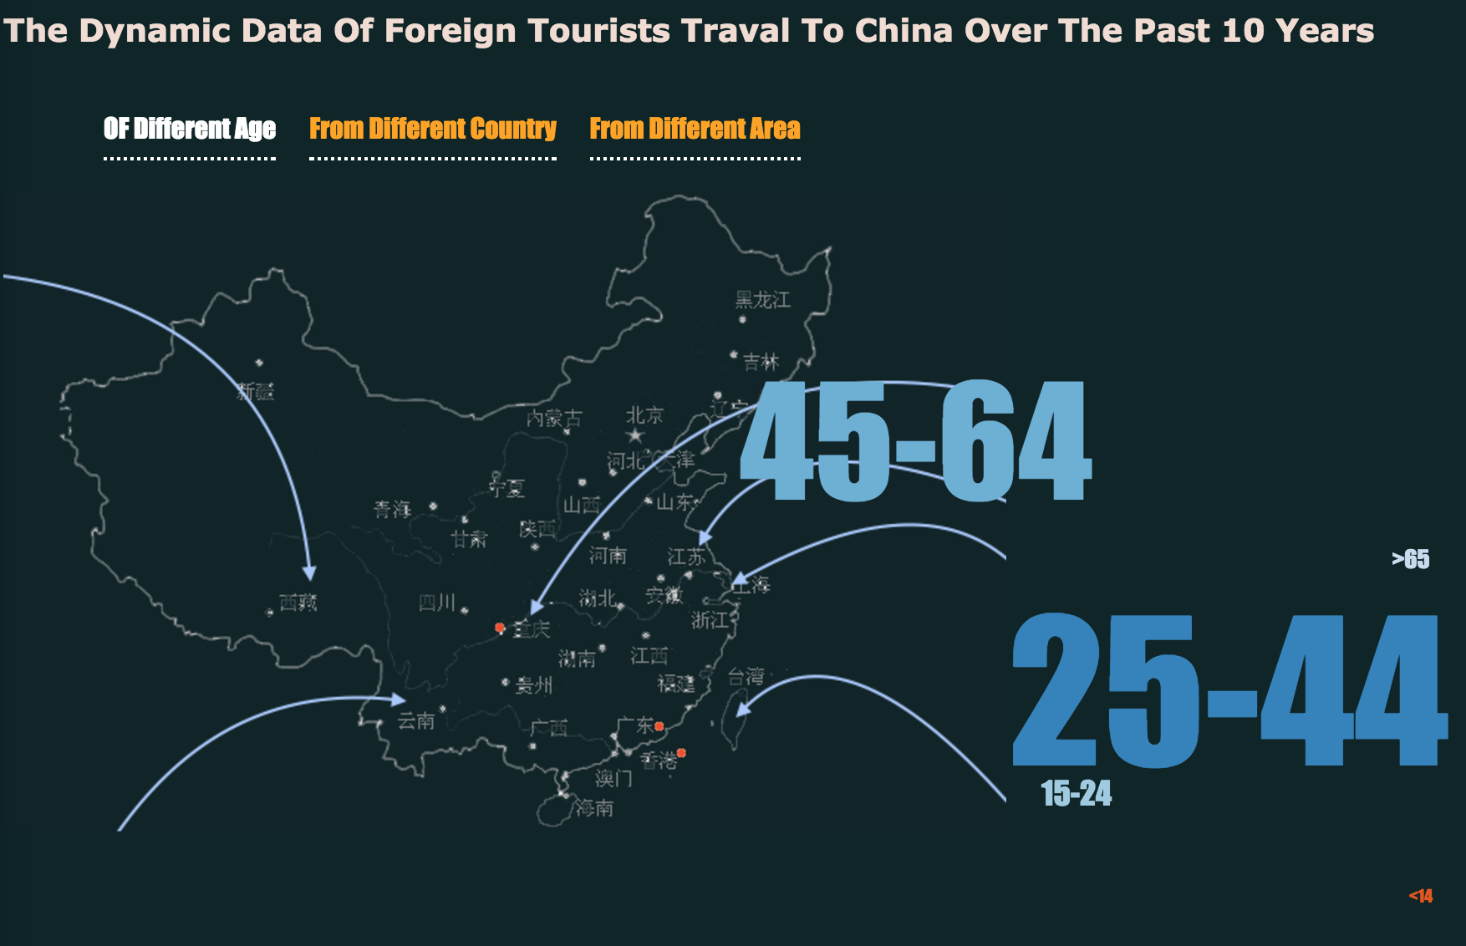

i ) The age group tag cloud reflects the average amount of foreign tourists over the past decade, we can easily find out that people who traveled to China are mainly adults(age from 25 to 44) and middle ages(age from 45 to 64). That is to say, children and old people share a little proportion of the total travelers.

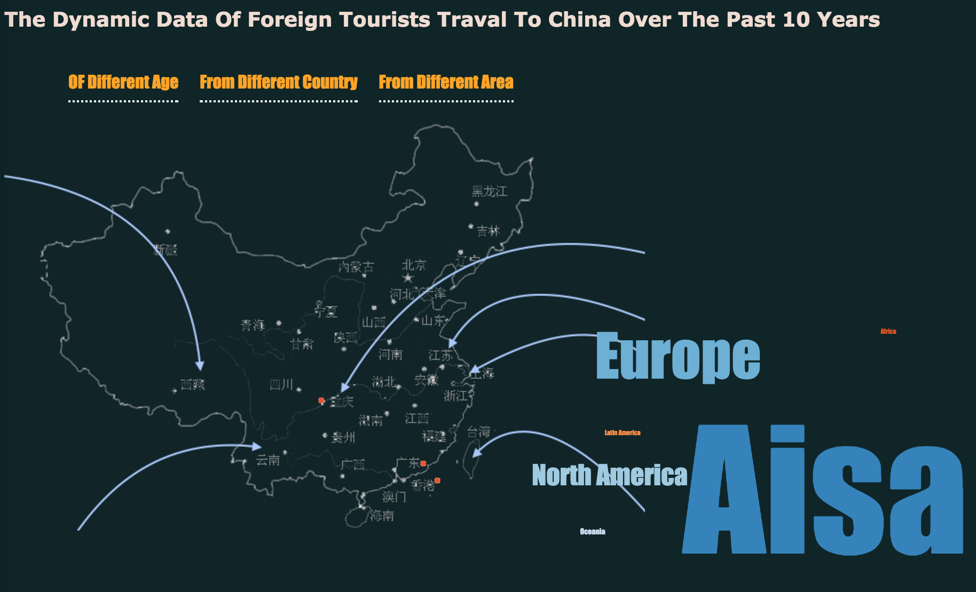 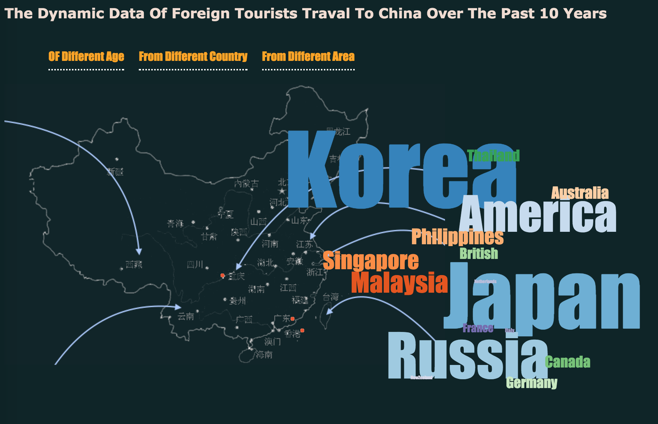

ii ) When it comes to travelers’ countries and areas, we can see people who traveled to china are mainly from Asia, typical countries are Japan, Korea and Russia. We can get a conclusion that distance is a very important factor that effects people’s travel destination selection. That means people tend to travel to a relatively near country because time and money consuming is an important factor that will always be taken into consideration.

1. ***Tourists of different age group: Children(<15), Young(15~24), Adult(25~44), Middle Age(45~64), Elder(>64)***

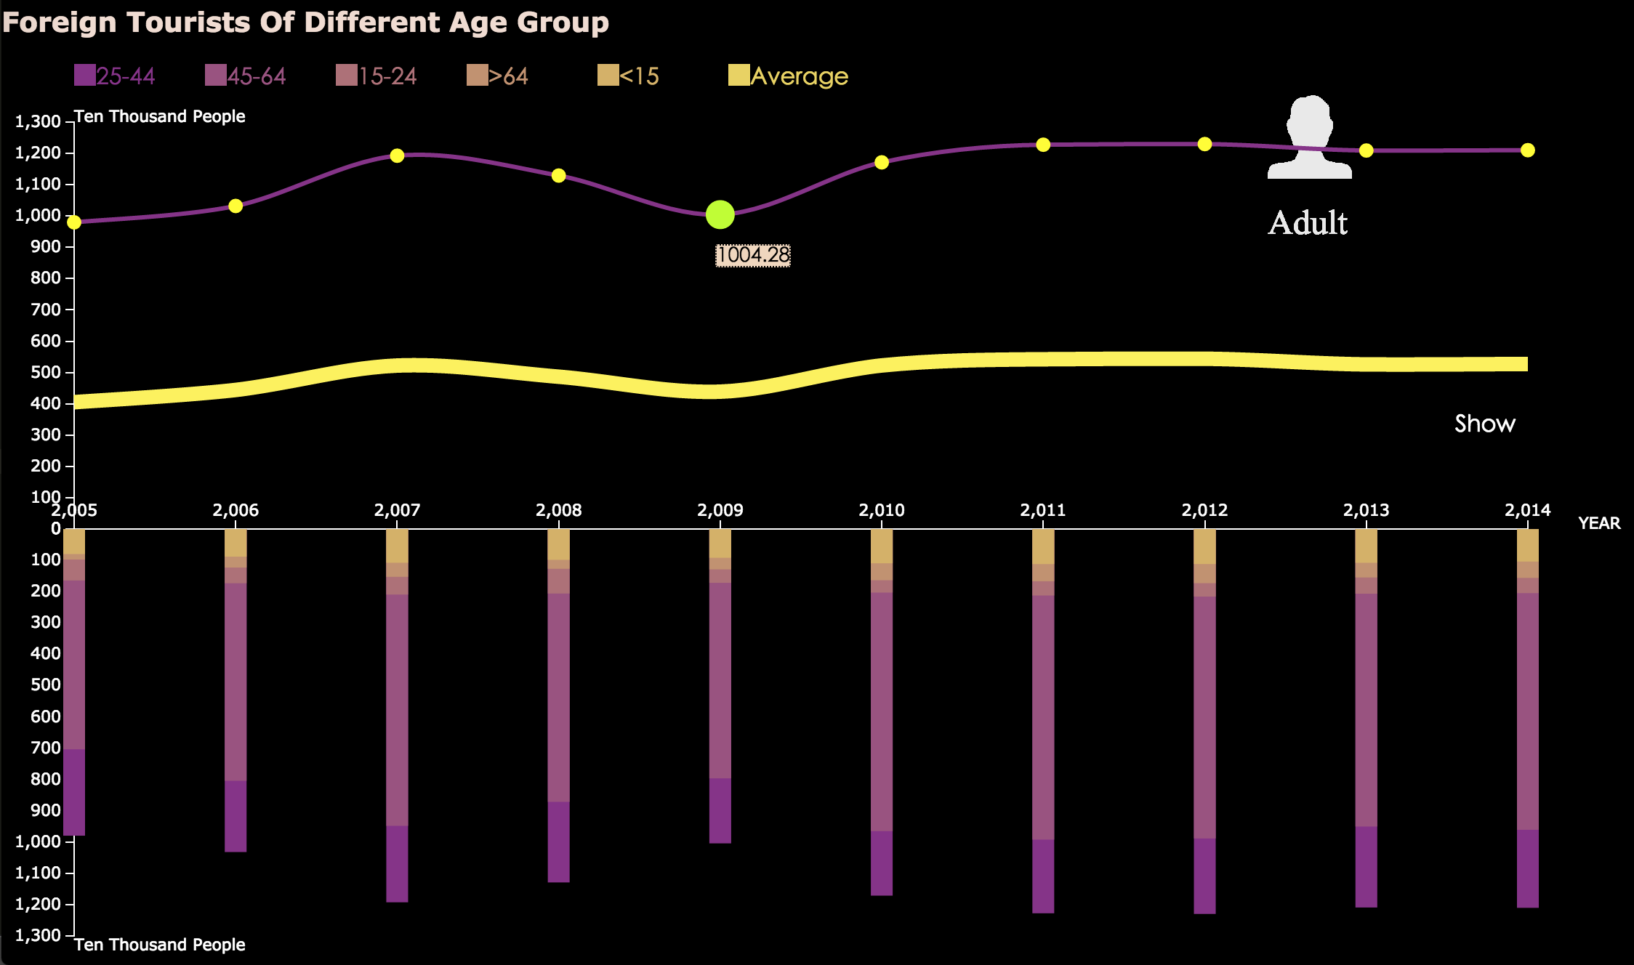

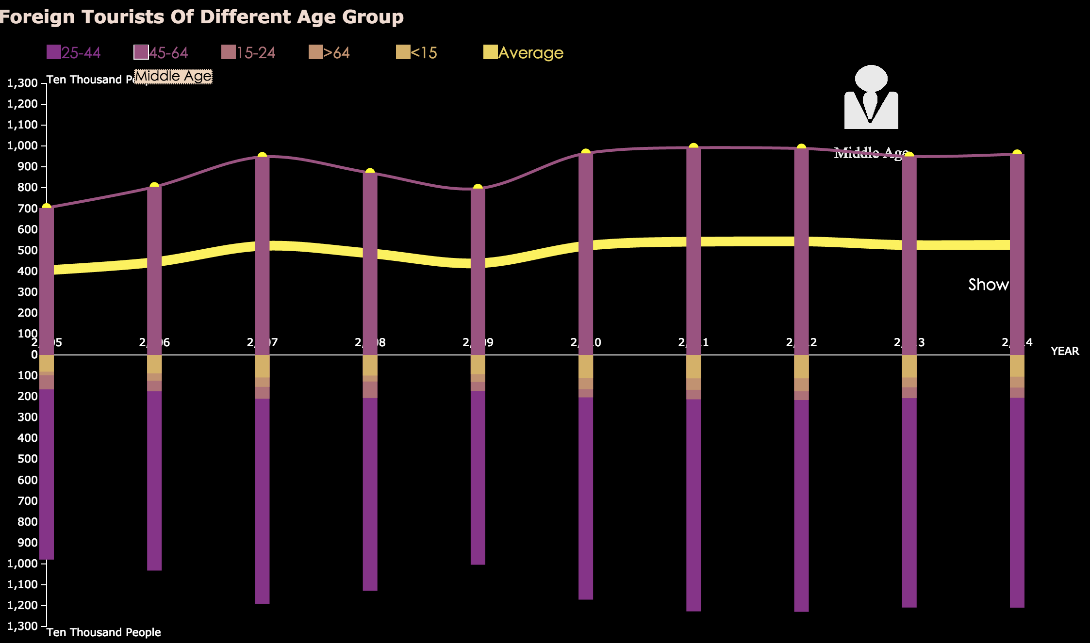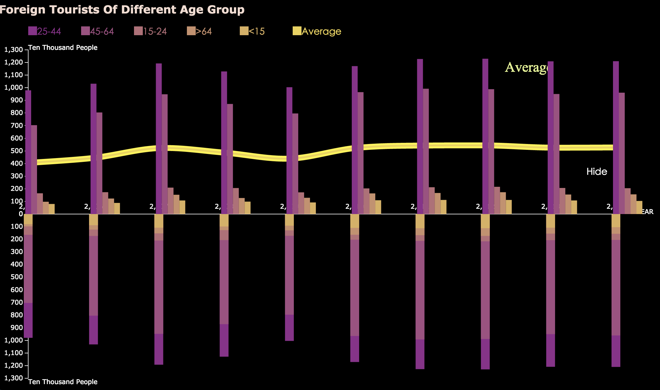

From the diagram of age group data, there is no sharp up and downs form 2005 to 2014. According to the average line, we can just see the amount of people traveled to china increased slightly in 2007 and decreased back in 2009 before another slow rise in 2010. Overall the amount is stable with a very slow increasing trend. The bar charts can also give us the same conclusion that most foreign travelers are adults and middle ages.

1. ***Tourists from different area: Europe, North America, Oceania, Africa, Latin America***

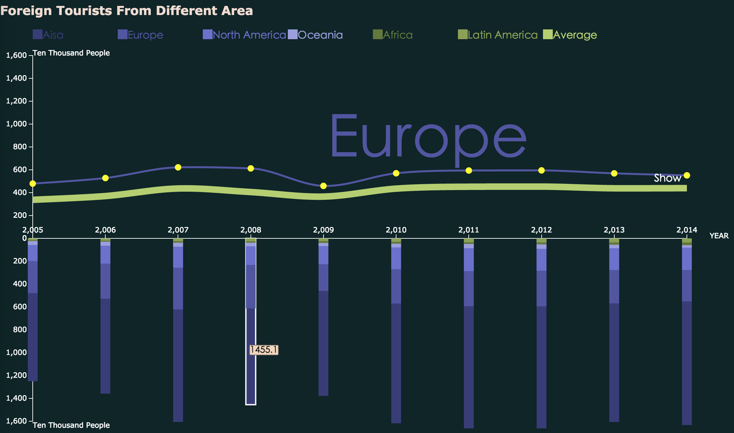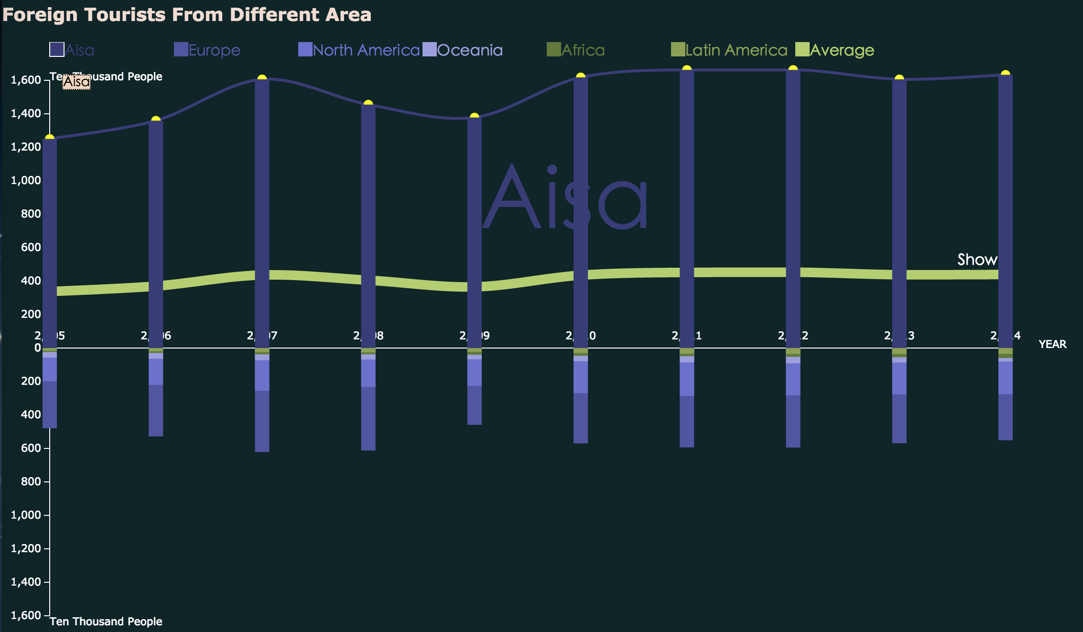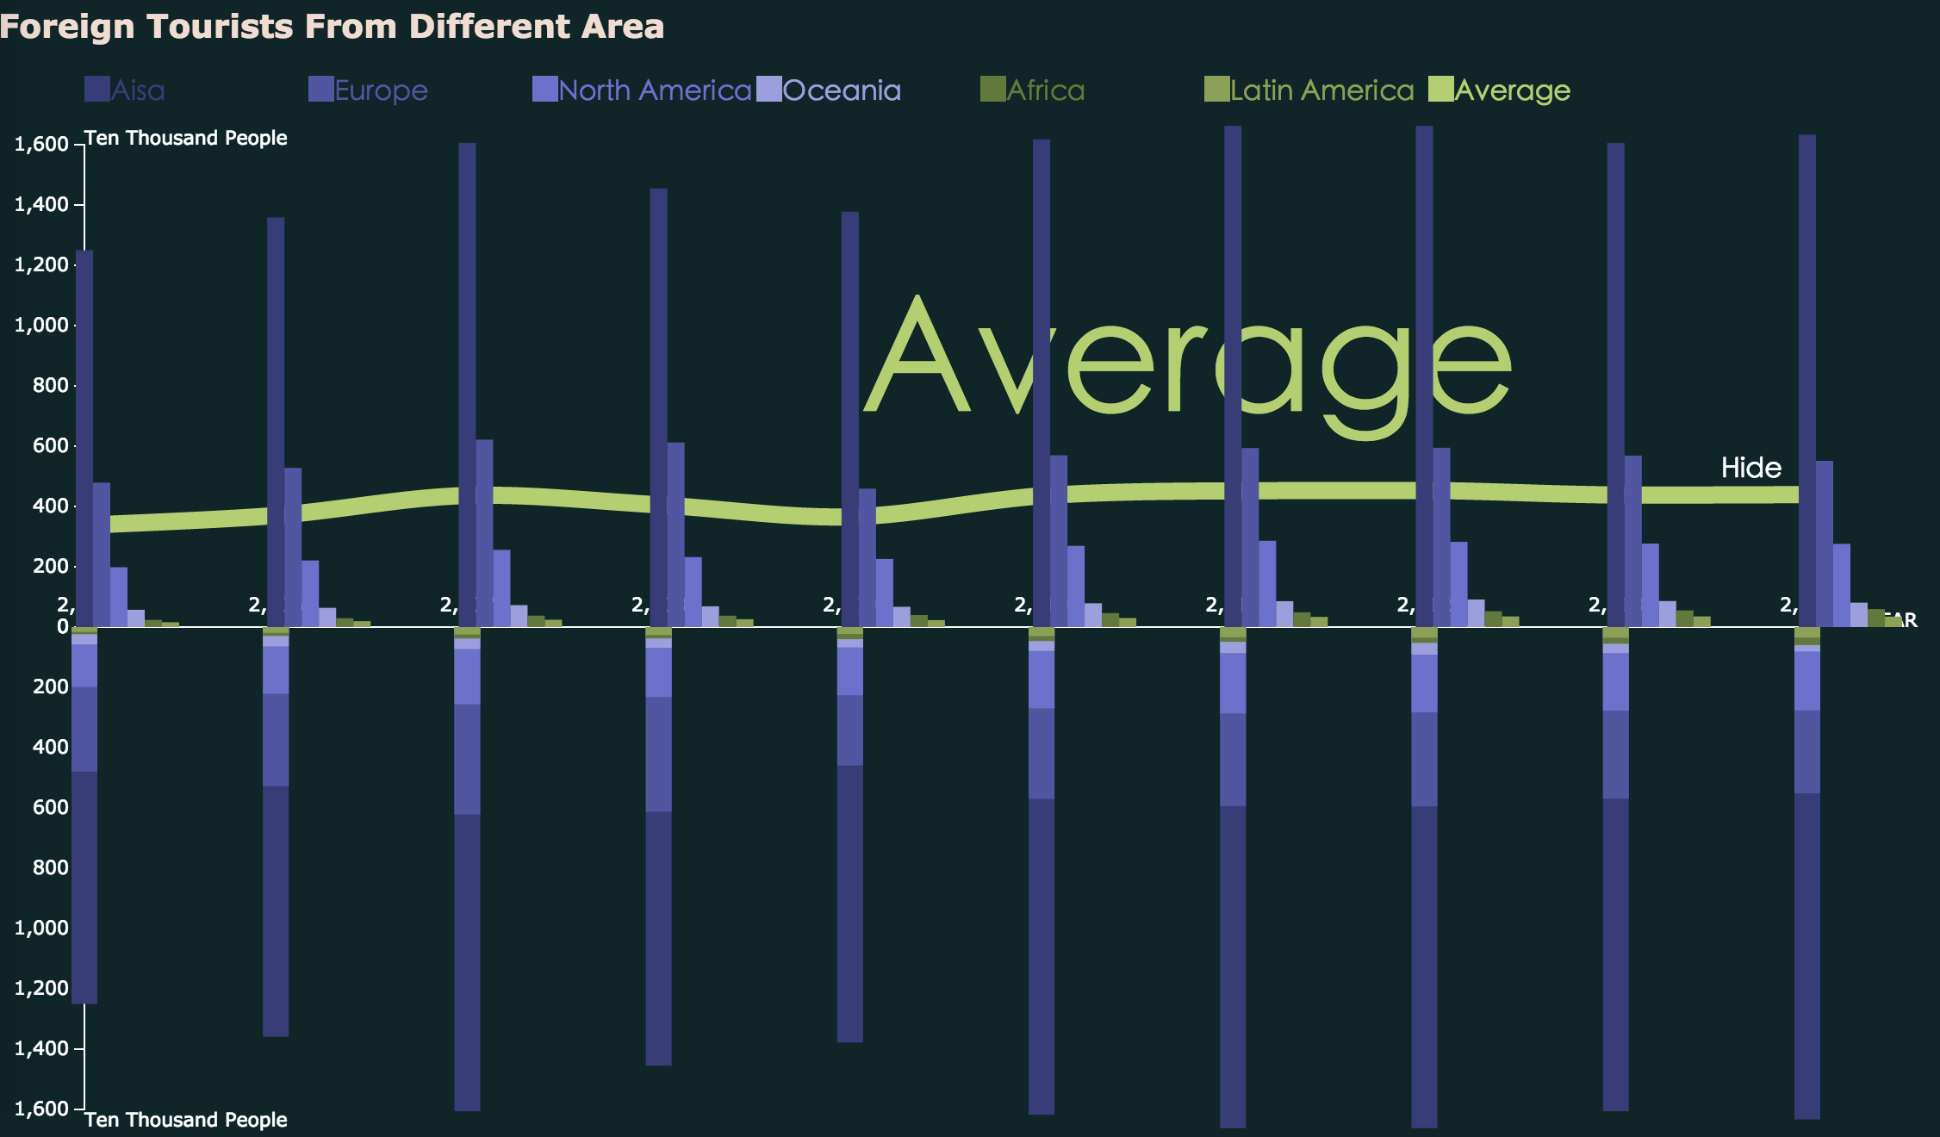

This part is similar to part2, using the same diagram. From this chart people can clearly see how many foreign travelers have come to china from these six areas. Most tourists are from Asia mainly because of the distance convenience, and there are also quite a lot of tourists come from Europe, North America these kind of developed areas. The overall amount of tourists is quite stable in the past decade.

1. **Tourist from different countries: Japan, America, Korea, Australia, etc.**

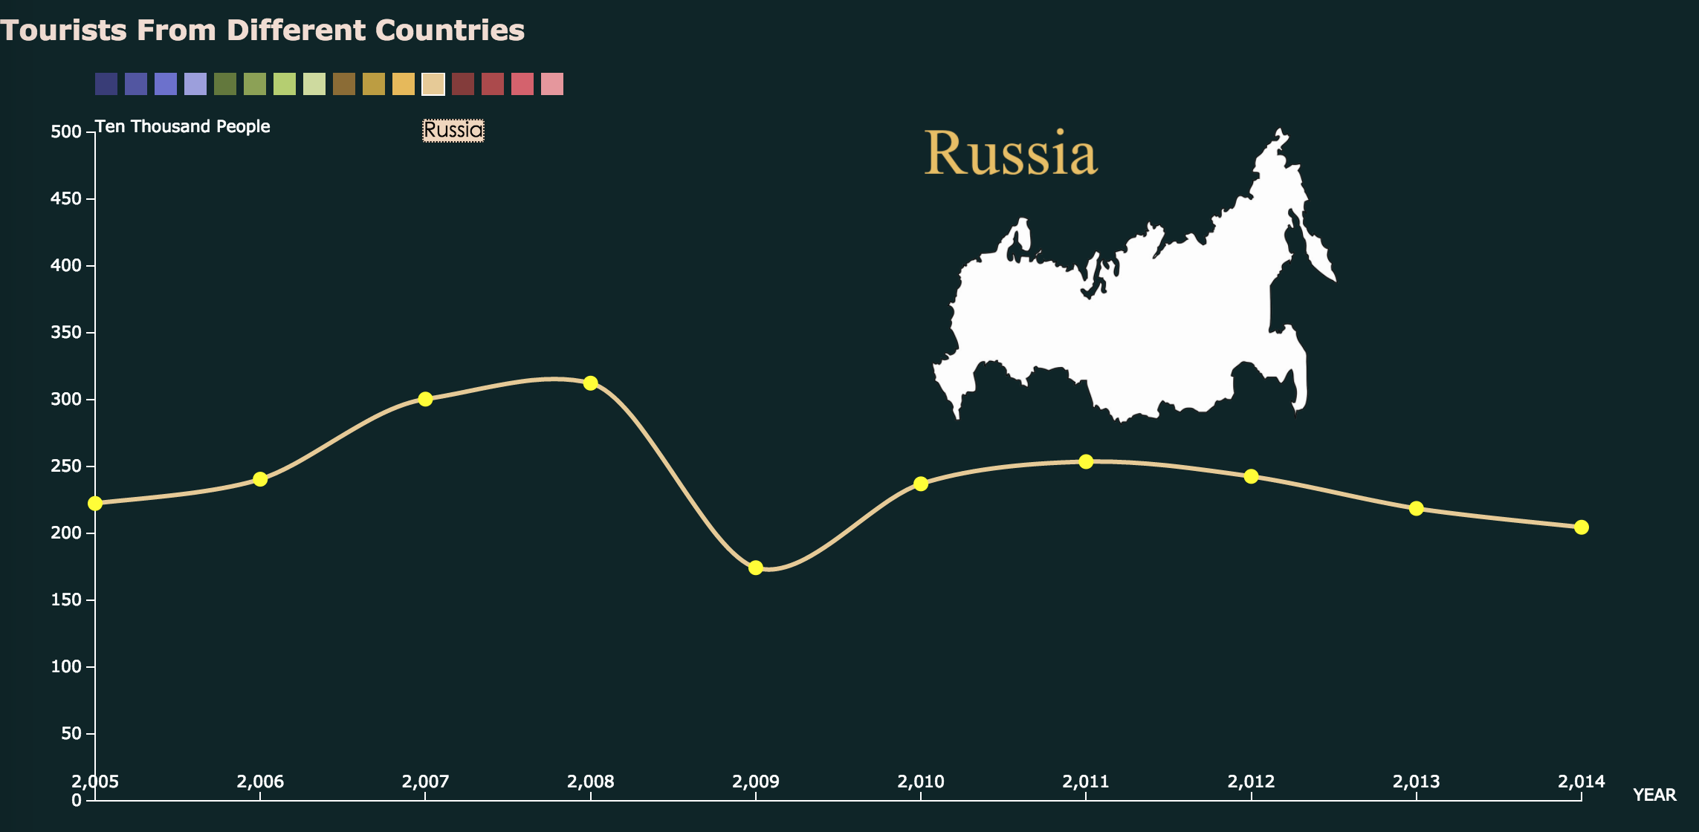

In the countries data visualization part, the bar charts are removed. The whole space are used to show the trending data of each country. For most countries, the corresponding maps are displayed on the top-right to help people know which country’s data is currently showing now, otherwise a single name of the country will be displayed instead because these countries’ map are uneasy to recognize, which is of little help for information giving.

Based on the previous line charts and this part, each country’s tourism data, we may find that there was rapidly increasing foreign tourists travel to china in 2007 and 2008, when was just before the 2008 Olympic Game in Beijing.

**Difficulties and Limitations:**

To be more flexible to achieve the design that I want, I choose to do visualization by programming with d3.js, but it takes me too much time to learn d3.js that I have very limited time to select and analyze data. I also tried to use some other relevant data sources but their data formats are differ greatly and hard to integrate and display them together with d3.js so I focus on how to show the current data efficiently and user friendly to interact. The data used is typical but quite limited and not compelted.