The purpose of my visualizations was to display the development of industry of China in the past. First of all, visualization consisted of bar chart and Gantt bar chart was created to present variation trend of GDP and industrial added valve (including the percentage of Industrial added valve in GDP) in China as shown in picture 1:

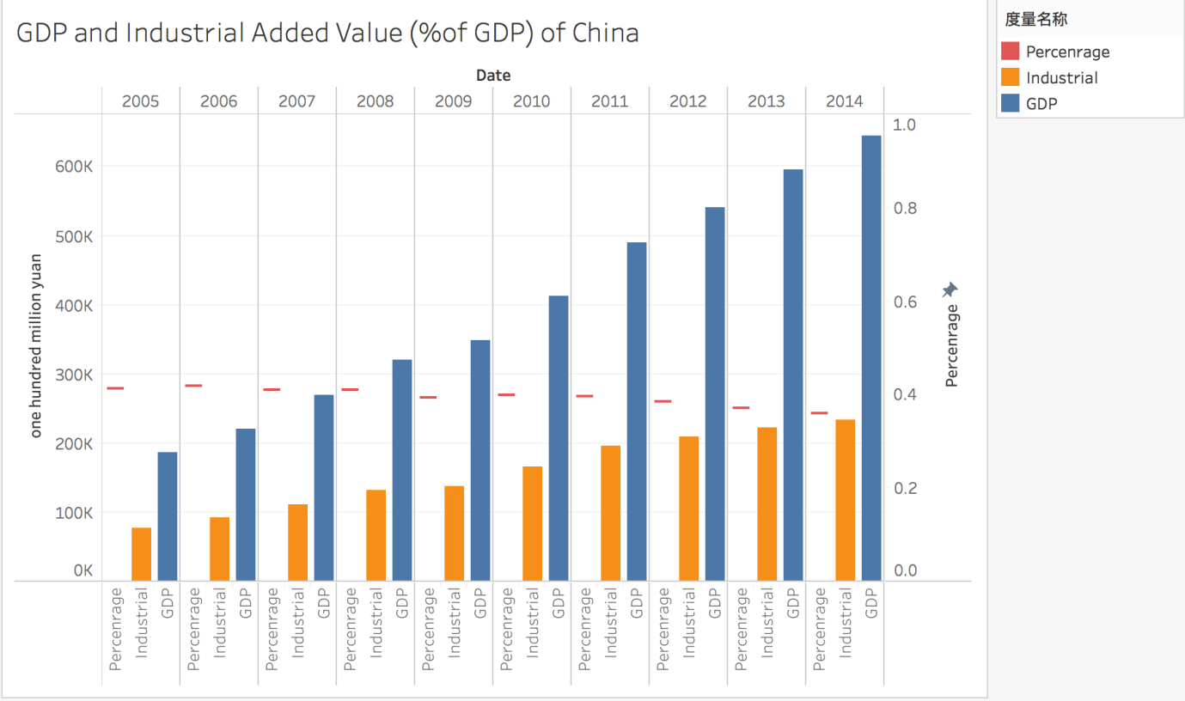

Picture 1: GDP and Industrial Added Value in China.

As can be seen in the picture, GDP of China kept raising from 2005 to 2014. Industrial added valve of China increased at the same time but the growth decreased as a whole. This also can be concluded from decline of the percentage industrial added valve in GDP. The phenomenon was called De-industrialization due to increase of labor cost, resource depletion and development of technology.

Secondly, I display regional distribution of industrial enterprises in China in 2014 as shown in picture 2 below:

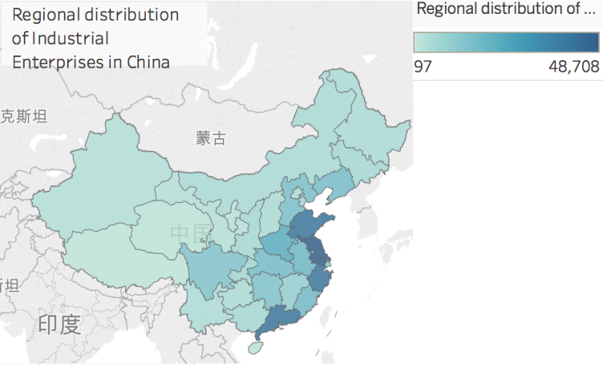

Picture 2: Regional distribution of industrial enterprises in China

It can be concluded that industrial enterprises were mainly distributed in south-east coastal areas such as Jiangsu, Zhejiang and Guangdong. The convenient of transportation contributed to development of industry.

Thirdly, the numbers of above-scale industrial enterprises is displayed in picture 3:

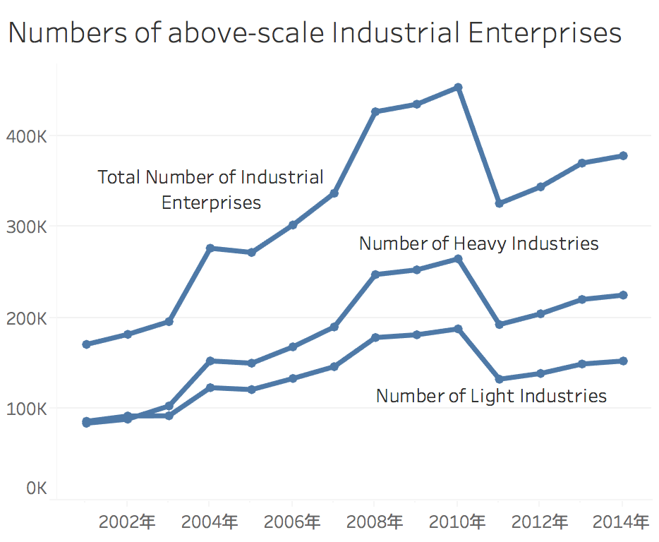

Picture 3: Numbers of above-scale industrial enterprises

The definition of above-scale was revenue from main operations above 5 million Yuan before 2011, but it was changed to revenue from main operation above 20 million Yuan after 2011. As a result, sharp decline existed between 2010 and 2011. The growth of industrial enterprises slowed down from 2005 to 2008 and even reverted from 2004 to 2005, but it raised sharply from 2008 to 2009 especially the growth of heavy industries. This was mainly because the government limited the establishment of industrial enterprises with heavy pollution and shut down pollution exceeded enterprises after 2005 for preparation of 2008 Beijing Olympic Games. Then the policy was loosened after 2008.

The impacts of Beijing Olympic Games can also be seen from the line chart of investment in environment pollution and industrial pollution control below:

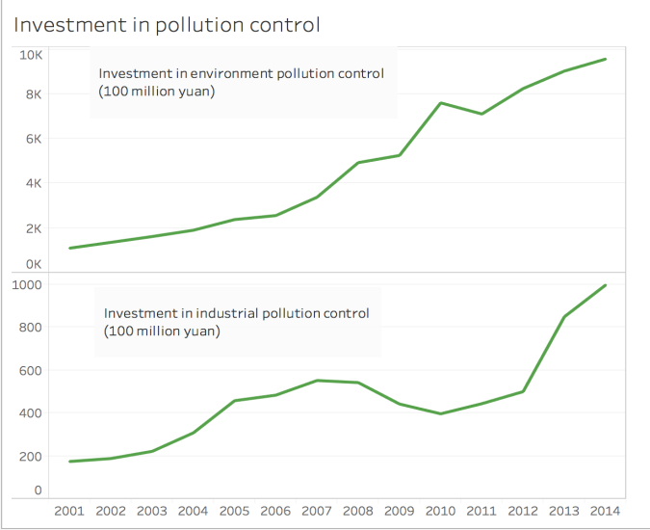

Picture 4: Investment in pollution control

The total investment in environment control was increased as a whole, but the investment in industrial pollution control rose rapidly from 2001 to 2005 and kept a high level from 2005 to 2008. Then it fall down after 2008 due to the end of Beijing Olympic Games in August. For deeper insight, scatter plots of comparison between investment in industrial pollution control in 2005 and 2004 and comparison between investment in industrial pollution control in 2008 and 2009 were shown below:

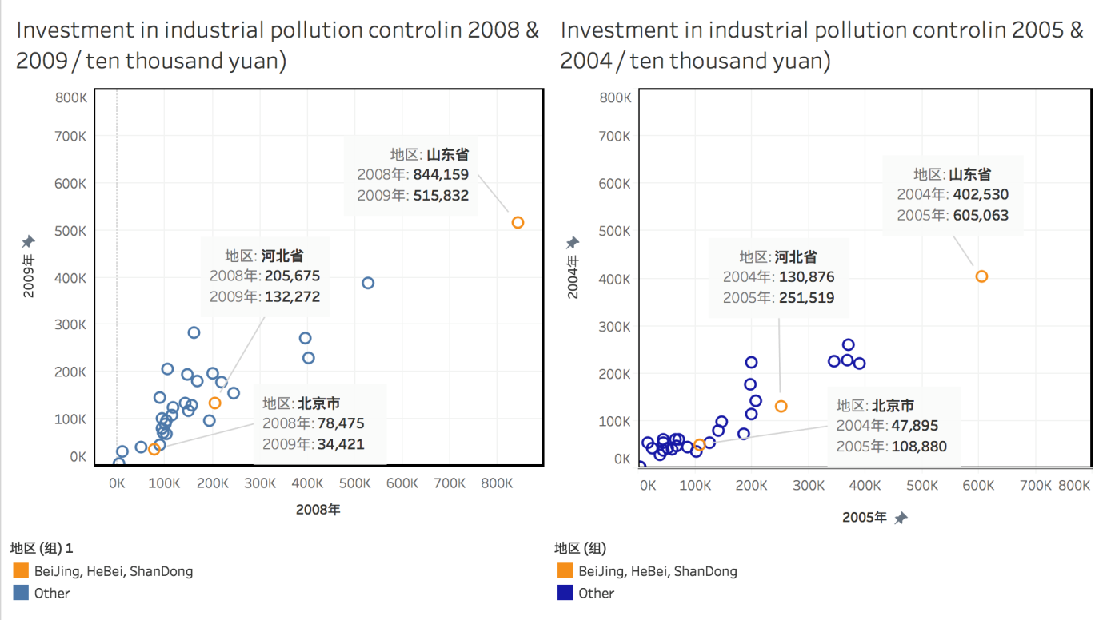

Picture 5: Scatter plots of comparison between investments in industrial pollution control

It can be concluded that investment in industrial pollution control in the most provinces increased sharply from 2004 to 2005 due to the preparation of 2008 Beijing Olympic Games. Then it decreased from 2008 to 2009 due to the end and the continued ramifications of high level investment before. The above phenomenon was shown obviously in Beijing (the host of 2008 Olympic Games), Hebei and Shandong (close to Beijing).

The development of industry relies on electricity generation, thus a bar chart of power generation in China from 2005 to 2014 was created:

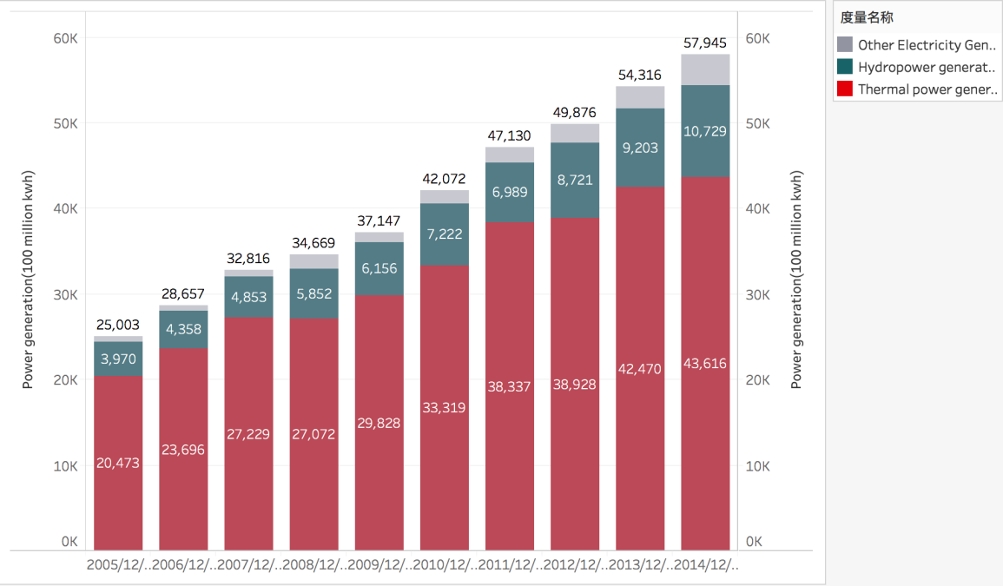

Picture 6: Power generation in China

As can be seen in picture 6, electricity generation kept going up from 2005 to 2014. The main method was thermal power generation but the proportion of it in electricity generation decreased in total. Moreover, the ratio of Hydropower generation and other method such as nuclear power and wind power generation increased, which were more environmental friendly.

There were some difficulties during the visualization. For instance, combining data in the same format and showing it with the same dimensions. However, these were solved by creating different worksheets and import them into one work package.

Various methods were tried such as bar chart, line chart, Gantt chart, Scatter chart and map. Proper methods were selected to display different aspects of data. For example, Gantt chart in picture 1 was used to show percentage distinguished from valves using bar chart; Map in picture 2 was used to display regional distribution; line charts in picture 3 and 4 were used to show variation trend; scatter charts in picture 5 was used to display comparison of large amount of data with two metrics; stack diagram in picture 6 was used to present number and proportion.

The changes of regional distributions were planned to be displayed, but the data was too much and proper method could not be found. The Tableau was used for visualization, however, it was inconvenient to show united data and difficult to combine various charts in one diagram.