The visualization that I have done include 5 parts.

1. The plastic usage and poison usage in Beijing, Shanghai, Gansu, Zhejiang and Heilongjiang from 1995 to 2014.
2. The distribution of per capita disposable personal income in China.
3. The agriculture gross output in Beijing and Shanghai from 1995 to 2014.
4. The agriculture gross output in Gansu and Heilongjiang from 1995 to 2014.
5. The primary industry structure in Beijing.

I used line chart, bar chart, stacked bar chart and graph chart to show the usage trend of certain objective.

1. Identify the relationship between economy and agriculture structure.

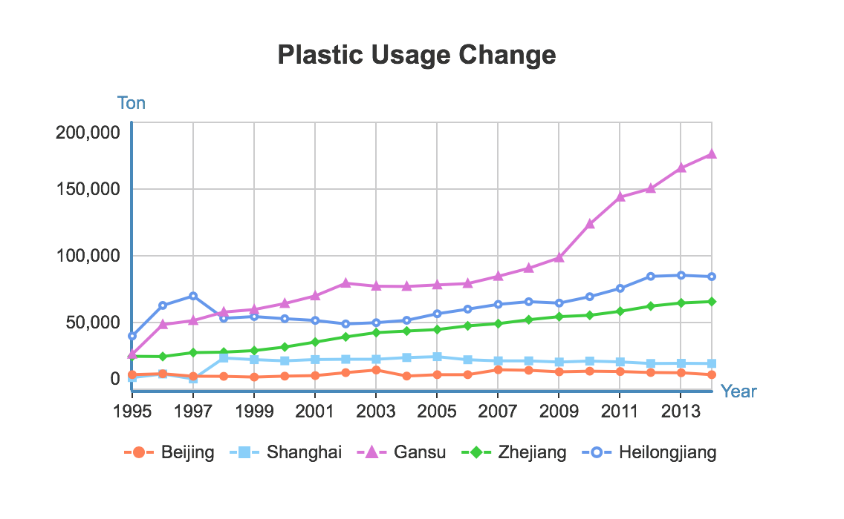

The first picture above shows the plastic usage change from 1995 to 2014. The purpose is to show how the amount of environment-unfriendly material changes together with the development of agriculture economy. Each different color represents a city or province and the line chart shows the plastic usage change from 1995 to 2014. I chose 5 different provinces and noticed that the more developed the city is, the less plastic it relies on. So I want to choose another different environment-unfriendly material and show how it changed during the same time.

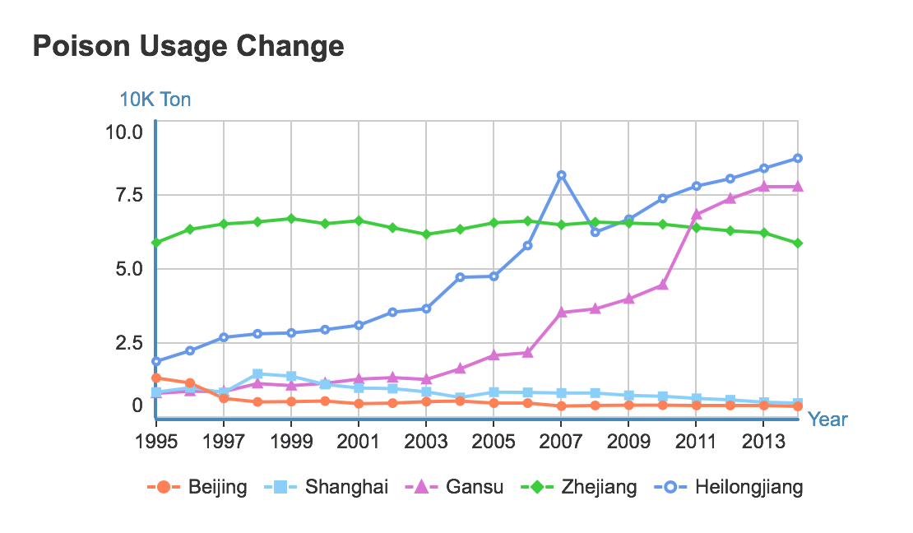

This picture above shows the poison usage change of the same 5 provinces in the first picture. Different color represents a different city or province. We can easily observe from the chart that although Zhejiang province used a large amount of poison as always, the figure stayed stable. Beijing and Shanghai also remained unchanged even drop down a little. By contrast, the figure of Gansu and Heilongjiang increased dramatically since 2003. Then I wonder how the economy of these provinces distributes.

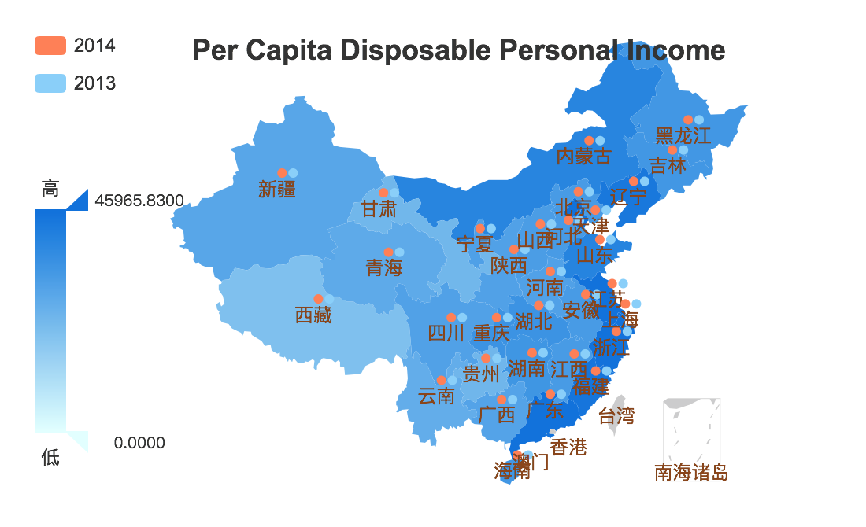

The picture above illustrates the per capita disposable personal income based on a Chinese map. The color shows the income difference between different provinces and cities. Income becomes higher when the color becomes deeper. And I get the information I want. Zhejiang, Shanghai and Beijing are all very developed city/province, but Heilongjiang and Gansu both have a comparably low income level. So by the visualization above it seems that as the development of the economy, people will use less and less environment-unfriendly material in agriculture.

2. Identify the role of agriculture in different economy structure.

In my opinion, development determines the economy structure. So I decide to dig much deeper into the agriculture development of the most developed cities in China which are Beijing and Shanghai.

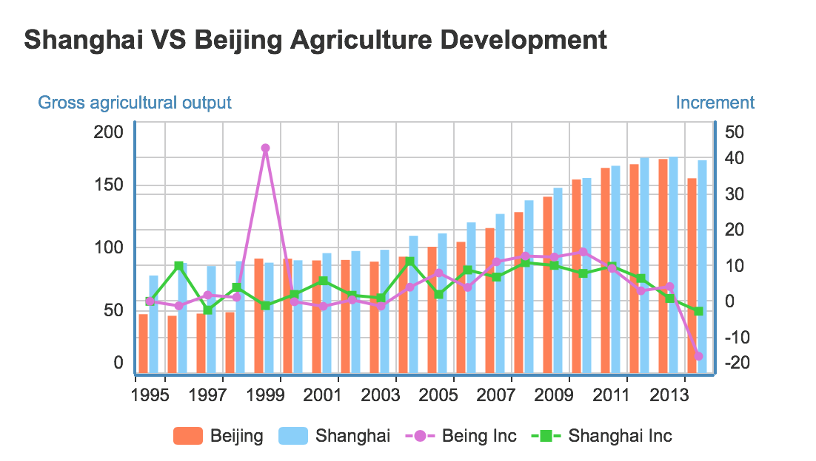

As you can see from the visualization showed above. I visualized the gross agriculture output of Beijing and Shanghai. The bar chart represents the gross agriculture output and the line chart shows the increment every year compared to the former year. We can easily observed that the gross agricultural output of Beijing and Shanghai both gradually increase but at a slower and slower pace. In the end, the increment become negative, which means the agriculture becomes a less and less important part of the cities’ economy.

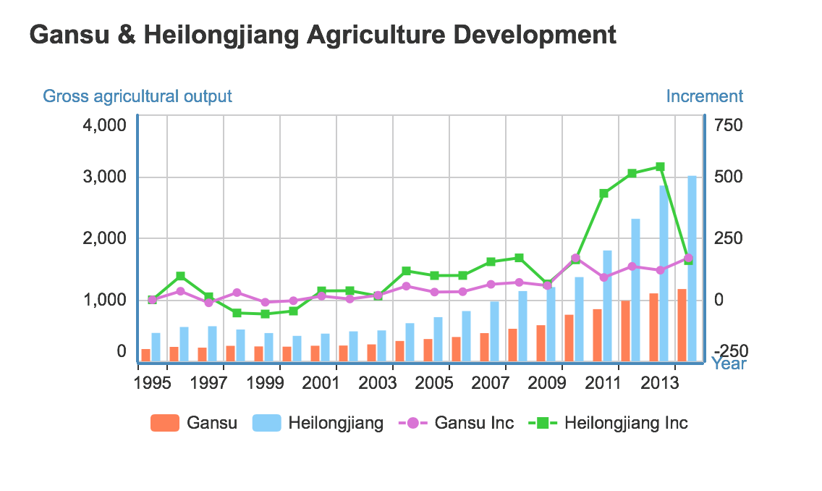

By contrast, I visualize the data of Gansu and Heilongjiang, the visualization result is showed above. Each bar represents the gross output of Gansu and Heilongjiang while each line shows the increment of the output compared to the former year. I find that both of these two provinces’ gross agriculture output are increasing steadily. This means that the agriculture development of these two cities are still in an upward trend. So in some provinces that are not as developed as Beijing and Shanghai, agriculture seems to play a much more important role in local economy.

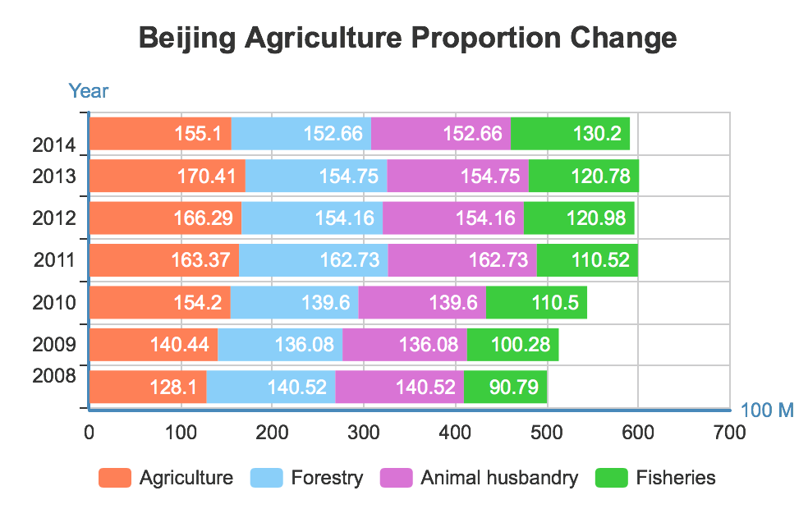

This picture above shows the different categories of primary industry in Beijing. This is a stacked bar chart and each bar represents the gross output of a certain year. Different color represents a different category in primary industry. As we can easily observe that three out of four categories remains stable in gross output and it can reflect my conclusion above. What’s interesting is that Fishery seems to develop well in Beijing.

Conclusion:

1. The environment-unfriendly material usage in different provinces or cities have a different trend. For those developed city, the usage of environment-unfriendly material becomes less and less. While in some province whose economy performance is not that good. There is still a upward trend in usage of these materials.
2. Agriculture plays a less and less important role in the city which has a fantastic economy status. However, for those cities whose economy is not that good, agriculture still plays a more and more important role in the local economy.
3. Beijing’s agriculture development remains stable these years as it is one of the most developed city in China. However, what’s interesting is that fishery is still developing fast these years.