1.Title:**The Overall Insight into Schools in Hong Kong**

2.Group Members:

|  |  |
| --- | --- |
| Name | Student ID |
| Jiang Xinhou | 3035347990 |
| Yang Yonggui | 3035348633 |
| Yu Qingtian | 3035348918 |
| Wang Kaili | 3035348114 |

3. Project objectives:

1) Display various aspects(distribution, school category, student) of Schools in Hong Kong with different visualization methods to help people better understand schools of Hong Kong;

2) Analyze the potential connection between school information and other local information like house distribution, transport status and so on.

3) Find and design proper visualization diagrams and interaction ways to help people exactly under stand the data efficiently.

4. Source and background of the data:

<https://data.gov.hk/en-data/dataset/hk-edb-schinfo-school-location-and-information>

The data is select from data.gov.hk education part mainly about schools’ location and information. This dataset provides Geo-referenced data and other relevant information of government, private, aided, Direct Subsidy Scheme, English Schools Foundation and international schools, kindergartens and kindergartens cum-child care center. The data attributes mainly include the school names, addresses, finance types, religions and the level of schools etc. in Hong Kong. We will also find other relevant dataset later and compared them with this one to dig out more potential information that most people care about.

5.Questions about the data:

How to use the longitude and latitude data (data format like: 22-23-11) in Tableau and what’s the exact meaning of Easting and Northing data?

6.Tasks:

7.Visualization tools and approaches:

1) Use Tableau to display some fundamental data.

2) Program with D3.js to show some data that have some special design need for flexiablity, which can not be accomplished with some visualization software.

8. Labor division:

**Preview of the data with teablue:**

1) .The amount of schools in different area: 2).The amount of different type of schools：

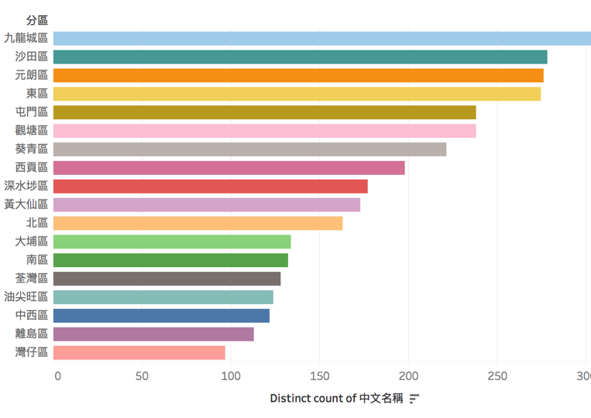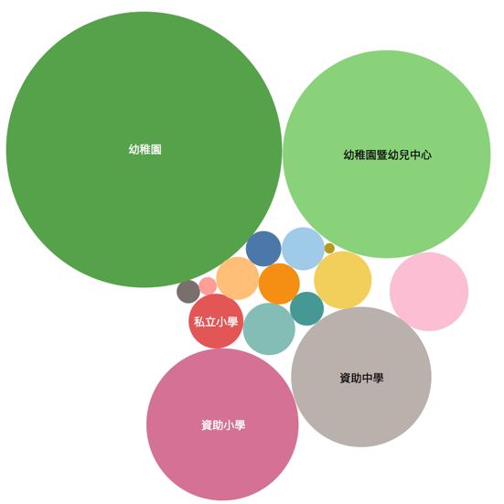

3).Religions: