

Precision Policy And Planning

**USER GUIDE**

Singapore Population Interactive Visualisation

*Explore Singapore’s Population & Demographics*

**Prepared By:**

Justin Choy

Ng Jun Hong

Jiang Xi

Contents

**Application Overview:** 3

**Population Tab:** 4

**Age Tab:** 5

**Education | Income Tab:** 6

# **Application Overview:**

This application consists of 3 dashboards which can be navigated to using the panel on the left of the screen the three dashboards available are:

1. Population – A high level overview of Singapore’s population distribution
2. Age – A more specific set of views showing distribution of Singapore’s population according to age group
3. Education | Income – A network diagram dashboard for specific analysis of planning areas and their residential demographic of Income, Education and Housing type.

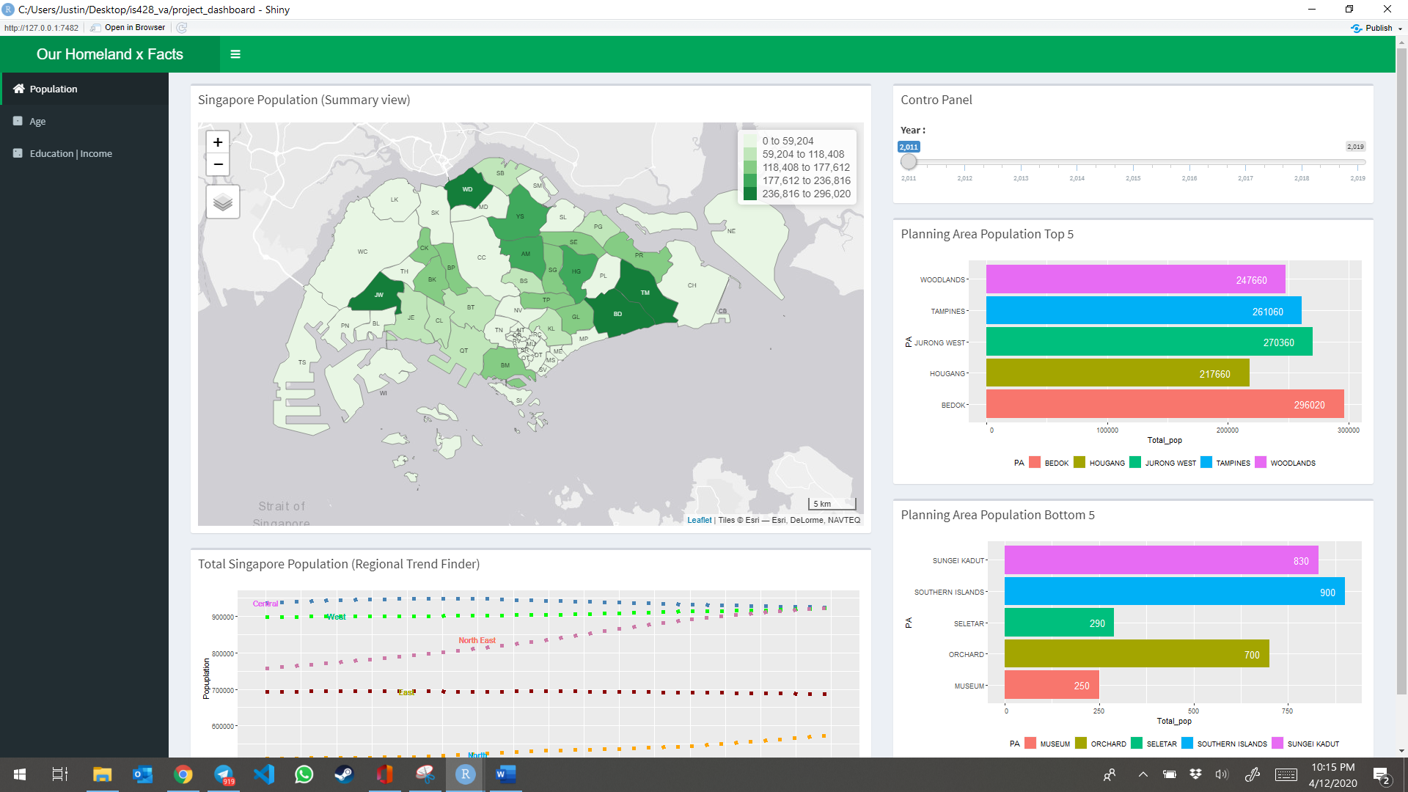

# **Population Tab:**

This dashboard contains 4 charts and an interactive timeline slider. The Choropleth map and Top 5/Bottom 5 charts (in Red boxes below) respond to the timeline slider, while the dotted line trend map is static and provides the overall population distribution trend by regions over the years 2011 to 2019. To use this view effectively, slide the timeline control to the specific year of interest and give it 2-4 seconds to load the corresponding charts.

Step 1: Move Timeline Slider (Blue box) & wait for loading



Step 2: View Loaded Charts

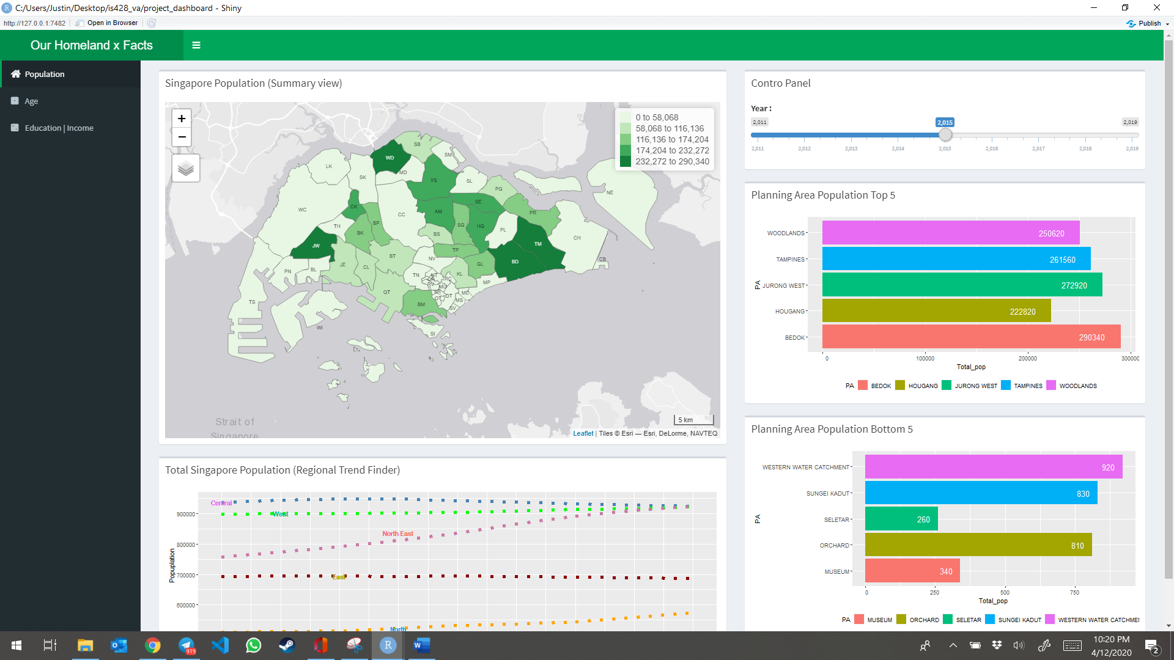

# **Age Tab:**

This dashboard contains 3 charts, an interactive timeline slider (Blue box below), and radio buttons to select Age group of interest (Green box below). The Choropleth map and age sex pyramid charts respond to the filters while the lollipop chart (Red box below) automatically shows the animation of change in age group distribution from 2011 to 2019. The lollipop chart also has 3 tabs on its top panel which can be selected to show the respective animation for each of the age groups of interest – e.g. Young, Economically Active, or Aged. Similar to the dashboard above, there is a 1-2 second waiting time for the loading of charts based on a change in the filters.

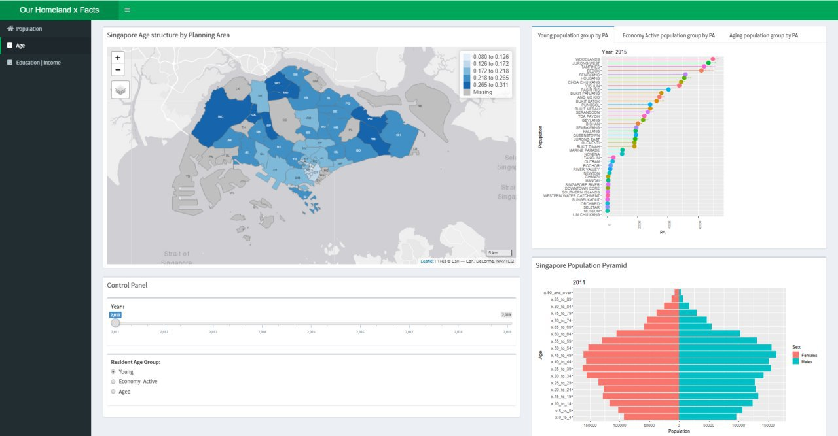

# **Education | Income Tab:**

This dashboard contains 2 charts types: Network Chart and Bar charts (faceted by Income and Education). These charts allow you to explore specific demographics of your selected planning area. This can be set using the dropdown filter shown in the red box below. Moreover, we support viewing data over two time periods 2010 and 2015. This can be set using the radio button shown in the blue box below.

