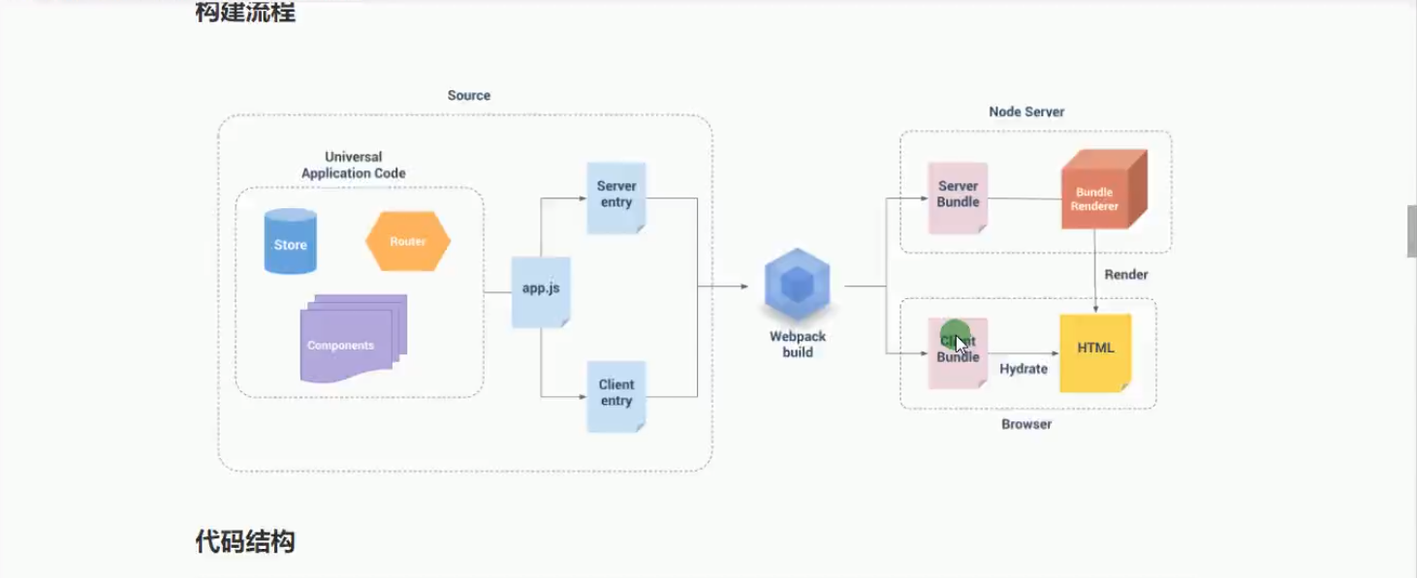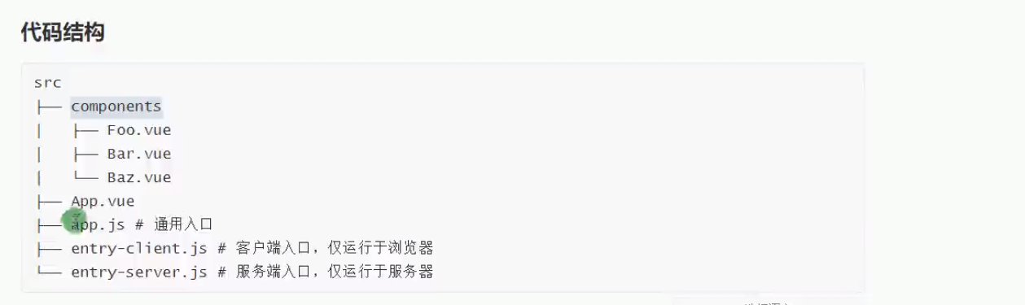

npm i webpack-node-externals lodash.merge –D

npm i cross-env –D // 命令跨平台