Location Based Mind Mapping
Now, you can associate nodes of a mindmap with geographical locations. Each node can have at most one location. With the integrated map viewer using maps from www.openstreetmaps.org you can visualize them inside of FreeMind as shown here:
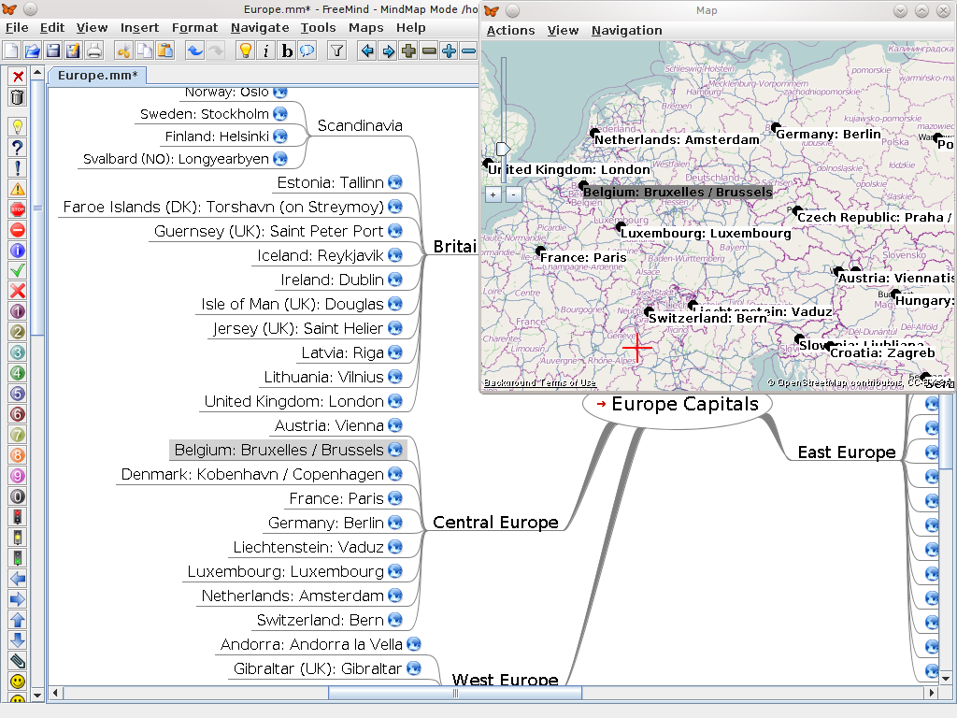

To add a node with a location, just open the map viewer (e.g. using Ctrl+Alt+M), search for it (using the geographical find Ctrl+F) and double click the location. At this location, the usual node edit window appears to enter its description. Finally, a new child with this location has been created.

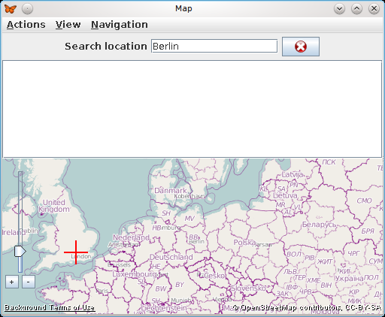

After having found the location, set the cursor per double click:

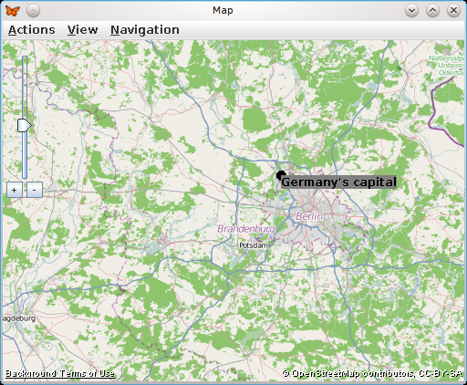
Now, the position, the map center, the zoom factor and the map source (the map provider, e.g. Mapnik) are stored. Moreover, a tooltip image is created and stored in the same directory as the map itself.

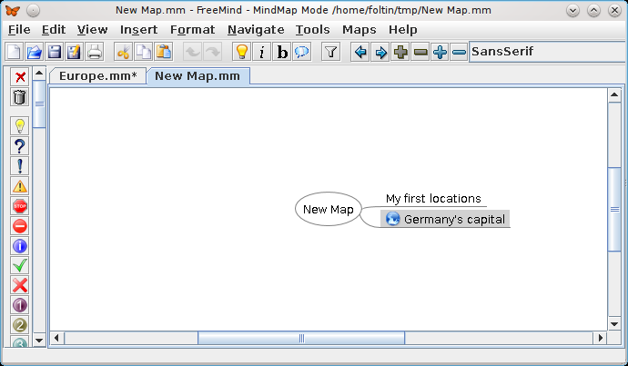
The positions of folded nodes are not displayed in the map viewer. Thus, the mind map structure is represented in the geographical map as well.

To change a node's position, just drag&drop it.

The node's context menu contains more actions. Each can be applied to multiple selected nodes as well.
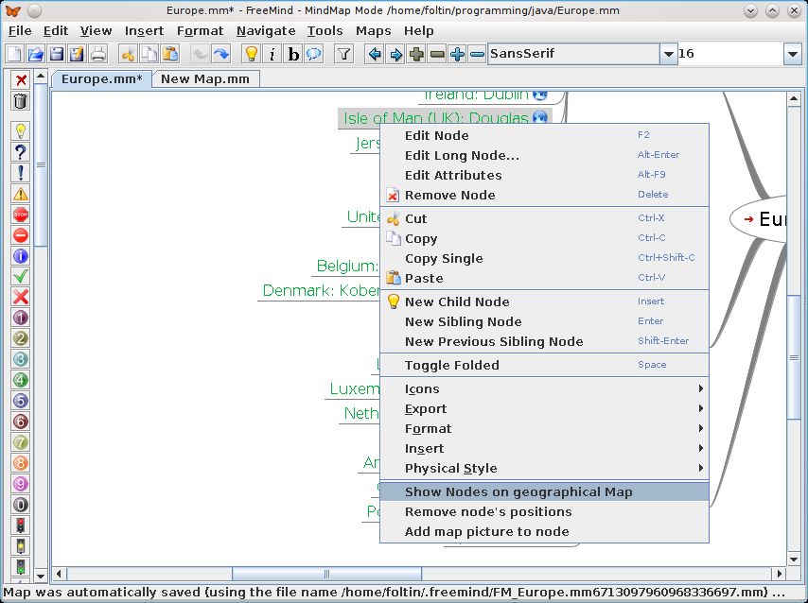

More features:
- You can add a little map to the node.
- You can jump to a node (restoring its position, zoom, etc.).
- You can remove its geographical position.
- You can export the map view as an image.
- In the viewer, you can use the mouse wheel to zoom.

