**Which code snippet has higher quality?**

<https://www.wjx.cn/vm/ejAB0B6.aspx>

In this questionnaire, you will be presented with two semantically equivalent code snippets. Your task is to evaluate which code snippet has higher quality. You can evaluate it based on readability, understandability, complexity, and maintainability.

**Readability:** how easily the code can be read and navigated

**Understandability:**how well the code’s logic, behavior, and purpose can be understood

**Complexity:**how complex or straightforward the code structure is

**Maintainability:** how easily the code can be modified or updated to fix issues or add new features

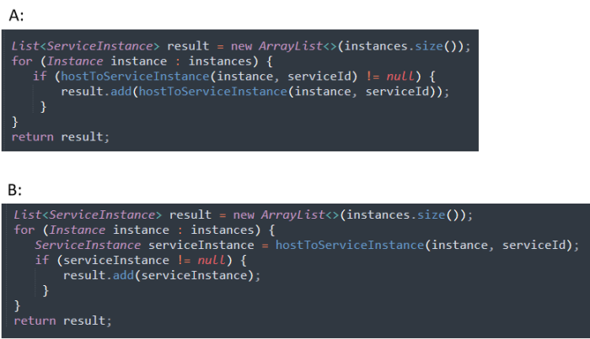

1. which code snippet has higher quality? *

|  |
| --- |
| ○A |
| ○B |
| ○A/B |

2. From the perspective of code readability, which code snippet is better? *

|  |
| --- |
| ○A |
| ○B |
| ○A/B |

3. From the perspective of code understandability, which code snippet is better? *

|  |
| --- |
| ○A |
| ○B |
| ○A/B |

4. From the perspective of code complexity, which code snippet is better?*

|  |
| --- |
| ○A |
| ○B |
| ○A/B |

5. From the perspective of code maintainability, which code snippet is better?*

|  |
| --- |
| ○A |
| ○B |
| ○A/B |

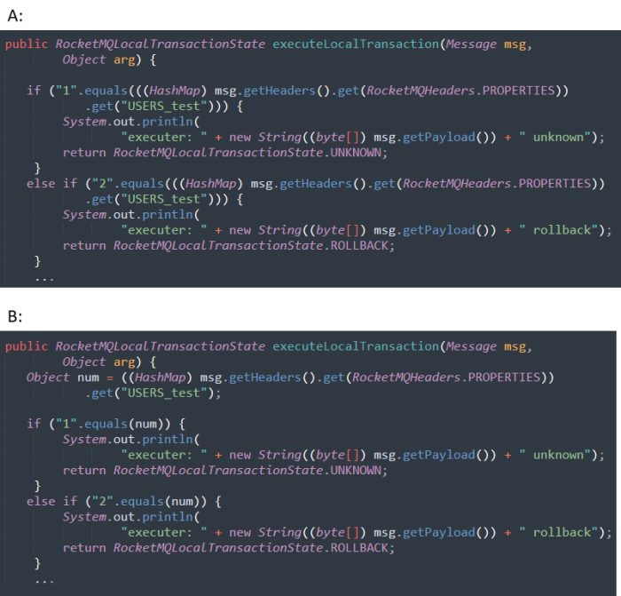

1.which code snippet has higher quality? *

|  |
| --- |
| ○A |
| ○B |
| ○A/B |

2.From the perspective of code readability, which code snippet is better? *

|  |
| --- |
| ○A |
| ○B |
| ○A/B |

3.From the perspective of code understandability, which code snippet is better? *

|  |
| --- |
| ○A |
| ○B |
| ○A/B |

4.From the perspective of code complexity, which code snippet is better? *

|  |
| --- |
| ○A |
| ○B |
| ○A/B |

5.From the perspective of code maintainability, which code snippet is better? *

|  |
| --- |
| ○A |
| ○B |
| ○A/B |

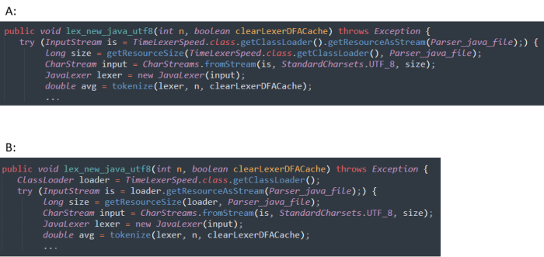

1.which code snippet has higher quality? *

|  |
| --- |
| ○A |
| ○B |
| ○A/B |

2.From the perspective of code readability, which code snippet is better?*

|  |
| --- |
| ○A |
| ○B |
| ○A/B |

3.From the perspective of code understandability, which code snippet is better? *

|  |
| --- |
| ○A |
| ○B |
| ○A/B |

4.From the perspective of code complexity, which code snippet is better? *

|  |
| --- |
| ○A |
| ○B |
| ○A/B |

5.From the perspective of code maintainability, which code snippet is better? *

|  |
| --- |
| ○A |
| ○B |
| ○A/B |

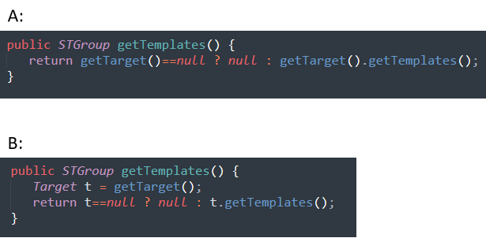

1.which code snippet has higher quality? *

|  |
| --- |
| ○A |
| ○B |
| ○A/B |

2.From the perspective of code readability, which code snippet is better? *

|  |
| --- |
| ○A |
| ○B |
| ○A/B |

3.From the perspective of code understandability, which code snippet is better? *

|  |
| --- |
| ○A |
| ○B |
| ○A/B |

4.From the perspective of code complexity, which code snippet is better? *

|  |
| --- |
| ○A |
| ○B |
| ○A/B |

5.From the perspective of code maintainability, which code snippet is better? *

|  |
| --- |
| ○A |
| ○B |
| ○A/B |

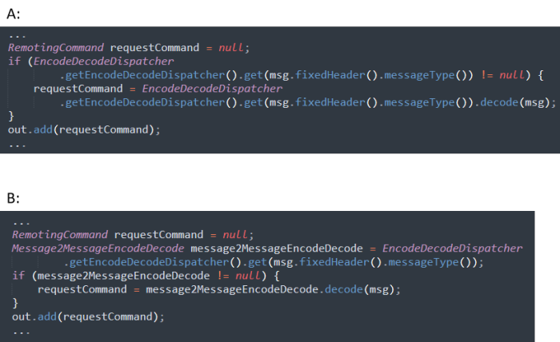

1.which code snippet has higher quality? *

|  |
| --- |
| ○A |
| ○B |
| ○A/B |

2.From the perspective of code readability, which code snippet is better? *

|  |
| --- |
| ○A |
| ○B |
| ○A/B |

3.From the perspective of code understandability, which code snippet is better? *

|  |
| --- |
| ○A |
| ○B |
| ○A/B |

4.From the perspective of code complexity, which code snippet is better?*

|  |
| --- |
| ○A |
| ○B |
| ○A/B |

5.From the perspective of code maintainability, which code snippet is better? *

|  |
| --- |
| ○A |
| ○B |
| ○A/B |

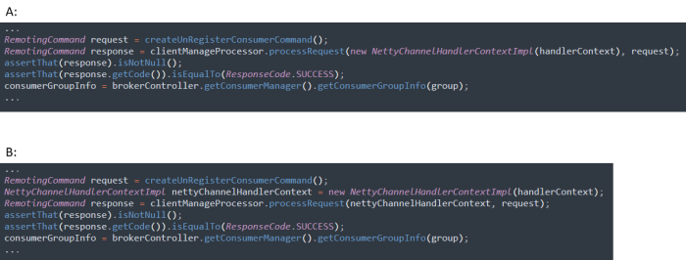

1.which code snippet has higher quality? *

|  |
| --- |
| ○A |
| ○B |
| ○A/B |

2.From the perspective of code readability, which code snippet is better? *

|  |
| --- |
| ○A |
| ○B |
| ○A/B |

3.From the perspective of code understandability, which code snippet is better?*

|  |
| --- |
| ○A |
| ○B |
| ○A/B |

4.From the perspective of code complexity, which code snippet is better? *

|  |
| --- |
| ○A |
| ○B |
| ○A/B |

5.From the perspective of code maintainability, which code snippet is better? *

|  |
| --- |
| ○A |
| ○B |
| ○A/B |

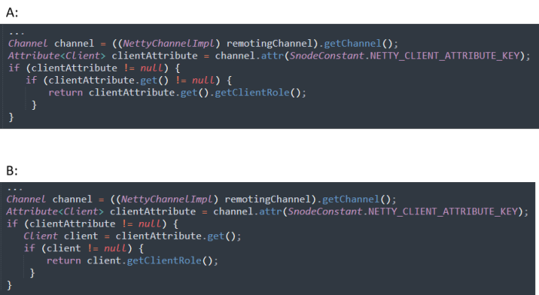

1.which code snippet has higher quality? *

|  |
| --- |
| ○A |
| ○B |
| ○A/B |

2.From the perspective of code readability, which code snippet is better? *

|  |
| --- |
| ○A |
| ○B |
| ○A/B |

3.From the perspective of code understandability, which code snippet is better? *

|  |
| --- |
| ○A |
| ○B |
| ○A/B |

4.From the perspective of code complexity, which code snippet is better?*

|  |
| --- |
| ○A |
| ○B |
| ○A/B |

5.From the perspective of code maintainability, which code snippet is better? *

|  |
| --- |
| ○A |
| ○B |
| ○A/B |

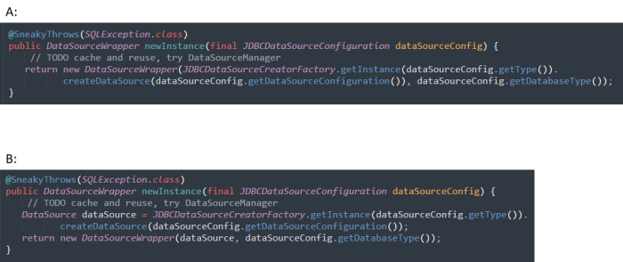

1.which code snippet has higher quality? *

|  |
| --- |
| ○A |
| ○B |
| ○A/B |

2.From the perspective of code readability, which code snippet is better? *

|  |
| --- |
| ○A |
| ○B |
| ○A/B |

3.From the perspective of code understandability, which code snippet is better? *

|  |
| --- |
| ○A |
| ○B |
| ○A/B |

4.From the perspective of code complexity, which code snippet is better? *

|  |
| --- |
| ○A |
| ○B |
| ○A/B |

5.From the perspective of code maintainability, which code snippet is better? *

|  |
| --- |
| ○A |
| ○B |
| ○A/B |

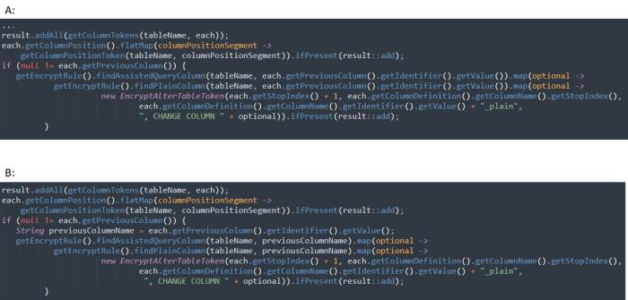

1.which code snippet has higher quality? *

|  |
| --- |
| ○A |
| ○B |
| ○A/B |

2.From the perspective of code readability, which code snippet is better? *

|  |
| --- |
| ○A |
| ○B |
| ○A/B |

3.From the perspective of code understandability, which code snippet is better? *

|  |
| --- |
| ○A |
| ○B |
| ○A/B |

4.From the perspective of code complexity, which code snippet is better? *

|  |
| --- |
| ○A |
| ○B |
| ○A/B |

5.From the perspective of code maintainability, which code snippet is better? *

|  |
| --- |
| ○A |
| ○B |
| ○A/B |

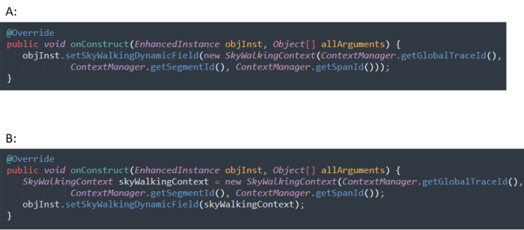

1.which code snippet has higher quality? *

|  |
| --- |
| ○A |
| ○B |
| ○A/B |

2.From the perspective of code readability, which code snippet is better? *

|  |
| --- |
| ○A |
| ○B |
| ○A/B |

3.From the perspective of code understandability, which code snippet is better?*

|  |
| --- |
| ○A |
| ○B |
| ○A/B |

4.From the perspective of code complexity, which code snippet is better? *

|  |
| --- |
| ○A |
| ○B |
| ○A/B |

5.From the perspective of code maintainability, which code snippet is better? *

|  |
| --- |
| ○A |
| ○B |
| ○A/B |

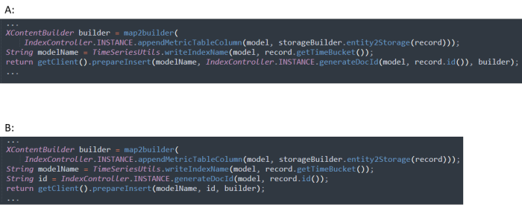

1.which code snippet has higher quality? *

|  |
| --- |
| ○A |
| ○B |
| ○A/B |

2.From the perspective of code readability, which code snippet is better? *

|  |
| --- |
| ○A |
| ○B |
| ○A/B |

3.From the perspective of code understandability, which code snippet is better? *

|  |
| --- |
| ○A |
| ○B |
| ○A/B |

4.From the perspective of code complexity, which code snippet is better? *

|  |
| --- |
| ○A |
| ○B |
| ○A/B |

5.From the perspective of code maintainability, which code snippet is better? *

|  |
| --- |
| ○A |
| ○B |
| ○A/B |

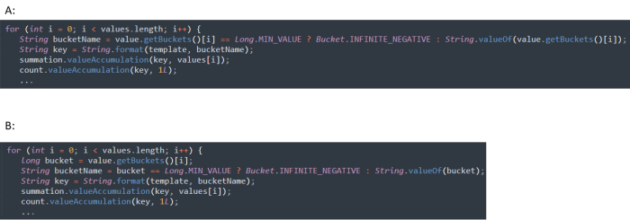

1.which code snippet has higher quality?*

|  |
| --- |
| ○A |
| ○B |
| ○A/B |

2.From the perspective of code readability, which code snippet is better? *

|  |
| --- |
| ○A |
| ○B |
| ○A/B |

3.From the perspective of code understandability, which code snippet is better? *

|  |
| --- |
| ○A |
| ○B |
| ○A/B |

4.From the perspective of code complexity, which code snippet is better? *

|  |
| --- |
| ○A |
| ○B |
| ○A/B |

5.From the perspective of code maintainability, which code snippet is better? *

|  |
| --- |
| ○A |
| ○B |
| ○A/B |

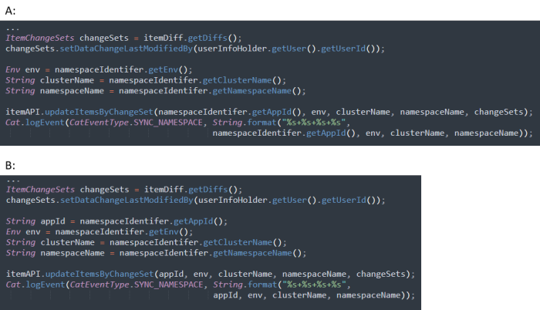

1.which code snippet has higher quality? *

|  |
| --- |
| ○A |
| ○B |
| ○A/B |

2.From the perspective of code readability, which code snippet is better? *

|  |
| --- |
| ○A |
| ○B |
| ○A/B |

3.From the perspective of code understandability, which code snippet is better? *

|  |
| --- |
| ○A |
| ○B |
| ○A/B |

4.From the perspective of code complexity, which code snippet is better?*

|  |
| --- |
| ○A |
| ○B |
| ○A/B |

5.From the perspective of code maintainability, which code snippet is better?*

|  |
| --- |
| ○A |
| ○B |
| ○A/B |

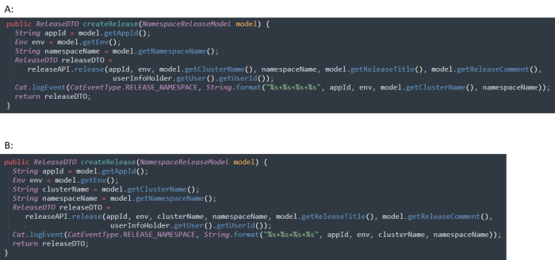

1.which code snippet has higher quality? *

|  |
| --- |
| ○A |
| ○B |
| ○A/B |

2.From the perspective of code readability, which code snippet is better? *

|  |
| --- |
| ○A |
| ○B |
| ○A/B |

3.From the perspective of code understandability, which code snippet is better? *

|  |
| --- |
| ○A |
| ○B |
| ○A/B |

4.From the perspective of code complexity, which code snippet is better? *

|  |
| --- |
| ○A |
| ○B |
| ○A/B |

5.From the perspective of code maintainability, which code snippet is better?*

|  |
| --- |
| ○A |
| ○B |
| ○A/B |

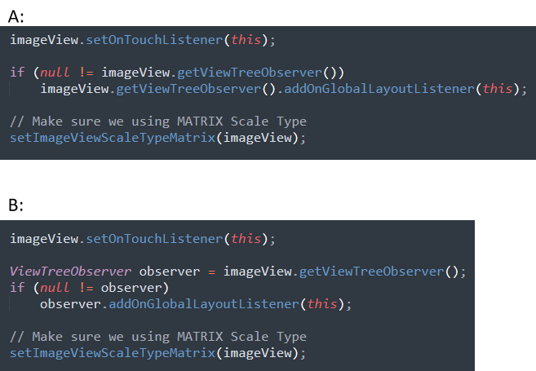

1.which code snippet has higher quality? *

|  |
| --- |
| ○A |
| ○B |
| ○A/B |

2.From the perspective of code readability, which code snippet is better? *

|  |
| --- |
| ○A |
| ○B |
| ○A/B |

3.From the perspective of code understandability, which code snippet is better? *

|  |
| --- |
| ○A |
| ○B |
| ○A/B |

4.From the perspective of code complexity, which code snippet is better? *

|  |
| --- |
| ○A |
| ○B |
| ○A/B |

5.From the perspective of code maintainability, which code snippet is better? *

|  |
| --- |
| ○A |
| ○B |
| ○A/B |

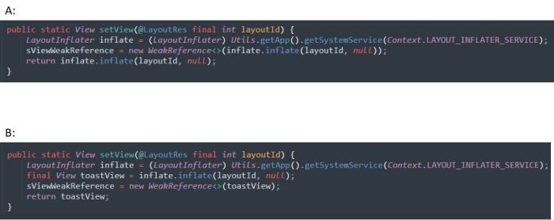

1.which code snippet has higher quality? *

|  |
| --- |
| ○A |
| ○B |
| ○A/B |

2.From the perspective of code readability, which code snippet is better? *

|  |
| --- |
| ○A |
| ○B |
| ○A/B |

3.From the perspective of code understandability, which code snippet is better? *

|  |
| --- |
| ○A |
| ○B |
| ○A/B |

4.From the perspective of code complexity, which code snippet is better? *

|  |
| --- |
| ○A |
| ○B |
| ○A/B |

5.From the perspective of code maintainability, which code snippet is better? *

|  |
| --- |
| ○A |
| ○B |
| ○A/B |

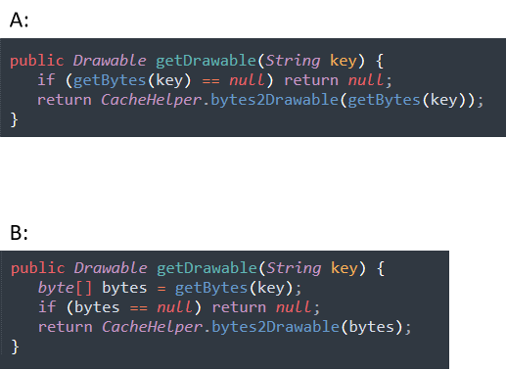

1.which code snippet has higher quality? *

|  |
| --- |
| ○A |
| ○B |
| ○A/B |

2.From the perspective of code readability, which code snippet is better? *

|  |
| --- |
| ○A |
| ○B |
| ○A/B |

3.From the perspective of code understandability, which code snippet is better? *

|  |
| --- |
| ○A |
| ○B |
| ○A/B |

4.From the perspective of code complexity, which code snippet is better? *

|  |
| --- |
| ○A |
| ○B |
| ○A/B |

5.From the perspective of code maintainability, which code snippet is better? *

|  |
| --- |
| ○A |
| ○B |
| ○A/B |

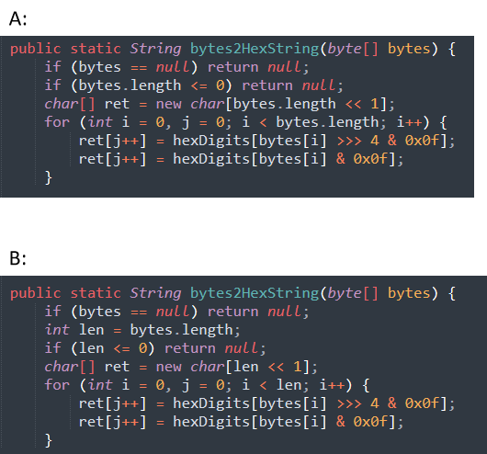

1.which code snippet has higher quality? *

|  |
| --- |
| ○A |
| ○B |
| ○A/B |

2.From the perspective of code readability, which code snippet is better? *

|  |
| --- |
| ○A |
| ○B |
| ○A/B |

3.From the perspective of code understandability, which code snippet is better? *

|  |
| --- |
| ○A |
| ○B |
| ○A/B |

4.From the perspective of code complexity, which code snippet is better? *

|  |
| --- |
| ○A |
| ○B |
| ○A/B |

5.From the perspective of code maintainability, which code snippet is better? *

|  |
| --- |
| ○A |
| ○B |
| ○A/B |

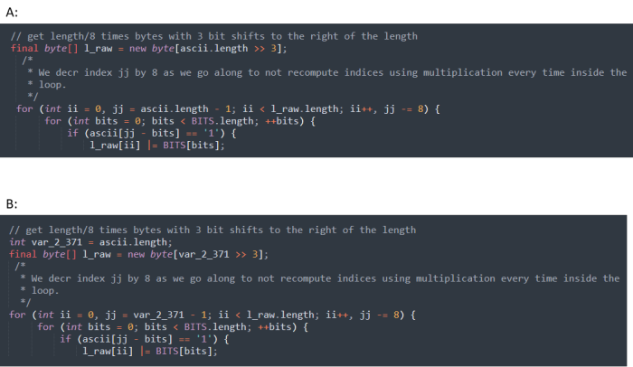

1.which code snippet has higher quality? *

|  |
| --- |
| ○A |
| ○B |
| ○A/B |

2.From the perspective of code readability, which code snippet is better? *

|  |
| --- |
| ○A |
| ○B |
| ○A/B |

3.From the perspective of code understandability, which code snippet is better? *

|  |
| --- |
| ○A |
| ○B |
| ○A/B |

4.From the perspective of code complexity, which code snippet is better? *

|  |
| --- |
| ○A |
| ○B |
| ○A/B |

5.From the perspective of code maintainability, which code snippet is better? *

|  |
| --- |
| ○A |
| ○B |
| ○A/B |

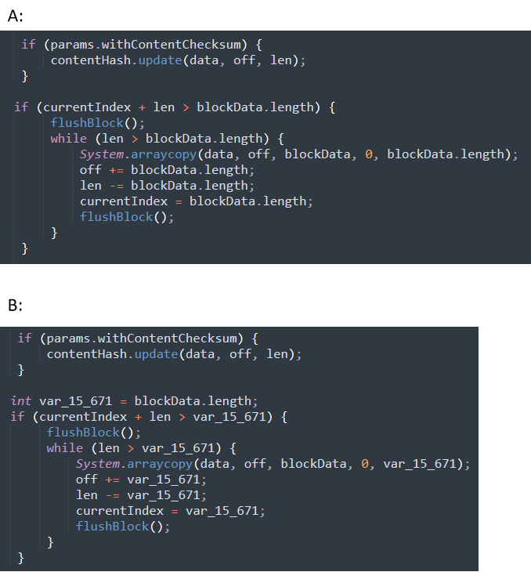

1.which code snippet has higher quality? *

|  |
| --- |
| ○A |
| ○B |
| ○A/B |

2.From the perspective of code readability, which code snippet is better? *

|  |
| --- |
| ○A |
| ○B |
| ○A/B |

3.From the perspective of code understandability, which code snippet is better? *

|  |
| --- |
| ○A |
| ○B |
| ○A/B |

4.From the perspective of code complexity, which code snippet is better? *

|  |
| --- |
| ○A |
| ○B |
| ○A/B |

5.From the perspective of code maintainability, which code snippet is better? *

|  |
| --- |
| ○A |
| ○B |
| ○A/B |

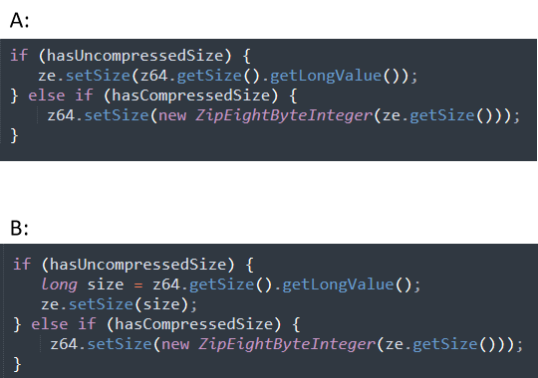

1.which code snippet has higher quality? *

|  |
| --- |
| ○A |
| ○B |
| ○A/B |

2.From the perspective of code readability, which code snippet is better? *

|  |
| --- |
| ○A |
| ○B |
| ○A/B |

3.From the perspective of code understandability, which code snippet is better? *

|  |
| --- |
| ○A |
| ○B |
| ○A/B |

4.From the perspective of code complexity, which code snippet is better? *

|  |
| --- |
| ○A |
| ○B |
| ○A/B |

5.From the perspective of code maintainability, which code snippet is better? *

|  |
| --- |
| ○A |
| ○B |
| ○A/B |

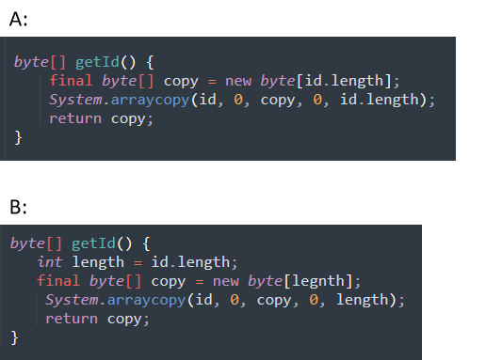

1.which code snippet has higher quality? *

|  |
| --- |
| ○A |
| ○B |
| ○A/B |

2.From the perspective of code readability, which code snippet is better? *

|  |
| --- |
| ○A |
| ○B |
| ○A/B |

3.From the perspective of code understandability, which code snippet is better? *

|  |
| --- |
| ○A |
| ○B |
| ○A/B |

4.From the perspective of code complexity, which code snippet is better? *

|  |
| --- |
| ○A |
| ○B |
| ○A/B |

5.From the perspective of code maintainability, which code snippet is better? *

|  |
| --- |
| ○A |
| ○B |
| ○A/B |

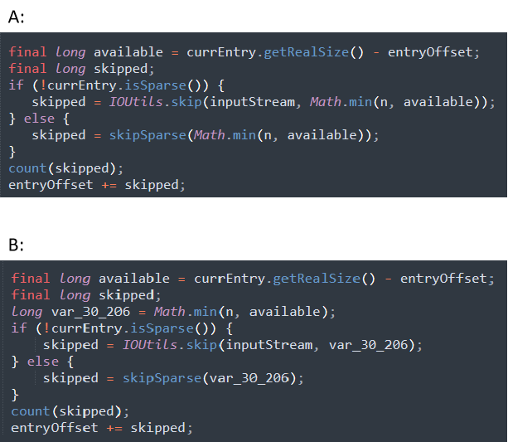

1.which code snippet has higher quality? *

|  |
| --- |
| ○A |
| ○B |
| ○A/B |

2.From the perspective of code readability, which code snippet is better? *

|  |
| --- |
| ○A |
| ○B |
| ○A/B |

3.From the perspective of code understandability, which code snippet is better? *

|  |
| --- |
| ○A |
| ○B |
| ○A/B |

4.From the perspective of code complexity, which code snippet is better? *

|  |
| --- |
| ○A |
| ○B |
| ○A/B |

5.From the perspective of code maintainability, which code snippet is better? *

|  |
| --- |
| ○A |
| ○B |
| ○A/B |

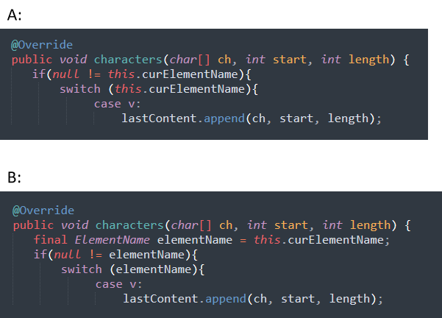

1.which code snippet has higher quality? *

|  |
| --- |
| ○A |
| ○B |
| ○A/B |

2.From the perspective of code readability, which code snippet is better? *

|  |
| --- |
| ○A |
| ○B |
| ○A/B |

3.From the perspective of code understandability, which code snippet is better? *

|  |
| --- |
| ○A |
| ○B |
| ○A/B |

4.From the perspective of code complexity, which code snippet is better? *

|  |
| --- |
| ○A |
| ○B |
| ○A/B |

5.From the perspective of code maintainability, which code snippet is better? *

|  |
| --- |
| ○A |
| ○B |
| ○A/B |

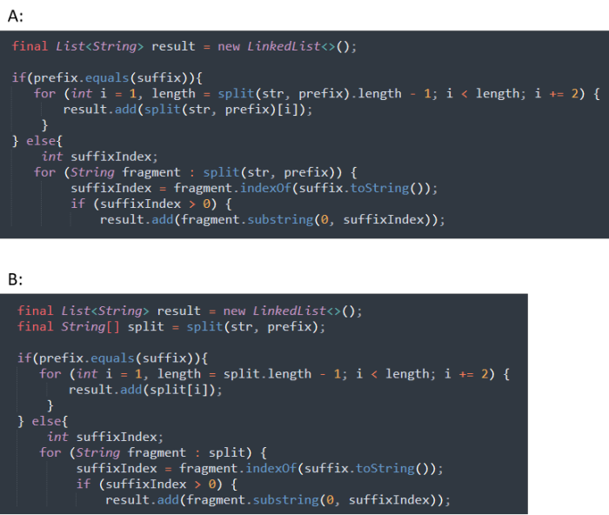

1.which code snippet has higher quality? *

|  |
| --- |
| ○A |
| ○B |
| ○A/B |

2.From the perspective of code readability, which code snippet is better? *

|  |
| --- |
| ○A |
| ○B |
| ○A/B |

3.From the perspective of code understandability, which code snippet is better? *

|  |
| --- |
| ○A |
| ○B |
| ○A/B |

4.From the perspective of code complexity, which code snippet is better? *

|  |
| --- |
| ○A |
| ○B |
| ○A/B |

5.From the perspective of code maintainability, which code snippet is better? *

|  |
| --- |
| ○A |
| ○B |
| ○A/B |

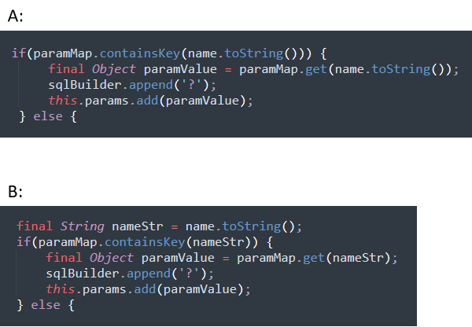

1.which code snippet has higher quality? *

|  |
| --- |
| ○A |
| ○B |
| ○A/B |

2.From the perspective of code readability, which code snippet is better? *

|  |
| --- |
| ○A |
| ○B |
| ○A/B |

3.From the perspective of code understandability, which code snippet is better? *

|  |
| --- |
| ○A |
| ○B |
| ○A/B |

4.From the perspective of code complexity, which code snippet is better? *

|  |
| --- |
| ○A |
| ○B |
| ○A/B |

5.From the perspective of code maintainability, which code snippet is better? *

|  |
| --- |
| ○A |
| ○B |
| ○A/B |

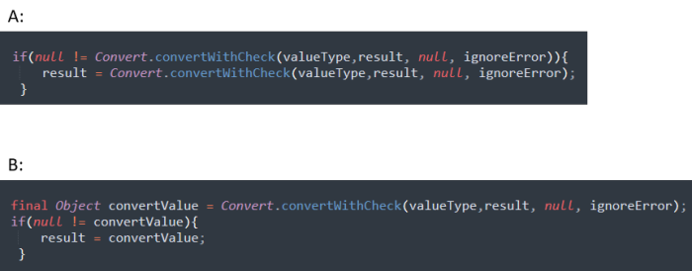

1.which code snippet has higher quality? *

|  |
| --- |
| ○A |
| ○B |
| ○A/B |

2.From the perspective of code readability, which code snippet is better? *

|  |
| --- |
| ○A |
| ○B |
| ○A/B |

3.From the perspective of code understandability, which code snippet is better? *

|  |
| --- |
| ○A |
| ○B |
| ○A/B |

4.From the perspective of code complexity, which code snippet is better? *

|  |
| --- |
| ○A |
| ○B |
| ○A/B |

5.From the perspective of code maintainability, which code snippet is better? *

|  |
| --- |
| ○A |
| ○B |
| ○A/B |

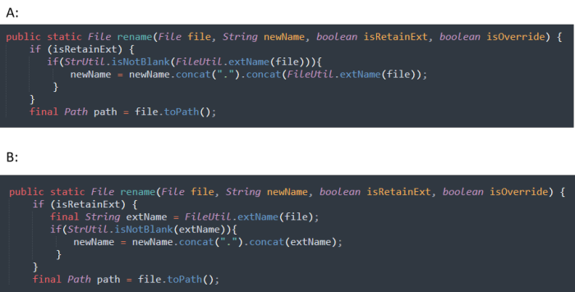

1.which code snippet has higher quality? *

|  |
| --- |
| ○A |
| ○B |
| ○A/B |

2.From the perspective of code readability, which code snippet is better? *

|  |
| --- |
| ○A |
| ○B |
| ○A/B |

3.From the perspective of code understandability, which code snippet is better? *

|  |
| --- |
| ○A |
| ○B |
| ○A/B |

4.From the perspective of code complexity, which code snippet is better? *

|  |
| --- |
| ○A |
| ○B |
| ○A/B |

5.From the perspective of code maintainability, which code snippet is better? *

|  |
| --- |
| ○A |
| ○B |
| ○A/B |

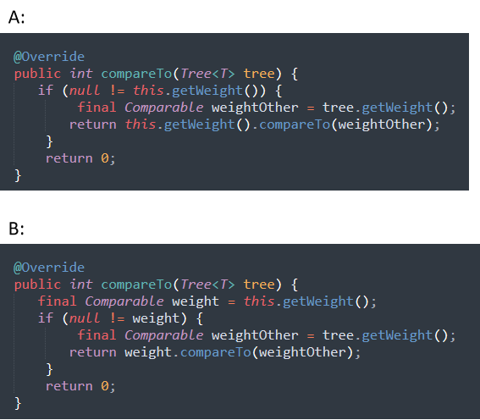

1.which code snippet has higher quality? *

|  |
| --- |
| ○A |
| ○B |
| ○A/B |

2.From the perspective of code readability, which code snippet is better? *

|  |
| --- |
| ○A |
| ○B |
| ○A/B |

3.From the perspective of code understandability, which code snippet is better? *

|  |
| --- |
| ○A |
| ○B |
| ○A/B |

4.From the perspective of code complexity, which code snippet is better? *

|  |
| --- |
| ○A |
| ○B |
| ○A/B |

5.From the perspective of code maintainability, which code snippet is better? *

|  |
| --- |
| ○A |
| ○B |
| ○A/B |

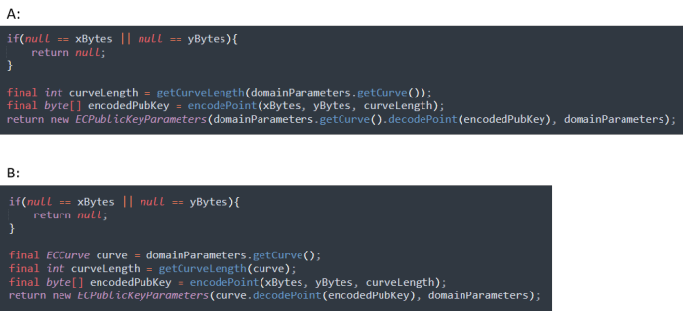

1.which code snippet has higher quality? *

|  |
| --- |
| ○A |
| ○B |
| ○A/B |

2.From the perspective of code readability, which code snippet is better? *

|  |
| --- |
| ○A |
| ○B |
| ○A/B |

3.From the perspective of code understandability, which code snippet is better? *

|  |
| --- |
| ○A |
| ○B |
| ○A/B |

4.From the perspective of code complexity, which code snippet is better? *

|  |
| --- |
| ○A |
| ○B |
| ○A/B |

5.From the perspective of code maintainability, which code snippet is better? *

|  |
| --- |
| ○A |
| ○B |
| ○A/B |

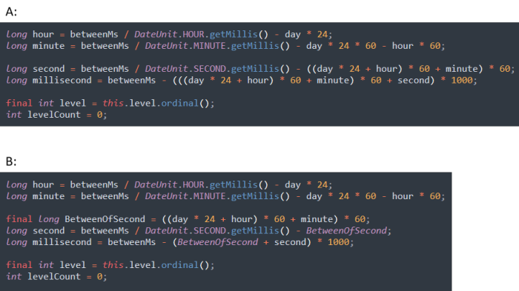

1.which code snippet has higher quality? *

|  |
| --- |
| ○A |
| ○B |
| ○A/B |

2.From the perspective of code readability, which code snippet is better? *

|  |
| --- |
| ○A |
| ○B |
| ○A/B |

3.From the perspective of code understandability, which code snippet is better? *

|  |
| --- |
| ○A |
| ○B |
| ○A/B |

4.From the perspective of code complexity, which code snippet is better? *

|  |
| --- |
| ○A |
| ○B |
| ○A/B |

5.From the perspective of code maintainability, which code snippet is better? *

|  |
| --- |
| ○A |
| ○B |
| ○A/B |

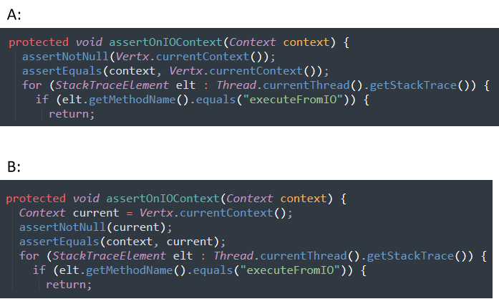

1.which code snippet has higher quality? *

|  |
| --- |
| ○A |
| ○B |
| ○A/B |

2.From the perspective of code readability, which code snippet is better? *

|  |
| --- |
| ○A |
| ○B |
| ○A/B |

3.From the perspective of code understandability, which code snippet is better? *

|  |
| --- |
| ○A |
| ○B |
| ○A/B |

4.From the perspective of code complexity, which code snippet is better? *

|  |
| --- |
| ○A |
| ○B |
| ○A/B |

5.From the perspective of code maintainability, which code snippet is better? *

|  |
| --- |
| ○A |
| ○B |
| ○A/B |

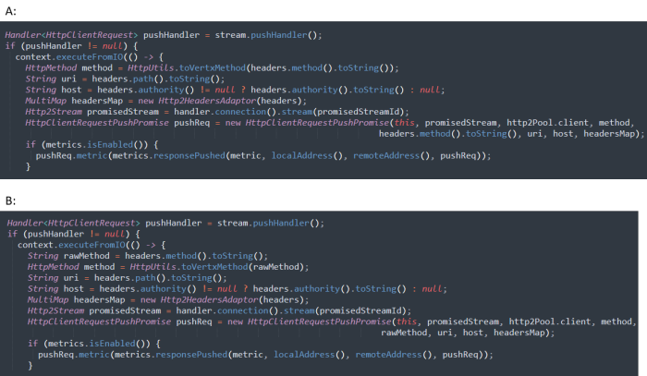

1.which code snippet has higher quality? *

|  |
| --- |
| ○A |
| ○B |
| ○A/B |

2.From the perspective of code readability, which code snippet is better? *

|  |
| --- |
| ○A |
| ○B |
| ○A/B |

3.From the perspective of code understandability, which code snippet is better? *

|  |
| --- |
| ○A |
| ○B |
| ○A/B |

4.From the perspective of code complexity, which code snippet is better? *

|  |
| --- |
| ○A |
| ○B |
| ○A/B |

5.From the perspective of code maintainability, which code snippet is better? *

|  |
| --- |
| ○A |
| ○B |
| ○A/B |

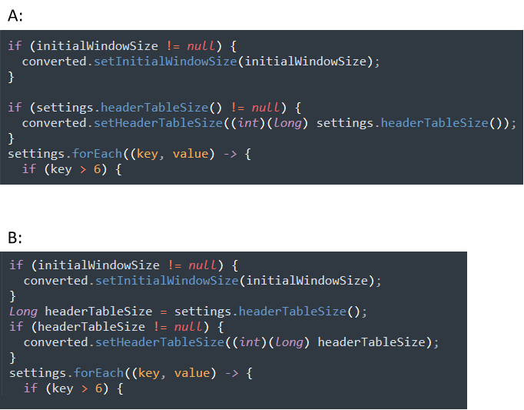

1.which code snippet has higher quality? *

|  |
| --- |
| ○A |
| ○B |
| ○A/B |

2.From the perspective of code readability, which code snippet is better? *

|  |
| --- |
| ○A |
| ○B |
| ○A/B |

3.From the perspective of code understandability, which code snippet is better? *

|  |
| --- |
| ○A |
| ○B |
| ○A/B |

4.From the perspective of code complexity, which code snippet is better? *

|  |
| --- |
| ○A |
| ○B |
| ○A/B |

5.From the perspective of code maintainability, which code snippet is better? *

|  |
| --- |
| ○A |
| ○B |
| ○A/B |

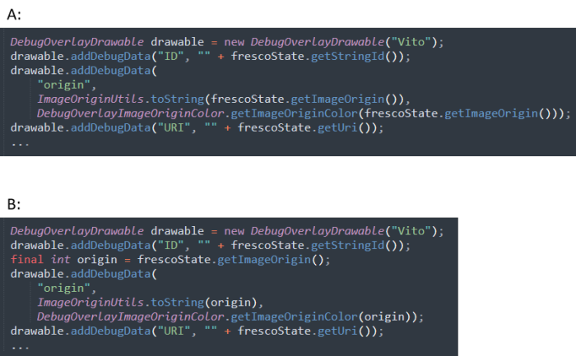

1.which code snippet has higher quality? *

|  |
| --- |
| ○A |
| ○B |
| ○A/B |

2.From the perspective of code readability, which code snippet is better? *

|  |
| --- |
| ○A |
| ○B |
| ○A/B |

3.From the perspective of code understandability, which code snippet is better? *

|  |
| --- |
| ○A |
| ○B |
| ○A/B |

4.From the perspective of code complexity, which code snippet is better? *

|  |
| --- |
| ○A |
| ○B |
| ○A/B |

5.From the perspective of code maintainability, which code snippet is better? *

|  |
| --- |
| ○A |
| ○B |
| ○A/B |

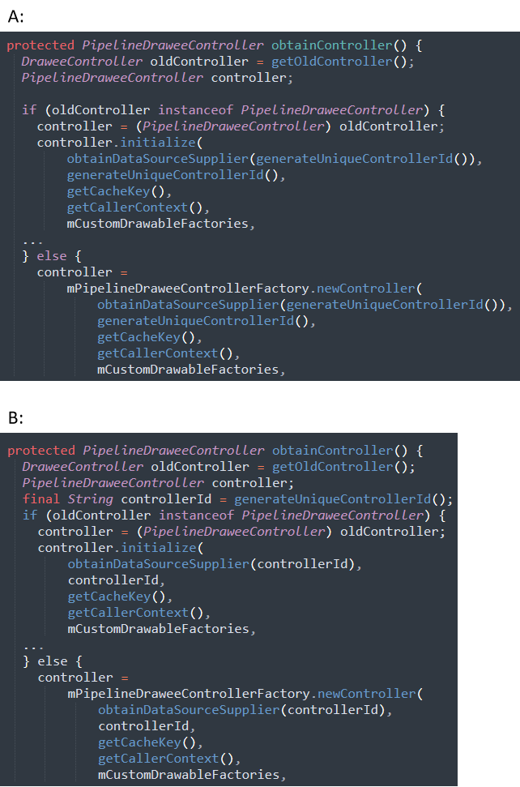

1.which code snippet has higher quality? *

|  |
| --- |
| ○A |
| ○B |
| ○A/B |

2.From the perspective of code readability, which code snippet is better? *

|  |
| --- |
| ○A |
| ○B |
| ○A/B |

3.From the perspective of code understandability, which code snippet is better? *

|  |
| --- |
| ○A |
| ○B |
| ○A/B |

4.From the perspective of code complexity, which code snippet is better? *

|  |
| --- |
| ○A |
| ○B |
| ○A/B |

5.From the perspective of code maintainability, which code snippet is better? *

|  |
| --- |
| ○A |
| ○B |
| ○A/B |

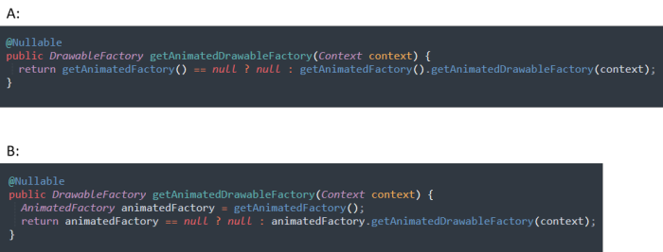

1.which code snippet has higher quality? *

|  |
| --- |
| ○A |
| ○B |
| ○A/B |

2.From the perspective of code readability, which code snippet is better? *

|  |
| --- |
| ○A |
| ○B |
| ○A/B |

3.From the perspective of code understandability, which code snippet is better? *

|  |
| --- |
| ○A |
| ○B |
| ○A/B |

4.From the perspective of code complexity, which code snippet is better? *

|  |
| --- |
| ○A |
| ○B |
| ○A/B |

5.From the perspective of code maintainability, which code snippet is better? *

|  |
| --- |
| ○A |
| ○B |
| ○A/B |

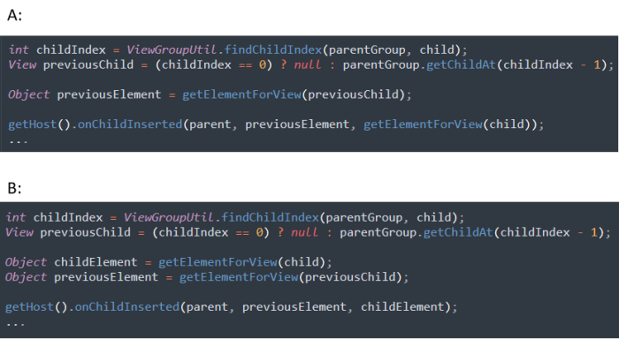

1.which code snippet has higher quality? *

|  |
| --- |
| ○A |
| ○B |
| ○A/B |

2.From the perspective of code readability, which code snippet is better? *

|  |
| --- |
| ○A |
| ○B |
| ○A/B |

3.From the perspective of code understandability, which code snippet is better? *

|  |
| --- |
| ○A |
| ○B |
| ○A/B |

4.From the perspective of code complexity, which code snippet is better? *

|  |
| --- |
| ○A |
| ○B |
| ○A/B |

5.From the perspective of code maintainability, which code snippet is better? *

|  |
| --- |
| ○A |
| ○B |
| ○A/B |

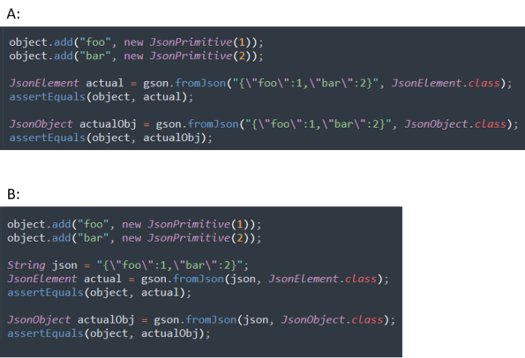

1.which code snippet has higher quality? *

|  |
| --- |
| ○A |
| ○B |
| ○A/B |

2.From the perspective of code readability, which code snippet is better? *

|  |
| --- |
| ○A |
| ○B |
| ○A/B |

3.From the perspective of code understandability, which code snippet is better? *

|  |
| --- |
| ○A |
| ○B |
| ○A/B |

4.From the perspective of code complexity, which code snippet is better? *

|  |
| --- |
| ○A |
| ○B |
| ○A/B |

5.From the perspective of code maintainability, which code snippet is better? *

|  |
| --- |
| ○A |
| ○B |
| ○A/B |

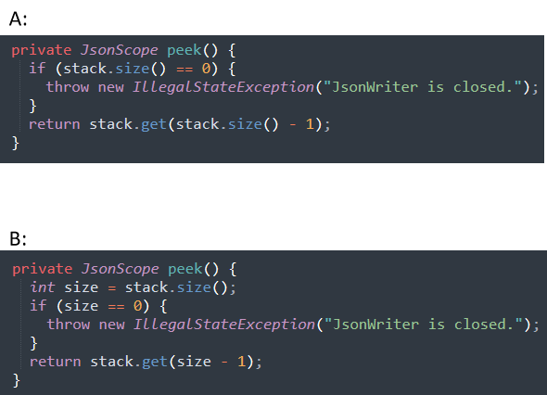

1.which code snippet has higher quality? *

|  |
| --- |
| ○A |
| ○B |
| ○A/B |

2.From the perspective of code readability, which code snippet is better? *

|  |
| --- |
| ○A |
| ○B |
| ○A/B |

3.From the perspective of code understandability, which code snippet is better? *

|  |
| --- |
| ○A |
| ○B |
| ○A/B |

4.From the perspective of code complexity, which code snippet is better? *

|  |
| --- |
| ○A |
| ○B |
| ○A/B |

5.From the perspective of code maintainability, which code snippet is better? *

|  |
| --- |
| ○A |
| ○B |
| ○A/B |

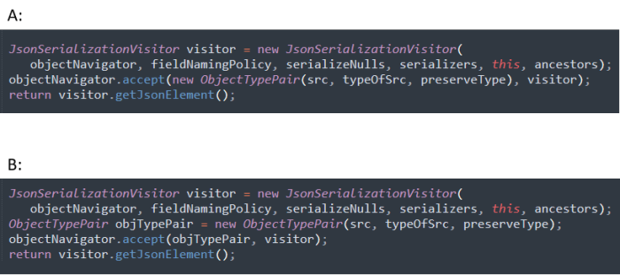

1.which code snippet has higher quality? *

|  |
| --- |
| ○A |
| ○B |
| ○A/B |

2.From the perspective of code readability, which code snippet is better? *

|  |
| --- |
| ○A |
| ○B |
| ○A/B |

3.From the perspective of code understandability, which code snippet is better? *

|  |
| --- |
| ○A |
| ○B |
| ○A/B |

4.From the perspective of code complexity, which code snippet is better? *

|  |
| --- |
| ○A |
| ○B |
| ○A/B |

5.From the perspective of code maintainability, which code snippet is better? *

|  |
| --- |
| ○A |
| ○B |
| ○A/B |

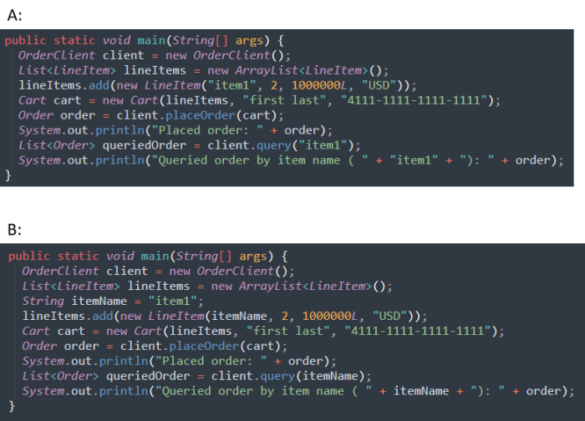

1.which code snippet has higher quality? *

|  |
| --- |
| ○A |
| ○B |
| ○A/B |

2.From the perspective of code readability, which code snippet is better? *

|  |
| --- |
| ○A |
| ○B |
| ○A/B |

3.From the perspective of code understandability, which code snippet is better? *

|  |
| --- |
| ○A |
| ○B |
| ○A/B |

4.From the perspective of code complexity, which code snippet is better? *

|  |
| --- |
| ○A |
| ○B |
| ○A/B |

5.From the perspective of code maintainability, which code snippet is better? *

|  |
| --- |
| ○A |
| ○B |
| ○A/B |

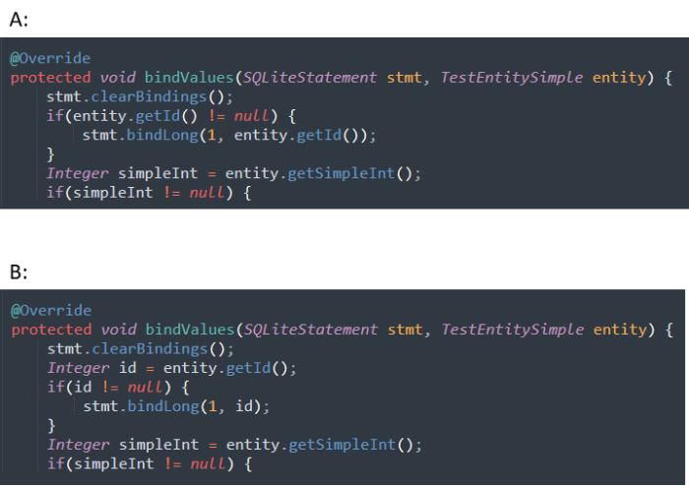

1.which code snippet has higher quality? *

|  |
| --- |
| ○A |
| ○B |
| ○A/B |

2.From the perspective of code readability, which code snippet is better? *

|  |
| --- |
| ○A |
| ○B |
| ○A/B |

3.From the perspective of code understandability, which code snippet is better? *

|  |
| --- |
| ○A |
| ○B |
| ○A/B |

4.From the perspective of code complexity, which code snippet is better? *

|  |
| --- |
| ○A |
| ○B |
| ○A/B |

5.From the perspective of code maintainability, which code snippet is better? *

|  |
| --- |
| ○A |
| ○B |
| ○A/B |

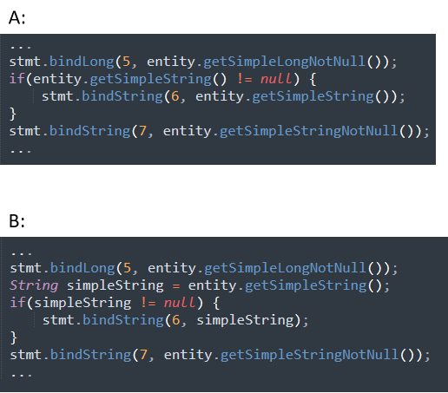

1.which code snippet has higher quality? *

|  |
| --- |
| ○A |
| ○B |
| ○A/B |

2.From the perspective of code readability, which code snippet is better? *

|  |
| --- |
| ○A |
| ○B |
| ○A/B |

3.From the perspective of code understandability, which code snippet is better? *

|  |
| --- |
| ○A |
| ○B |
| ○A/B |

4.From the perspective of code complexity, which code snippet is better? *

|  |
| --- |
| ○A |
| ○B |
| ○A/B |

5.From the perspective of code maintainability, which code snippet is better? *

|  |
| --- |
| ○A |
| ○B |
| ○A/B |

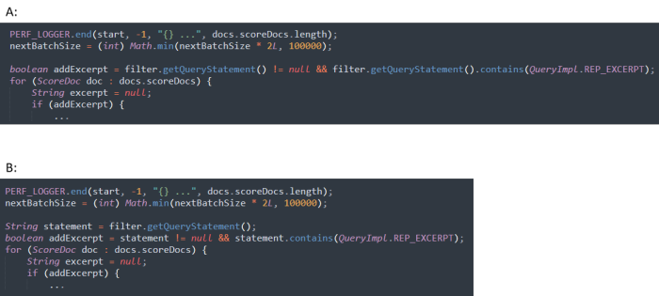

1.which code snippet has higher quality? *

|  |
| --- |
| ○A |
| ○B |
| ○A/B |

2.From the perspective of code readability, which code snippet is better? *

|  |
| --- |
| ○A |
| ○B |
| ○A/B |

3.From the perspective of code understandability, which code snippet is better? *

|  |
| --- |
| ○A |
| ○B |
| ○A/B |

4.From the perspective of code complexity, which code snippet is better? *

|  |
| --- |
| ○A |
| ○B |
| ○A/B |

5.From the perspective of code maintainability, which code snippet is better? *

|  |
| --- |
| ○A |
| ○B |
| ○A/B |

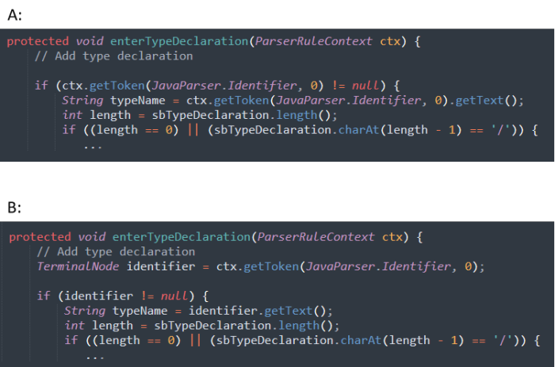

1.which code snippet has higher quality? *

|  |
| --- |
| ○A |
| ○B |
| ○A/B |

2.From the perspective of code readability, which code snippet is better? *

|  |
| --- |
| ○A |
| ○B |
| ○A/B |

3.From the perspective of code understandability, which code snippet is better? *

|  |
| --- |
| ○A |
| ○B |
| ○A/B |

4.From the perspective of code complexity, which code snippet is better? *

|  |
| --- |
| ○A |
| ○B |
| ○A/B |

5.From the perspective of code maintainability, which code snippet is better? *

|  |
| --- |
| ○A |
| ○B |
| ○A/B |

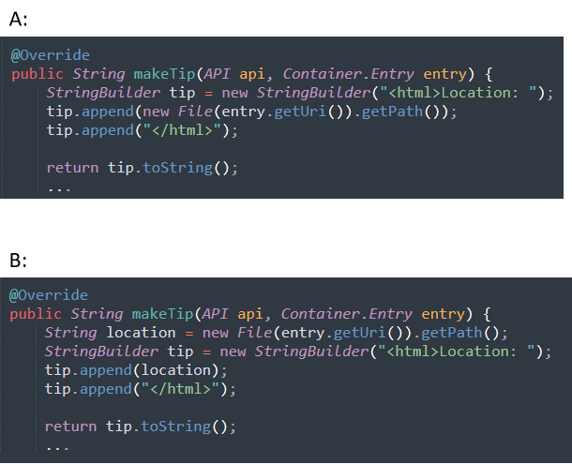

1.which code snippet has higher quality? *

|  |
| --- |
| ○A |
| ○B |
| ○A/B |

2.From the perspective of code readability, which code snippet is better? *

|  |
| --- |
| ○A |
| ○B |
| ○A/B |

3.From the perspective of code understandability, which code snippet is better? *

|  |
| --- |
| ○A |
| ○B |
| ○A/B |

4.From the perspective of code complexity, which code snippet is better? *

|  |
| --- |
| ○A |
| ○B |
| ○A/B |

5.From the perspective of code maintainability, which code snippet is better? *

|  |
| --- |
| ○A |
| ○B |
| ○A/B |

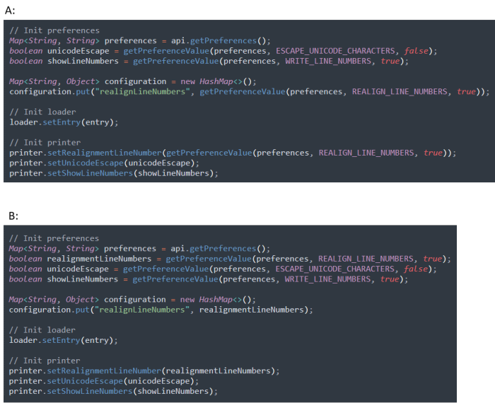

1.which code snippet has higher quality? *

|  |
| --- |
| ○A |
| ○B |
| ○A/B |

2.From the perspective of code readability, which code snippet is better? *

|  |
| --- |
| ○A |
| ○B |
| ○A/B |

3.From the perspective of code understandability, which code snippet is better? *

|  |
| --- |
| ○A |
| ○B |
| ○A/B |

4.From the perspective of code complexity, which code snippet is better? *

|  |
| --- |
| ○A |
| ○B |
| ○A/B |

5.From the perspective of code maintainability, which code snippet is better? *

|  |
| --- |
| ○A |
| ○B |
| ○A/B |

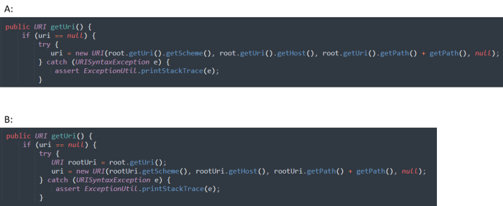

1.which code snippet has higher quality? *

|  |
| --- |
| ○A |
| ○B |
| ○A/B |

2.From the perspective of code readability, which code snippet is better? *

|  |
| --- |
| ○A |
| ○B |
| ○A/B |

3.From the perspective of code understandability, which code snippet is better? *

|  |
| --- |
| ○A |
| ○B |
| ○A/B |

4.From the perspective of code complexity, which code snippet is better? *

|  |
| --- |
| ○A |
| ○B |
| ○A/B |

5.From the perspective of code maintainability, which code snippet is better? *

|  |
| --- |
| ○A |
| ○B |
| ○A/B |

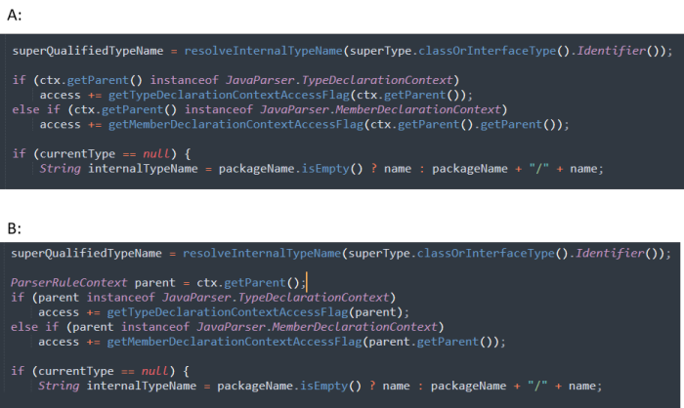

1.which code snippet has higher quality? *

|  |
| --- |
| ○A |
| ○B |
| ○A/B |

2.From the perspective of code readability, which code snippet is better? *

|  |
| --- |
| ○A |
| ○B |
| ○A/B |

3.From the perspective of code understandability, which code snippet is better? *

|  |
| --- |
| ○A |
| ○B |
| ○A/B |

4.From the perspective of code complexity, which code snippet is better? *

|  |
| --- |
| ○A |
| ○B |
| ○A/B |

5.From the perspective of code maintainability, which code snippet is better? *

|  |
| --- |
| ○A |
| ○B |
| ○A/B |