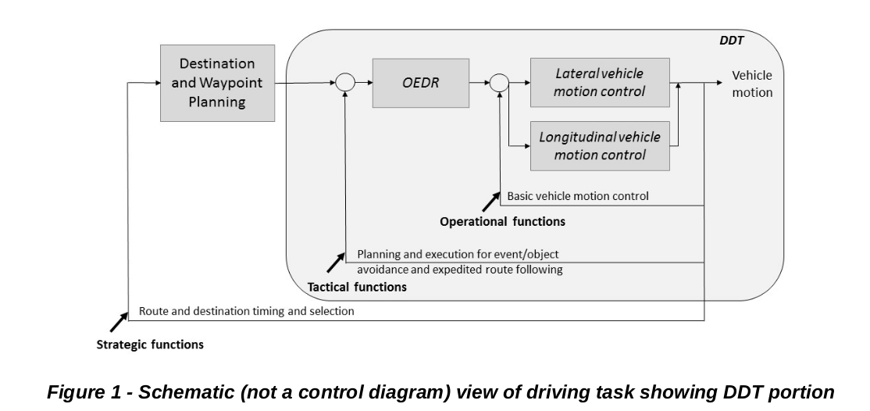

3.17 MINIMAL RISK CONDITION

A condition to which a user or an ADS may bring a vehicle after performing the DDT fallback in order to reduce the risk of

a crash when a given trip cannot or should not be completed.

NOTE 1: At levels 1 and 2, the conventional driver is expected to achieve a minimal risk condition as needed.

NOTE 2: At level 3, given a DDT performance-relevant system failure in the ADS or vehicle, the DDT fallback-ready

user is expected to achieve a minimal risk condition when s/he determines that it is necessary, or to

otherwise perform the DDT if the vehicle is drivable.

NOTE 3: At levels 4 and 5, the ADS is capable of automatically achieving a minimal risk condition when necessary

(i.e., due to ODD exit, if applicable, or due to a DDT performance-relevant system failure in the ADS or

vehicle). The characteristics of automated achievement of a minimal risk condition at levels 4 and 5 will

vary according to the type and extent of the system failure, the ODD (if any) for the ADS feature in question,

and the particular operating conditions when the system failure or ODD exit occurs. It may entail

automatically bringing the vehicle to a stop within its current travel path, or it may entail a more extensive

maneuver designed to remove the vehicle from an active lane of traffic and/or to automatically return the

vehicle to a dispatching facility.

EXAMPLE 1: A level 4 ADS feature designed to operate a vehicle at high speeds on freeways experiences a DDT

performance-relevant system failure and automatically removes the vehicle from active lanes of traffic

before coming to a stop.

EXAMPLE 2: A vehicle in which a level 4 ADS is installed experiences a DDT performance-relevant system failure in its

primary electrical power system. The ADS utilizes a backup power source in order to achieve a minimal

risk condition.

3.20 OBJECT AND EVENT DETECTION AND RESPONSE (OEDR)

The subtasks of the DDT that include monitoring the driving environment (detecting, recognizing, and classifying objects

and events and preparing to respond as needed) and executing an appropriate response to such objects and events (i.e.,

as needed to complete the DDT and/or DDT fallback).

3.22 OPERATIONAL DESIGN DOMAIN (ODD)

Operating conditions under which a given driving automation system or feature thereof is specifically designed to function,

including, but not limited to, environmental, geographical, and time-of-day restrictions, and/or the requisite presence or

absence of certain traffic or roadway characteristics.

NOTE: Section 6 discusses the significance of ODDs in the context of the levels of driving automation.

EXAMPLE 1: An ADS feature is designed to operate a vehicle only on fully access-controlled freeways in low-speed traffic,

under fair weather conditions and optimal road maintenance conditions (e.g., good lane markings and not

under construction).

EXAMPLE 2: An ADS-dedicated vehicle is designed to operate only within a geographically-defined military base, and

only during daylight at speeds not to exceed 25 mph.

EXAMPLE 3: An ADS-dedicated commercial truck is designed to pick up parts from a geofenced sea port and deliver

them via a specific route to a distribution center located 30 miles away. The vehicle’s ODD is limited to day-

time operation within the specified sea port and the specific roads that constitute the prescribed route

between the sea port and the distribution center.

3.14 [DYNAMIC DRIVING TASK (DDT)] FALLBACK

The response by the user to either perform the DDT or achieve a minimal risk condition after occurrence of a DDT

performance-relevant system failure(s) or upon operational design domain (ODD) exit, or the response by an ADS to

achieve minimal risk condition, given the same circumstances.

NOTE 1: The DDT and the DDT fallback are distinct functions, and the capability to perform one does not necessarily

entail the ability to perform the other. Thus, a level 3 ADS, which is capable of performing the entire DDT

within its ODD, may not be capable of performing the DDT fallback in all situations that require it and thus

will issue a request to intervene to the DDT fallback-ready user when necessary.

NOTE 2: Some level 3 features may be designed to automatically perform the fallback and achieve a minimal risk

condition in some circumstances, such as when an obstacle-free, adjacent shoulder is present, but not in

others, such as when no such road shoulder is available. The assignment of level 3 therefore does not

restrict the ADS from automatically achieving the MRC, but it cannot guarantee automated achievement of

MRC in all cases within its ODD. Moreover, automated MRC achievement in some, but not all,

circumstances that demand it does not constitute level 4 functionality.

NOTE 3: At level 3, an ADS is capable of continuing to perform the DDT for at least several seconds after providing

the fallback-ready user with a request to intervene. The DDT fallback-ready user is then expected to achieve

a minimal risk condition if s/he determines it to be necessary.

3.29.3 [DDT] FALLBACK-READY USER

The user of a vehicle equipped with an engaged level 3 ADS feature who is able to operate the vehicle and is receptive to

ADS-issued requests to intervene and to evident DDT performance-relevant system failures in the vehicle compelling him

or her to perform the DDT fallback.

NOTE 1: DDT performance by a level 3 ADS assumes that a DDT fallback-ready user is available to perform the

DDT as required. There is no such assumption at levels 4 and 5.

NOTE 2: A DDT fallback-ready user who transitions to performing part or all of the DDT becomes a driver.

EXAMPLE: A level 3 ADS that is performing the DDT in congested traffic on a freeway encounters emergency

responders who are rerouting traffic to the exit due to a serious crash; the ADS issues a request to intervene

to the DDT fallback-ready user instructing him or her to resume performing the DDT (i.e., to become a

driver).

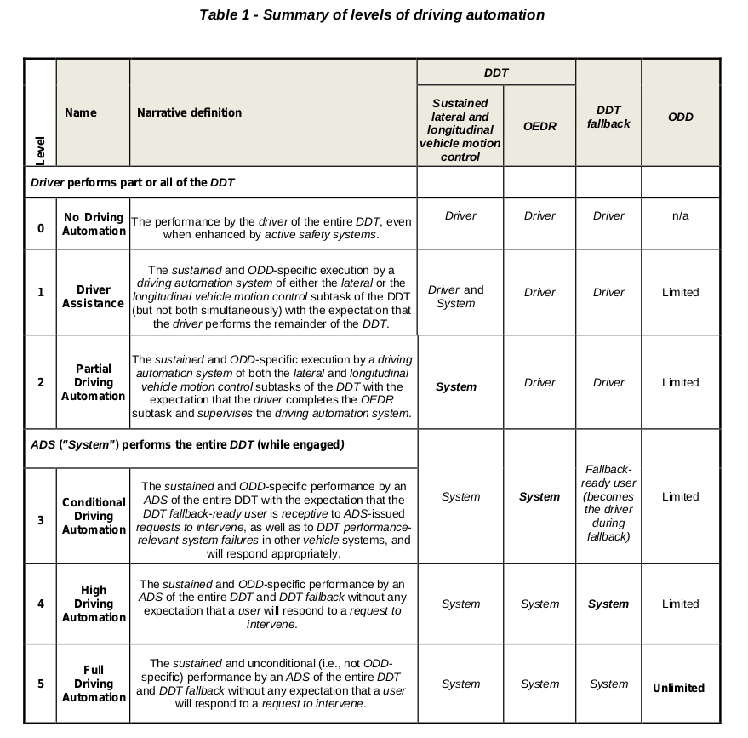

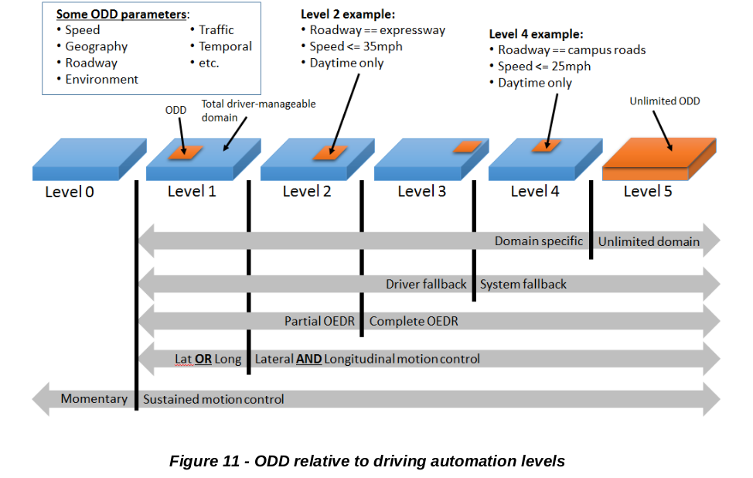

动态驾驶任务后援(dynamic driving task fallback)

当发生即将超出设计运行范围、驾驶自动化系统失效或车辆其他系统失效等不满足设计运行条件的情况时，由用户接管或由自动驾驶系统化系统执行最小风险策略的后备支援行为。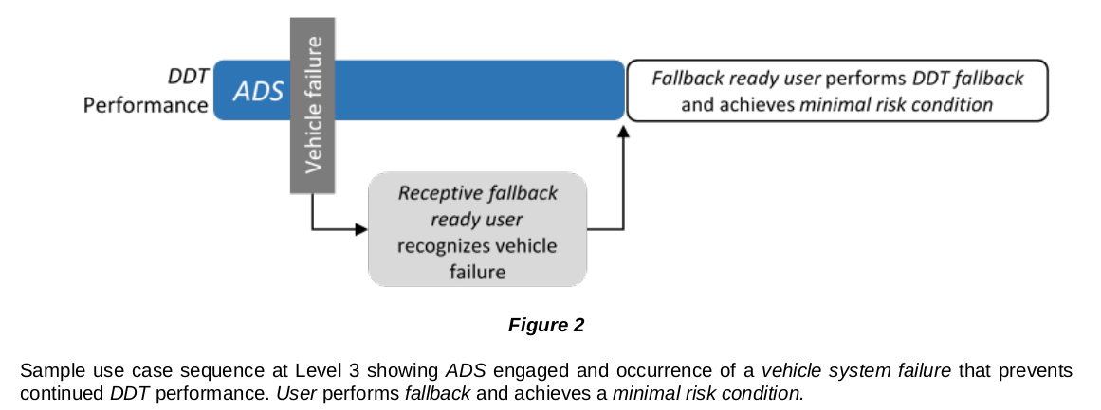

其他失效，如制动出现问题，驾驶员要负责接管

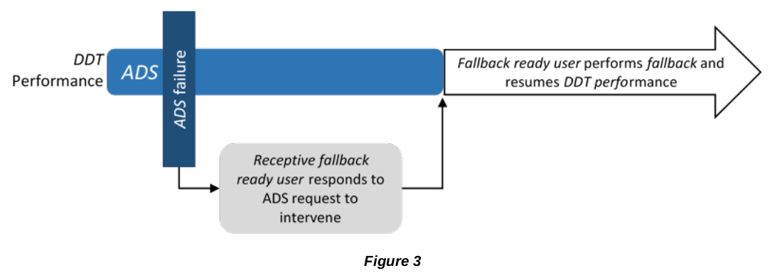



ADS failure，及时向动态驾驶任务后援用户发出介入请求 ，用户响应

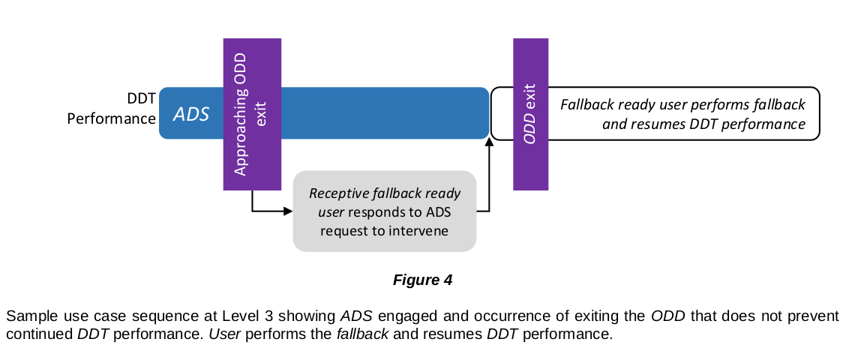

ADS out of ODD，及时向动态驾驶任务后援用户发出介入请求，用户响应

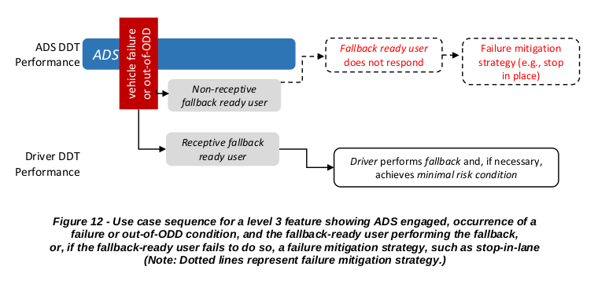

用户不响应

及时向动态驾驶任务后援用户发出介入请求

识别动态驾驶任务后援用户的接管能力

DDT performance, fallback performance, and minimal risk condition achievement are separate functions.

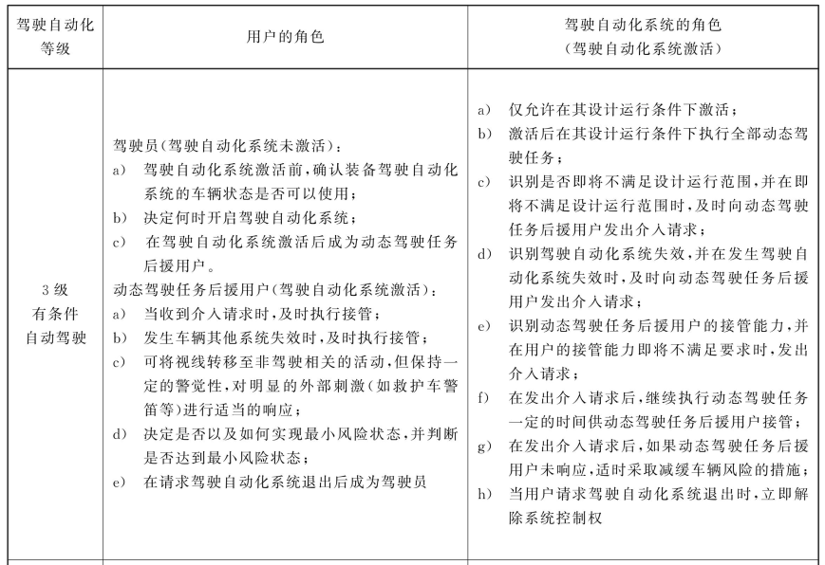

J3016解读

L3 与责任

L3在功能激活的情况下，DDT全权给予系统，

能力层面： 在满足ODC下，执行全部DDT。ODER+ long&lat ，相比L2, 有完整的ODER能力。

责任层面：涉及的角色有ADS系统和用户，ADS 系统无法再执行DDT performance时，（如ADS激活后，发生vehicle failture或ADS failure或即将超出ODD），会采取DDT fallback, DDT fallback包括用户接管获得车辆驾驶权和ADS系统执行最小风险策略，但必须包含`介入请求`这一条。通过`介入请求`完成责任传递给动态驾驶任务后援用户（fallback ready user），可以是车内或车外。对于极端情况，用户是 Non-receptive fallback user,系统可以采取Failure mitigation strategy(e.g. ,stop in place)。

除了发生vehicle failture或ADS failure或即将超出ODD是发出介入请求，L3系统还需要监控驾驶员状态，在动态驾驶任务后援用户没有接管能力时，也要发出介入请求。（甩锅也要有人接，那个接锅的人要一直availble.）