Q1.

footpath(52,53).

footpath(52,0).

footpath(53,54).

footpath(56,57).

footpath(56,58).

footpath(57,58).

footpath(57,1).

footpath(57,59).

footpath(58,59).

footpath(59,60).

footpath(83,65).

footpath(65,68).

footpath(76,69).

motorway(0,62).

motorway(53,62).

motorway(54,56).

motorway(54,62).

motorway(1,62).

motorway(59,60).

motorway(59,68).

motorway(59,83).

motorway(83,62).

motorway(68,66).

motorway(68,62).

motorway(68,63).

motorway(68,76).

motorway(68,64).

motorway(66,63).

motorway(66,69).

motorway(66,76).

motorway(66,64).

motorway(63,62).

motorway(63,64).

motorway(63,76).

motorway(63,69).

motorway(64,69).

motorway(64,76).

motorway(0,59).

motorway(0,60).

motorway(0,68).

motorway(0,83).

motorway(1,54).

routeFoot(A,B) :-

footpath(B,A);

footpath(A,B).

routeMotor(A,B) :-

motorway(A,B);

motorway(B,A).

routeMixed(A,Connector,B):-

footpath(A,Connector);

motorway(Connector,B);

footpath(Connector,A);

motorway(B,Connector).

footpathSearch(A,B,V) :-

(routeFoot(A,X),

not(member(X,V)),

(B=X;footpathSearch(X,B,[A|V]))).

motorwaySearch(A,B,V):-

(routeMotor(A,X),

not(member(X,V)),

(B=X;motorwaySearch(X,B,[A|V]))).

mixedSearch(A,B,C,V):-

(routeMixed(A,C,B),

not(member(X,V))),

(B=X;mixedSearch(A,B,C,[A|V])).

footpathRoute(A,B) :-

footpathSearch(A,B,[]).

motorwayRoute(A,B):-

motorwaySearch(A,B,[]).

mixedRoute(A,B,C):-

mixedSearch(A,B,C,[]).

route(A,B):-

footpathRoute(A,B);motorwayRoute(A,B);mixedRoute(A,B,0);mixedRoute(A,B,1).

highwayDesirable(A,B):-

\+(motorwayRoute(A,B);mixedRoute(A,B,0);mixedRoute(A,B,1)).

The above codes are for searching different kinds of paths from A to B. The function “footpathRoute(A,B) :-

footpathSearch(A,B,[]).

” is used to find paths consist of footpath only, and the function “motorwayRoute(A,B):-

motorwaySearch(A,B,[]).

” is used to find paths consist of motorway only, and the function “mixedRoute(A,B,C):-

mixedSearch(A,B,C,[]).

” is used to find paths consist of footpath and footpath. Here C refers to the connector(the link point of single line and double line), and C=0 refers to the connector connected to building 52 while C=1 refers to the connector connected to building 57

b)

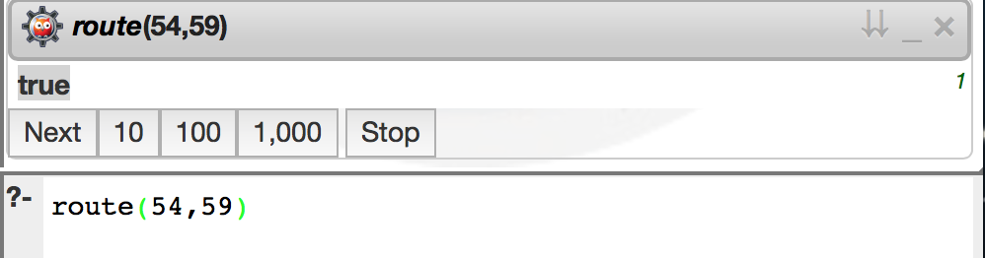

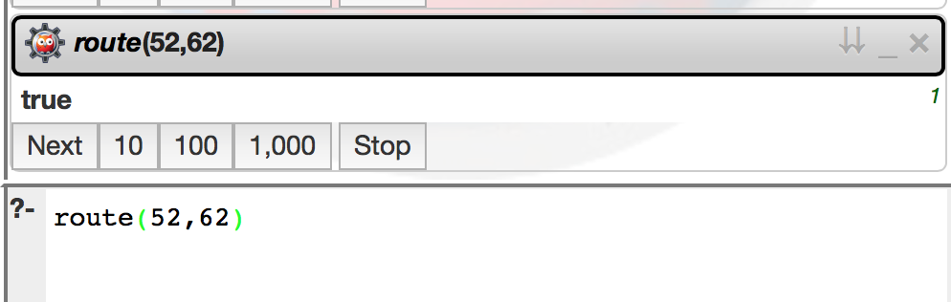

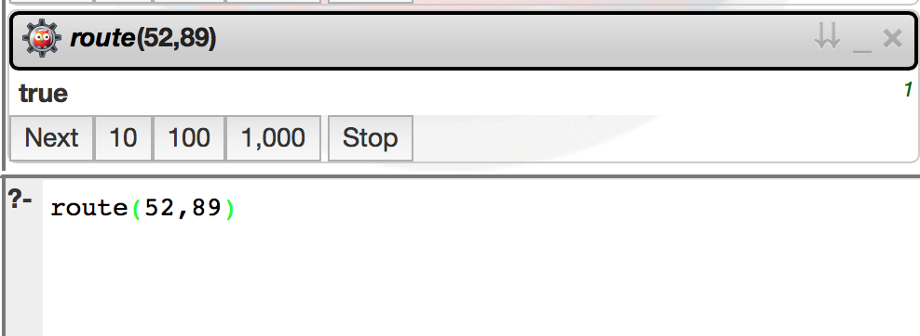

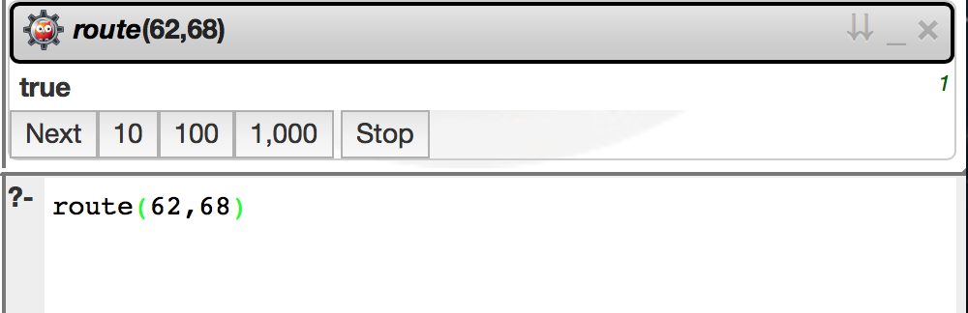

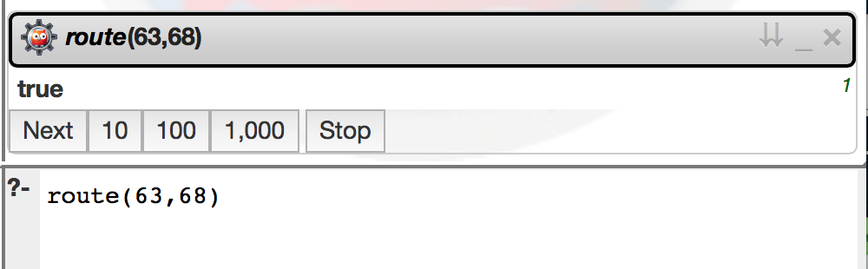:

c)

* call the method

motorwayRoute(A,B):-

motorwaySearch(A,B,[]).

and set A = 58, B=59

it will return whether there is an motorway connecting A and B

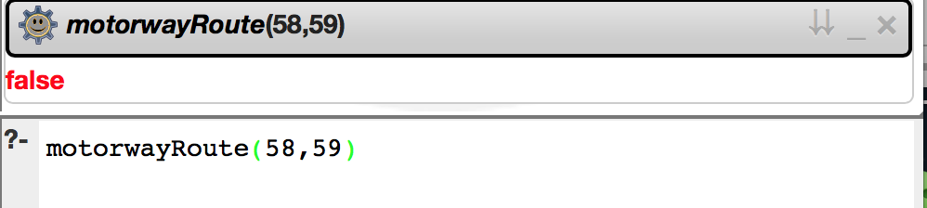

* call the method

highwayDesirable(A,B):-

\+(motorwayRoute(A,B);mixedRoute(A,B,0);mixedRoute(A,B,1)).

it will return whether a highway required. Here as long as one segment of the path from A to B is high way, it will not require a highway.