实验编号： 11 **四川师大《IOS》实验报告 2018** 年 **11** 月 **21** 日

### **计算机科学学院** 2016 级 4 班 实验名称： 多MVC _

姓名：___蒋宇童______ 学号：_2016110419_________ 指导老师：__李贵洋__ 实验成绩:_____

**实验 十一 ____**多MVC **_______**

1. 实验目的及要求
2. 掌握多MVC的设计以及实现；
3. 完成苹果官网的FoodTracker全部内容；
4. 实验内容
5. 实现一个简单的多mvc程序
   1. 控制器之间正向传参
   2. 控制器之间反向传参
6. 完成苹果官网的FoodTracker Demo（多MVC）
   1. TableView（自定制Cell）；
   2. NavigationController；
   3. Modal Controller;
   4. ImagePickerController;

说明：苹果官网Demo网址如下

<https://developer.apple.com/library/content/referencelibrary/GettingStarted/DevelopiOSAppsSwift/index.html>

1. 实验主要流程、基本操作或核心代码、算法片段（该部分如不够填写，请另加附页）
2. 实现一个简单的多mvc程序
   1. 控制器之间正向传参
   2. 控制器之间反向传参

* 程序代码：

右边文件列表

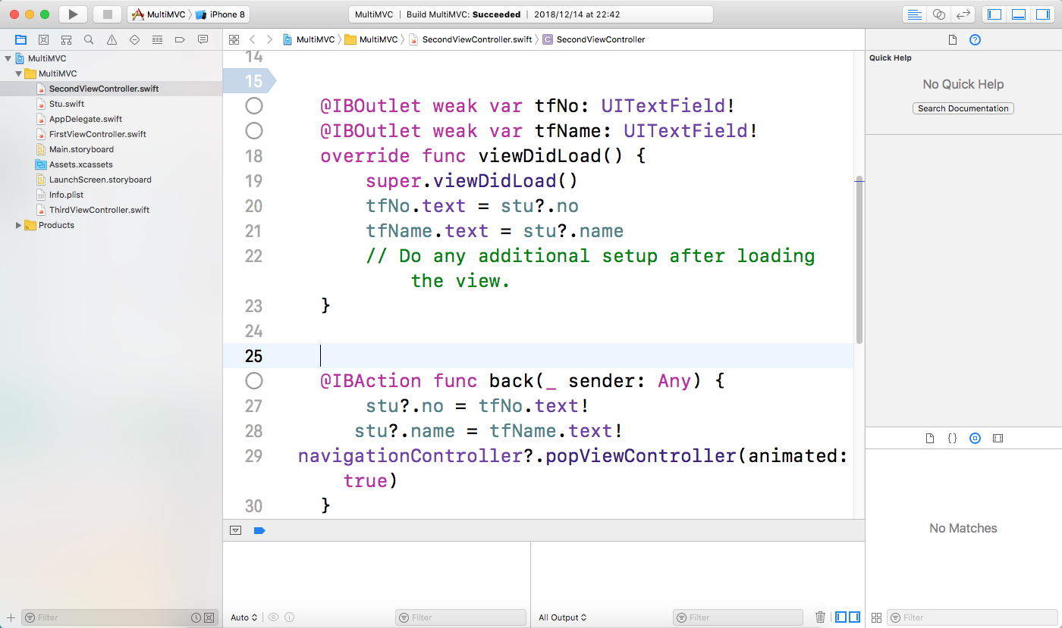

//

// SecondViewController.swift

// MultiMVC

//

// Created by jiang on 2018/12/14.

// Copyright © 2018年 蒋宇童. All rights reserved.

//

import UIKit

class SecondViewController: UIViewController {

var stu:Student?

@IBOutlet weak var tfNo: UITextField!

@IBOutlet weak var tfName: UITextField!

override func viewDidLoad() {

super.viewDidLoad()

tfNo.text = stu?.no

tfName.text = stu?.name

// Do any additional setup after loading the view.

}

@IBAction func back(_ sender: Any) {

stu?.no = tfNo.text!

stu?.name = tfName.text!

navigationController?.popViewController(animated: true)

}

/*

// MARK: - Navigation

// In a storyboard-based application, you will often want to do a little preparation before navigation

override func prepare(for segue: UIStoryboardSegue, sender: Any?) {

// Get the new view controller using segue.destination.

// Pass the selected object to the new view controller.

}

*/

}

import Foundation

class Student

{

var name = ""

var no = ""

}

//

// ViewController.swift

// MultiMVC

//

// Created by jiang on 2018/12/14.

// Copyright © 2018年 蒋宇童. All rights reserved.

//

import UIKit

class FirstViewController: UIViewController {

var stu = Student()

@IBOutlet weak var tfNo: UITextField!

@IBOutlet weak var tfName: UITextField!

override func viewDidLoad() {

super.viewDidLoad()

// Do any additional setup after loading the view, typically from a nib.

}

override func viewWillAppear(_ animated: Bool) {

tfNo.text = stu.no

tfName.text = stu.name

}

override func prepare(for segue: UIStoryboardSegue, sender: Any?) {

if segue.identifier == "Second"

{

stu.no=tfNo.text!

stu.name=tfName.text!

let secVC = segue.destination as!SecondViewController

secVC.stu=stu

}

}

// @IBAction func showSecondVC(_ sender: Any) {

// stu.no = tfNo.text!

// stu.name = tfName.text!

//

// let secVC = UIStoryboard(name: "Main", bundle: nil).instantiateViewController(withIdentifier: "SecondVC") as! SecondViewController

// secVC.stu=stu

//

//

// self.navigationController?.pushViewController(secVC, animated: true)

// }

//

// @IBAction func showThirdVC(_ sender: Any) {

// let thirdVC = UIStoryboard(name: "Main", bundle: nil).instantiateViewController(withIdentifier: "ThirdVC")

// present(thirdVC, animated: true, completion: nil)

// }

}

//

// ThirdViewController.swift

// MultiMVC

//

// Created by jiang on 2018/12/14.

// Copyright © 2018年 蒋宇童. All rights reserved.

//

import UIKit

class ThirdViewController: UIViewController {

override func viewDidLoad() {

super.viewDidLoad()

// Do any additional setup after loading the view.

}

@IBAction func close(_ sender: Any) {

dismiss(animated: true, completion: nil)

}

/*

// MARK: - Navigation

// In a storyboard-based application, you will often want to do a little preparation before navigation

override func prepare(for segue: UIStoryboardSegue, sender: Any?) {

// Get the new view controller using segue.destination.

// Pass the selected object to the new view controller.

}

*/

}

* 运行结果：

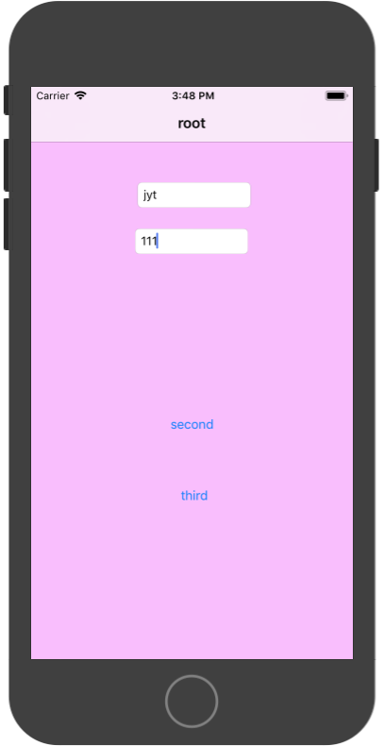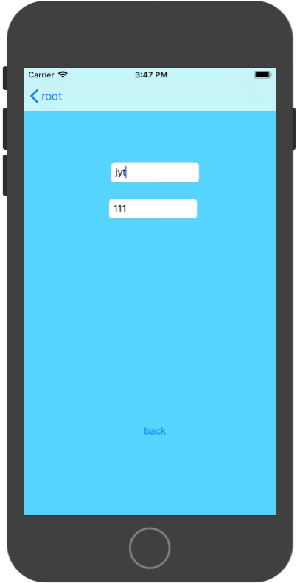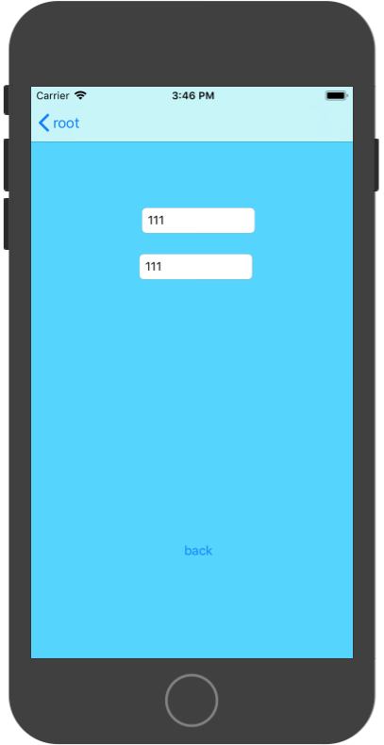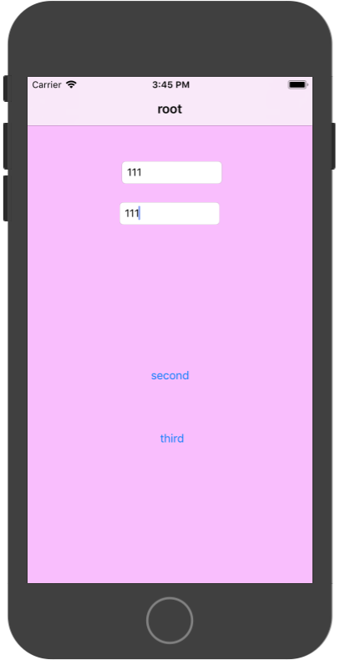

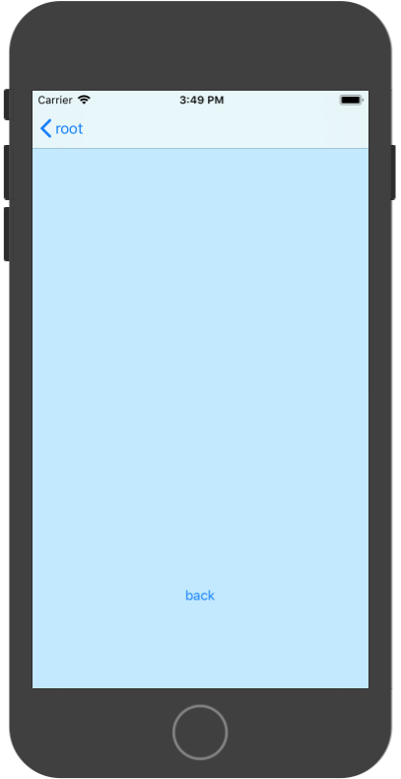

1. 完成苹果官网的FoodTracker Demo（多MVC）
   1. TableView（自定制Cell）；
   2. NavigationController；
   3. Modal Controller;
   4. ImagePickerController;

说明：苹果官网Demo网址如下

<https://developer.apple.com/library/content/referencelibrary/GettingStarted/DevelopiOSAppsSwift/index.html>

* 程序代码：

右边都文件列表

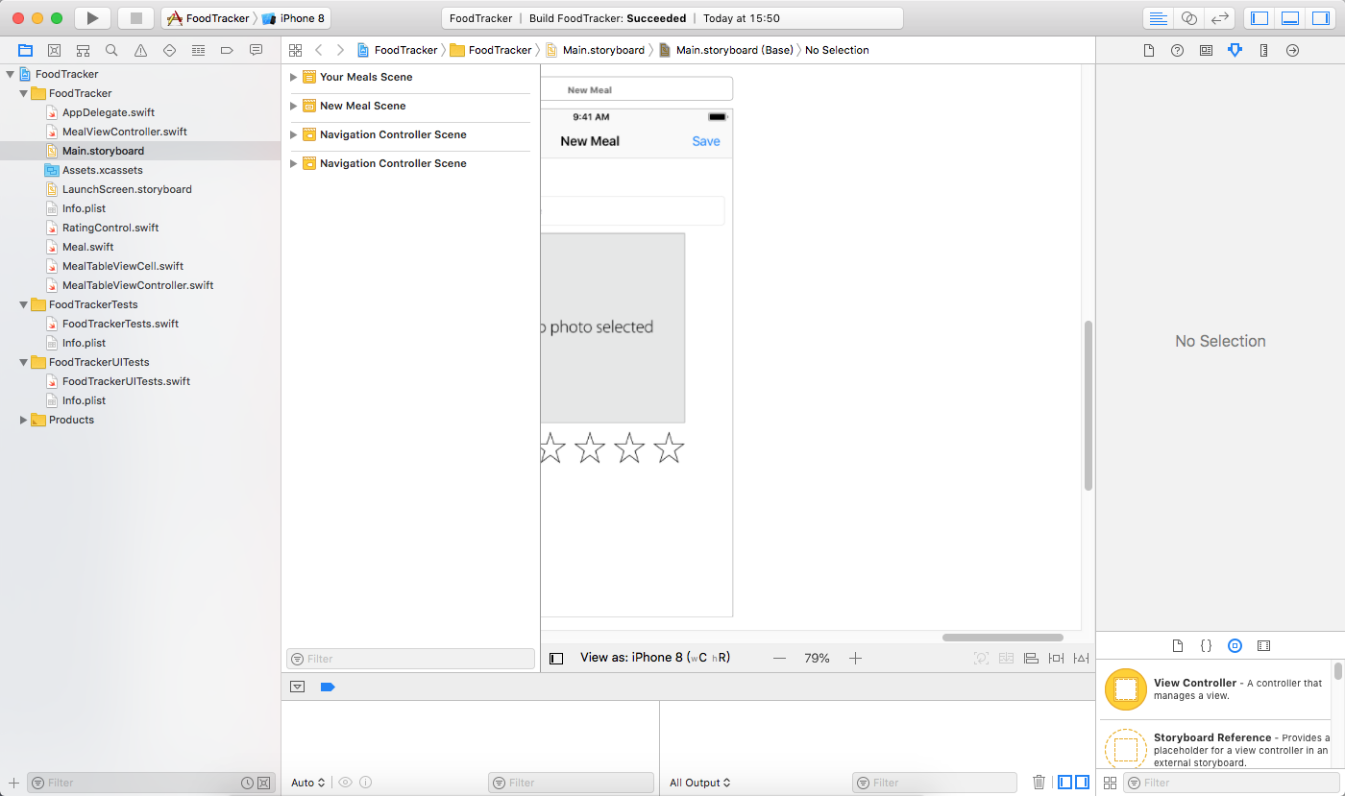

部分代码

//

// ViewController.swift

// FoodTracker

//

// Created by Jane Appleseed on 10/17/16.

// Copyright © 2016 Apple Inc. All rights reserved.

//

import UIKit

import os.log

class MealViewController: UIViewController, UITextFieldDelegate, UIImagePickerControllerDelegate, UINavigationControllerDelegate {

var meal: Meal?

//MARK: Properties

@IBOutlet weak var saveButton: UIBarButtonItem!

@IBOutlet weak var nameTextField: UITextField!

@IBOutlet weak var photoImageView: UIImageView!

@IBOutlet weak var ratingControl: RatingControl!

override func viewDidLoad() {

super.viewDidLoad()

// Handle the text field’s user input through delegate callbacks.

nameTextField.delegate = self

photoImageView.isUserInteractionEnabled=true

// Set up views if editing an existing Meal.

if let meal = meal {

navigationItem.title = meal.name

nameTextField.text = meal.name

photoImageView.image = meal.photo

ratingControl.rating = meal.rating

}

// Enable the Save button only if the text field has a valid Meal name.

updateSaveButtonState()

}

//MARK: UITextFieldDelegate

func textFieldShouldReturn(_ textField: UITextField) -> Bool {

// Hide the keyboard.

textField.resignFirstResponder()

return true

}

func textFieldDidEndEditing(_ textField: UITextField) {

updateSaveButtonState()

navigationItem.title = textField.text

}

//MARK: UIImagePickerControllerDelegate

func imagePickerControllerDidCancel(_ picker: UIImagePickerController) {

// Dismiss the picker if the user canceled.

dismiss(animated: true, completion: nil)

}

func imagePickerController(_ picker: UIImagePickerController, didFinishPickingMediaWithInfo info: [String : Any]) {

// The info dictionary may contain multiple representations of the image. You want to use the original.

guard let selectedImage = info[UIImagePickerControllerOriginalImage] as? UIImage else {

fatalError("Expected a dictionary containing an image, but was provided the following: \(info)")

}

// Set photoImageView to display the selected image.

photoImageView.image = selectedImage

// Dismiss the picker.

dismiss(animated: true, completion: nil)

}

//MARK: Actions

@IBAction func selectImageFromPhotoLibrary(_ sender: UITapGestureRecognizer) {

// Hide the keyboard.

nameTextField.resignFirstResponder()

// UIImagePickerController is a view controller that lets a user pick media from their photo library.

let imagePickerController = UIImagePickerController()

// Only allow photos to be picked, not taken.

imagePickerController.sourceType = .photoLibrary

// Make sure ViewController is notified when the user picks an image.

imagePickerController.delegate = self

present(imagePickerController, animated: true, completion: nil)

}

@IBAction func cancel(_ sender: UIBarButtonItem) {

// Depending on style of presentation (modal or push presentation), this view controller needs to be dismissed in two different ways.

let isPresentingInAddMealMode = presentingViewController is UINavigationController

if isPresentingInAddMealMode {

dismiss(animated: true, completion: nil)

}

else if let owningNavigationController = navigationController{

owningNavigationController.popViewController(animated: true)

}

else {

fatalError("The MealViewController is not inside a navigation controller.")

}

}

func textFieldDidBeginEditing(_ textField: UITextField) {

// Disable the Save button while editing.

saveButton.isEnabled = false

}

//MARK: Private Methods

private func updateSaveButtonState() {

// Disable the Save button if the text field is empty.

let text = nameTextField.text ?? ""

saveButton.isEnabled = !text.isEmpty

}

//MARK: Navigation

override func prepare(for segue: UIStoryboardSegue, sender: Any?) {

super.prepare(for: segue, sender: sender)

// Configure the destination view controller only when the save button is pressed.

guard let button = sender as? UIBarButtonItem, button === saveButton else {

os_log("The save button was not pressed, cancelling", log: OSLog.default, type: .debug)

return

}

let name = nameTextField.text ?? ""

let photo = photoImageView.image

let rating = ratingControl.rating

// Set the meal to be passed to MealTableViewController after the unwind segue.

meal = Meal(name: name, photo: photo, rating: rating)

}

}

* 运行结果：

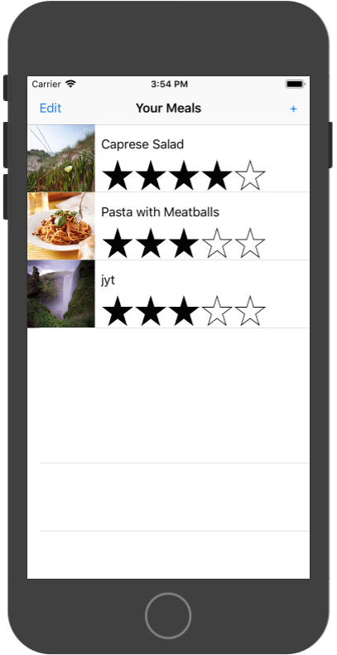 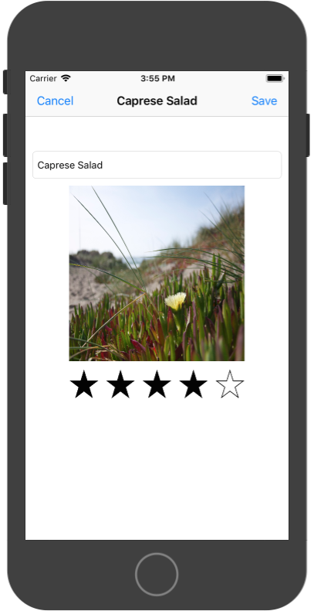

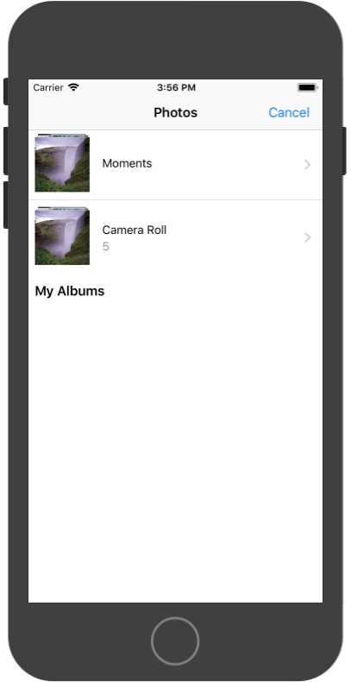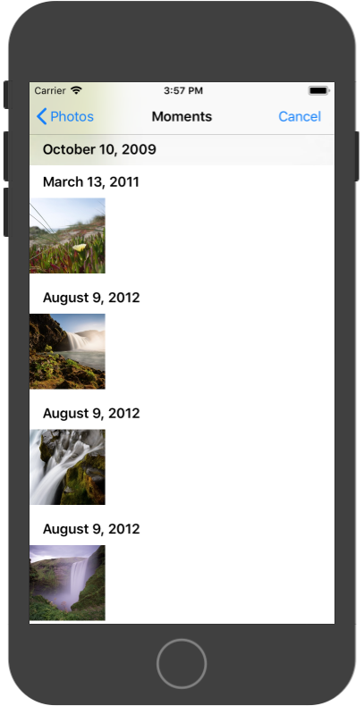

1. 实验结果的分析与评价（该部分如不够填写，请另加附页）

**Github地址：**[**https://github.com/jiangyutong/swiftWork/tree/master/代码**](https://github.com/jiangyutong/swiftWork/tree/master/代码)

这次实验主要是写多界面的，我觉得多界面有一个基础就是要会正反传至，我觉得最简单的正反传值就是共用一个数据模型。这样子有没有破坏规则，可以简单很好的在两个界面传值。多界面汇总navigation和bar也很重要，他们让多界面写起来更加的简单。

注：实验成绩等级分为（90－100分）优，（80－89分）良，(70-79分)中，（60－69分）及格，（59分）不及格。