Binary connect

128, (3,3), pad =1,

Batch norm

128, (3,3), pad =1,

Maxpooling, (2,2)

Batch norm,

256, (3,3), pad =1,

Batch norm

256, (3,3), pad =1,

Maxpooling, (2,2)

Batch norm,

512, (3,3), pad =1,

Batch norm

512, (3,3), pad =1,

Maxpooling, (2,2)

Batch norm

Dense 1024,

Batch norm

Dense 1024,

Batch norm.

Dense 10,

Batch norm

Using binary weight for forward and backword, but not for parameter update.

Resource : https://github.com/MatthieuCourbariaux/BinaryConnect

BinaryNet:

The same as binary connect, but use GPU to realize the XOR operation for dot product.

https://github.com/MatthieuCourbariaux/BinaryNet

Max out

Just output the maximum

https://github.com/philipperemy/tensorflow-maxout

LeNet

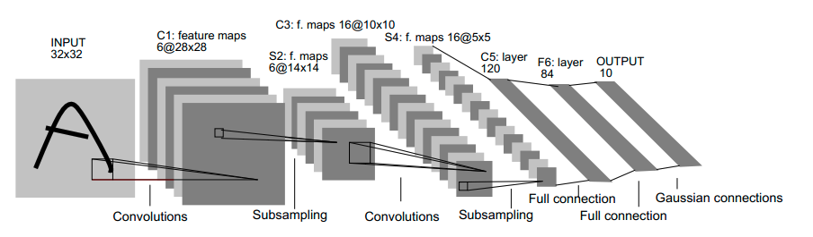

Kernel size = [5 5]

VGG

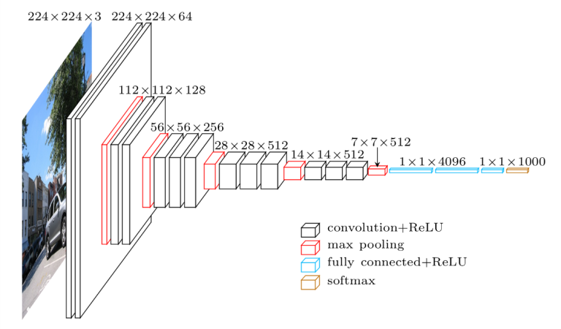

AlexNet

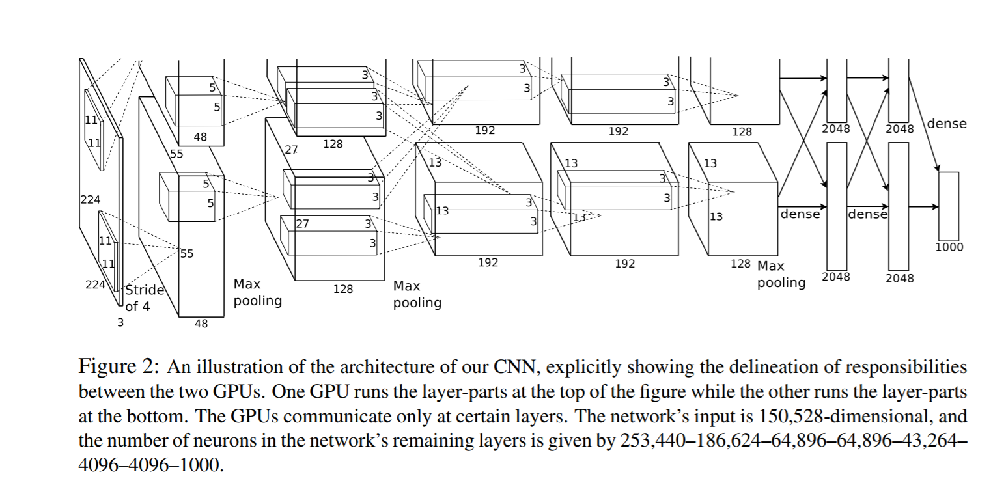

Densely Connected Convolutional Networks (best paper this year)

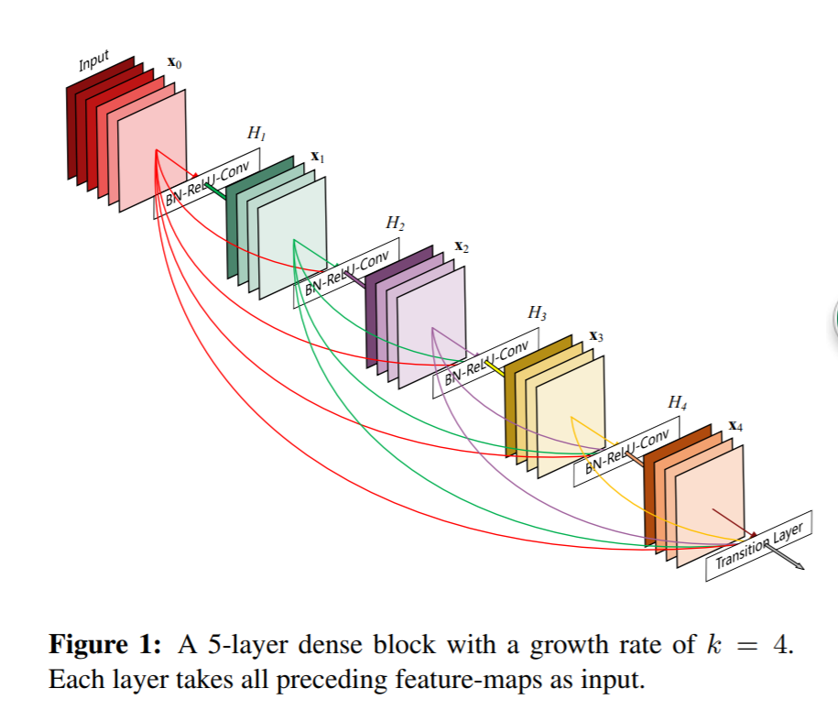

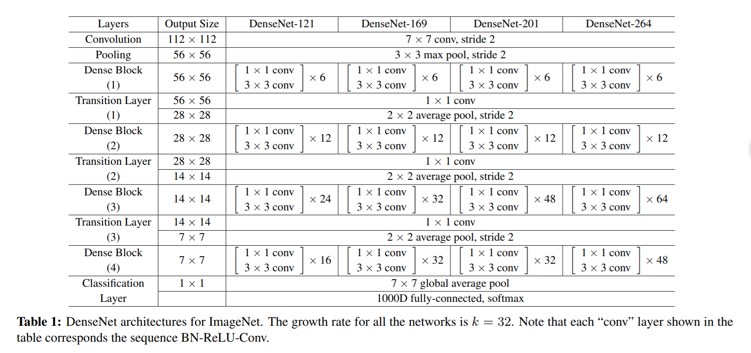

https://github.com/liuzhuang13/DenseNet