**PETS3写作必备模板——应用文写作**

1. **【书信】**

**书信格式1：**

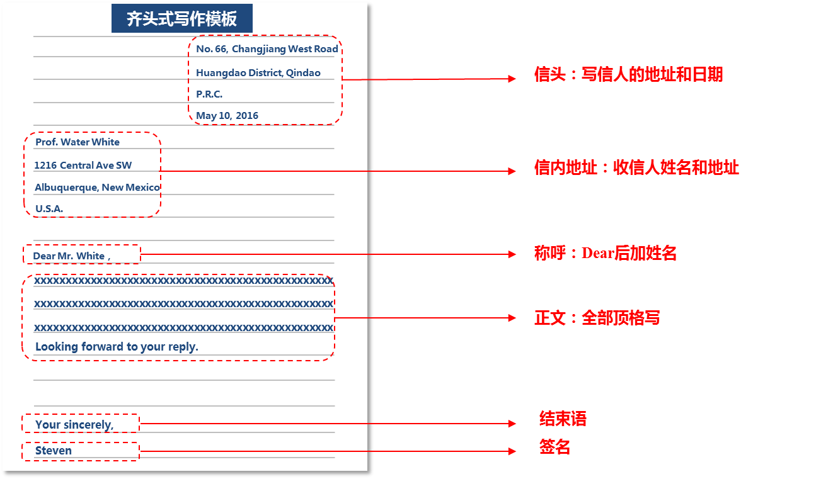

**书信格式2：**

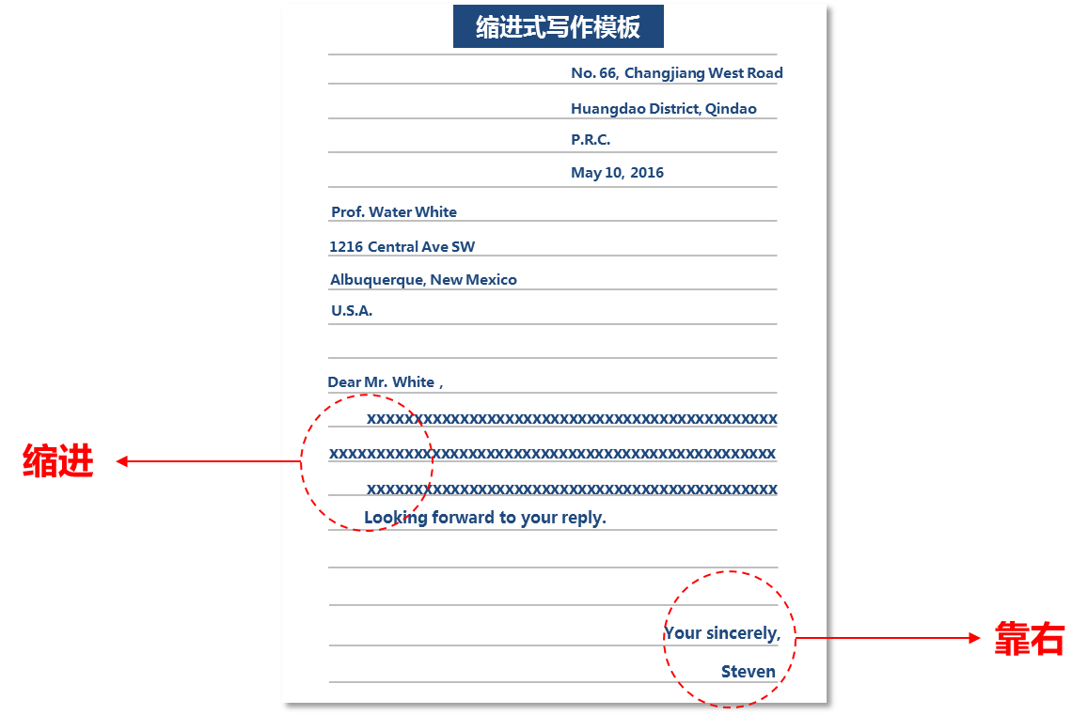

**例题1：**You have read the following advertisement about a volunteer program for an international sports event．You want to get in touch with the organizer．

**Volunteers Wanted**  
　　**Tasks**：interpreting，guiding，reception work，medical aid，driving，etc．  
　　Good level of English required．  
　　Contact US at volunteerswanted@gamil．com

Write an email to the organizer, telling about  
1)your interest in the program；  
2)your qualifications for the task；  
3)your time available for the task．  
You should write about l00 words．Do not sign your own name at the end of your email．Use “Wang Lin” instead．

书信写作一般采用三段式，开头段表达写作动机，中间段写任务要求，结尾段写结束套语。

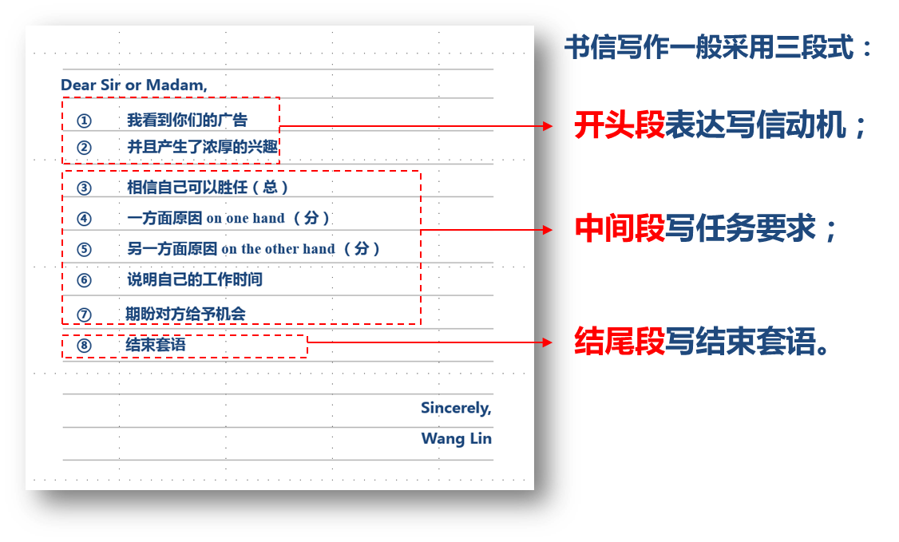

范文：

**Dear Sir or Madam,**

**I`ve read your advertisement and I`m very interested in interpreting, guiding and reception work.**

**I believe my education and experience qualify me for this position. On one hand, I can speak fluent English, for I have studied it for three years as an English major. I used to guide foreign friends to visit my college, from which I`ve learned how to be a qualified volunteer. On the other hand, I`ve got a driver`s license, and can work as a driver if necessary.**

**I`ll be free next week when the sports event is held. I`ll greatly appreciate it if you can give me the chance.**

**Looking forward to your reply.**

**Sincerely,**

**Wang Lin**

**例题2：**Your friend Paul wants to know in detail about the part-time job you took at the restaurant during the summer vacation. Write an email to Paul, telling him about:

1. what you did on the job;
2. how you felt about the working environment and co-workers;
3. what you learned from the job.

You should write about 100 words. Do not sign your own name at the end of your email. Use “Wang Lin” instead.

范文：

**Dear Paul,**

**As you know, during this summer vacation, I`ve taken a part-time job as a waiter in ABC restaurant. Most of the time, I was asked to serve customers, including placing orders, cleaning the table, etc.**

**The restaurant is well decorated and the environment is very comfortable. In addition, the co-workers there are easy-going.**

**The most important thing I learn from being a waiter is that you need to be patient and nice to customers. Did you do something exciting this summer? Tell me about it.**

**I`m looking forward to seeing you soon.**

**Yours,**

**Wang Lin**

**二、【便条】**

**格式1：**

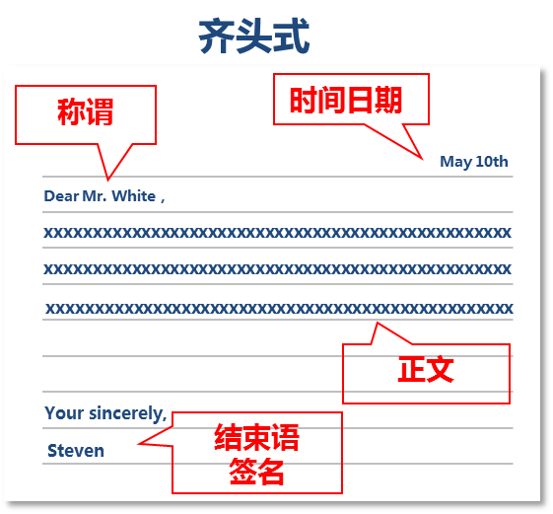

**格式2：**

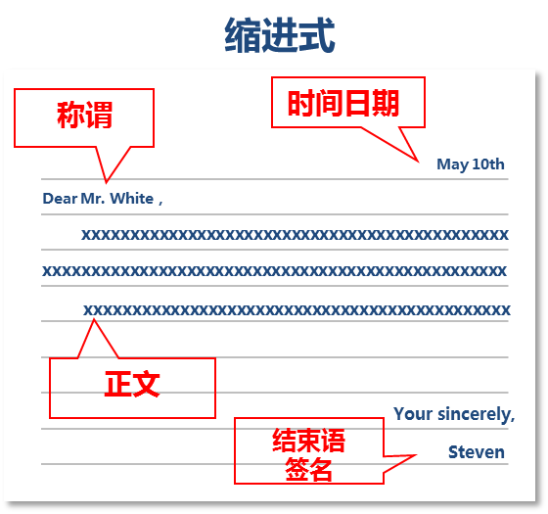

**便条内容简短，一般不需要分段，一段即可。**

* **[邀请]**

**写作思路：**

1. 诚挚邀请对方参加某活动
2. 介绍活动的内容、时间、地点，相关内容
3. 再次发出邀请或者期待对方回复

**经典例句：**

1. May I take this opportunity to invite you to…….?
2. I`m writing to invite you to…
3. I am extending to you our formal invitation to...
4. It gives me the greatest pleasure to invite you to...
5. We would be very pleased if you could honor us with your company.

Anticipating your reply.

1. We hope you can come and look forward to seeing you later.

**例题1：**You have a ticket to the Russian National Ballet Troupe, which is visiting and you want to give it to your friend Alice. Write a note to her and say:

1) the time of the show,

2) the place where you will wait for her

You should write about 100 words. Do not sign your own name at the end of your email.

范文：

**May 10th**

**Dear Alice,**

**I`m writing to invite you to watch the performance given by the Russian National Ballet Troupe. It will be performed in the National Grand Theater tomorrow evening. I am sure that you will be happy to watch it and I leave you a ticket. The performance will begin at 7 P.M. I will wait for you at the theater entrance. I hope you can come and look forward to seeing you later.**

**Yours sincerely,**

**Tom**

* **[道歉]**

**写作思路：**

1. 错误的行为，
2. 具体原因，
3. 弥补方法，
4. 再次致歉。

**经典例句：**

错误的行为

1. I`m writing to express my apologies for not being able to…
2. Excuse me for my...

弥补方法

1. I am sure I can make up the loss by…
2. I promise it will never happen again.
3. I promise to make up my mistakes.

再次致歉

1. Please forgive me.
2. It would be very kind of you to give me another chance to…
3. I'm thankful to you for overlooking my fault

**例题1**：You didn’t hand in your homework on time. Now you have to write a note to your teacher for apology in about 100 words. Do not sign your own name at the end of your email.

范文：

**May 10th**

**Dear Mr. Wang,**

**I`m writing to express my apologies for not being able to hand in my homework before the deadline. I know that you must have been disappointed. I also feel worried and anxious about this. The fact is that my computer broke down when I’m finishing my homework. If my computer worked well last night, I would have handed in on schedule. I promise it will never happen again. It would be very kind of you to give me another chance to hand in another homework. Please forgive me and I am waiting for your reply.**

**Yours sincerely,**

**Tom**

* **[祝贺]**

**写作思路：**

1. 祝贺之事
2. 表示祝贺
3. 赞美之词
4. 忠心祝福（再次祝贺＋祝福未来）

**经典例句：**

祝贺之事

1. I`m so happy to learn that….

表示祝贺

1. Please accept my warmest congratulations.
2. Warm congratulations on…

赞美之词

1. You really deserve it because...
2. I have been appreciating your excellent performance in study and ability in your work.

衷心祝福

1. You will have a brilliant future.
2. You'll make greater progress
3. Congratulations again and all good wishes for you.

例题1: Please write a note of congratulations to your friend Wang Fang, who have done very well in the college entrance exam and has been enrolled in China University of Petroleum. You should write approximately 100 words. Do not sign your own name at the end of the letter. Use “Wang Lin” instead.

范文：

**May 10th**

**Dear Wang Fang,**

**I`m so happy to learn that you have done very well in the college entrance exam this year and has been admitted into China University of Petroleum. Warm congratulations on your achievements. You really deserve it because you have paid hard work and sweat. I have been appreciating your excellent performance in study. You will have a brilliant future. Congratulations again and wish you make greater progress.**

**Yours,**

**Wang Lin**

* [致谢]

**写作思路：**

1. 致谢之事
2. 自己受到的益处
3. 再次致谢，表示回报

**经典例句：**

致谢之事

1. I am writing to express my gratitude to you for….
2. I am writing to tell you how much I appreciate your hospitality.
3. Thank you so much for your assistance you gave to me.

再次致谢,表示回报

1. Please accept my warmest thanks.
2. I hope I have the chance to reciprocate [rɪ'sɪprəket] your kindness.

例题1: Suppose your tutor Professor Wu gave you advices on the writing of the paper. Write him a note to show your gratitude. You should write approximately 100 words. Do not sign your own name at the end of the letter. Use “Wang Lin” instead.

范文：

**May 10th**

**Dear Professor Wu,**

**I am writing to express my gratitude to you for your advices on the writing of my paper. Your guidance inspired me a lot and helped me complete the research paper. I couldn’t have done it without your suggestions and encouragements. I have finished my research paper, and I owe it to your help. Please accept my warmest thanks. I hope I have the chance to reciprocate your help.**

**Respectful yours,**

**Wang Lin**

* **[申请]**

**写作思路：**

1. 申请的内容
2. 符合的条件
3. 期待给予机会

**经典例句：**

* 1. I`ve read your advertisement and I`m very interested in…..
  2. I am writing to apply for the vacant post of...advertised in...
  3. In reply to your advertisement in..., I beg to apply for the post of...in your company.
  4. I have learned from the newspaper that there is a vacancy for…..
  5. I wish to become a graduate student in the Department of Economics at your university.
  6. I believe my education and experience qualify me for this position.
  7. I believe I have the necessary qualifications and experience needed for the position of... advertised in the paper.
  8. I`ll greatly appreciate it if you can give me the chance.
  9. Enclosed is a copy of my resume, which should give you a broader picture of my experience.
  10. I hope I may be granted an interview when I can explain my qualification more fully.

范文：

**May 10th**

**Dear Sirs,**

**I am writing to apply for the vacant post of English teacher advertised in newspaper.** **I believe I have the necessary qualifications and experience needed for the position. Enclosed is a copy of my resume, which should give you a broader picture of my experience. I would be greatly grateful if you would grant me a chance for an interview.**

**Respectfully yours,**

**Wang Lin**

三、【通知】

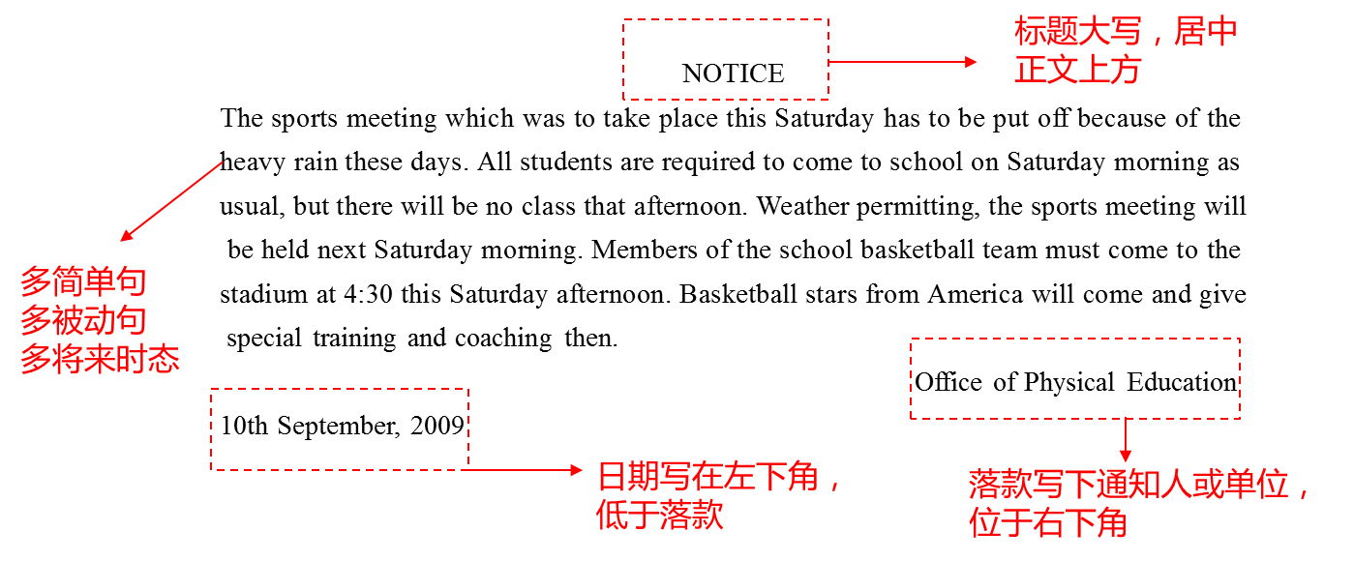

**例题1：**

Your university is celebrating its 60th anniversary, and the Preparation Committee is planning to hold art exhibitions. As an organizer of the activity, you are making a call for works from all the teachers and students. Your notice should state:

1. Who you represent and why you are looking for works
2. What kind of works you are looking for, and
3. When the deadline is and where the teachers and students should send

You should write about 100 words. Do not sign your name at the end of the notice. Use “The 60th Anniversary Preparation Committee” instead.

范文：

**NOTICE**

**In celebration of the 60th anniversary of our university, the Preparation Committee has decided to hold art exhibitions with the theme of “Cohesion and Development”. All the teachers and students from different departments are greatly encouraged to send your works. The works are expected to be a good display of achievements in the past sixty years and to show vigor of development in the future. The deadline for submission is September 10th, 2016. Works should be sent directly to the Preparation Committee`s office on the 10th floor of the Administration Building.**

**The 60th Anniversary Preparation Committee**

**May 10th, 2016**