一、话题作文-解决问题型

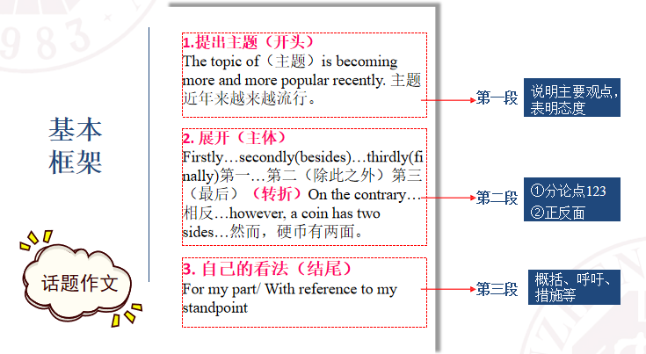

People can place an order through the App. And the products ordered will be delivered to their door within several days.

I need your contributions in class.

You need contribute some ideas to the discussion in class.

It contributes to/ results in/ leads to the further development of the internet.

When shopping online, we should be alert to prevent us from being cheated.

模板：A 提出问题--B分析问题--C 解决问题

Today /Nowadays ,__问题____has become a matter of great concern（关注，关心） of the general public in our society, which is especially described among people involving it. And I(we , people) believe that ②观点________ .

当今，。。。已经成了社会上人们普遍关注的一个问题，尤其是与这个问题相关的人经常会说到。 我/人们认为：____________.

What I believe/My idea/ belief is based on the following reasons.

To begin with, ③ 原因一 .

What’s more(even more), ______④原因二 .

The most important factor is that(last but more importantly), ⑤原因三 , as is shown in the theme given above.

Therefore, I would like to take the following steps to ⑥ 回应观点 .

(For one thing) on one hand , ⑦措施一 .

(For other thing)on the other hand, ⑧二 .

I believe where there is hope there is brightness ___.

Today /Nowadays , phubbing has become a matter of great concern（关注，关心） of the general public in our society, which is especially described among people involving it. And I(we , people) believe that ②观点 it does more harm than good to people . do harm to sb do good to sb

What I believe/My idea/ belief is based on the following reasons. To begin with, ③ 原因一 too many people just focus on their phones, playing games, listening to music or watching videos, no matter where they are, on the metro, bus or at home, so that they have less time to work or care for their family members

,what’s more(even more), long time spent on phone will hurt their eyes and it is not good for health in the long run.

④原因二 the most important factor is that(last but more importantly), ⑤原因三 as is shown in the theme given above. Addictive 容易上瘾的 making them less motivated to do something meaning or valuable.

Therefore, I would like to take the following steps to avoid to be a phubber ⑥ 回应观点 . (for one thing) on one hand , I will take part in more activities to make friends⑦措施一 . (for other thing)on the other hand, ⑧措施二 . I believe where there is hope there is brightness i will spend more time in accompanying my families.

模板应用：the importance of obtaining degree

1、学位为什么重要？ 2、你打算如何取得学位？

学位成了关注一个问题。学位非常的重要

原因1. 学位意味着 你经历专门的某个学科的训练，而这个学位将会是你未来谋生的一个手段。2. 学位成了找工作的敲门砖。换句话说，没有学位，甚至就不能参加面试。

Appreciate 升值

There is a tendency that degree is a little depreciated, and the low degree holders give way to high degree holders.

Having a degree means you have some way to make a living.

When you look for a job, degree will be a must./ the basic requirement from the company.

Today , ①中心词degree has become a matter of great concern of the general public in our society, which is especially described among people involving it. And I(we , people) believe that ②观点there is nothing more important than degree in today’s highly competitive labor market .

What I believe is based on the following reasons. To begin with, ③ 原因一degree is a symbol of knowledge, which can entitle you to engage in the professional work. what’s more(even more), ④原因二it is connected with wealth ,about 70% people who have degree get 90% wealth according to the sociologists’ survey .the most important factor is that(last but more importantly), ⑤原因三(it is degree that someone focus on and struggle for), as is shown in the theme given above.

Therefore, I would like to take the following steps to ⑥ 回应观点get degree . (for one thing) on one hand , ⑦措施一I will try my best to study English for the test for degree . (for other thing)on the other hand, ⑧措施二I will write good essays about my major as much as possible during my study in university . I believe where there is hope there is brightness

Where there is will there is way

解决问题型作文可套用的话题：

1. How do you see the social phenomenon “phubbing”? snub sb because of your phone

你如何看待“低头族现象”

* 你周围有低头族吗他们成为“低头族”的原因。 看新闻，玩游戏，看视频
* 成为“低头族”给学习和生活带来的影响。 花太多的时间在手机上，忽略了学习，对家人关注不够， 对眼睛也不好。 不利于身体健康
* 就如何“拒为低头族”提一些建议。 参加活动，陪伴家人。

词汇：phubbers

1. 话题作文-观点论述型

模板：对立观点式A有人认为X 是好事，赞成X，为什么？

B. 有人认为X 是坏事，反对X，为什么？

C. 我的看法

* **having hobbies make boredom a thing of the past**
* 你认为业余爱好对人们有好处还是坏处? relax energetic refreshing
* making friends
* 举例说明业余爱好对人们有什么好处或坏处。Digressive
* time-wasting, money-wasting

人 Choose 产品

There are a good few products for consumers to choose from online.

There is no consensus (一致看法)of opinions among society about 中心词 .

社会上，人们关于某个问题的看法意见是不一致的。

Some people are in favor of the idea that 观点① . 支持

Not only do they point out the the fact that 理由①, but also argue that 理由②

However, other people take an opposite side. They firmly believe that 观点② . An example can give the details of this argument: 举例子 .

There is some truth in both arguments.

As for me, I agree to the former/latter idea, which I think the advantages of 观点③ overweigh the disadvantages. My beliefs are based on the following reasons: 理由① In addition to the above-mentioned effects ,it might bring about 附带好处1 as well as 附带好处2 .

A hobby can make boredom a thing of the past

Kill time and fill their empty hours with interesting and meaningful activities

Relax ourselves and make us more energetic and refreshing when we resume work.

Can also add to the sense of self-esteem 增加自信

Some hobbies may be time-wasting and money-wasting, making individuals less concentrated on their work or study.

模板应用：Finding Jobs

1、有些父母给孩子选工作 2、有些孩子认为应该自己选工作3、你的看法

Pay too much attention to the prospects of the job in the long run

Mature and rational avoid detours. 少走弯路

Interest is the most important thing, more motivated and persist for long time be like to make achievements.

Is a way to cultivate independence, which is a significant ability to one’s growth.

As far as the work is concerned, what the parents concerns most is more money, less work, being near home/being close to home. Stability stable

Corporate culture

There is no consensus of opinions among society about 中心词 choosing jobs. Some people are in favor of the idea that 观点①parents should help their kids to choose jobs . Not only do they point out the the fact that理由① most jobs are mere time-killing, they are not meaningful, but also argue that 理由② there are extra options out there, such as supporting family businesses, startups, etc.

However, other people take an opposite side. They firmly believe that观点② parents should let their kids choose jobs by themselves .An example can give the details of this argument:举例子HE Qiulong, Son of HE hongshen(casino king), started his own path of career step by step.There is some truth in both argument.

As for me, I agree to the latter idea, which I think the advantages of choosing jobs by oneself 中心词③ overweigh the disadvantages. My beliefs are based on the following reasons:理由① Interests are what keep people motivated. In addition to the above-mentioned effects , it might bring about happiness as well as sense of fulfillment .

|  |  |  |  |  |
| --- | --- | --- | --- | --- |
| 类型  段落 | 解决问题型 | 观点论述型 | 观点阐述型  唯一写结果的文章 | 看图说话型 |
| Para 1 | Nowadays， 问题has become a matter of great concern of the general public in our society, which is especially described among people involving it. And I believe that 观点。 | There is no consensus of opinions among society about _话题____ .  Some people are in favor of the idea that 观点① .  Not only do they point out the the fact that 理由①, but also argue that 理由② . | Recently, there has been a growing concern among the public over the topic of ① (主题词). （通常是好的事情） | As is revealed in the picture/cartoon , ①(描述图片). The picture is fairly thought-provoking, which tends to convey to us this message : ②(图片传达的信息). |
| Para 2 | My idea is based on the following reasons.  To begin with, 原因一 .  What’s more), 原因二 .  The most important factor is that, 原因三 , as is shown in the theme given above. | However, other people take an opposite side. They firmly believe that 观点② . An example can give the details of this argument: 举例子 .  There is some truth in both arguments. | This will definitely generate a variety of positive effects . To begin with , ② (积极影响一). Moreover , ③ (积极影响二). Last but not the least , ④ (积极影响三). If there’s no such an activity , ⑤ (后果). | We can easily recognize the significance of ③(与主题相关因素)in terms of ④(主题词). So how did this problem come into being? For me, the reasons of this phenomenon are as follows: Firstly, ⑤(原因一) Secondly, ⑥（原因二） |
| Para 3 | Therefore, I would like to take the following steps to 回应.  For one thing, 措施一 .  For other thing, 措施二.  I believe where there is hope there is brightness. | As for me, I agree to the former /latter idea, which I think the advantages of 观点③ over- weigh the disadvantages. My beliefs are based on the following reasons: 理由① In addition to the above-mentioned effects, it might bring about 附带好处1 as well as 附带好处2 . | To the best of my knowledge , it is sensible that we make our due contributions . In the first place, we can ⑥ (举措一). In the second place/secondly, we may ⑦ (举措二). Finally , we are supposed to ⑧ (举措三). In conclusion , we have good reasons to believe that it will have a pro[mi](http://kaoyan.koolearn.com/zhuanshuo/mi/" \t "https://kaoyan.koolearn.com/20171213/_blank)sing prospect . | Considering all the points discussed above , it is advisable that we highly value ⑦(与主题相关因素) and apply it in our lives. We are , therefore , supposed to take a rational attitude . |
| 本质 | 问题-作者观点-原因-措施 | 观点A-----观点B -----我观点 | 点明主题-----分析好处-----提出想法 | 图画传达含义（表面意思，深层含义）  通常是社会问题 原因是什么  解决方法是什么 |
| 例文1 | 学历问题 观点- 重要  为什么重要  自己怎么努力获得学位 | 大学生住校内还是住校外  住校内--原因  住校外-原因  我的看法 大一大二住校内，大三大四住校外 | 共享单车  好出多多  呼吁（人人显出一份爱，世界会更美好）个人+朋友加社会 | 学生提不起来劲儿  困---缺乏睡眠  原因，长时间玩游戏，睡眠习惯不好  怎么做 |
| 例文2 | 低头族问题 观点 有害  为什么有害  自己怎么克服 | 注意：  如果你同意A观点或B观点，一定要留着压箱底的观点自己总结说。 |  | 子女养老足球赛  养老问题很重要，子女不养老人的原因  国家社会个人应该怎么做 |
|  | 问题一边倒 原因加 措施 | 各有利弊 和稀泥 | 好事提倡 呼吁 | 问题一边倒 原因 解决方法 |

好的 好处（结果） 提倡呼吁 个人 他人加社会

坏的 原因 应对策略 图画加个图画本身描述

好坏都有 原因 正反说你的观点

观点对立型/事物正反两面可套用的话题：

1. **The advantages and disadvantages of having hobbies**

* 你认为业余爱好对人们有好处还是坏处? relax energetic refreshing
* making friends
* 举例说明业余爱好对人们有什么好处或坏处。Digressive
* time-wasting, money-wasting

1. **Finding a job in a big city or in a small town?**

* 现在许多大学毕业生都想在大城市、大公司找工作，甚至为此而等上几年也在所不惜。你对此如何看待?
* 请举例说明你的观点。

大城市找工作 好处 机会多，福利好 提升快，

Attractive salary fast promotion

大城市大公司好公司多，这样的话待遇高

管理成熟 晋升快 人为因素干预少

Mature less human intervention

小城镇 竞争不那么激烈 压力就相对小

工作稳定 离家近 生活成本低

1. **观点阐述型**

模板：A 点明主题--B分析好处--C 提出想法

Recently , today/ nowadays there has been a growing concern among the public over the topic of ① (主题词).

There is no doubt/ This will definitely generate/produce a variety of /many positive effects . To begin with/firstly , ② (积极影响一). Moreover/besides , ③ (积极影响二). Last but not the least , ④ (积极影响三). If there’s no such an activity , ⑤ (后果).

To the best of my knowledge/in my opinion/ as far as i am concerned, (据我所知) , it is sensible that we make our due contributions . In the first place/firstly, we can ⑥ (举措一). In the second place/secondly, we may ⑦ (举措二). Finally , we are supposed to ⑧ (举措三). In conclusion /in a word, we have good reasons to believe that it will have a pro[mi](http://kaoyan.koolearn.com/zhuanshuo/mi/" \t "https://kaoyan.koolearn.com/20171213/_blank)sing/bright prospect/future .

**应用：Shared bicycles 共享单车**

Recently , there has been a growing concern among the public over the topic of ① (主题词) shared bicycles.

This will definitely generate a variety of positive effects . To begin with , ② (积极影响一) shared bicycles can relieve the pressure of transportation. Moreover , ③ (积极影响二) shared bicycles can help protect the environment. Last but not the least , ④ (积极影响三) shared bicycles will help people save money and time when commuting/going to and from work. If there’s no such an activity , ⑤ (后果) the world will be worse than what it appears now.

To the best of my knowledge , it is sensible that we make our due contributions . Firstly, we can ⑥ (举措一) drive less and use shared bicycles more. Secondly, we may ⑦ (举措二)encourage/teach our friends and families how to use shared bicycles. Finally , we are supposed to /⑧ (举措三) we should together promote the idea of a shared economy. In conclusion , we have good reasons to believe that it will have a pro[mi](http://kaoyan.koolearn.com/zhuanshuo/mi/" \t "https://kaoyan.koolearn.com/20171213/_blank)sing prospect . 个人/亲朋好友邻居/社会/政府

观点对立型/事物正反两面可套用的话题：

1. Online Shopping 网购

* 网购的优势
* 网购的弊端
* 你会选择网购吗？

1. My opinions on new technology (5G Technology and AI technology, etc）

* 5G技术
* AI智能
* 你觉得新科技会给你带来什么

1. The most important quality for a person to be successful in the world today

* 你认为在现在的世界上要想成功什么素质最重要?
* 请举例说明你的理由。

1. Do You Think Awards and Prizes can Serve a Useful Purpose?

* 你认为奖励和奖金重要吗? 它们能起到激励人们努力工作的作用吗?
* 请举例说明你的观点。

1. Do you think games are as important for adults as they are for children?

* 你认为游戏对成年人也很重要吗?
* 请举例说明你的观点。

1. What would you consider as an ideal work environment?

* 工作环境包括很多方面∶空间、空气、温度、光线、噪声、设施、伙伴……
* 我想要的理想的工作环境是……

**四、看图说话型（社会问题居多）**

模板：A 点明主题--B分析原因--C 摆明态度

As is revealed/shown in the picture/cartoon , ①(描述图片)直接描述. The picture is fairly thought-provoking , which tends to convey to us this message : ②(图片传达的信息). 深层含义

We can easily recognize the significance of ③(与主题相关因素)in terms of ④(主题词). So how did this problem come into being? For me, the reasons for this phenomenon are as follows(如下): Firstly, ⑤(原因一) Secondly, ⑥（原因二）

Considering all the points discussed above , it is advisable that we highly value ⑦(与主题相关因素) and apply it in our lives. We are , therefore , supposed to take a rational attitude .

**应用：Lack of Sleep among students 学生睡眠不足问题**

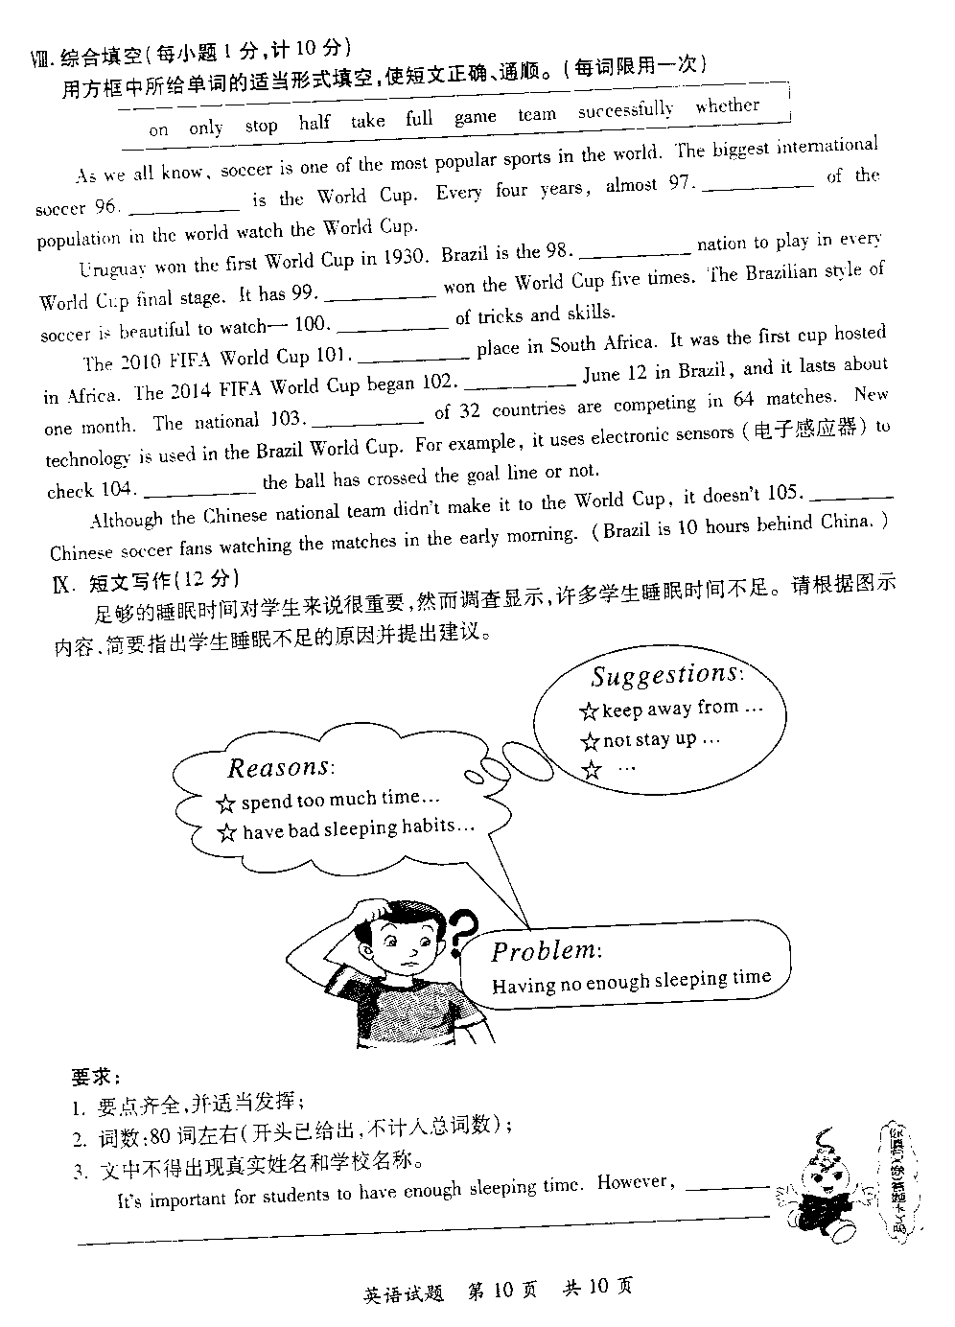

足够的睡眠时间对学生来讲很重要，然而调查显示，许多学生睡眠不足。请根据图示内容，简要指出学生睡眠不足的原因并提出建议。

As is shown vividly /revealed in the picture/cartoon , ①(描述图片)many students feel tired and sleepy. The picture is fairly thought-provoking, which tends to convey to us this message : ②(图片传达的信息)they don’t have enough time to sleep.

We can easily recognize the significance of ③(与主题相关因素) having enough sleep in terms of ④(主题词)students’ long-term health. So how did this problem come into being? For me, the reasons for this phenomenon are as follows: Firstly, ⑤(原因一)some students always stay up late into night, playing computer games or viewing websites. Secondly, ⑥（原因二）others have unhealthy diet and chaotic routine of daily life, such as drinking too much coffee at night.

Considering all the points discussed above , it is advisable that we highly value ⑦(与主题相关因素) regular and enough sleep and apply it in our lives. ~~We are , therefore , supposed to take a rational attitude.~~

看图作文（社会现象居多）可套用的话题：

1.低碳生活（low carbon life）

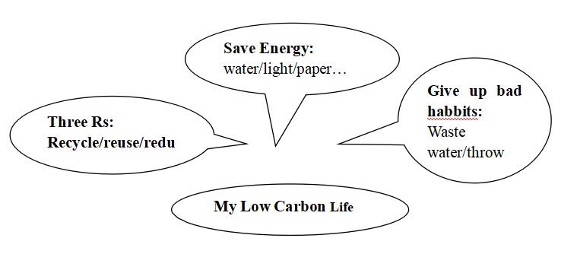

1. 互联网是福是祸Is Internet a Blessing o a Curse?

As is revealed in the picture/cartoon , ①(描述图片). The picture is fairly thought-provoking , which tends to convey to us this message : ②(图片传达的信息).

We can easily recognize the significance of ③(与主题相关因素)in terms of ④(主题词). So how did this problem come into being? For me, the reasons of this phenomenon are as follows: Firstly, ⑤(原因一) Secondly, ⑥（原因二）

Considering all the points discussed above , it is advisable that we highly value ⑦(与主题相关因素) and apply it in our lives. We are , therefore , supposed to take a rational attitude .

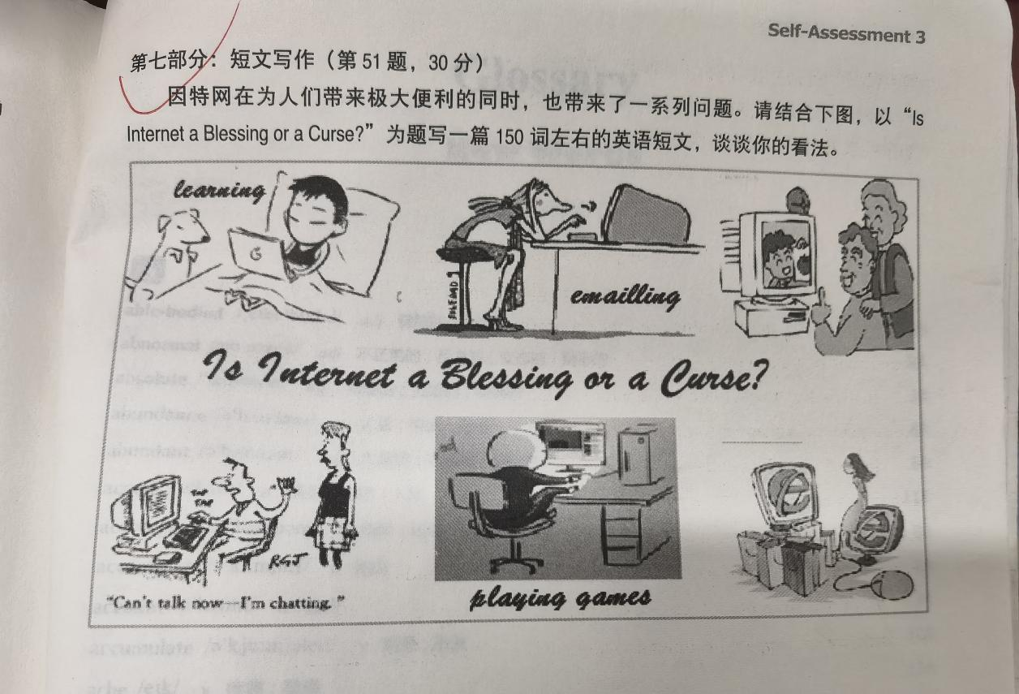

As is vividly revealed in the picture, individuals can do a lot of things via internet. The picture is fairly thought-provoking , which tends to convey to us this message : Is internet a blessing or a curse on earth?.

We can easily recognize that internet is playing an increasingly important role in our daily life, no matter whether it is used for good or bad things. On the one hand, internet can do good to us: people can study online without going out; people can email others for business purpose; people can keep in touch with their family members via internet. On the other hand, internet can do harm to us: internet is highly addictive--people spend too much time in chatting or playing games online but ignore families in front of them; internet can trigger impulse buying/purchasing, for online shopping is too convenient, and unconsciously they have bought too much.

Considering all the points discussed above , it is hard to say whether internet is a blessing or a curse. As we know, science and technology is a two-edged sword. We should make full use of its advantage and try our best to avoid its disadvantage.

About what is an ideal work/working environment.

Official facilities

Can show/demonstrate the strong economic strength

Low cost can yield more profits.

Is conducive to people’s health physically and mentally

Which can make me productive/efficient in my work

An ideal work environment involves/includes many factors.

The first one that comes in my mind is friendly coworkers so that I can turn to them for help when in trouble.

The next one is location. There should be no factory around producing a lot of noise, which is a great distraction to me .

The third one is convenient facilities around: for example, fitness room, where you can take physical exercise in your spare time so that you can relax and feel refreshed and energetic when you come back to work.

It is the ideal work environment that can bring us efficiency, pleasure and happiness.

I can have a comfortable environment to work in.

Co-workers

No one was born lucky

Do good to

Online shopping

当今，随着互联网技术的迅猛发展，网购已变成了一种时尚。网购受到人们欢迎的原因有很多。 第一， 可以节省消费者的时间，尤其是没有太多闲暇时间的人。 第二， 对卖家来说，可以节省成本。然而，也有很多不好的地方。 首先，缺乏面对面的沟通会使网购不太可靠和可信。再次，人们可能会失去讨价还价的乐趣。

当前最为迫切的是国家需要进行相关的立法。只有这样我们在享受网购给我们带来的乐趣和便利的同时而不用担心被欺骗。

Today/nowadays, with the rapid development of the internet, online shopping has become/grown into a fashion. Many factors contribute to the fact that it is welcomed by a good few individuals./Many factors contribute to the popularity of online shopping.On the one hand, online shopping can save time for consumers who don’t have enough spare time. On the other hand, it can save some costs for the sellers. However, there are also some disadvantages in terms of online shopping. Firstly, lack of face-to-face communication will make shopping online less reliable or trustworthy. Chances are that people will lost the fun of bargain.

For the moment, it is of great urgency for the government to set up relevant laws in accordance with online shopping. Only in this way can we enjoy the pleasure and convenience of online shopping /brought by online shopping without the concern of being cheated by dishonest sellers.

Why do people like Iphones?

观点：nice-looking appearance

Excellent performance

Fewer advertisements

Durable 耐用的

Quality picture

手机在人们的生活中扮演着非常重要的角色。

Nowadays, mobile phones play an important role in our lives. You can find that a good few individuals look at their phones when they are waiting for the buses, on the train or in the elevator. I can not imagine a life without a phone. Therefore, there are many brands of phones in the market, such as, OPPO, HUAWEI, XIAOMI, and so on. But the phone that appeals to me greatly is iphone, and my reasons are as follows.

First, it is characterized by unique design-simplicity, which refers to the fact that there is only one button on the whole interface. However, simple as it is, it is powerful in functions, that’s to say, simple but great. Furthermore, the photos taken by the iphone camera are very quality. It can charge quickly. Due to quick update, consumers are expected to purchase new types of iphone every few years, which can better cater for people’s curiosity.

1设计独特 简单 但是简约却不简单，

2它功能强大， 拍照清晰，充电快

1. 更新快，能满足人们的猎奇心理
2. 是身份的象征，

To learn or to practice

Some people think college students should take part in social practice to prepare for their future career. Others argue/maintain/ claim that the the priority for the students in this period is to study. Therefore, they should not pay much attention to the social practice while in college. However, I hold a different idea from both of them.

I still remember a famous saying by Hamlet: “to be or not to be, that is a question.” In my opinion, “To learn or to practice” , that is also a question faced by college students. But the latter is far from so difficult as the former one. Actually they can be integrated properly. Learning aims at better practice in the future, for college students will enter the society sooner or later. And practice is another way of learning, as we know, great truth(knowledge) comes from practice. They can be facilitated mutually and develop together.

一些人说大学生应该参加社会实践为未来的职业做好准备。另外一些人认为大学生的首要任务是学习，因此不应该太过在意社会实践在大学的时候。

在我看来，学习还是实践远远不像哈姆雷特所面临的生死之问题那么难抉择，他们可以有机的结合起来，学习是为了更好的实践，实践也是另一种方式的学习。两者相互促进共同发展。比如：

Is it hard to succeed without confidence?