FuseVirome: A Machine Learning Framework with Dynamic Reference Construction for Viral Identification in Veterinary Metatranscriptomics
Shuting Yang1, Mengyao Wang1, Wenjun Liu1, Xinliang Fu1, Chunhong Zhang4, Jianhua Zheng1, Jun He2,*,,Ming Liao1,3,4,*,
1Guangdong Engineering Technology Research Center of Biosafety and Intelligent Control for Aquatic Animals Diseases, Zhongkai University of Agriculture and Engineering, No. 1188 Guangcong 8th Road, Baiyun District, Guangzhou, 510550, Guangdong, China.
2Institute of Laboratory Animal Science, Key Laboratory of Viral Pathogenesisb& Infection Prevention and Control, Ministry of Education; Guangzhou Key Laboratory for Germ-free Animals and Microbiota Application, Jinan University, No. 601 Huangpu Avenue West, Tianhe District, Guangzhou, 510632, Guangdong, China.
3Key Laboratory for Prevention and Control of Avian Influenza and Other Major Poultry Diseases, Ministry of Agriculture and Rural Affairs, P. R. China, State Key Laboratory of Swine and Poultry Breeding Industry, Institute of Animal Health, Guangdong Academy of Agriculture Sciences Baishigang, Wushan, Tianhe District, Guangzhou 510640, China.
4National and Regional Joint Engineering Laboratory for Medicament of Zoonosis Prevention and Control, Institute of Animal Health, College of Veterinary Medicine, South China Agricultural University,Guangzhou 510642, Guangdong, China.
* To whom correspondence should be addressed.

Abstract
Motivation: Viruses exhibit remarkable genetic diversity and rapid evolutionary capacity, enabling continual adaptation to novel hosts and evasion of immune surveillance, thereby posing persistent and severe threats to human health and global public health security. Against this backdrop, accurate identification of viral species across diverse ecosystems is essential for elucidating viral evolutionary dynamics, assessing ecological risks, and guiding clinical interventions. Although metatranscriptomic next- generation sequencing (mNGS) has emerged as a powerful tool for unbiased viral detection, its results remain susceptible to false positives arising from host homologous sequence interference and bioinformatic artifacts. More critically, mNGS-identified viruses typically require validation by quantitative PCR (qPCR), yet suboptimal primer design may introduce systematic biases that not only confound result interpretation but also lead to viral misclassification.
Results: We present FuseVirome, a qPCR-independent machine learning framework for the identification of viral signals from mNGS data. The framework comprises four sequential stages: (i) de novo assembly, (ii) dynamic reference construction, (iii) multi-source feature extraction, and (iv) machine learning classification. FuseVirome extracts an optimized 29-dimensional feature set and was benchmarked against six classifiers on a training cohort comprising 120 viral sample records, with Random Forest identified as the optimal model. On an independent external test set comprising 179 records (110 positive, 69 negative, encompassing 9 viruses across 102 samples), the Random Forest- based FuseVirome achieved an AUC of 0.9972 (95% CI: 0.9921– 1.0000), a sensitivity of 0.9909 (109/110), a specificity of 0.9275 (64/69), an F1 score of 0.9732 (95% CI: 0.9496–0.9915), and a Brier score of 0.0365.
Availability and implementation:
Contact: mliao@scau.edu.cn; hejun@jnu.edu.cn
Supplementary information: Supplementary data are available at Bioinformatics online

1 Introduction
Metatranscriptomic next-generation sequencing (mNGS) has emerged as a powerful tool for unbiased viral detection and pathogen surveillance (Gu et al., 2021) . Current analytical strategies broadly fall into two categories: reference-free assembly and reference-based coverage analysis. Although reference-free assembly obviates the need for predefined references, downstream viral annotation still relies on curated reference sequence databases. Moreover, this approach typically enforces rigid length thresholds (e.g., > 300 nt) for contig filtering, inevitably resulting in missed detection of short viral fragments (Zhang et al., 2024). Confirmatory validation by quantitative PCR (qPCR), constrained by the static nature of primer sequences and their infrequent updating (Wang et al., 2022), often fails to capture variant strains or emerging pathogens (Wylezich et al., 2021), thereby introducing systematic bias. Conversely, reference-based coverage analysis is inherently confined to existing reference libraries, limiting its scope to known viruses and yielding unacceptably high false-negative rates for novel or highly divergent strains (Zablocki et al., 2024). Consequently, accurate discrimination of viral signals from metatranscriptomic data represents a critical prerequisite for reliable clinical diagnosis and effective epidemiological intervention (Ko et al., 2022; Gaston et al., 2022).
Conventional validation algorithms operate under a closed-set assumption, indexing candidate sequences against static reference databases (Edgar et al., 2022). This design choice renders them inherently brittle to out-of-distribution inputs, namely novel viruses absent from the reference space (Kosmopoulos et al., 2025), thereby creating a fundamental domain mismatch with the open-set nature of unbiased pathogen discovery. While k-mer-based classifiers such as Kraken2 and Centrifuge achieve low-latency taxonomic assignment, their output posteriors are poorly calibrated (Bradford et al.,2024), offering no principled decision threshold for downstream confirmation (Meyer et al., 2022). More critically, existing pipelines rely on unimodal feature extractors that project high-dimensional sequencing data into narrow, task-specific subspaces, incurring severe information bottlenecks: read-level features collapse under class-conditional noise from host contamination (Edgar et al., 2022); contig-level features suffer coverage-dependent recall degradation below assembly cutoffs (Bai et al., 2022); and homology-based features propagate semantic bias, erroneously elevating conserved domains and endogenous viral elements to exogenous pathogen status (Zheng et al., 2023). Consequently, an end-to-end, reference-agnostic machine learning framework that learns multi-modal latent representations and outputs calibrated uncertainty estimates is imperative to close the generalization gap between open-set viral discovery and rigorous validation (Monshizadeh et al.,2024).
Here, we present FuseVirome, a lightweight, high-precision, interpretable, and reference-independent machine learning framework for the computational validation of mNGS-derived viral signals. The framework integrates four synergistic algorithmic modules: (i) de novo assembly, (ii) dynamic reference construction, (iii) multi-source feature extraction, and (iv) machine learning classification. We curated a comprehensive dataset from clinical samples and benchmarked FuseVirome against six candidate classifiers and existing state-of-the-art tools. In various experiments, FuseVirome consistently outperforms these existing tools, with Random Forest emerging as the optimal backbone and attaining an F1 score of 0.9732 on independent external validation.

2 Materials and Methods
2.1 Clinical dataset and validation design
The clinical dataset comprised metatranscriptomic sequencing data from 102 mixed goose tissue samples collected from diseased goose flocks across Guangdong Province, China. Each sample was a pool of 5 diseased geese (510 diseased geese total), following standard veterinary epidemiological sampling practice for cost-effective pathogen surveillance in flock settings. This pooling strategy captured within-flock pathogen diversity while maintaining feasibility for large-scale screening.
A critical distinction was made between an NGS sample and a machine learning (ML) sample. A single NGS sample could test positive for multiple viruses, and each virus-sample combination constituted an independent ML instance (Gu et al., 2021; Roux et al., 2022; Portik et al., 2022). For example, if one pooled sample was qPCR-positive for one virus and qPCR-negative for another, it generated two ML records: one positive and one negative. This per-virus-per-sample granularity was essential because the framework evaluated evidence for each candidate virus independently. The 102 NGS samples yielded 299 ML records after qPCR validation: 120 training records (72 virus-positive, 48 virus-negative) for model development and feature refinement, and 179 external test records (110 virus-positive, 69 virus-negative) for final independent validation.
All positive and negative labels were confirmed by qPCR (Zheng et al., 2024). Positive records corresponded to NGS samples where qPCR confirmed presence of the target virus; negative records correspond to samples where qPCR confirmed absence (Meyer et al., 2022). This per-virus qPCR validation ensured that the ground truth reflected individual viral presence rather than overall sample status, which was critical for training a model that discriminated true from false positive signals at the virus level (Luo et al., 2024).
2.2 Framework overview
The FuseVirome framework comprised four sequential analytical stages (Figure 1): (i) de novo assembly, (ii) dynamic reference construction, (iii) multi-source feature extraction, and (iv) machine learning classification. The framework was designed to operate without pre-defined reference libraries, which enabled validation of mNGS-detected viral signals even when reference genomes are incomplete or absent in public databases.
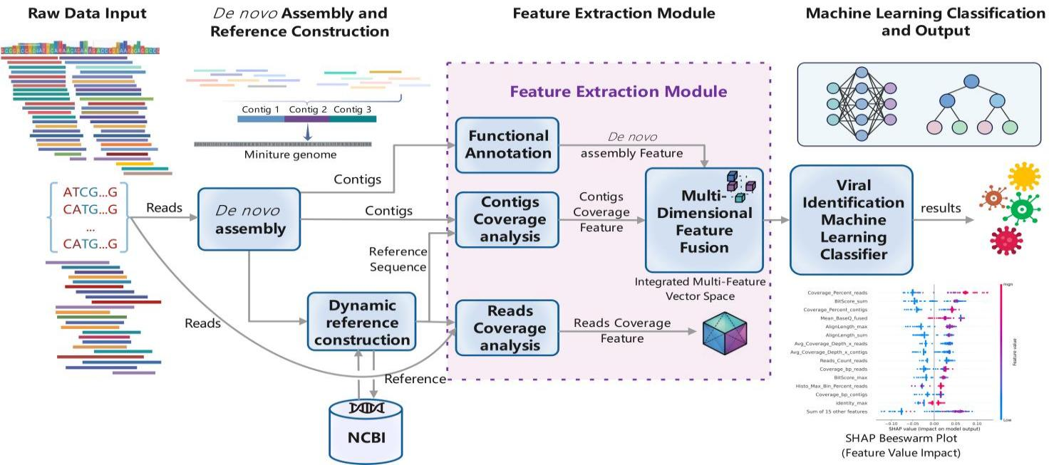
Stage 1: De novo assembly. Raw metatranscriptomic reads were assembled de novo using MEGAHIT (v1.2.9) without reference guidance (Li et al., 2015) . MEGAHIT employed a succinct de Bruijn graph representation, which enabled memory-efficient assembly of datasets with irregular coverage depths. This step produced assembled contigs (FASTA format) and assembly statistics that quantify output quality and complexity (Bai et al., 2022).
Figure 1. Overview of the FuseVirome framework. The pipeline comprises four stages: (1) de novo assembly of metatranscriptomic reads; (2) dynamic reference construction by querying assembled contigs against NCBI and retrieving sample-specific reference genomes; (3) multi-source feature extraction, including functional annotation of contigs (DIAMOND BLASTx), reads coverage analysis (Bowtie2), and contigs coverage analysis (Minimap2/BLAST+), followed by multi-dimensional feature fusion; and (4) machine learning classification to produce a probabilistic viral validation score.

Stage 2: Dynamic reference construction. Assembled contigs were queried against the NCBI nucleotide database using BLAST+ (megablast) with an E-value threshold of 1e−5 (Camacho et al., 2009) . For each candidate virus identified by upstream mNGS analysis, the top BLAST hit, ranked by BitScore and sequence identity, was retrieved, and the corresponding reference genome was downloaded from NCBI RefSeq. These retrieved references constituted a sample-specific dynamic reference library constructed on-the-fly from assembled contigs, obviating the need for a static pre-curated panel.
This dynamic strategy offered three advantages. First, it enabled coverage-based scoring for viruses lacking reference genomes in curated databases, provided a sufficiently similar genome existed in NCBI. Second, it automatically selected the optimal reference for each sample, thereby accommodating viral strain variation that might otherwise render a generic reference suboptimal. Third, it transformed the framework from a closed-set validation problem into an open-set retrieval-and-validation paradigm that generalized to novel viral detections.
Stage 3: Multi-source feature extraction. The feature extraction module integrated three complementary analytical branches: functional annotation of assembled contigs, read-level coverage analysis, and contig-level coverage analysis.
Step 3.1: Functional annotation. Assembled contigs were functionally annotated by alignment against the NCBI non-redundant protein database using DIAMOND (BLASTx mode) with stringent thresholds
Step 3.1: Functional annotation. Assembled contigs are functionally annotated by alignment against the NCBI non-redundant protein database using DIAMOND (BLASTx mode) with stringent thresholds (E-value ≤ 1e−10, sequence identity ≥ 50%, effective alignment length ≥ 50 nt, contig coverage ≥ 30%, reference coverage ≥ 30%, and contig length ≥ 100 nt) (Buchfink et al., 2015,2021). For each contig, the best match was selected by BitScore, and taxonomic lineage was reconstructed using TaxonKit based on the NCBI accession number. Sequences were filtered to retain animal-infecting viruses while excluding phages, plant viruses, and fungal viruses. This branch generated de novo assembly and annotation features, including contig counts and BLAST-derived similarity metrics (Section 2.3).
Step 3.2: Reads coverage analysis. Clean reads were aligned to the dynamic reference using Bowtie2 (v2.3.5) (Langmead and Salzberg, 2012) in end-to-end alignment mode, which required complete read alignments without soft clipping, thereby ensuring that only high-confidence alignments informed feature extraction (Zheng et al., 2023). Seven read coverage features were extracted, including aligned read count, coverage in base pairs, coverage percentage, average depth, mean Phred base quality, mean mapping quality, and maximum coverage histogram bin percentage (Gu et al., 2021).
Step 3.3: Contigs coverage analysis. Assembled contigs were aligned to the dynamic reference using Minimap2 (Li, 2018) and BLAST+ (Camacho et al., 2009), and seven contig coverage features mirroring the read-track dimensions were extracted. Read and contig alignments were merged using SAMtools (Danecek et al., 2021) to generate a consensus alignment, from which seven fused consensus features are derived. In total, thirty-five features were extracted across the de novo assembly, read coverage, contig coverage, fused consensus, and BLAST-derived similarity categories (Section 2.3).
Step 3.4: Feature fusion. The three analytical branches are fused into an initial 35-dimensional feature vector, comprising 3 de novo assembly features from functional annotation, 7 read coverage features, 7 contig coverage features, 7 fused consensus features derived from merged read-and-contig alignments, and 11 BLAST-derived similarity features (Section 2.3). This 35-feature set then undergoes a two-step refinement procedure that removes zero-variance and highly correlated variables, yielding the final optimized 29-feature set (Section 2.4).
Stage 4: Machine learning classification. The final 29-feature set was input to a Random Forest classifier (Topcuoglu et al., 2020; Bai et al., 2022). The classifier output a probabilistic score P(virus|sample) ∈ [0, 1] that serves as the validation metric: high values indicated supported true positives, whereas low values flagged likely false positives for further review (Collins et al., 2024, Camargo et al., 2024).
2.3 Feature extraction
Feature extraction captured five complementary dimensions of viral detection evidence from the dynamic reference alignments. De novo assembly features (3 features) quantified MEGAHIT output: Count_Total_Contigs (total number of assembled contigs), Count_Correct_Contigs (number of contigs aligning to the dynamic reference with E-value ≤ 1e−5), and Count_Noise_Contigs (number of non-aligning contigs) (Bai et al., 2022; Nayfach et al., 2021). Read coverage features (7 features) quantified read-level alignment to the dynamic reference, including Reads_Count_reads (aligned read count), Coverage_bp_reads (coverage in base pairs), Coverage_Percent_reads (percentage of reference covered), Avg_Coverage_Depth_x_reads (average depth), Mean_BaseQ_reads (mean Phred base quality), Mean_MapQ_reads (mean mapping quality), and Histo_Max_Bin_Percent_reads (maximum coverage histogram bin percentage). Contig coverage features (7 features) mirrored the read-track dimensions at the contig level, including Reads_Count_contigs, Coverage_bp_contigs, Coverage_Percent_contigs, Avg_Coverage_Depth_x_contigs, Mean_BaseQ_contigs, Mean_MapQ_contigs, and Histo_Max_Bin_Percent_contigs. Fused consensus features (7 features) were derived from merged read-and-contig alignments, providing cross-validated metrics that reconciled evidence from both tracks: Reads_Count_fused, Coverage_bp_fused, Coverage_Percent_fused, Avg_Coverage_Depth_x_fused, Mean_BaseQ_fused, Mean_MapQ_fused, and Histo_Max_Bin_Percent_fused. BLAST-derived similarity features (11 features) quantified sequence homology from BLAST+ alignment of contigs to the dynamic reference, including BitScore_sum, BitScore_max, and BitScore_mean (cumulative, maximum, and mean BitScore), Identity_max and Identity_mean (maximum and mean sequence identity), AlignLength_sum, AlignLength_max, and AlignLength_mean (alignment length statistics), Mismatch_sum and Mismatch_max (mismatch statistics), and Evalue_min (minimum E-value). Detailed feature definitions and refinement status were provided in Supplementary Table S1.
2.4 Feature refinement
The implemented refinement workflow removed non-informative and redundant variables while preserving biologically meaningful signal (Supplementary Table S2). Stage 1 eliminated zero-variance features; in the current run, Mean_BaseQ_contigs was removed. Stage 2 removed fused-track features exhibiting Pearson correlation r > 0.95 with either constituent track (read or contig); five fused features were eliminated (Reads_Count_fused, Coverage_bp_fused, Coverage_Percent_fused, Avg_Coverage_Depth_x_fused, and Mean_MapQ_fused). No additional collinearity-pruning step was applied in the executed main workflow. The final 29-feature set was detailed in Supplementary Table S1.
2.5 Model training and evaluation
Classifier comparison. Six classification algorithms were evaluated: Random Forest (RF) (Breiman, 2001), Extra Trees (ET) (Geurts et al., 2006), Gradient Boosting (GB) (Friedman, 2001), Logistic Regression (LR) (Cox, 1958), k-Nearest Neighbors (kNN) (Cover and Hart, 1967), and Decision Tree (DT) (Breiman et al., 1984). All classifiers were trained on the 29 retained features and evaluated on the held-out test set (n = 179). Hyperparameters were configured as follows: RF and ET used 100 trees with max_depth = 3, GB used 100 estimators with max_depth = 3, LR used class balancing with max_iter = 1000, kNN used n_neighbors = 5, and DT used max_depth = 3 with class balancing.
Model configuration. The RF classifier was configured with n_estimators = 100 and max_depth = 3. The shallow maximum depth served as deliberate regularization to prevent overfitting and enforce robust decision boundaries.
Evaluation metrics. The primary metric was the area under the receiver operating characteristic curve (AUC), which provided a threshold-independent measure of discriminative performance. Secondary metrics included F1 score, sensitivity, specificity, and accuracy. Confidence intervals for AUC and F1 were estimated via bootstrap resampling (10,000 iterations). The optimal classification threshold was determined by maximizing Youden's J statistic:
(J = sensitivity + specificity−1),
which yielded J = 0.9673 at a probability threshold of 0.6649. Model calibration was assessed using Brier score (0.0365). Decision curve analysis was performed to evaluate clinical utility across threshold probabilities by comparing net benefit against treat-all and treat-none strategies.
Feature importance validation. Gini importance (mean decrease in impurity) was computed from the trained RF to quantify each feature's contribution. Permutation importance (30 repeats on the test set) provided a model-agnostic validation of the ranking. Multi-seed stability testing (10 independent random seeds) yielded a mean AUC of 0.9967 ± 0.0009 (coefficient of variation, CV < 0.001). Feature importance stability was assessed by computing the coefficient of variation for each feature's Gini importance across seeds; features with CV < 0.40 were considered stable.
Computational environment. Read alignment was performed using Bowtie2 (v2.3.5) (Langmead and Salzberg, 2012). De novo assembly was performed using MEGAHIT (v1.2.9) (Li et al., 2015). Contig alignment was performed using BLAST+ (Camacho et al., 2009) and Minimap2 (Li, 2018). Alignment merging was performed using SAMtools (Danecek et al., 2021). Machine learning was implemented in Python with NumPy, pandas, Matplotlib, and scikit-learn (v1.3.0) (Pedregosa et al., 2011). The complete pipeline was reproducible with version-pinned dependencies.

3 Results
3.1 Classifier Comparison
On the 29-dimensional optimized feature set, Random Forest (RF) outperformed the five other classifiers, achieving an AUC of 0.9972, sensitivity (Se) of 0.9909 (109/110), specificity (Sp) of 0.9275 (64/69), and an F1 score of 0.9732 (Table 1). Extra Trees (ET) closely followed (AUC = 0.9957, F1 = 0.9725, Sp = 0.9710), with Gradient Boosting (GB) ranking third (AUC = 0.9874). ROC curves revealed a clear performance hierarchy: RF and ET clustered as a distinct upper-tier group, separated from the remaining classifiers (Figure. 2). RF was selected as the primary classifier based on its optimal metric balance—highest AUC and F1 score with only one false negative. Despite ET's superior specificity (0.9710 versus 0.9275), it incurred four false negatives versus one for RF; GB matched RF in sensitivity but produced more false positives. The weaker performance of Logistic Regression (AUC = 0.9241), k-Nearest Neighbors (kNN, AUC = 0.9498), and Decision Tree (AUC = 0.9067) further confirmed nonlinear decision boundaries in the fused feature space (Table 1).
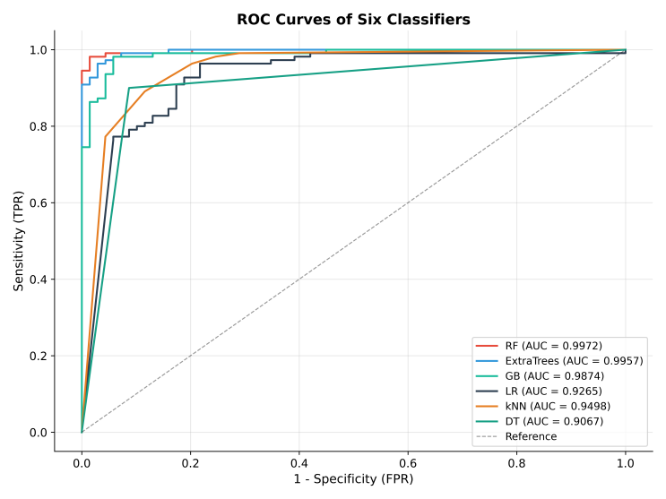Figure 2. ROC curves of the six evaluated classifiers on the independent external test set. Random Forest achieved the highest AUC (0.9972), followed by ExtraTrees (0.9957), Gradient Boosting (0.9874), k-Nearest Neighbors (0.9498), Logistic Regression (0.9241), and Decision Tree (0.9067).

3.2 Feature Importance
The top 10 features ranked by mean Gini importance from the RF model revealed a concentrated discriminative structure spanning read, contig, and BLAST-derived evidence (Supplementary Table S3 and Figure S1). The top three predictors, Coverage_Percent_reads, BitScore_sum, and Coverage_Percent_contigs were drawn from complementary evidence layers. Model-agnostic permutation importance
Table 1. Six-classifier comparison on the external test set (29 features)
Classifier | AUC | F1 | Acc | Se | Sp | TP | TN | FP | FN
Random Forest | 0.9972 | 0.9732 | 0.9665 | 0.9909 | 0.9275 | 109 | 64 | 5 | 1
Extra Trees | 0.9957 | 0.9725 | 0.9665 | 0.9636 | 0.9710 | 106 | 67 | 2 | 4
Gradient Boosting | 0.9874 | 0.9520 | 0.9385 | 0.9909 | 0.8551 | 109 | 59 | 10 | 1
Logistic Regression | 0.9241 | 0.9060 | 0.8771 | 0.9636 | 0.7391 | 106 | 51 | 18 | 4
k-Nearest Neighbors | 0.9498 | 0.9217 | 0.8994 | 0.9636 | 0.7971 | 106 | 55 | 14 | 4
Decision Tree | 0.9067 | 0.8384 | 0.8212 | 0.7545 | 0.9275 | 83 | 64 | 5 | 27

Bootstrap resampling confirmed the classifier ranking observed in the fixed test set (Figure 3). RF achieved the best sensitivity-accuracy trade-off across 1,000 resampled sets and maintained high recall with a tight F1 distribution. Extra Trees remained competitive but carried a higher false-negative burden, whereas Gradient Boosting preserved sensitivity at the expense of increased false positives. Logistic Regression, kNN, and Decision Tree showed broader resampling distributions, which indicated reduced stability when classification relied on interacting read-level, contig-level, and BLAST-derived features.
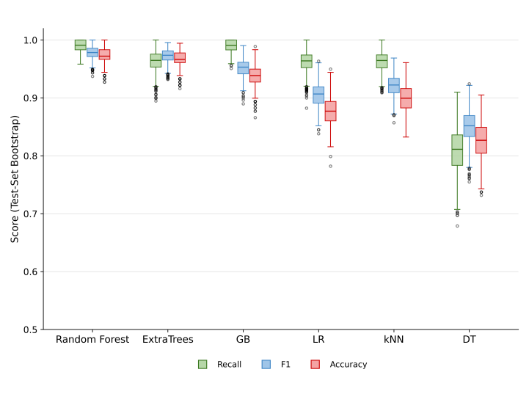
Figure 3. Bootstrap distributions of recall, F1 score, and accuracy across 10,000 test-set resamples for the six classifiers. Random Forest exhibited the highest median values and the narrowest interquartile ranges across all three metrics.

corroborated Coverage_Percent_reads as the primary predictor and further elevated AlignLength_max and Histo_Max_Bin_Percent_reads as high-impact variables. The track distribution within the top 10 (4 read-level, 4 BLAST-derived, 2 contig-level) indicates that no single evidence type dominates the final classifier.
3.3 Ablation Study
A 9-configuration ablation experiment was conducted to quantify the contribution of each feature track and the implemented refinement pipeline (Supplementary Table S4). The final 29-feature model achieved optimal F1 score (0.9732) and specificity (0.9275), whereas the 27-feature DeNovo+Read+Contig+BLAST configuration produced a marginally higher AUC (0.9975) with an equivalent false-negative count (1). Relative to the full 35-feature baseline, the 29-feature model improved AUC from 0.9966 to 0.9972 and specificity from 0.8841 to 0.9275 while maintaining sensitivity at 0.9909. Single-track configurations revealed complementary strengths: read-coverage features optimized sensitivity, contig-coverage features optimized specificity, and de novo features alone were insufficient for reliable classification.
3.4 Model Validation
We evaluated the statistical reliability and robustness of the final model through six complementary strategies (Table 2; Supplementary Figure S2). Bootstrap resampling (n = 10,000) yielded tight 95% confidence intervals for AUC (0.9921–1.0000) and F1 score (0.9496–0.9915), confirming stable classification performance. Multi-seed validation across 10 independent random initializations produced a mean AUC of 0.9967 ± 0.0009, indicating robustness to stochastic variation. The Brier score of 0.0365 indicated favorable probability calibration, essential for interpreting model outputs as reliable confidence measures. PPV/NPV analyses across varying prevalence scenarios and VIF diagnostics for the 29-feature set are provided in Supplementary Table S5. Decision curve analysis demonstrated net-benefit superiority over both treat-all and treat-none strategies across the clinically actionable threshold range (0.05–0.98), with a maximum net benefit of 0.6106 (Supplementary Figure S3). At the Youden-optimized threshold (0.6649, J = 0.9673), sensitivity and specificity were 0.9818 and 0.9855, respectively.
Table 2. Validation metrics for the final Random Forest model (29 features)
Metric | Estimate | 95% Confidence Interval
AUC | 0.9972 | [0.9921, 1.0000]
F1 score | 0.9732 | [0.9496, 0.9915]
Youden's J | 0.9673 | Threshold = 0.6649
Multi-seed AUC (10 seeds) | 0.9967 ± 0.0009 | CV < 0.001
Brier score | 0.0365 | -

3.5 Model Interpretability with SHAP
SHAP (SHapley Additive exPlanations) analysis with TreeExplainer was applied to the final 29-feature Random Forest model on the independent external test set to decompose predictions into feature-level contributions, enabling both global importance ranking and local case-level interpretation (Supplementary Figures S5-S7).
The top five features by mean |SHAP value| were Coverage_Percent_reads (0.0641), Mean_BaseQ_fused (0.0412), AlignLength_max (0.0403), Reads_Count_reads (0.0358), and BitScore_sum (0.0350), consistent with their high Gini and permutation importance rankings. Global analysis (Figure 4) revealed that positive predictions were driven by broad, high-quality viral alignment evidence rather than isolated high-depth signals. High values of Coverage_Percent_reads, AlignLength_max, Reads_Count_reads, and BitScore_sum shifted predictions toward the qPCR-confirmed positive class, whereas low coverage breadth and weak BLAST support shifted predictions toward the negative class. Mean_BaseQ_fused served as a refinement signal in marginal cases, distinguishing reliable alignments from lower-quality evidence. This pattern indicates that the model learned a biologically coherent decision rule requiring convergent support across genomic span, read abundance, sequence similarity, and alignment quality.
Feature-dependence analysis (Figure 5) demonstrated that Coverage_Percent_reads contributed strongly once coverage broadened across the candidate viral genome, approaching saturation at high values. BitScore_sum and Coverage_Percent_contigs exhibited similar positive but diminishing-return patterns, consistent with their roles as confirmatory evidence rather than linear score multipliers. Mean_BaseQ_fused exerted its greatest influence at intermediate quality values, supporting its role in refining ambiguous cases. These relationships explain the retention of complementary read-, contig-, and BLAST-derived variables despite partial correlation among alignment summary statistics. Local waterfall explanations for representative cases—including high-confidence true-positive and true-negative instances, the sole false negative, a false positive, and a near-threshold sample—revealed the feature-level contributions driving individual predictions (Supplementary Figure S7). Collectively, these analyses confirm that FuseVirome predictions are grounded in biologically meaningful alignment and assembly signals, providing a transparent basis for case-level review.
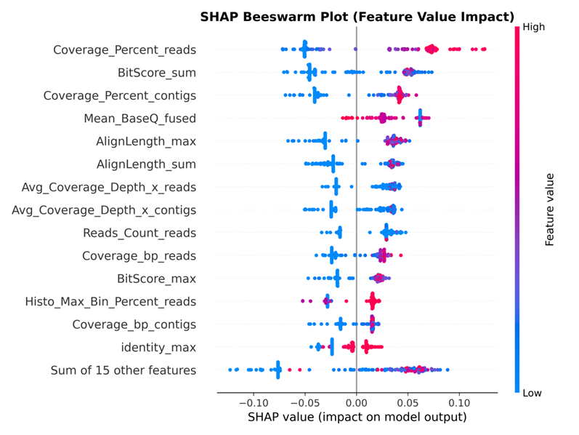
Figure 4. SHAP beeswarm plot showing global feature importance for the final Random Forest model. Each point represents one virus-sample instance, colored by feature value; positive SHAP values increase the predicted probability of a true viral signal.

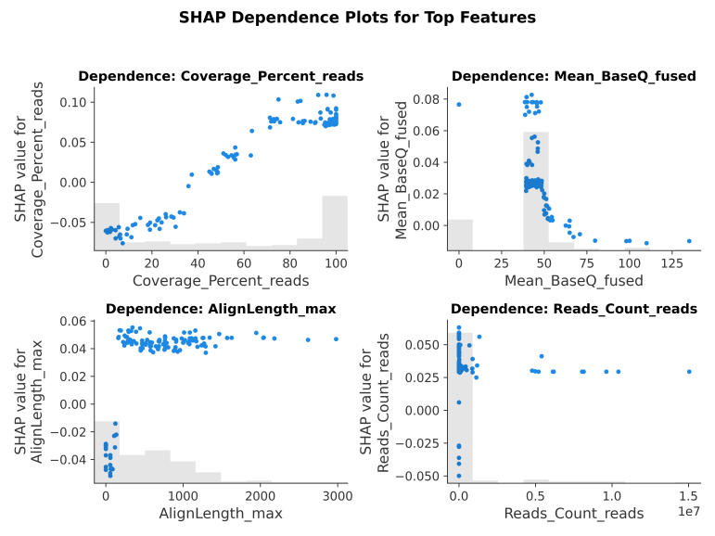
Figure 5. SHAP dependence plots for the top four predictive features. (A) Coverage_Percent_reads. (B) BitScore_sum. (C) Coverage_Percent_contigs. (D) Mean_BaseQ_fused.

4 Discussion
Here, we introduce FuseVirome, a machine learning framework for the computational validation of viral signals in metatranscriptomic sequencing (mNGS) data. The framework comprises four synergistic modules:(i) de novo assembly, (ii) dynamic reference construction, (iii) multi-source feature extraction, and (iv) machine learning classification.Eliminating reliance on fixed reference panels, FuseVirome synthesizes genomic alignment and functional annotation information across heterogeneous sequence sources to enable robust discrimination and precise identification of viral signals across diverse sequence lengths. Validated against qPCR-confirmed mNGS viral signals, the framework attained an AUC of 0.9972 (95% CI: 0.9921–1.0000) and an F1 score of 0.9732 (95% CI: 0.9496–0.9915). These results demonstrate strong discriminative performance and broad generalizability, effectively bridging the gap between unbiased viral discovery and targeted confirmatory testing.
The key innovations of FuseVirome are threefold. First, it eliminates dependency on predefined reference libraries, which are inherently ineffective for novel or divergent viruses, by leveraging BLAST+ to dynamically retrieve closest-matching NCBI genomes and construct sample-specific reference sets. This reframes viral detection as a similarity-based retrieval task, enabling automated scoring and feature extraction from coverage depth, sequence similarity, and functional annotation without reliance on fixed panels. Second, its multi-source feature extraction architecture synergistically optimizes sensitivity and specificity. Read-level alignments capture low-abundance signals even when assembly remains incomplete, whereas contig-level alignments suppress host background noise through robust structural evidence, and functional annotation provides orthogonal homology-based discrimination. Ablation studies confirmed their complementarity: read-coverage features maximize sensitivity, while contig-coverage features maximize specificity. The Random Forest classifier further exploits nonlinear interactions among these multimodal features, reflecting the biological reality that authentic infections generate concordant evidence across reads, contigs, and homology, whereas artifacts are typically confined to a single modality. Third, FuseVirome exhibits strong translational potential. SHAP analysis confirmed that predictions are driven by biologically interpretable signals, including coverage breadth, alignment quality, and sequence similarity, rather than spurious artifacts. Third, FuseVirome exhibits strong translational potential. SHAP analysis confirmed that predictions are driven by biologically interpretable signals, including coverage breadth, alignment quality, and sequence similarity, rather than spurious artifacts.
Furthermore, FuseVirome is designed to complement, rather than supplant, existing detection pipelines, serving as a computational triage and prioritization tool for downstream confirmatory testing. Future efforts will focus on expanding the dynamic reference library to capture viral dark matter (unclassified and novel viruses), thereby enhancing sensitivity to fragmented viral signals. We will also optimize the algorithmic architecture through feature dimensionality reduction and model pruning to reduce the computational overhead of full-feature fusion, further enhancing the framework's scalability for high-throughput diagnostic applications.

Author contributions
Shuting Yang: Formal analysis, Software, Visualization, Writing - original draft. Mengyao Wang: Investigation, Resources, Data curation. Wenjun Liu: Resources. Chunhong Zhang: Supervision, Funding acquisition. Xinliang Fu: Resources.Chunhong Zhang: Resources. Jun He: Supervision, Writing - review & editing, Funding acquisition. Jianhua Zheng: Methodology, Supervision, Writing - review & editing, Funding acquisition. Ming Liao: Methodology, Supervision, Funding acquisition.

Conflict of interests
None declared.

Funding
The authors thank the anonymous reviewers for their valuable suggestions. This work was supported by the Epidemiological Survey and Research on Key Prevention and Control Technologies for Waterfowl Diseases in South China (2024ZDJS001), the National Natural Science Foundation of China (grant NO. 32273036), Open Research Project of the Key Laboratory of Viral Pathogenesis & Infection Prevention and Control of the Ministry of Education (Fund No. 2025VPPC-R02), Core Task Research Project of State Key Laboratory of Swine and Poultry Breeding Industry (ZQQZ-G16), Special Project of Guangdong Province for Promoting Coordinated Urban-Rural and Regional Development via Transfer of Scientific and Technological Achievements to Counties and Towns (2026A0202020026), the Undergraduate Teaching Quality Project of Guangdong Province: Teaching and Research Section of Artificial Intelligence Curriculum Group (Guangdong Higher Education Letter [2024] No. 9), and the Guangdong Postgraduate Education Innovation Plan Project (grant No. 2024JGXM_090).

Reference
Bai J et al.. A systematic evaluation of tools for identifying viruses from metagenomic data. Brief Bioinform 2022;23:bbac346.
Bradford LM, Carrillo C, Wong A. Managing false positives during detection of pathogen sequences in shotgun metagenomics datasets. BMC Bioinformatics 2024;25. doi:10.1186/s12859-024-05952-x.
Breiman L et al.. Classification and Regression Trees. Boca Raton, FL: CRC Press, 1984.
Breiman L. Random forests. Mach Learn 2001;45:5–32.
Buchfink B, Xie C, Huson DH. Fast and sensitive protein alignment using DIAMOND. Nat Methods 2015;12:59–60.
Buchfink B, Reuter K, Drost HG. Sensitive protein alignments at tree-of-life scale using DIAMOND. Nat Methods 2021;18:366–8.
Camacho C et al.. BLAST+: architecture and applications. BMC Bioinformatics 2009;10:421.
Camargo AP et al.. Identification of mobile genetic elements with geNomad. Nat Biotechnol 2024;42:303–11.
Collins GS et al.. TRIPOD+AI statement: updated guidance for reporting clinical prediction models that use machine learning. BMJ 2024;385:e078378.
Cover T, Hart P. Nearest neighbor pattern classification. IEEE Trans Inf Theory 1967;13:21–27.
Cox DR. The regression analysis of binary sequences. J R Stat Soc Series B Stat Methodol 1958;20:215–32.
Danecek P et al.. Twelve years of SAMtools and BCFtools. GigaScience 2021;10:giab008.
Edgar RC et al.. Petabase-scale sequence alignment catalyses viral discovery. Nature 2022;602:142–7.
Friedman JH. Greedy function approximation: a gradient boosting machine. Ann Stat 2001;29:1189–1232.
Gaston DC et al.. Evaluation of metagenomic and targeted next-generation sequencing workflows for detection of respiratory pathogens from bronchoalveolar lavage fluid specimens. J Clin Microbiol 2022;60:e00526–22.
Geurts P, Ernst D, Wehenkel L. Extremely randomized trees. Mach Learn 2006;63:3–42.
Gu W et al.. Rapid pathogen detection by metagenomic next-generation sequencing of infected body fluids. Nat Med 2021;27:115–24.
Ko KKK, Chng KRM, Nagarajan N. Metagenomic next-generation sequencing (mNGS) in clinical infectious diseases: where are we now and where are we heading?. Clin Microbiol Infect 2022;28:1413–22.
Kosmopoulos JC, Anantharaman K. Viral dark matter: illuminating protein function, ecology, and biotechnological promises. arXiv 2025. doi:10.48550/arXiv.2506.11942.
Langmead B, Salzberg SL. Fast gapped-read alignment with Bowtie 2. Nat Methods 2012;9:357–9.
Li D et al.. MEGAHIT: an ultra-fast single-node solution for large and complex metagenomics assembly via succinct de Bruijn graph. Bioinformatics 2015;31:1674–6.
Li H. Minimap2: pairwise alignment for nucleotide sequences. Bioinformatics 2018;34:3094–3100.
Luo Y et al.. Managing false positives during detection of pathogen sequences in shotgun metagenomics datasets. BMC Bioinformatics 2024;25:1–14.
Meyer F et al.. Critical assessment of metagenome interpretation—the second round of challenges. Nat Methods 2022;19:429–40.
Monshizadeh M, Ye Y. Incorporating metabolic activity, taxonomy and community structure to improve microbiome-based predictive models for host phenotype prediction. Gut Microbes 2024;16. doi:10.1080/19490976.2024.2302076.
Nayfach S et al.. CheckV assesses the quality and completeness of metagenome-assembled viral genomes. Nat Biotechnol 2021;39:578–85.
Neri U et al.. Expansion of the global RNA virome reveals diverse clades of bacteriophages. Cell 2022;185:4023–37.
Pedregosa F et al.. Scikit-learn: machine learning in Python. J Mach Learn Res 2011;12:2825–30.
Portik WJ et al.. Evaluation of taxonomic classification and profiling methods for long-read and short-read metagenomics. BMC Bioinformatics 2022;23:541.
Roux S et al.. iPHoP: an integrated machine-learning framework to maximize host prediction for metagenome-assembled virus genomes. PLoS Biol 2022;21:e3002083.
Shen W, Ren H. TaxonKit: a practical and efficient NCBI taxonomy toolkit. J Genet Genomics 2021;48:844–50.
Topçuoğlu BD et al.. A framework for effective application of machine learning to microbiome data. mBio 2020;11:e00434–20.
Wang H et al.. Impact of SARS-CoV-2 variants on the analytical sensitivity of rRT-PCR assays. J Clin Microbiol 2022;60:e02374–21.
Wylezich C et al.. Next-generation diagnostics: virus capture facilitates a sensitive viral diagnosis for epizootic and zoonotic pathogens. Microbiome 2021;9:51.
Zablocki O et al.. Phage quest: a beginner's guide to explore viral diversity in the prokaryotic world. Brief Bioinform 2024;25:bbaf449.
Zhang Y et al.. SegVir: reconstruction of complete segmented RNA viral genomes from metatranscriptomes. Mol Biol Evol 2024;41:msae171.
Zheng T et al.. Mining the virome for insights into host-microbe interactions. Nat Rev Microbiol 2023;21:62
Zheng Y et al. Metagenomic next-generation sequencing of cell-free DNA for the identification of viruses causing central nervous system infections. Microbiol Spectr 2024;12:e02264–23.

