Supplementary Material
FuseVirome: A Machine Learning Framework with Dynamic Reference Construction for Scoring Viral Signals in Veterinary Metatranscriptomic Sequencing
This supplementary document provides detailed methods, complete feature definitions, and extended results supporting the main manuscript.

1 Supplementary for Methods and materials

1.1 Feature Refinement Pipeline
A two-step feature refinement pipeline was applied to the initial 35-feature set to derive the final 29-feature set used in the Random Forest classifier.
Stage 1: Zero-variance feature removal(Greener et al. 2022). Feature variance was computed across the training set. Features with zero variance provide no discriminative signal and can destabilize model training. One feature was removed: Mean_BaseQ_contigs (constant value 255—the maximum Phred quality score—across all samples due to upstream base quality filtering). Retained: 34 features.
Stage 2: Fused-track redundancy elimination. Pearson correlation coefficients were computed between each fused-track feature and its corresponding read-track and contig-track features. Fused features exhibiting correlation r > 0.95 with either constituent track were flagged for removal(Whalen et al. 2022; Greener et al. 2022). Five fused features were removed: Reads_Count_fused, Coverage_bp_fused, Coverage_Percent_fused, Avg_Coverage_Depth_x_fused, and Mean_MapQ_fused. Each was nearly perfectly correlated with its read-track counterpart because read alignment dominated the merged alignment. Retained: 29 features.
No additional collinearity-pruning stage was executed in the current main workflow. All results reported in the main manuscript are based on this retained 29-feature set.
Supplementary Table S1 documents the full feature inventory used to construct the final model. Of the 35 engineered variables, 29 were retained after removing one zero-variance base-quality feature and five redundant fused-track summaries. The retained set spans assembly, read coverage, contig coverage, fused consensus, and BLAST-derived evidence, preserving the multi-track structure required for virus-level signal validation.
Table S1. Complete feature set and refinement status
No. | Feature Name | Category | Track | Status
1 | Count_Total_Contigs | De novo assembly | Assembly | Retained
2 | Count_Correct_Contigs | De novo assembly | Assembly | Retained
3 | Count_Noise_Contigs | De novo assembly | Assembly | Retained
4 | Reads_Count_reads | Read coverage | Read | Retained
5 | Coverage_bp_reads | Read coverage | Read | Retained
6 | Coverage_Percent_reads | Read coverage | Read | Retained
7 | Avg_Coverage_Depth_x_reads | Read coverage | Read | Retained
8 | Mean_BaseQ_reads | Read coverage | Read | Retained
9 | Mean_MapQ_reads | Read coverage | Read | Retained
10 | Histo_Max_Bin_Percent_reads | Read coverage | Read | Retained
11 | Coverage_bp_contigs | Contig coverage | Contig | Retained
12 | Coverage_Percent_contigs | Contig coverage | Contig | Retained
13 | Avg_Coverage_Depth_x_contigs | Contig coverage | Contig | Retained
14 | Mean_BaseQ_contigs | Contig coverage | Contig | Removed(S1)
15 | Mean_MapQ_contigs | Contig coverage | Contig | Retained
16 | Histo_Max_Bin_Percent_contigs | Contig coverage | Contig | Retained
17 | Reads_Count_fused | Fused consensus | Fused | Removed(S2)
18 | Coverage_bp_fused | Fused consensus | Fused | Removed(S2)
19 | Coverage_Percent_fused | Fused consensus | Fused | Removed(S2)
20 | Avg_Coverage_Depth_x_fused | Fused consensus | Fused | Removed (S2)
21 | Mean_BaseQ_fused | Fused consensus | Fused | Retained
22 | Mean_MapQ_fused | Fused consensus | Fused | Removed(S2)
23 | Histo_Max_Bin_Percent_fused | Fused consensus | Fused | Retained
24 | BitScore_sum | BLAST-derived | BLAST | Retained
25 | BitScore_max | BLAST-derived | BLAST | Retained
26 | BitScore_mean | BLAST-derived | BLAST | Retained
27 | identity_max | BLAST-derived | BLAST | Retained
28 | identity_mean | BLAST-derived | BLAST | Retained
29 | qlen_mean | BLAST-derived | BLAST | Retained
30 | qlen_max | BLAST-derived | BLAST | Retained
31 | qlen_sum | BLAST-derived | BLAST | Retained
32 | Mismatches_sum | BLAST-derived | BLAST | Retained
33 | Mismatches_max | BLAST-derived | BLAST | Retained
34 | Mismatches_mean | BLAST-derived | BLAST | Retained
35 | Evalue_min | BLAST-derived | BLAST | Retained

1.2 Variance Inflation Factor Analysis
VIF was computed on the final 29-feature set to quantify residual multicollinearity. Because Count_Total_Contigs, Count_Correct_Contigs, and Count_Noise_Contigs are exactly linearly related, the maximum and mean VIF are infinite. Additional retained features also showed large VIF values, indicating strong structural correlation among alignment-derived metrics. Random Forest remains comparatively robust to this dependence because trees select features locally and aggregate across many correlated partitions.

2 Supplementary for Results

2.1 Feature refinement performance
As shown in Supplementary Table S2, the performance gain resulted from targeted redundancy control rather than from increased model complexity. Excluding the five highly correlated fused-track features improved specificity from 0.8841 to 0.9275 and slightly increased AUC from 0.9967 to 0.9972, with sensitivity maintained at 0.9909. These results support the 29-feature configuration as a cleaner and more discriminative input set.
Table S2. Feature refinement pipeline performance
Stage | Features | AUC | Specificity | Key Change
Initial set | 35 | 0.9966 | 0.8841 | Baseline 35-feature model
After Stage 1 | 34 | 0.9967 | 0.8841 | Remove zero-variance feature
After Stage 2 (Final) | 29 | 0.9972 | 0.9275 | Remove 5 redundant fused-track features

2.2 Feature importance
Supplementary Table S3 indicates that the top 10 variables accounted for 73.76% of total Gini importance. Coverage_Percent_reads ranked first (Gini = 0.1255), followed by BitScore_sum (0.1006) and Coverage_Percent_contigs (0.0829). The leading features thus combine genome-wide coverage breadth, sequence-similarity strength, and assembly-supported coverage, confirming that the classifier is not driven by a single measurement channel.
Table S3. Top 10 features ranked by mean Gini importance
Rank | Feature | Gini | Track
1 | Coverage_Percent_reads | 0.1255 | Read coverage
2 | BitScore_sum | 0.1006 | BLAST-derived
3 | Coverage_Percent_contigs | 0.0829 | Contig coverage
4 | AlignLength_sum | 0.0724 | BLAST-derived
5 | Avg_Coverage_Depth_x_contigs | 0.0704 | Contig coverage
6 | AlignLength_max | 0.0640 | BLAST-derived
7 | Avg_Coverage_Depth_x_reads | 0.0577 | Read coverage
8 | Coverage_bp_reads | 0.0557 | Read coverage
9 | BitScore_max | 0.0552 | BLAST-derived
10 | Reads_Count_reads | 0.0533 | Read coverage

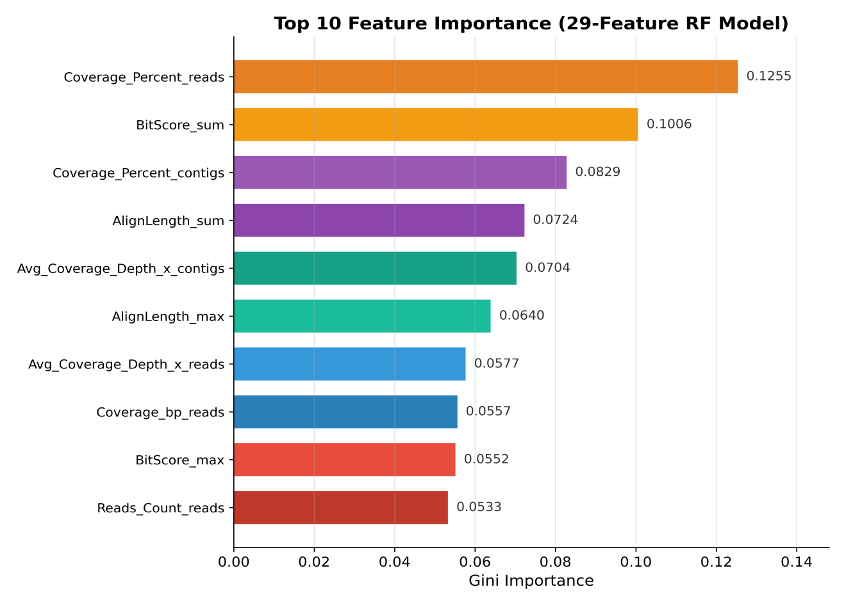
Fig. S1. Feature importance ranking. Bar plot displaying the top 10 features ranked by mean Gini importance from the final 29-feature Random Forest model. Coverage_Percent_contigs (Gini = 0.1475), Coverage_Percent_reads (0.1194), and BitScore_sum (0.1144) constitute the three most informative features.
The importance profile supports the multi-track architecture of FuseVirome: coverage-breadth variables and BLAST-derived alignment-strength metrics form the leading contributors, with both read-level and contig-level evidence represented among the top-ranked predictors.

2.3 Ablation study
Supplementary Table S4 demonstrates the complementary value of the feature tracks. Single-track models were informative but incomplete: the DeNovo track alone missed 18 positives, ReadCov and ContigCov each missed 2, and the BLAST track alone missed 10. Multi-track configurations reduced this error burden. The final 29-feature model achieved the best F1 score (0.9732) and specificity (0.9275) with only one false negative. Although the 27-feature DeNovo+Read+Contig+BLAST configuration achieved a marginally higher AUC (0.9975), the final model was retained for its superior overall balance of F1, specificity, and sensitivity.
Table S4. Nine-configuration ablation study
Config | Features | AUC | Se | Sp | FN
DeNovo | 3 | 0.9495 | 0.8364 | 0.8696 | 18
ReadCov | 7 | 0.9781 | 0.9818 | 0.8551 | 2
ContigCov | 6 | 0.9852 | 0.9818 | 0.9130 | 2
BLAST | 11 | 0.9814 | 0.9091 | 0.8986 | 10
Read+Contig | 13 | 0.9810 | 0.9909 | 0.8551 | 1
Read+Contig+Fused | 15 | 0.9806 | 0.9818 | 0.8551 | 2
DeNovo+Read+Contig | 16 | 0.9856 | 0.9909 | 0.8841 | 1
DeNovo+Read+Contig+BLAST | 27 | 0.9975 | 0.9909 | 0.9130 | 1
Full_29f | 29 | 0.9972 | 0.9909 | 0.9275 | 1

2.4 Predictive values across prevalence settings
Supplementary Table S5 converts test-set sensitivity and specificity into predictive values across clinically plausible prevalence settings. At 5% prevalence, representative of targeted veterinary screening, the PPV was 41.9% and the NPV was 99.95%. The consistently high NPV across 1–20% prevalence indicates strong rule-out utility; conversely, the lower PPV at low prevalence underscores that positive scores warrant confirmatory qPCR or expert review rather than stand-alone diagnosis.
Table S5. PPV and NPV at different disease prevalence assumptions
Prevalence | PPV | NPV
1% | 12.1% | 99.99%
5% | 41.9% | 99.95%
10% | 60.3% | 99.89%
20% | 77.4% | 99.76%

2.5 Collinearity assessment
Supplementary Table S6 documents substantial residual multicollinearity, with infinite maximum and mean VIF values arising from exact linear dependence among the three assembly count features. This structure is expected because several retained variables summarize related alignment evidence at different resolutions. The VIF results therefore characterize feature architecture rather than invalidate the RF model, which is comparatively robust to correlated predictors and was further validated through external testing, permutation importance, and multi-seed stability analysis.
Table S6. VIF analysis and collinearity assessment
Metric | Value
Maximum VIF | Inf
Mean VIF | Inf
Features with VIF > 10 | 26/29 (89.7%)

2.6 Model validation and classifier comparison
To evaluate the statistical reliability and robustness of FuseVirome, we performed bootstrap resampling, calibration analysis, decision curve analysis, and a six-classifier comparison. The results are summarized in Supplementary Figures S2–S4.
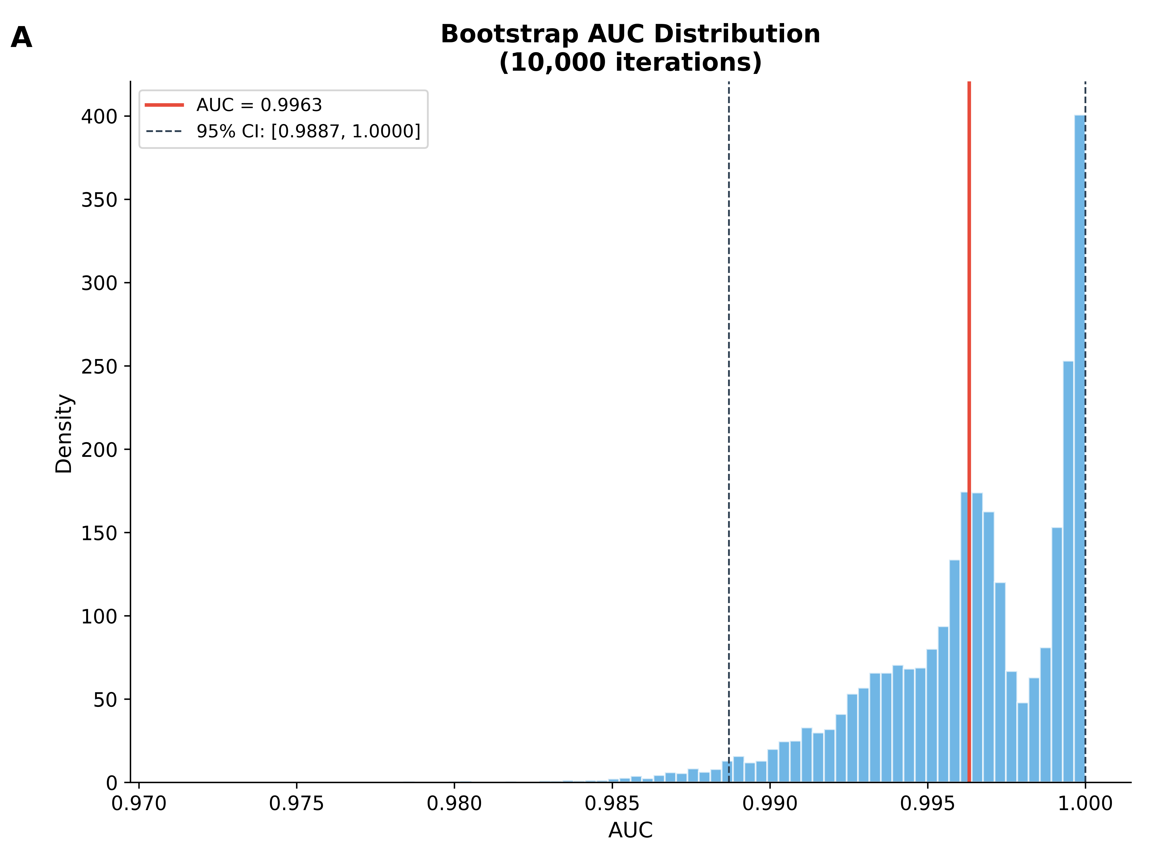
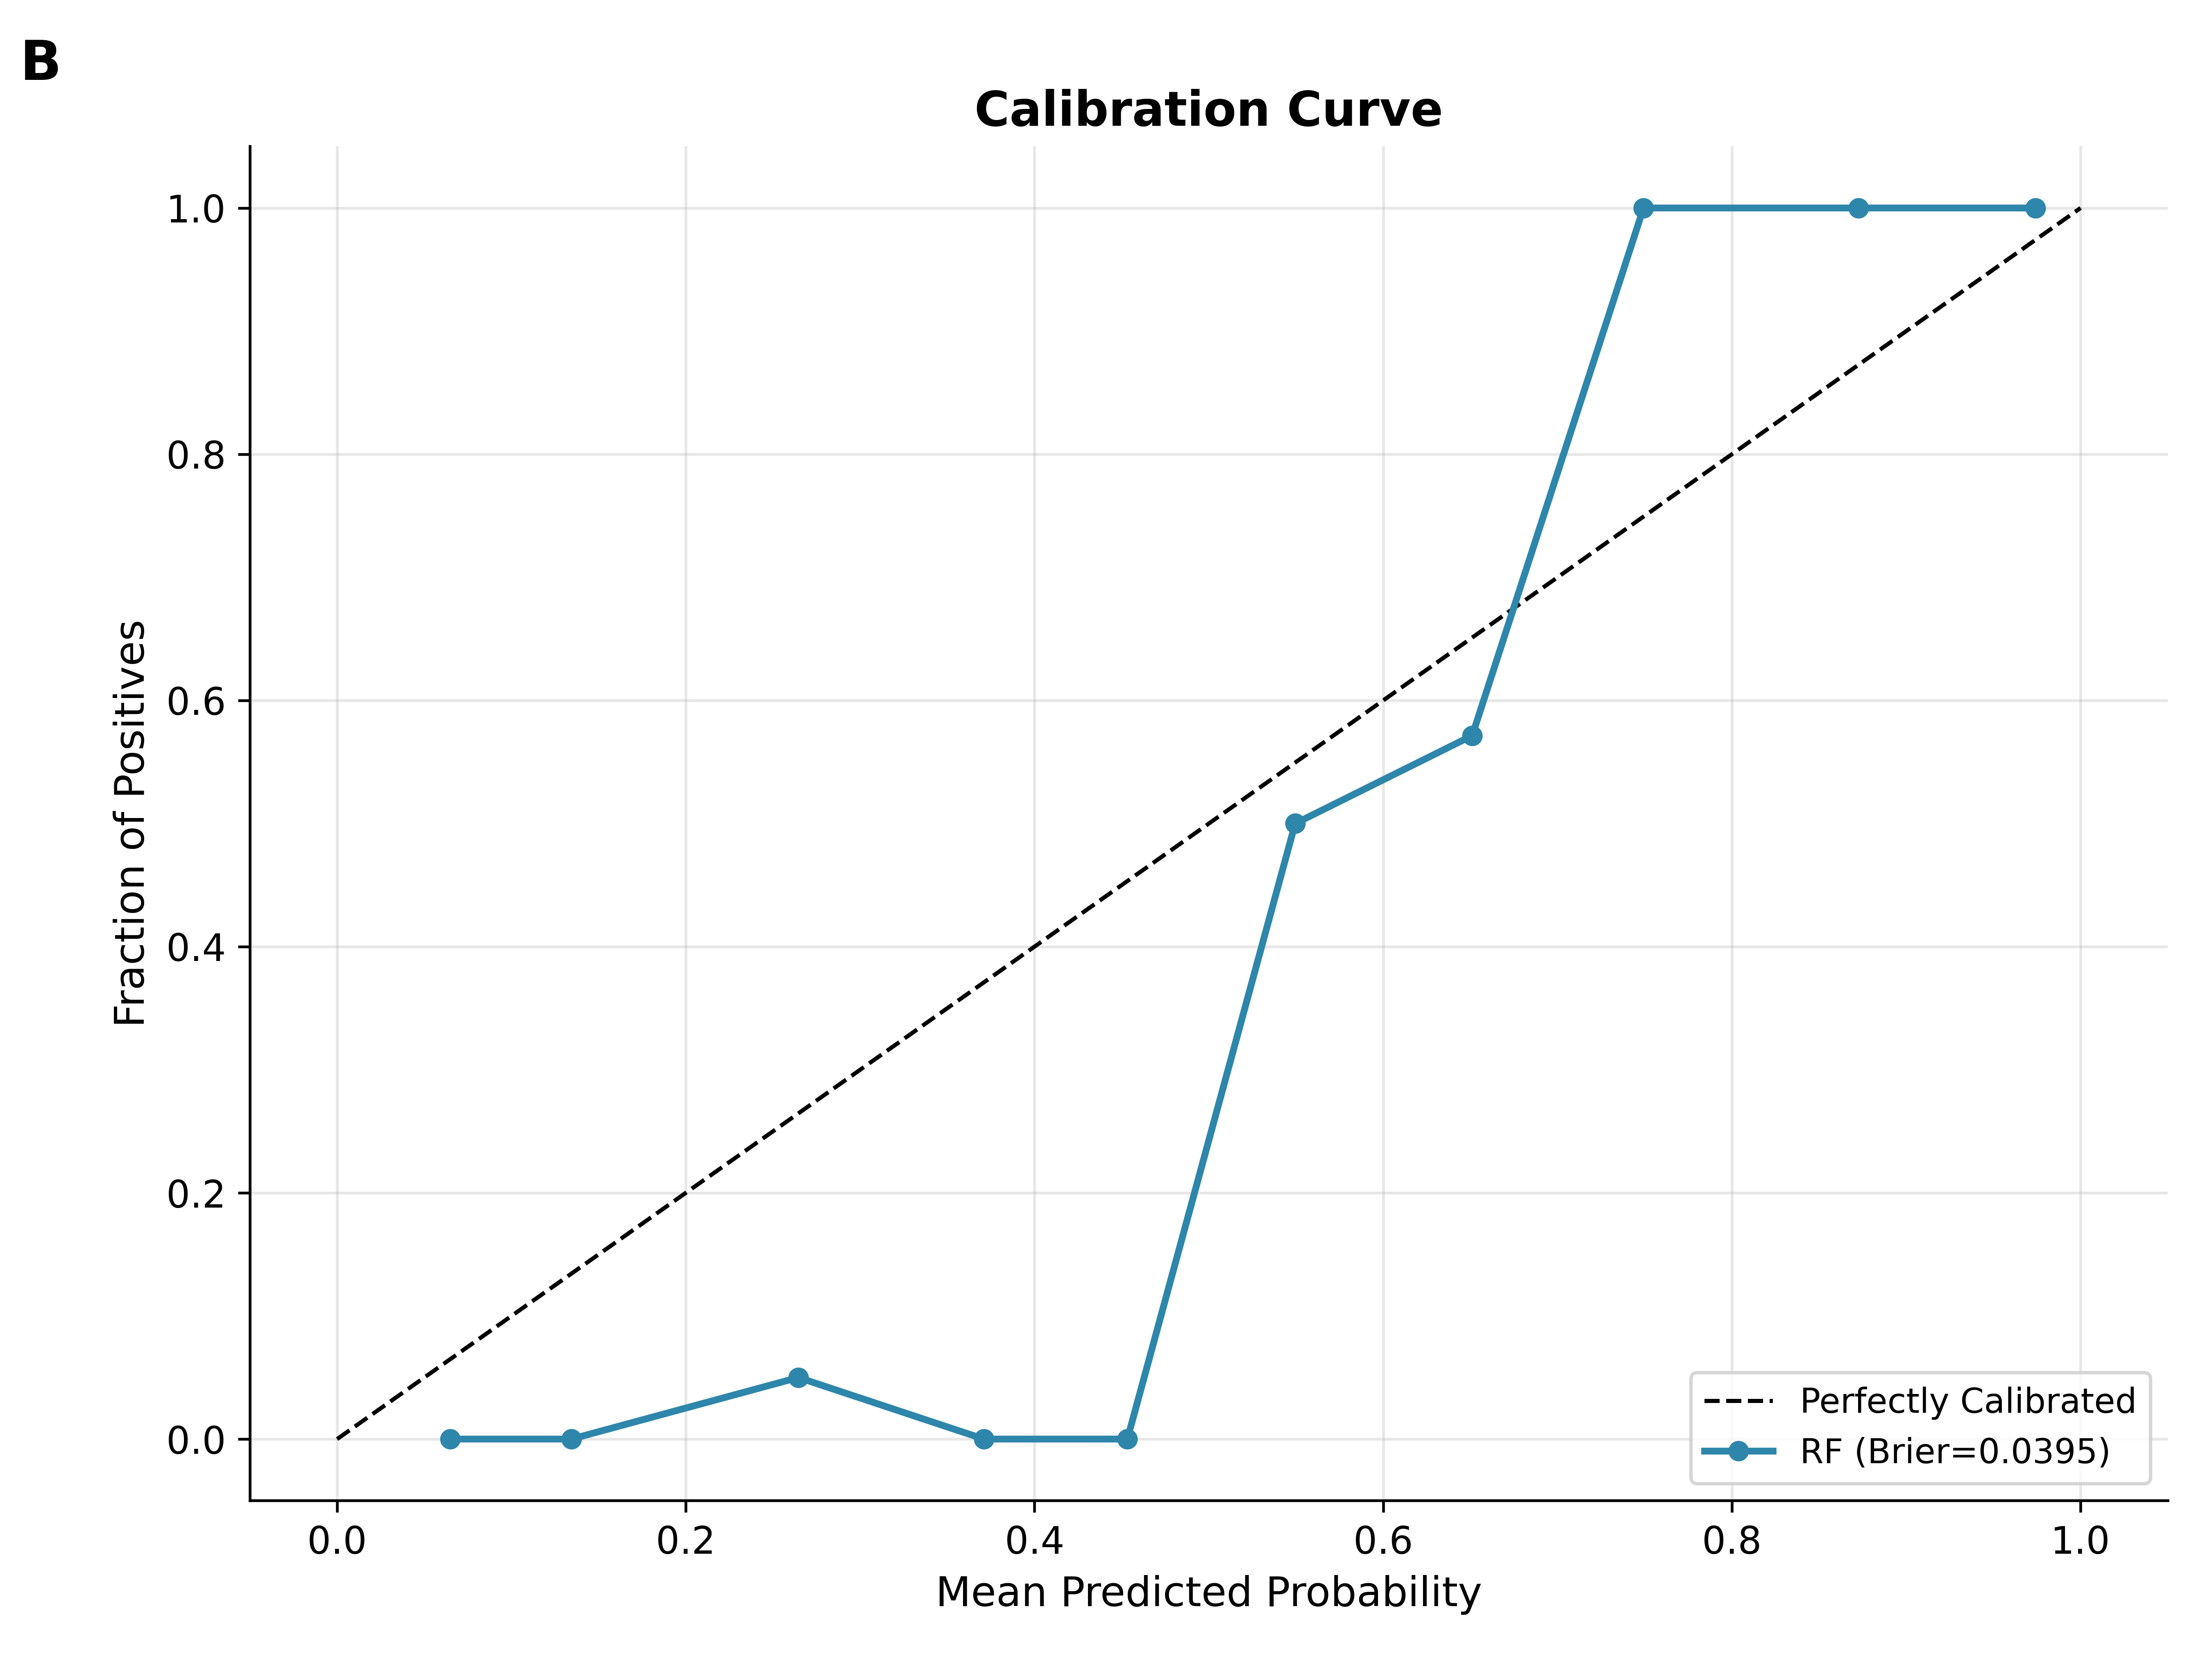
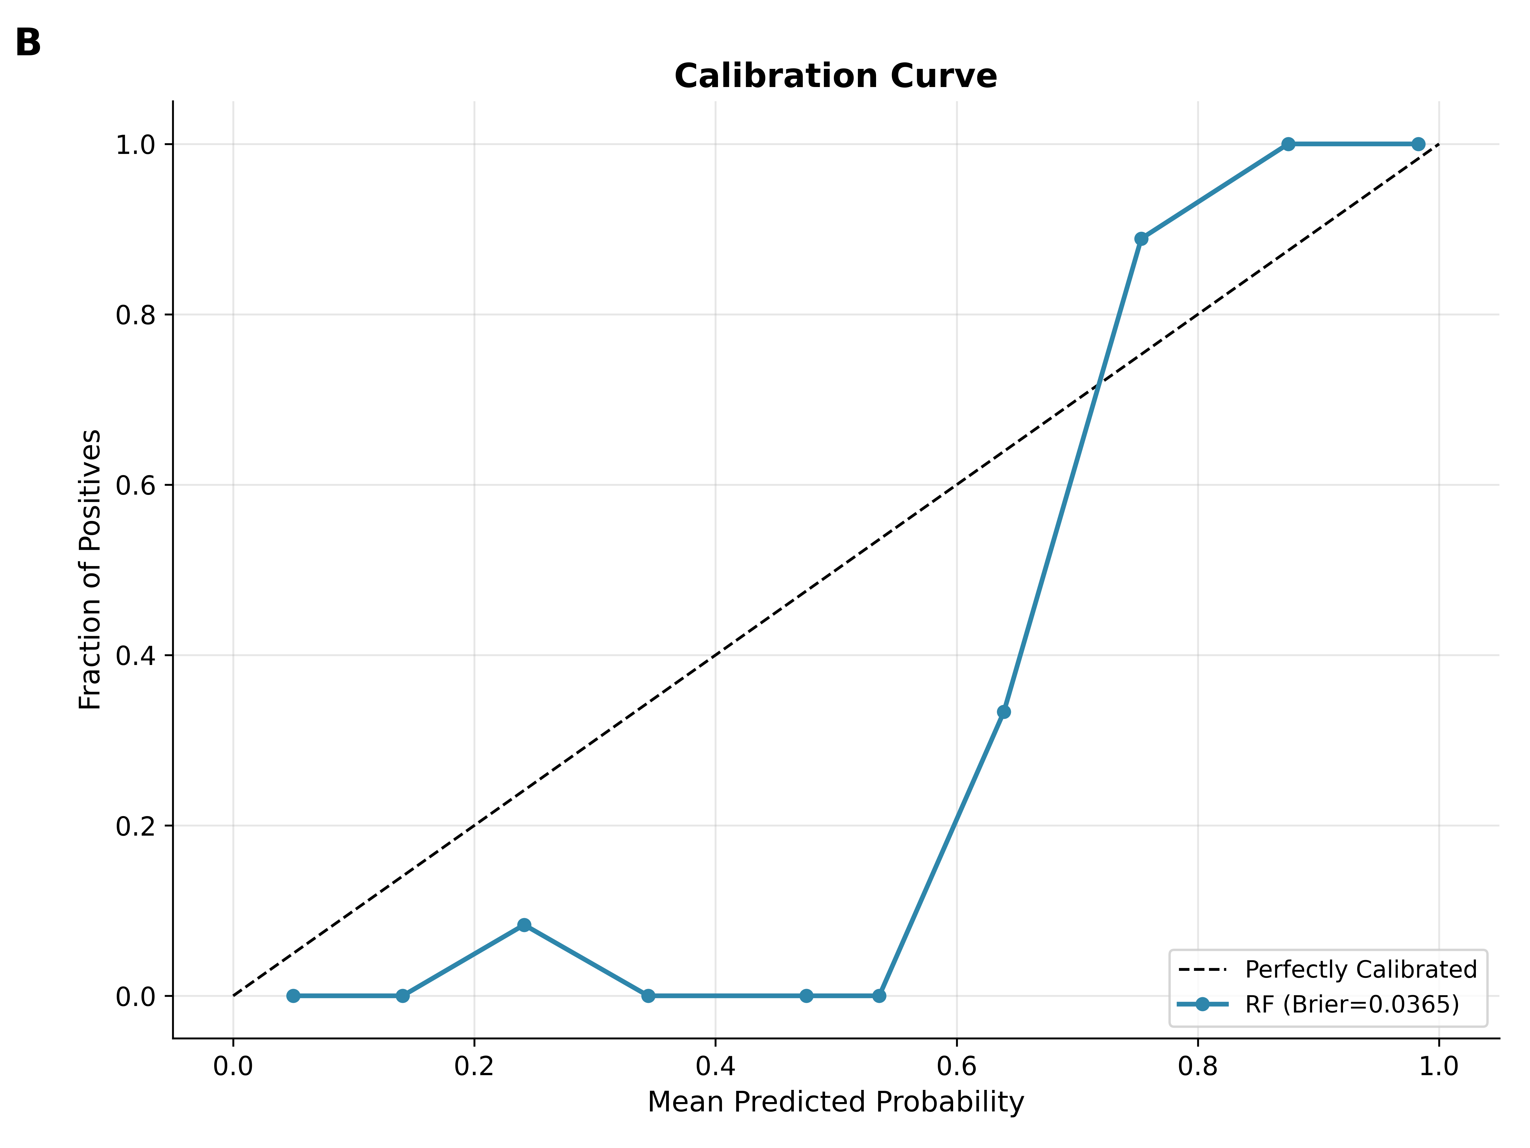
Fig. S2. Bootstrap confidence interval and calibration analysis. (A) Distribution of 10,000 bootstrap AUC estimates; red line denotes the point estimate (0.9972), with the 95% confidence interval indicated by dashed lines [0.9921, 1.0000]. (B) Calibration plot comparing mean predicted probabilities against observed positive fractions; the Brier score is 0.0365.
The bootstrap analysis confirms that the AUC estimate is stable, and the tight confidence interval indicates robust discriminative performance. The calibration plot demonstrates that predicted probabilities align well with observed outcomes, supporting the interpretability of the model outputs.
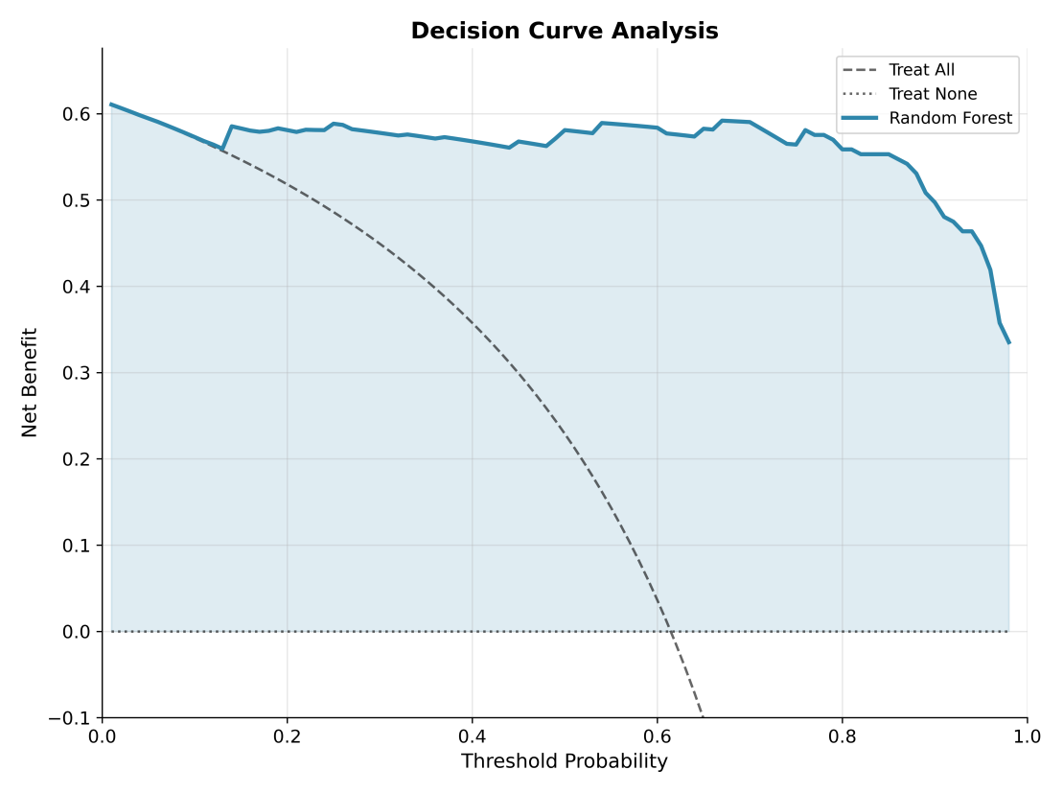
Fig. S3. Decision Curve Analysis. Net benefit plotted against threshold probability for the FuseVirome model (solid line), treat-all (dashed line), and treat-none (dotted line) strategies. This analysis extends performance evaluation beyond AUC to the decision-analytic domain.
Decision curve analysis shows that the FuseVirome model delivers higher net benefit than both treat-all and treat-none strategies across a wide range of threshold probabilities, indicating its clinical utility for prioritizing confirmatory testing.
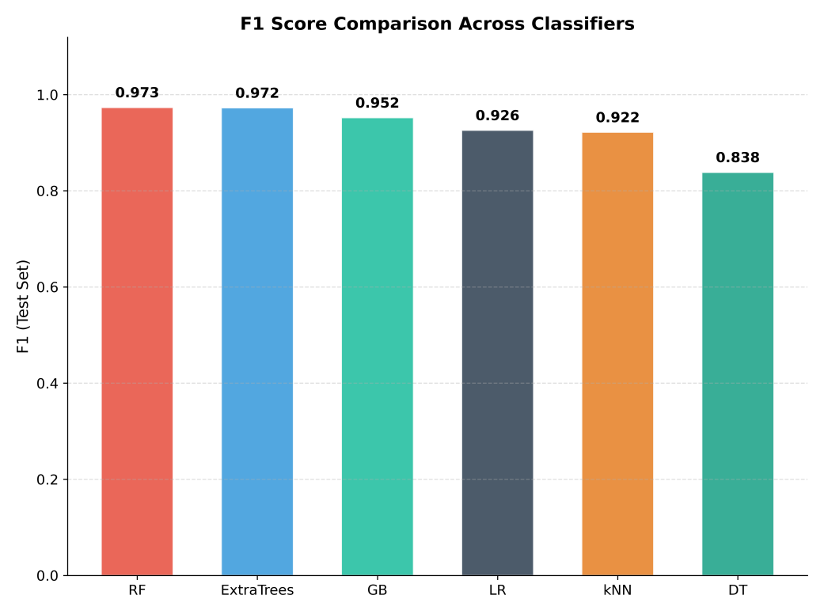
Fig. S4. Classifier comparison on the independent external test set. RF achieved the highest F1 score (0.973), followed closely by Extra Trees (0.972); Gradient Boosting, Logistic Regression, kNN, and Decision Tree yielded progressively lower F1 scores. The marked performance gap between the top two ensemble methods and the simpler models indicates a nonlinear, interaction-rich feature space.
These results corroborate the classifier choice in the main text and justify the selection of Random Forest as the final model.

2.7 Supplementary SHAP Interpretability Analysis
To improve the transparency of the FuseVirome classifier, we applied SHAP (SHapley Additive exPlanations) analysis to the final 29-feature Random Forest model using TreeExplainer on the external test set. SHAP values quantify the directional contribution of each feature to the predicted probability of a positive viral signal.
Table S7. SHAP feature importance
Rank | Feature | SHAP | Gini | Permutation
1 | Coverage_Percent_reads | 0.064091 | 0.129374 | 0.002385
2 | Mean_BaseQ_fused | 0.041245 | 0.023662 | -0.001480
3 | AlignLength_max | 0.040307 | 0.092498 | 0.001625
4 | Reads_Count_reads | 0.035828 | 0.057783 | -0.001274
5 | BitScore_sum | 0.034991 | 0.069592 | 0.000312
6 | AlignLength_sum | 0.033949 | 0.082591 | -0.000088
7 | Avg_Coverage_Depth_x_reads | 0.029666 | 0.051578 | -0.000461
8 | Coverage_Percent_contigs | 0.027150 | 0.063511 | 0.000474
9 | BitScore_mean | 0.024162 | 0.055016 | -0.000193
10 | qlen_mean | 0.022576 | 0.065769 | 0.000685
11 | Avg_Coverage_Depth_x_contigs | 0.019486 | 0.045771 | -0.000523
12 | Coverage_bp_reads | 0.017398 | 0.034922 | -0.000777
13 | BitScore_max | 0.015198 | 0.039281 | -0.000026
14 | identity_mean | 0.015148 | 0.021890 | 0.000786
15 | Align_Qlen_Ratio_Max | 0.015104 | 0.028902 | 0.000690
16 | Coverage_bp_contigs | 0.015006 | 0.039007 | -0.001072
17 | Histo_Max_Bin_Percent_reads | 0.014839 | 0.018349 | 0.000795
18 | identity_max | 0.011111 | 0.017290 | 0.000057
19 | Histo_Max_Bin_Percent_contigs | 0.010149 | 0.016383 | 0.000184
20 | Histo_Max_Bin_Percent_fused | 0.009773 | 0.015556 | 0.000439
21 | Mean_MapQ_contigs | 0.005036 | 0.004643 | 0.000312
22 | Mismatches_mean | 0.003668 | 0.006273 | -0.000088
23 | Count_Correct_Contigs | 0.003031 | 0.005906 | 0.000097
24 | Count_Total_Contigs | 0.002030 | 0.003799 | -0.000553
25 | Count_Noise_Contigs | 0.001972 | 0.000881 | -0.000000
26 | Mean_BaseQ_reads | 0.001709 | 0.005676 | -0.000180
27 | Reads_Count_contigs | 0.001618 | 0.003133 | -0.000215
28 | Mean_MapQ_reads | 0.001072 | 0.000964 | -0.000070
29 | Evalue_min | 0.000000 | 0.000000 | -0.000000

Supplementary Table S8 normalizes Gini, permutation, and SHAP importance metrics to compare their relative emphasis among the top 10 features. Coverage_Percent_reads was consistently ranked first across all three metrics. Mean_BaseQ_fused and AlignLength_max showed metric-specific rankings, underscoring the utility of multi-metric importance assessment.
Table S8. Top 10 features by SHAP importance with normalized metrics
Rank | Feature | SHAP | Gini_norm | Permutation_norm | SHAP_norm
1 | Coverage_Percent_reads | 0.0641 | 1.0000 | 1.0000 | 1.0000
2 | Mean_BaseQ_fused | 0.0412 | 0.1829 | -0.6206 | 0.6435
3 | AlignLength_max | 0.0403 | 0.7150 | 0.6814 | 0.6289
4 | Reads_Count_reads | 0.0358 | 0.4466 | -0.5341 | 0.5590
5 | BitScore_sum | 0.0350 | 0.5379 | 0.1308 | 0.5460
6 | AlignLength_sum | 0.0339 | 0.6384 | -0.0368 | 0.5297
7 | Avg_Coverage_Depth_x_reads | 0.0297 | 0.3987 | -0.1934 | 0.4629
8 | Coverage_Percent_contigs | 0.0271 | 0.4909 | 0.1989 | 0.4236
9 | BitScore_mean | 0.0242 | 0.4253 | -0.0810 | 0.3770
10 | qlen_mean | 0.0226 | 0.5084 | 0.2873 | 0.3523

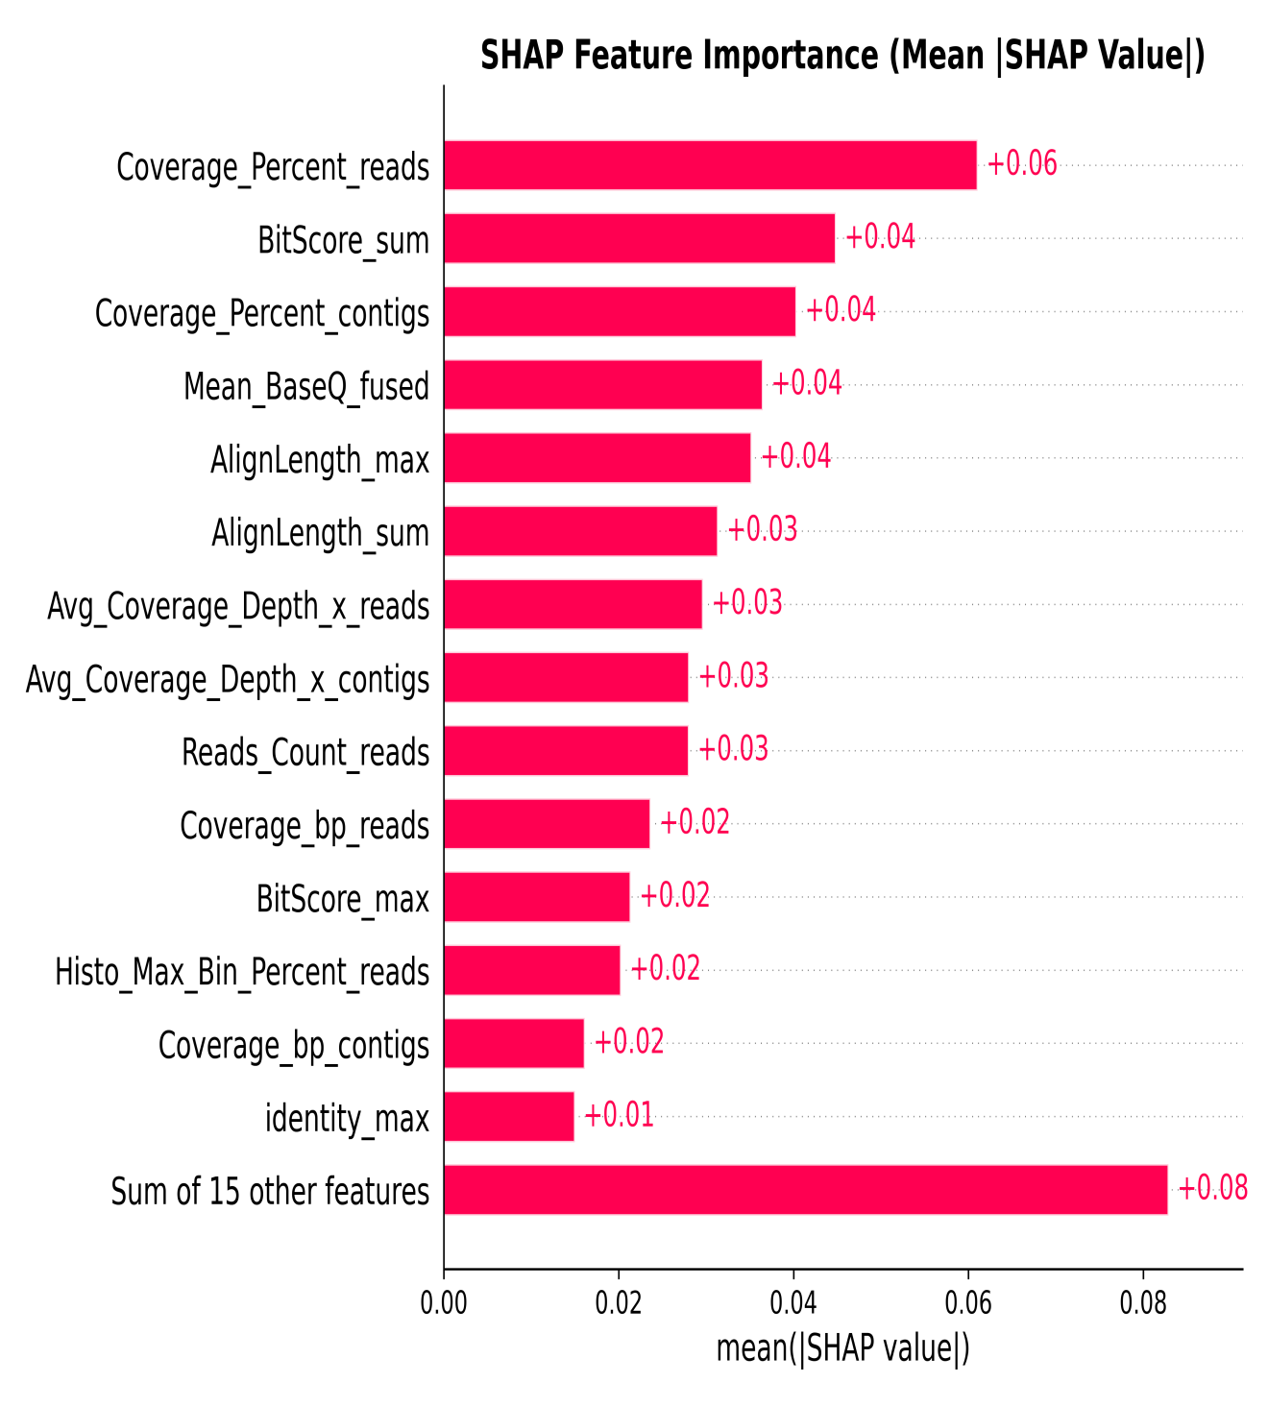
Fig. S5. Global SHAP feature importance. This plot identifies the dominant additive drivers of RF predictions. Coverage_Percent_reads ranked first (mean |SHAP| = 0.06), followed by BitScore_sum, Coverage_Percent_contigs, and Mean_BaseQ_fused (mean |SHAP| ≈ 0.04 each).
Global SHAP analysis indicates that predictions are driven by a combination of coverage breadth, alignment quality, and sequence-similarity metrics rather than by isolated signals, confirming the biological coherence of the classifier.
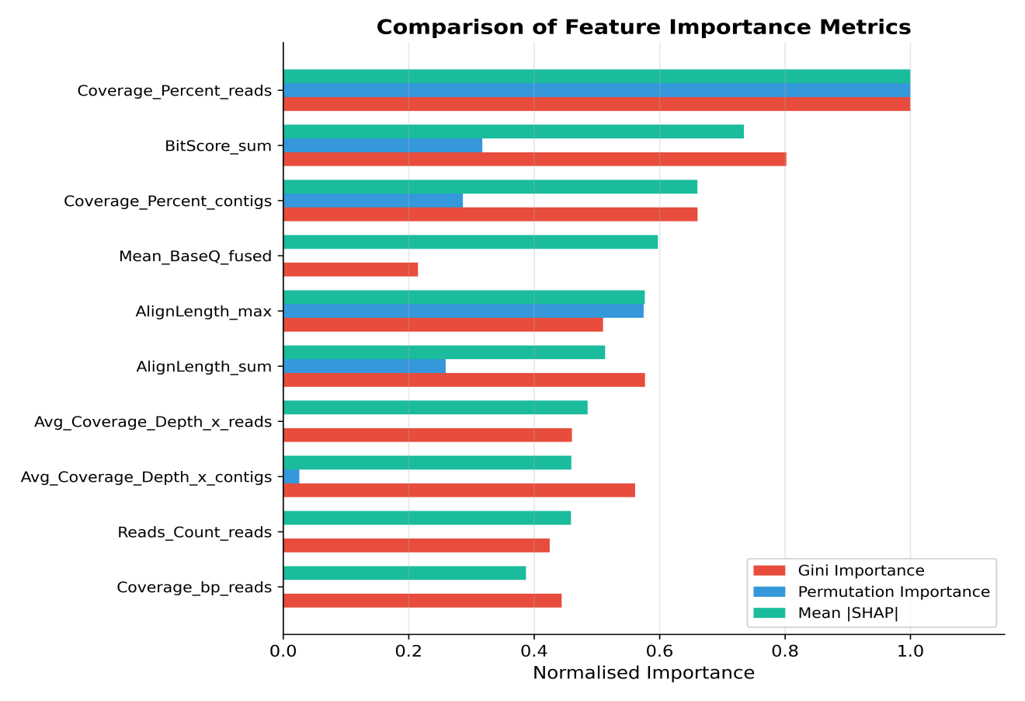
Fig. S6. Side-by-side comparison of Gini importance, permutation importance, and mean |SHAP| for the top 10 features.
Despite differences in absolute magnitudes, the three importance metrics agree on the top predictors, strengthening confidence that Coverage_Percent_reads, BitScore_sum, and Coverage_Percent_contigs are the most influential features.
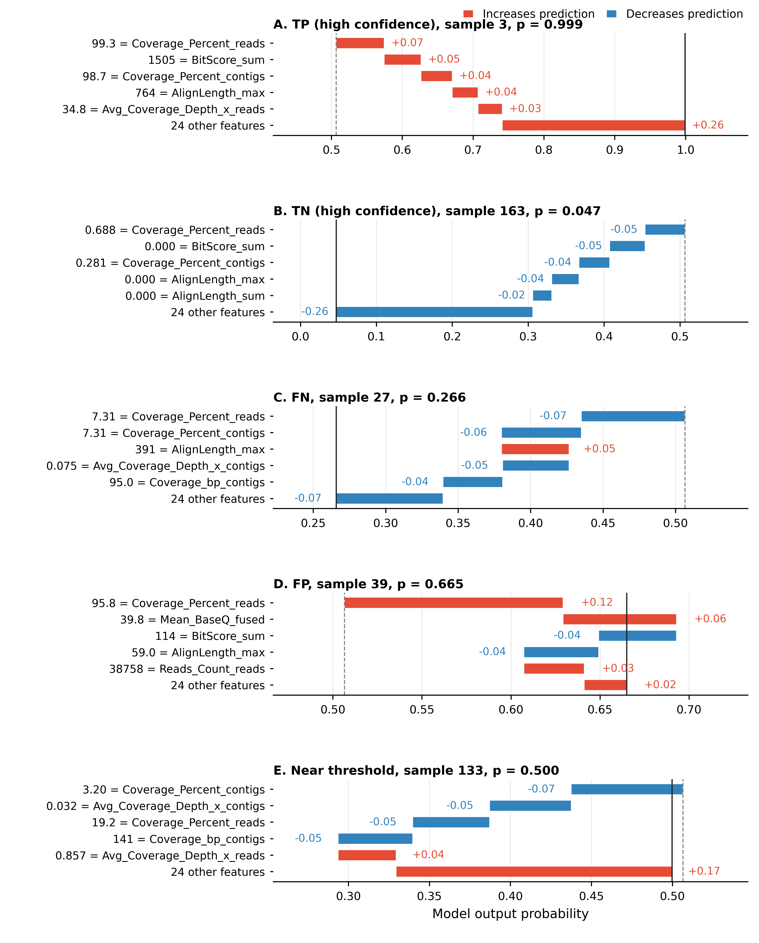
Fig. S7. Local SHAP waterfall plots for representative samples: a high-confidence true positive, a high-confidence true negative, a false negative, a false positive, and a near-threshold case.
Supplementary Figure S7 provides case-level evidence for how the model reaches individual predictions. High-confidence true positives were driven by broad coverage and strong alignment features, high-confidence true negatives lacked these supports, and the near-threshold case contained competing positive and negative contributions. The false-positive and false-negative examples identify the types of borderline evidence that should be prioritized for manual review or confirmatory qPCR.

References (Supplementary)

Greener, J. G., S. M. Kandathil, L. Moffat and D. T. Jones (2022). A guide to machine learning for biologists. Nat Rev Mol Cell Biol. England. 23: 40–55.

Greener, J. G., S. M. Kandathil, L. Moffat and D. T. Jones (2022). A guide to machine learning for biologists. Nat Rev Mol Cell Biol. England. 23: 40–55.
Whalen, S., J. Schreiber, W. S. Noble and K. S. Pollard (2022). Navigating the pitfalls of applying machine learning in genomics. Nat Rev Genet. England. 23: 169–181.
Greener JG et al. A guide to machine learning for biologists. Nat Rev Mol Cell Biol 2022;23:40–55.
Whalen S et al. Navigating the pitfalls of applying machine learning in genomics. Nat Rev Genet 2022;23:169–81.

