07 级

1. The design pattern “Iterator” can be viewed as a special case of which pattern? A Factory Method B DAO C Façade D Delegate
2. Which UML diagram describes the static perspective of a design model?

A class diagram B state diagram C sequence diagram D communication diagram

1. What are the four phases in a Unified Process? P25 UP 的阶段 A Inception, Analysis, Design, Transfer

B Analysis, Design, Coding, Testing

C Inception, Elaboration, Construction, Implementaion D Transfer, Construction, Elaboration, Inception

1. In a Design Class Diagram, which relation can be used to represent a “has-a” relation?

A generalization B composition C dependence D inheritance

5 Which agile method belongs to Extreme Programming? 极限编程

A test driven development 测试驱动开发

B common project workroom 常见的项目工作室 C self-organizing teams 自组织团队

D regression testing 回归测试

1. How many statements are true?
   1. The actors in use cases can only be people, organizations and external systems 对

UML 的类图就是这么定义的。见 microsoft

* 1. Assigning responsibilities is the main task of object-oriented design 错 P5 OOD 强调 的是定义软件对象以及它们如何协作以实现需求
  2. UML is a methodology of object-oriented analysis and design 没找到

A 0 B 1 C 2 D 3

1. How many statements are NOT true?
   1. The actors of use cases can be categorized into primary actors, supporting actors and

offstage actors

* 1. A use case can contains several scenarios
  2. The main idea of MVC pattern is separating presentation logic code from business logic

code

A 0 B 1 C 2 D 3

1. How many statements are true?
   1. Pre-condition is the most important part in an operation contract 错。最重要的是后 置条件。
   2. Domain models are also called conceptual models, domain object models, and analysis

object models 对。 领域模型概念 P100

* 1. Use cases are mainly used to capture non-functional requirements 错。

A 0 B 1 C 2 D 3

1. How many statements are true?
   1. Analysis emphasizes an investigation of the problem and requirements, rather than a solution.对
   2. Most of the challenging, interesting, useful design work happens while drawing the UML

dynamic-view interaction diagrams 对。大部分具有挑战性、有益和有效的设计工作都会在绘

制 UML 动态视图的交互图的时候发Th。P158

* 1. Use cases can only be used in object-oriented analysis and design 错。

A 0 B 1 C 2 D 3

1. How many statements are true?
2. Sequence diagram and communication diagram are equivalent. 错。
3. In elaboration phase, we usually schedule the use cases with higher risks before the ones

with lower risks. 对。PML 的 PPT 上的话：Elaboration: Build the core architecture, resolve

the highrisk elements, define most requirements, and estimate the overall schedule and resources.

1. In design, we usually complete all the sequence diagrams before we start to draw the

design class diagrams. 对

A 0 B 1 C 2 D 3

09 级

1. How many statements are true?
2. The Domain Analysis helps us in finding concepts for Domain Model, and candidate methods for our classes. 找不到
3. Design emphasizes a solution (in software and hardware) and its implementation. 错
4. Divide and Conquer is a common methodology in solving complex problems. 翻译为 “分而治之是在解决复杂问题的常见方法。” 谷歌到“Whereas virtually every other field has been able to solve large complex problems using a divide and conquer strategy” 大概是 对的？

***Answers:*** A 0 B 1 C 2 D 3

1. How many statements are true?
2. The observer pattern is a structural pattern. 谷歌到：“The Gang of Four classifies the Observer pattern as a behavioral pattern.” 对？
3. An abstract class has none of implementation at all. 错
4. Inception will take six or more weeks long. 对

***Answers:*** A 0 B 1 C 2 D 3

1. How many statements are true?
2. An object is an instant of its class/type.
3. In a Design Class Diagram, inheritance relation can be used to represent a “has-a” relation. 错。应该是“组合”
4. Domain Analysis is often applied before Use Case Analysis in building software of a complex domain, but after of a simple one.

***Answers:*** A 0 B 1 C 2 D 3

1. How many statements are true?
2. Analysis, Design, Coding, Testing are the four phases in a Unified Process. 错。见 P5 UP 的四个过程
3. Both the decorate pattern and proxy pattern using delegation.
4. When one class inherits from another, then polymorphism allows a superclass to stand

in for the subclass.

***Answers:*** A 0 B 1 C 2 D 3

1. How many statements are true?
2. Instead of avoiding changes, embracing changes and refactoring existing design/code is

one of best practices in contemporary software design.

1. The Marco Command is a combination of the decorator and command pattern.
2. We shouldn’t code to an interface instead to an implementation.

***Answers:*** A 0 B 1 C 2 D 3

1. How many statements are true?
2. Elaboration is to fully and carefully define models which are translated into code during construction. 错。细化阶段的定义见 P25
3. Assigning responsibilities is the main task of object-oriented design. 错
4. The Mythical Man-Month: Essays on Software Engineering is a popular book on Object-Oriented programming which published recently. 对？

***Answers:*** A 0 B 1 C 2 D 3

1. How many statements are true?
2. We take two or three months to acquire to most of requirements for supporting analysis

and design. 错

1. Elaboration is not the requirements or design phase; rather, it is a phase where the core

architecture is iteratively implemented, and high-risk issues are mitigated 原话。见 P25

1. There are analysis, design, coding and testing activities in each iteration. 对？

***Answers:*** A 0 B 1 C 2 D 3

1. How many statements are true?
2. Java standard editions before version 5 allow two methods within a class different only

on their return type. 大概是错的

1. Composition relationships are shown with a white diamond attached to the composing

class. 错。组合用的是黑色菱形。

1. Some objects have unique identity, they are not equal even all their attributes are equal. 对？

***Answers:*** A 0 B 1 C 2 D 3

1. How many statements are true?
2. Design principles are not really implementable in code, they are just guidelines in our

design practices. 设计原则不需要真的在代码中实现，它们在我们的设计手法只是指导方针。

1. The Unified Modeling Language (UML) is a visual language for specifying, constructing and documenting the artifacts of systems. 原话 P8. UML 是描述、构造和文档 化系统制品的可视化语言。
2. A common practice in software engineering is validating the result of each working steps. 在软件工程中一种常见的做法是验证了每个工作步骤的结果

***Answers:*** A 0 B 1 C 2 D 3

1. How many statements are true?
2. The Law of Demeter principle is another name of the Least Knowledge Principle, which

means “Talk only to your immediate friends”.

1. Every object in your system should have a single responsibility, and all the object’s services should be focused on carrying it out. 在你的系统中的每个对象应该有一个单独的 责任，所有对象的服务应侧重于执行它。
2. A class is a blueprint for an object, where the attributes (aka. instance variables) and methods of the object specified. 类是一个蓝图的对象，其中的属性（亦称实例变量）和指定 的对象的方法。

***Answers:*** A 0 B 1 C 2 D 3

10 级

1. How many statements are true?
2. The UML is the de facto standard diagramming notation for drawing or presenting software model. UML 是图形化表示法的事实标准，用来绘制和展示与软件相关的图形。P8
3. In Design Class Diagram(DCD), a association line between classes may has an association name. 对。关联表示的属性，不需要关联名称，但是可以有。 P182 书上的原话：

In Design Class Diagram(DCD), a association line between classes may has an association name.

1. UML property-string denote characteristic of UML Attributes of UML Class. 可以通过

许多方法来表示元素的特性，但 UML 规范采用 UML 特性字符串（property string）P188 书上 对 于 property 的 定 义 ： In the UML, a property is “a named value denoting a characteristic of an element. A property has semantic impact.”

A 0, B 1 , C 2, D 3

1. How many statements are true?
2. The precondition of buy drink for a vending machine(售货机) is "OK" displayed.
3. Software engineering is the application of a systematic, disciplined, quantifiable approach to develop software. 软件工程是一个系统的，规范的，可量化方法的应用软件开发。
4. In DCD, use a navigability arrow(导航箭头) to indicate that a Register object has an attribute of one Sale object. 导航性箭头由源对象（Register）指向目标对象（Sale），表示 Register 的一个属性是 Sale 对象。P182

A 0, B 1, C 2, D 3

1. How many statements are true?
2. Finding conceptual classes with noun phrase identification is a useful technique. 通过 识别名词短语寻找概念类。P105
3. XP "story card" practice is acceptable for catching requirements in UP. 寻找需求可 以采用的方法 5.3 P42
4. In GoF Composite pattern, the whole object and its part objects have the same interface.

A 0, B 1, C 2, D 3

1. How many statements are true?
2. Arrow line indicates the relation of a user use use cases in UML Use Case Diagram.
3. Informally, a use case is a specific sequence of actions and interactions between actors and the system. 场景（scenario）是参与者和系统之间的一系列特定的活动和交互，也 称用例实例（use case instance）。用例（use case）是一组相关的成功和失败场景集合，用来 描述参与者如何使用系统来实现目标。P47
4. "condition: actions ..." structure can be used to describe a Use case Main Success Scenario. 主成功场景是典型的、无条件的、理想方式的成功场景。P50

A 0, B 1, C 2, D 3

1. How many statements are true?
2. The requirements and object-oriented analysis focused on learning to do the thing right（把事情做好）. 需求和面向对象分析重点关注学习做正确的事。P143 注：PML 的 PPT 上 do the thing right 是 design 而不是 analysis
3. In software design, Aggregation（聚合） over Composition（组合）P191 组合优于聚合
4. Spend significant time doing class diagrams than UML interactive diagrams. 应该把时 间花费在交互图（顺序图或通信图），而不仅是类图上。P159

A 0, B 1, C 2, D 3

1. How many statements are true?
2. It is more than "a few" weeks long for most projects in Inception. 大多数项目的初始 阶段的持续时间相对较短，例如耗时一周或几周。实际上，许多项目中如果初始阶段超过一周， 那“初始”就失去意义。
3. A "/" symbol before the attribute name is wrong in domain model. 表示这是重要属性， 但是可以导出。导出属性的意思是可以由其他信息导出的属性。P118
4. In Agile modeling, a suitable iteration length is two to six weeks time_box. P29 PPT 上的话：“each iteration is recommended to be 2~6 weeks”

A 0, B 1 , C 2, D 3

1. How many statements are true?
2. To implement a singleton （单例） class, we prefer eager initialization （预先式初始

化）. 单实例类更倾向于使用缓式初始化（lazy initialization）。P322

1. During OOA, there is an emphasis on finding and describing the objects or conception in the problem domain.在面向对象分析过程中，强调的是问题领域内发现和描述 对象（或概念）P5
2. "Find Product Help" with underline in a use case text means emphasis. 在 Cockburn

表示法中，下划线表示所执行的第二个用例。P58 A 0, B 1 , C 2, D 3

1. How many statements are true?
2. Use Case name must start with a verb. 用例名称以动词开始。P50
3. In Agile Principles, our highest priority is early and continuously delivers valuable software to customer. 优先级最高的是，通过早期和持续交付有价值的软件来满足客户。P21
4. A domain model can show UI elements and database in a business project. 软件制品 例如窗口或数据库不适用于领域模型。P101

A 0, B 1, C 2, D 3

1. How many statements are true?
2. In elaboration, we do not need deliver a runnable product to user for testing. 大多数 需求分析在细化阶段（elaboration）进行，并且伴有具有产品品质的早期编程和测试。P37
3. "+doSomething(b:B)" of class A means that the class A dependent on the class B.
4. In the UP, requirements are categorized according to the FURPS+ model. A 0, B 1, C 2, D 3
5. How many statements are true?
6. In Design Class Diagram(DCD), attributes are usually assumed private if no visibility is given. 如果没有给出可见性，则通常假设属性为私有。P182
7. SSD should involving other external systems. In general, the external system place at the left of the ":system".
8. The sequence of software development in UP should be: 1) define the requirements;

2) design the architecture; 3) implement. 见 P29 A 0, B 1, C 2, D 3

## Test0

1.How many statement are true?

1. 'Find Product Help' with underline in a use case text means emphasis **F 简单地使用 下划线或某种高亮显示风格是表示被包含的用例的较为简洁的表示法 P359**
2. In practical OOD, we draw interactive diagram firstly, and then draw Design Class Diagram

## Ｔ 题目的意思，在ＯＯＤ中，我们先画交互图，然后画设计类图

**课本：类图的定义能够给从交互图中产Th。这表明一种线性的顺序，即先绘制交互图，再绘制 类图。但是在实践中，尤其是应用了并行建模的敏捷建模实践后，这些互补的动态视图和静态 视图是并行创建的。例如，１０分钟绘制静态视图，１０分钟绘制动态视图，交替进行。。 所以。。到底要不要交互提，在设计类图前？？按出题的感觉，应该是在前的吧。**

1. Software Engineering are the application of a systematic, disciplined, quantifiable approach to the development, operation, and maintenance of software

## T ,貌似是导论里面的，下面来自维基百科

Answer is: A 0, B 1, C 2, D 3 2.How many statement are true?

(1) Any UML diagram in OOA must describe the System as Black Box **F P62 ， useful**

## ,not must,电子课本是第二版的

（2）XP 'story card' practice is acceptable for catching requirements in UP. **T 课本：UP 欢迎任何能够带来价值并提高用户度的需求启发方法，如果能够是工作有效， UP 项目甚至可 以接受简单的 XP“素材卡片实践”（需要客户专家的全程参与，是一种很好的实践，但是通常 难以实现）。。。（这也考得太细了。。）**

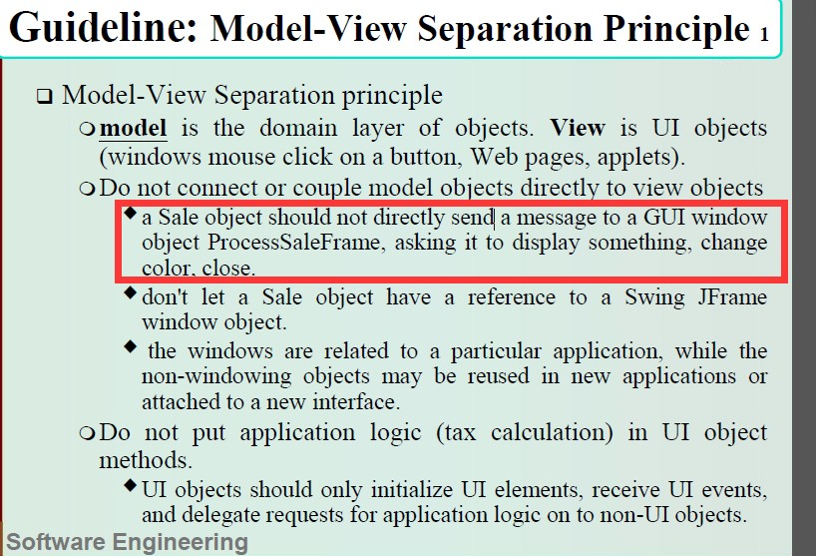(3) An object in domain layer can send messages to an UI object **F P152**

## 模型-视图分离原则规定，模型（领域）对象不应该直接与视图（UI）对象连接，对于视图对 象也是如此。例如，Register 或 Sale 对象不应该直接向 GUI 窗口对象 ProcessSaleFrame 发送 消息、请求其显示、改变颜色、关闭等等。P152

Answer is: A 0, B 1, C 2, D 3

1. How many statement are true?
2. 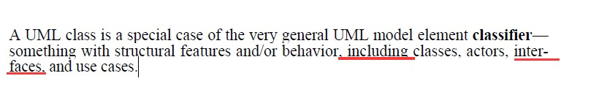Interface is a UML classifier（UML 类元） **T P182**
3. Primary actors always be on the left and supporting actors on the right in UML Use Case Diagram **T 主要 参与者至于左侧，支持性参与者置于右侧 P69**

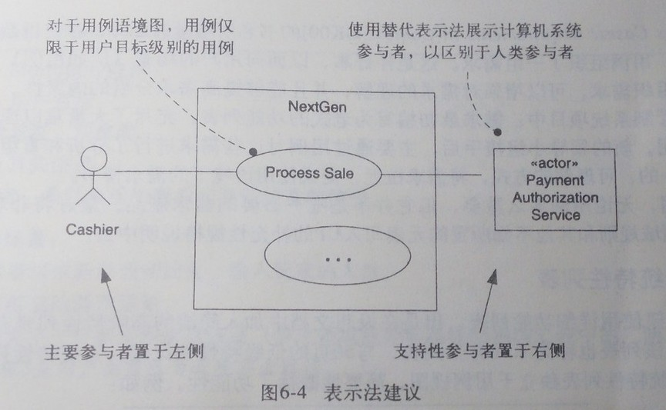

1. 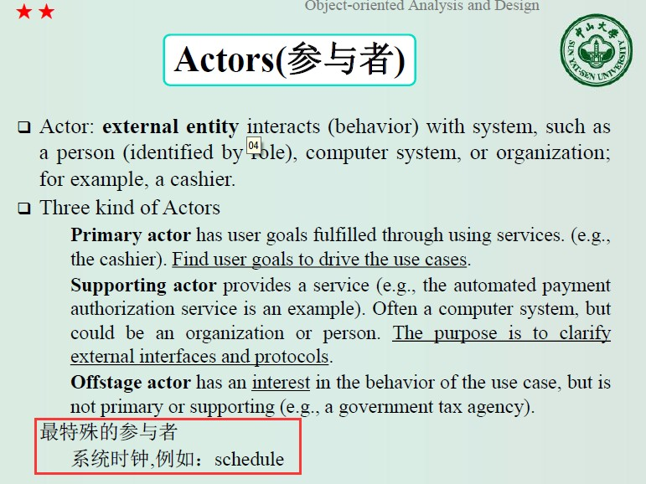A timer may be a special actor of the system **T**

Answer is: A 0, B 1, C 2, D 3

1. How many statement are true?
2. 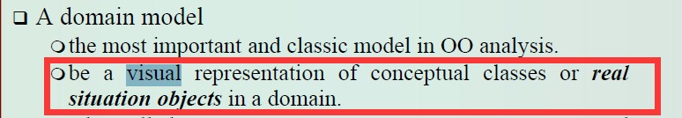A domain model is a visual representation of conceptual classes or real-situation objects in a domain **T P100**
3. In Agile modeling, the purpose of modeling (sketching UML, …) is primarily to understand, not to document **T P22，课本：建模（构建 UML 草图……）的目的主要是为理 解，而非文档。在“Alige Modeling”一书中，将这种观点及与至一致的敏捷方法称为敏捷建模。**
4. 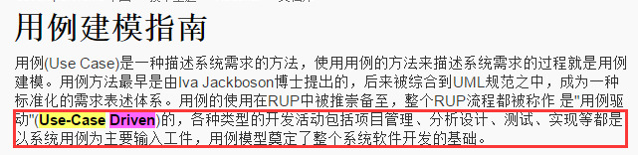Use-case-driven means the development team employs the use cases from requirements gathering through code and test **T**

Answer is: A 0, B 1, C 2, D 3 5.How many statement are true?

1. 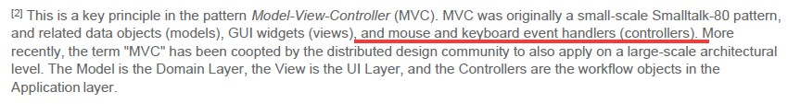The System Event handled by model layer in the MVC pattern **F P154 事件处理在控 制层，controllers**
2. Showing a report object in a domain model is always useful. **F P108**

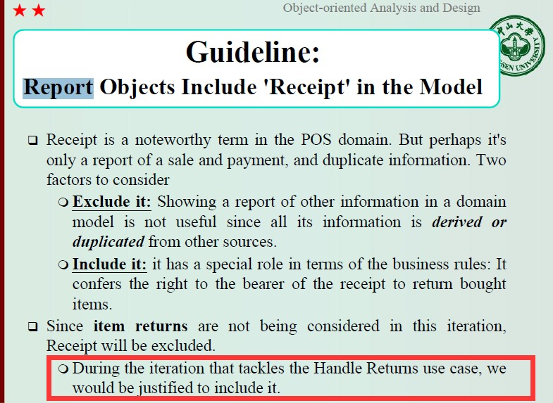

## 在解决处理退货用例的迭代中，我们会考虑将“票据”包含在内

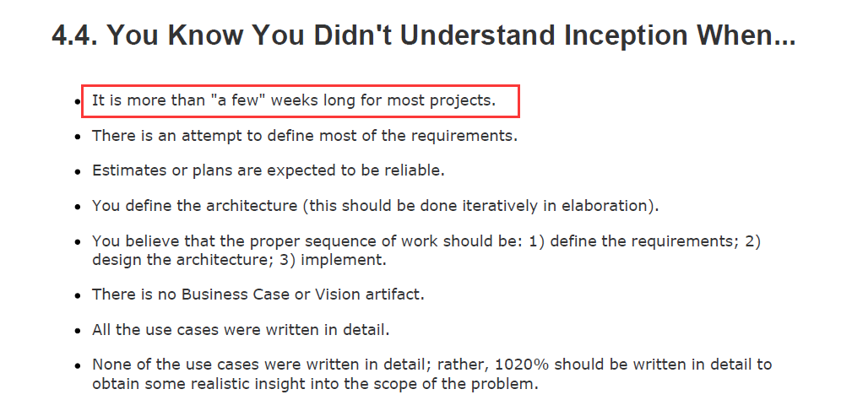（3）It is more than a few weeks long for most projects in Inception. **F P39 如果发Th了 以下情况，就知道自己不了解初试阶段，当 认为大部分项目的初试阶段会持续几周或更长时间。**

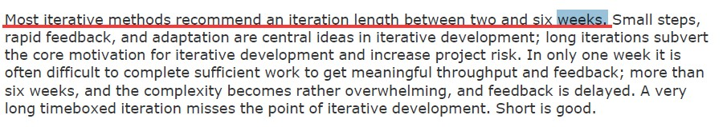Answer is: A 0, B 1, C 2, D 3 6.How many statement are true?

1. A use case named 'Manage <X>', such as manage user, means that the user goal is to collapse(集中) CRUD on object X **T P65 书上：用例名称应使用动词开头，对于每个目标 的一个用例来说，常见的例外是，将分散的 CRUD（增删改查）目标合并成一个 CRUD 用例， 并习惯性的称为管理<X>。**

## Finding stakeholders of the system is the most important thing for catching requirements？？

1. In domian model, only show some meaningful and interesting associations among classes **T**

## 关联的定义是 meaningful and interesting associations：

**但是我们不考虑全部关联，只需要考虑“需要记住”的关联，和从常见关联列表中派Th的关联**

Answer is: A 0, B 1, C 2, D 3

7.How many statement are true?

1. 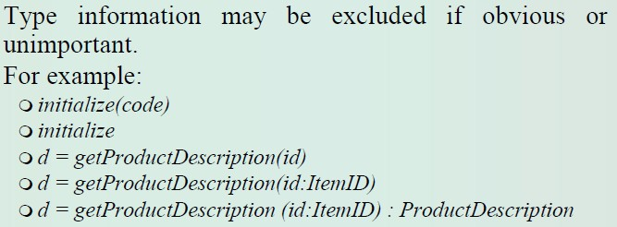The message 'd = getProductDescription(id)' in sequence diagram is wrong syntax for missing a type of id **F P165，如果明显或不中要，可以不包含类型信息**
2. In UP, a suitable iteration length is two to six weeks timebox **T P22，每次迭代 2~6**

## 周之间

1. 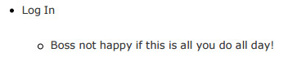The candidate use case 'Log In' can pass usefull Test, for we use it every day F P67

Answer is: A 0, B 1, C 2, D 3 8.How many statement are true?

1. Composition in the UML loosely suggests whole-part relationships F P191
2. The same UML diagram can be used in multiple perspectives T P181



1. Incremental development for the same use case across iterations T P93

Answer is: A 0, B 1, C 2, D 3 9.How many statement are true?

1. An end user can find the operation process in UML Use Case Diagram
2. 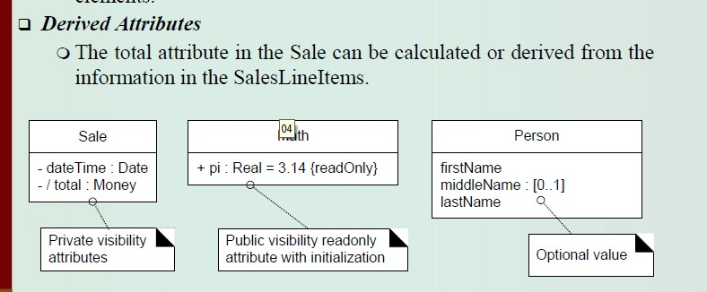A '/' symbol before the attribute name is wrong in domain model **F P117 导出属性**

## 表示导出属性：sale 中的 totle 属性可以从 SalesLineItems 中的信息计算或导出。

1. Inception in one sentence: Envision the product scope, vision, and business case T P37

Answer is: A 0, B 1, C 2, D 3 10.How many statement are true?

1. In Agile Principles, our highest priority is early and continuously deliver valuable software to customer T P21
2. In UP, A Kickoff meeting should be hold to clarify goals in days at the beginning of iteration T P15

(4) Logical Architecture divides the software classes into packages, subsystems, and layers T P146

Answer is: A 0, B 1, C 2, D 3

Test1

1. How many statement are true?
2. Incremental development for the same use case across iterations 对
3. Interface is a UML classifier 对
4. Showing a report object in a domain model is always useful. 错。 谷歌： A report object of other information in a domain model is not useful since all its information is derived from other sources.

Answer is: A 0, B 1, C 2, D 3

1. How many statement are true?
2. In Agile modeling, the purpose of modeling (sketching UML, …) is primarily to understand, not to document 对
3. In Agile Principles, our highest priority is early and continuously deliver valuable software to customer 对
4. The System Event handled by model layer in the MVC pattern 错

Answer is: A 0, B 1, C 2, D 3

1. How many statement are true?
2. Use-case-driven means the development team employs the use cases from requirements gathering through code and test 对，PML 的 PPT 原话
3. Composition in the UML loosely suggests whole-part relationships 错。
4. A '/' symbol before the attribute name is wrong in domain model 错。

Answer is: A 0, B 1, C 2, D 3

1. How many statement are true?
2. Any UML diagram in OOA must describe the System as Black Box 错
3. In UP, A Kickoff meeting should be hold to clarify goals in days at the beginning of iteration 对
4. A domain model is a visual representation of conceptual classes or real-situation objects in a domain 对。

Answer is: A 0, B 1, C 2, D 3

1. How many statement are true?
2. An object in domain layer can send messages to an UI object 错。
3. Inception in one sentence: Envision the product scope, vision, and business case 对
4. XP 'story card' practice is acceptable for catching requirements in UP. 对

Answer is: A 0, B 1, C 2, D 3

1. How many statement are true?
2. A timer may be a special actor of the system 对
3. The same UML diagram can be used in multiple perspectives 对
4. Logical Architecture divides the software classes into packages, subsystems, and layers 对

Answer is: A 0, B 1, C 2, D 3

1. How many statement are true?
2. Primary actors always be on the left and supporting actors on the right in UML Use Case Diagram 对
3. Finding stakeholders of the system is the most important thing for catching requirements 对
4. 'Find Product Help' with underline in a use case text means emphasis 错

Answer is: A 0, B 1, C 2, D 3

1. How many statement are true?
2. A use case named 'Manage <X>', such as manage user, means that the user goal is to collapse(集中) CRUD on object X 对
3. Software Engineering are the application of a systematic, disciplined, quantifiable approach to the development, operation, and maintenance of software 对
4. The message 'd = getProductDescription(id)' in sequence diagram is wrong syntax for missing a type of id 错

Answer is: A 0, B 1, C 2, D 3

1. How many statement are true?
2. An end user can find the operation process in UML Use Case Diagram 没找到
3. The candidate use case 'Log In' can pass usefull Test, for we use it every day 错
4. In UP, a suitable iteration length is two to six weeks timebox 对

Answer is: A 0, B 1, C 2, D 3

1. How many statement are true?
2. It is more than a few weeks long for most projects in Inception. 错
3. In domian model, only show some meaningful and interesting associations among classes 对
4. In practical OOD, we draw interactive diagram firstly, and then draw Design Class Diagram 不确定

Answer is: A 0, B 1, C 2, D 3

Test 2

1. How many statement are true?
2. Interface is a UML classifier 对
3. In UP, A Kickoff meeting should be hold to clarify goals in days at the beginning of iteration 对
4. Finding stakeholders of the system is the most important thing for catching requirements 没找到 算对？

Answer is: A 0, B 1, C 2, D 3

1. How many statement are true?
2. The message 'd = getProductDescription(id)' in sequence diagram is wrong syntax for missing a type of id 错
3. Showing a report object in a domain model is always useful. 错
4. A timer may be a special actor of the system 对

Answer is: A 0, B 1, C 2, D 3

1. How many statement are true?
2. An object in domain layer can send messages to an UI object 错
3. In Agile Principles, our highest priority is early and continuously deliver valuable software to customer 对
4. An end user can find the operation process in UML Use Case Diagram 没找到

Answer is: A 0, B 1, C 2, D 3

1. How many statement are true?
2. XP 'story card' practice is acceptable for catching requirements in UP. 对
3. In UP, a suitable iteration length is two to six weeks timebox 对
4. Primary actors always be on the left and supporting actors on the right in UML Use Case Diagram 对

Answer is: A 0, B 1, C 2, D 3

1. How many statement are true?
2. Any UML diagram in OOA must describe the System as Black Box 错
3. Use-case-driven means the development team employs the use cases from requirements gathering through code and test 对
4. It is more than a few weeks long for most projects in Inception. 错

Answer is: A 0, B 1, C 2, D 3

1. How many statement are true?
2. The System Event handled by model layer in the MVC pattern 错
3. Logical Architecture divides the software classes into packages, subsystems, and layers 对
4. The candidate use case 'Log In' can pass usefull Test, for we use it every day 错

Answer is: A 0, B 1, C 2, D 3

1. How many statement are true?
2. In Agile modeling, the purpose of modeling (sketching UML, …) is primarily to understand, not to document 对
3. Software Engineering are the application of a systematic, disciplined, quantifiable approach to the development, operation, and maintenance of software 对
4. A domain model is a visual representation of conceptual classes or real-situation objects in a domain 对

Answer is: A 0, B 1, C 2, D 3

1. How many statement are true?
2. A use case named 'Manage <X>', such as manage user, means that the user goal is to collapse(集中) CRUD on object X 对
3. 'Find Product Help' with underline in a use case text means emphasis 错
4. A '/' symbol before the attribute name is wrong in domain model 错

Answer is: A 0, B 1, C 2, D 3

1. How many statement are true?
2. Incremental development for the same use case across iterations 对
3. Composition in the UML loosely suggests whole-part relationships 错
4. Inception in one sentence: Envision the product scope, vision, and business case 对

Answer is: A 0, B 1, C 2, D 3

1. How many statement are true?
2. In practical OOD, we draw interactive diagram firstly, and then draw Design Class Diagram 对
3. The same UML diagram can be used in multiple perspectives 对
4. In domian model, only show some meaningful and interesting associations among classes 对

Answer is: A 0, B 1, C 2, D 3

Test 3

1. How many statement are true?
2. A use case named 'Manage <X>', such as manage user, means that the user goal is to collapse(集中) CRUD on object X 对
3. Logical Architecture divides the software classes into packages, subsystems, and layers 对
4. The same UML diagram can be used in multiple perspectives 对

Answer is: A 0, B 1, C 2, D 3

1. How many statement are true?
2. In UP, a suitable iteration length is two to six weeks timebox 对
3. In domian model, only show some meaningful and interesting associations among classes 对
4. The System Event handled by model layer in the MVC pattern 错

Answer is: A 0, B 1, C 2, D 3

1. How many statement are true?
2. The message 'd = getProductDescription(id)' in sequence diagram is wrong syntax for missing a type of id 错
3. Incremental development for the same use case across iterations 对
4. An end user can find the operation process in UML Use Case Diagram 没找到

Answer is: A 0, B 1, C 2, D 3

1. How many statement are true?
2. In Agile modeling, the purpose of modeling (sketching UML, …) is primarily to understand, not to document 对
3. XP 'story card' practice is acceptable for catching requirements in UP. 对
4. Any UML diagram in OOA must describe the System as Black Box 错

Answer is: A 0, B 1, C 2, D 3

1. How many statement are true?
2. A timer may be a special actor of the system 对
3. Finding stakeholders of the system is the most important thing for catching requirements 没找到 对？
4. Software Engineering are the application of a systematic, disciplined, quantifiable approach to the development, operation, and maintenance of software 对

Answer is: A 0, B 1, C 2, D 3

1. How many statement are true?
2. Interface is a UML classifier 对
3. Primary actors always be on the left and supporting actors on the right in UML Use Case Diagram 对
4. 'Find Product Help' with underline in a use case text means emphasis 错

Answer is: A 0, B 1, C 2, D 3

1. How many statement are true?
2. Use-case-driven means the development team employs the use cases from requirements gathering through code and test 对
3. A '/' symbol before the attribute name is wrong in domain model 错
4. Composition in the UML loosely suggests whole-part relationships 错

Answer is: A 0, B 1, C 2, D 3

1. How many statement are true?
2. In Agile Principles, our highest priority is early and continuously deliver valuable software to customer 对
3. Inception in one sentence: Envision the product scope, vision, and business case 对？
4. In UP, A Kickoff meeting should be hold to clarify goals in days at the beginning of iteration 对

Answer is: A 0, B 1, C 2, D 3

1. How many statement are true?
2. A domain model is a visual representation of conceptual classes or real-situation objects in a domain 对
3. In practical OOD, we draw interactive diagram firstly, and then draw Design Class Diagram 对
4. It is more than a few weeks long for most projects in Inception. 错

Answer is: A 0, B 1, C 2, D 3

1. How many statement are true?
2. The candidate use case 'Log In' can pass usefull Test, for we use it every day 错
3. Showing a report object in a domain model is always useful. 错
4. An object in domain layer can send messages to an UI object 错

Answer is: A 0, B 1, C 2, D 3

Test 4

1. How many statement are true?
2. 'Find Product Help' with underline in a use case text means emphasis
3. Composition in the UML loosely suggests whole-part relationships
4. XP 'story card' practice is acceptable for catching requirements in UP. Answer is: A 0, B 1, C 2, D 3
5. How many statement are true?
6. Finding stakeholders of the system is the most important thing for catching requirements
7. Any UML diagram in OOA must describe the System as Black Box
8. Incremental development for the same use case across iterations Answer is: A 0, B 1, C 2, D 3
9. How many statement are true?
10. Showing a report object in a domain model is always useful.
11. Inception in one sentence: Envision the product scope, vision, and business case
12. The System Event handled by model layer in the MVC pattern Answer is: A 0, B 1, C 2, D 3
13. How many statement are true?
14. The candidate use case 'Log In' can pass usefull Test, for we use it every day
15. An end user can find the operation process in UML Use Case Diagram
16. The same UML diagram can be used in multiple perspectives Answer is: A 0, B 1, C 2, D 3
17. How many statement are true?
18. Use-case-driven means the development team employs the use cases from requirements gathering through code and test
19. A '/' symbol before the attribute name is wrong in domain model
20. A use case named 'Manage <X>', such as manage user, means that the user goal is to collapse(集中) CRUD on object X

Answer is: A 0, B 1, C 2, D 3

1. How many statement are true?
2. In UP, A Kickoff meeting should be hold to clarify goals in days at the beginning of iteration
3. The message 'd = getProductDescription(id)' in sequence diagram is wrong syntax for missing a type of id
4. An object in domain layer can send messages to an UI object Answer is: A 0, B 1, C 2, D 3
5. How many statement are true?
6. In practical OOD, we draw interactive diagram firstly, and then draw Design Class Diagram
7. A domain model is a visual representation of conceptual classes or real-situation objects in a domain
8. Software Engineering are the application of a systematic, disciplined, quantifiable approach to the development, operation, and maintenance of software

Answer is: A 0, B 1, C 2, D 3

1. How many statement are true?
2. In domian model, only show some meaningful and interesting associations among classes
3. In Agile Principles, our highest priority is early and continuously deliver valuable software to customer
4. It is more than a few weeks long for most projects in Inception. Answer is: A 0, B 1, C 2, D 3
5. How many statement are true?
6. A timer may be a special actor of the system
7. Interface is a UML classifier
8. In Agile modeling, the purpose of modeling (sketching UML, …) is primarily to understand, not to document

Answer is: A 0, B 1, C 2, D 3

1. How many statement are true?
2. Logical Architecture divides the software classes into packages, subsystems, and layers
3. Primary actors always be on the left and supporting actors on the right in UML Use Case Diagram
4. In UP, a suitable iteration length is two to six weeks timebox Answer is: A 0, B 1, C 2, D 3

Test 5

1. How many statement are true?
2. A timer may be a special actor of the system
3. In domian model, only show some meaningful and interesting associations among classes
4. An end user can find the operation process in UML Use Case Diagram Answer is: A 0, B 1, C 2, D 3
5. How many statement are true?
6. A use case named 'Manage <X>', such as manage user, means that the user goal is to collapse(集中) CRUD on object X
7. In Agile Principles, our highest priority is early and continuously deliver valuable software to customer
8. Use-case-driven means the development team employs the use cases from requirements gathering through code and test

Answer is: A 0, B 1, C 2, D 3

1. How many statement are true?
2. It is more than a few weeks long for most projects in Inception.
3. Inception in one sentence: Envision the product scope, vision, and business case
4. In Agile modeling, the purpose of modeling (sketching UML, …) is primarily to understand, not to document

Answer is: A 0, B 1, C 2, D 3

1. How many statement are true?
2. In UP, A Kickoff meeting should be hold to clarify goals in days at the beginning of iteration
3. 'Find Product Help' with underline in a use case text means emphasis
4. Any UML diagram in OOA must describe the System as Black Box Answer is: A 0, B 1, C 2, D 3
5. How many statement are true?
6. In UP, a suitable iteration length is two to six weeks timebox
7. Software Engineering are the application of a systematic, disciplined, quantifiable approach to the development, operation, and maintenance of software
8. Showing a report object in a domain model is always useful. Answer is: A 0, B 1, C 2, D 3
9. How many statement are true?
10. A domain model is a visual representation of conceptual classes or real-situation objects in a domain
11. Primary actors always be on the left and supporting actors on the right in UML Use Case Diagram
12. XP 'story card' practice is acceptable for catching requirements in UP. Answer is: A 0, B 1, C 2, D 3
13. How many statement are true?
14. In practical OOD, we draw interactive diagram firstly, and then draw Design Class Diagram
15. The message 'd = getProductDescription(id)' in sequence diagram is wrong syntax for missing a type of id
16. The candidate use case 'Log In' can pass usefull Test, for we use it every day Answer is: A 0, B 1, C 2, D 3
17. How many statement are true?
18. Logical Architecture divides the software classes into packages, subsystems, and layers
19. Interface is a UML classifier
20. An object in domain layer can send messages to an UI object Answer is: A 0, B 1, C 2, D 3
21. How many statement are true?
22. Incremental development for the same use case across iterations
23. The same UML diagram can be used in multiple perspectives
24. Finding stakeholders of the system is the most important thing for catching requirements

Answer is: A 0, B 1, C 2, D 3

1. How many statement are true?
2. Composition in the UML loosely suggests whole-part relationships
3. A '/' symbol before the attribute name is wrong in domain model
4. The System Event handled by model layer in the MVC pattern Answer is: A 0, B 1, C 2, D 3

Test 6

1. How many statement are true?
2. A timer may be a special actor of the system
3. The System Event handled by model layer in the MVC pattern
4. Logical Architecture divides the software classes into packages, subsystems, and layers

Answer is: A 0, B 1, C 2, D 3

1. How many statement are true?
2. Software Engineering are the application of a systematic, disciplined, quantifiable approach to the development, operation, and maintenance of software
3. Use-case-driven means the development team employs the use cases from requirements gathering through code and test
4. Any UML diagram in OOA must describe the System as Black Box Answer is: A 0, B 1, C 2, D 3
5. How many statement are true?
6. A '/' symbol before the attribute name is wrong in domain model
7. Primary actors always be on the left and supporting actors on the right in UML Use Case Diagram
8. In domian model, only show some meaningful and interesting associations among classes

Answer is: A 0, B 1, C 2, D 3

1. How many statement are true?
2. XP 'story card' practice is acceptable for catching requirements in UP.
3. It is more than a few weeks long for most projects in Inception.
4. An object in domain layer can send messages to an UI object Answer is: A 0, B 1, C 2, D 3
5. How many statement are true?
6. In Agile Principles, our highest priority is early and continuously deliver valuable software to customer
7. In UP, A Kickoff meeting should be hold to clarify goals in days at the beginning of iteration
8. 'Find Product Help' with underline in a use case text means emphasis Answer is: A 0, B 1, C 2, D 3
9. How many statement are true?
10. In Agile modeling, the purpose of modeling (sketching UML, …) is primarily to understand, not to document
11. The same UML diagram can be used in multiple perspectives
12. Interface is a UML classifier Answer is: A 0, B 1, C 2, D 3
13. How many statement are true?
14. Showing a report object in a domain model is always useful.
15. In UP, a suitable iteration length is two to six weeks timebox
16. In practical OOD, we draw interactive diagram firstly, and then draw Design Class Diagram

Answer is: A 0, B 1, C 2, D 3

1. How many statement are true?
2. The candidate use case 'Log In' can pass usefull Test, for we use it every day
3. An end user can find the operation process in UML Use Case Diagram
4. A use case named 'Manage <X>', such as manage user, means that the user goal is to collapse(集中) CRUD on object X

Answer is: A 0, B 1, C 2, D 3

1. How many statement are true?
2. Incremental development for the same use case across iterations
3. Inception in one sentence: Envision the product scope, vision, and business case
4. A domain model is a visual representation of conceptual classes or real-situation objects in a domain

Answer is: A 0, B 1, C 2, D 3

1. How many statement are true?
2. The message 'd = getProductDescription(id)' in sequence diagram is wrong syntax for missing a type of id
3. Composition in the UML loosely suggests whole-part relationships
4. Finding stakeholders of the system is the most important thing for catching requirements

Answer is: A 0, B 1, C 2, D 3

Test 7

1. How many statement are true?
2. In domian model, only show some meaningful and interesting associations among classes
3. XP 'story card' practice is acceptable for catching requirements in UP.
4. 'Find Product Help' with underline in a use case text means emphasis Answer is: A 0, B 1, C 2, D 3
5. How many statement are true?
6. An end user can find the operation process in UML Use Case Diagram
7. An object in domain layer can send messages to an UI object
8. Software Engineering are the application of a systematic, disciplined, quantifiable approach to the development, operation, and maintenance of software

Answer is: A 0, B 1, C 2, D 3

1. How many statement are true?
2. In practical OOD, we draw interactive diagram firstly, and then draw Design Class Diagram
3. Inception in one sentence: Envision the product scope, vision, and business case
4. Incremental development for the same use case across iterations Answer is: A 0, B 1, C 2, D 3
5. How many statement are true?
6. A '/' symbol before the attribute name is wrong in domain model
7. Composition in the UML loosely suggests whole-part relationships
8. In Agile Principles, our highest priority is early and continuously deliver valuable software to customer

Answer is: A 0, B 1, C 2, D 3

1. How many statement are true?
2. The System Event handled by model layer in the MVC pattern
3. A timer may be a special actor of the system
4. It is more than a few weeks long for most projects in Inception. Answer is: A 0, B 1, C 2, D 3
5. How many statement are true?
6. The message 'd = getProductDescription(id)' in sequence diagram is wrong syntax for missing a type of id
7. Logical Architecture divides the software classes into packages, subsystems, and layers
8. Interface is a UML classifier Answer is: A 0, B 1, C 2, D 3
9. How many statement are true?
10. Use-case-driven means the development team employs the use cases from requirements gathering through code and test
11. A domain model is a visual representation of conceptual classes or real-situation objects in a domain
12. In Agile modeling, the purpose of modeling (sketching UML, …) is primarily to understand, not to document

Answer is: A 0, B 1, C 2, D 3

1. How many statement are true?
2. In UP, A Kickoff meeting should be hold to clarify goals in days at the beginning of iteration
3. Showing a report object in a domain model is always useful.
4. In UP, a suitable iteration length is two to six weeks timebox Answer is: A 0, B 1, C 2, D 3
5. How many statement are true?
6. A use case named 'Manage <X>', such as manage user, means that the user goal is to collapse(集中) CRUD on object X
7. The candidate use case 'Log In' can pass usefull Test, for we use it every day
8. Primary actors always be on the left and supporting actors on the right in UML Use Case Diagram

Answer is: A 0, B 1, C 2, D 3

1. How many statement are true?
2. Any UML diagram in OOA must describe the System as Black Box
3. The same UML diagram can be used in multiple perspectives
4. Finding stakeholders of the system is the most important thing for catching requirements

Answer is: A 0, B 1, C 2, D 3

Test 8

1. How many statement are true?
2. In Agile Principles, our highest priority is early and continuously deliver valuable software to customer
3. The message 'd = getProductDescription(id)' in sequence diagram is wrong syntax for missing a type of id
4. Primary actors always be on the left and supporting actors on the right in UML Use Case Diagram

Answer is: A 0, B 1, C 2, D 3

1. How many statement are true?
2. Inception in one sentence: Envision the product scope, vision, and business case
3. A timer may be a special actor of the system
4. In UP, a suitable iteration length is two to six weeks timebox Answer is: A 0, B 1, C 2, D 3
5. How many statement are true?
6. A domain model is a visual representation of conceptual classes or real-situation objects in a domain
7. Logical Architecture divides the software classes into packages, subsystems, and layers
8. A '/' symbol before the attribute name is wrong in domain model Answer is: A 0, B 1, C 2, D 3
9. How many statement are true?
10. In practical OOD, we draw interactive diagram firstly, and then draw Design Class Diagram
11. It is more than a few weeks long for most projects in Inception.
12. Showing a report object in a domain model is always useful. Answer is: A 0, B 1, C 2, D 3
13. How many statement are true?
14. Interface is a UML classifier
15. Composition in the UML loosely suggests whole-part relationships
16. In UP, A Kickoff meeting should be hold to clarify goals in days at the beginning of iteration

Answer is: A 0, B 1, C 2, D 3

1. How many statement are true?
2. The System Event handled by model layer in the MVC pattern
3. The candidate use case 'Log In' can pass usefull Test, for we use it every day
4. Finding stakeholders of the system is the most important thing for catching requirements

Answer is: A 0, B 1, C 2, D 3

1. How many statement are true?
2. XP 'story card' practice is acceptable for catching requirements in UP.
3. Incremental development for the same use case across iterations
4. An object in domain layer can send messages to an UI object Answer is: A 0, B 1, C 2, D 3
5. How many statement are true?
6. Software Engineering are the application of a systematic, disciplined, quantifiable approach to the development, operation, and maintenance of software
7. The same UML diagram can be used in multiple perspectives
8. Any UML diagram in OOA must describe the System as Black Box Answer is: A 0, B 1, C 2, D 3
9. How many statement are true?
10. A use case named 'Manage <X>', such as manage user, means that the user goal is to collapse(集中) CRUD on object X
11. In domian model, only show some meaningful and interesting associations among classes
12. An end user can find the operation process in UML Use Case Diagram Answer is: A 0, B 1, C 2, D 3
13. How many statement are true?
14. 'Find Product Help' with underline in a use case text means emphasis
15. In Agile modeling, the purpose of modeling (sketching UML, …) is primarily to understand, not to document
16. Use-case-driven means the development team employs the use cases from requirements gathering through code and test

Answer is: A 0, B 1, C 2, D 3

Test 9

1. How many statement are true?
2. Any UML diagram in OOA must describe the System as Black Box
3. The candidate use case 'Log In' can pass usefull Test, for we use it every day
4. The System Event handled by model layer in the MVC pattern Answer is: A 0, B 1, C 2, D 3
5. How many statement are true?
6. In practical OOD, we draw interactive diagram firstly, and then draw Design Class Diagram
7. 'Find Product Help' with underline in a use case text means emphasis
8. In UP, a suitable iteration length is two to six weeks timebox Answer is: A 0, B 1, C 2, D 3
9. How many statement are true?
10. In Agile Principles, our highest priority is early and continuously deliver valuable software to customer
11. Software Engineering are the application of a systematic, disciplined, quantifiable approach to the development, operation, and maintenance of software
12. It is more than a few weeks long for most projects in Inception. Answer is: A 0, B 1, C 2, D 3
13. How many statement are true?
14. Incremental development for the same use case across iterations
15. In UP, A Kickoff meeting should be hold to clarify goals in days at the beginning of iteration
16. Interface is a UML classifier Answer is: A 0, B 1, C 2, D 3
17. How many statement are true?
18. Use-case-driven means the development team employs the use cases from requirements gathering through code and test
19. XP 'story card' practice is acceptable for catching requirements in UP.
20. The same UML diagram can be used in multiple perspectives Answer is: A 0, B 1, C 2, D 3
21. How many statement are true?
22. Showing a report object in a domain model is always useful.
23. Logical Architecture divides the software classes into packages, subsystems, and layers
24. A domain model is a visual representation of conceptual classes or real-situation objects in a domain

Answer is: A 0, B 1, C 2, D 3

1. How many statement are true?
2. Finding stakeholders of the system is the most important thing for catching requirements
3. A use case named 'Manage <X>', such as manage user, means that the user goal is to collapse(集中) CRUD on object X
4. In domian model, only show some meaningful and interesting associations among classes

Answer is: A 0, B 1, C 2, D 3

1. How many statement are true?
2. A '/' symbol before the attribute name is wrong in domain model
3. Composition in the UML loosely suggests whole-part relationships
4. An object in domain layer can send messages to an UI object Answer is: A 0, B 1, C 2, D 3
5. How many statement are true?
6. Primary actors always be on the left and supporting actors on the right in UML Use Case Diagram
7. In Agile modeling, the purpose of modeling (sketching UML, …) is primarily to understand, not to document
8. The message 'd = getProductDescription(id)' in sequence diagram is wrong syntax for missing a type of id

Answer is: A 0, B 1, C 2, D 3

1. How many statement are true?
2. A timer may be a special actor of the system
3. Inception in one sentence: Envision the product scope, vision, and business case
4. An end user can find the operation process in UML Use Case Diagram Answer is: A 0, B 1, C 2, D 3

# “A”

A "/" symbol before the attribute name is wrong in domain model. **F**

A domain model can show UI elements and database in a business project. **F** Arrow line indicates the relation of a user use use cases in UML Use Case Diagram. **F** Any UML diagram in OOA must describe the System as Black Box. **F**

An object in domain layer can send messages to an UI object. **F**

A timer may be a special actor of the system. **T**

A domain model is a visual representation of conceptual classes or real-situation objects in a domain. **T**

A use case named 'Manage <X>', such as manage user, means that the user goal is to collapse( 集

中) CRUD on object X . **T**

An end user can find the operation process in UML Use Case Diagram. **F**

**“C-D”**

Composition in the UML loosely suggests whole-part relationships. **F**

"condition: actions ..." structure can be used to describe a Use case Main Success Scenario. **F**

"+doSomething(b:B)" of class A means that the class A dependent on the class B. **T**

During OOA, there is an emphasis on finding and describing the objects or conception in the problem domain. **T**

**“I”**

In Design Class Diagram(DCD), a association line between classes may has an association name.

**F**

In DCD, use a navigability arrow(导航箭头) to indicate that a Register object has an attribute of one Sale object. **T**

In GoF Composite pattern, the whole object and its part objects have the same interface. **T** Informally, a use case is a specific sequence of actions and interactions between actors and the system. **F**

In software design, Aggregation over Composition. **F**

It is more than "a few" weeks long for most projects in Inception. **F**

In Agile modeling, a suitable iteration length is two to six weeks time_box. **T**

In UP, a suitable iteration length is two to six weeks timebox. **T**

In Agile Principles, our highest priority is early and continuously delivers valuable software to customer. **T**

In elaboration, we do not need deliver a runnable product to user for testing. **F**

In the UP, requirements are categorized according to the FURPS+ model. **T**

In Design Class Diagram(DCD), attributes are usually assumed privateif no visibility is given. **T** In practical OOD, we draw interactive diagram firstly, and then draw Design Class Diagram. **T** Interface is a UML classifier. **T**

In Agile modeling, the purpose of modeling (sketching UML, …) is primarily to understand, not to document. **T**

In domian model, only show some meaningful and interesting associations among classes. **T**

Incremental development for the same use case across iterations. **T**

Inception in one sentence: Envision the product scope, vision, and business case. **T**

In UP, A Kickoff meeting should be hold to clarify goals in days at the beginning of iteration.

**T**

**“F”**

Finding conceptual classes with noun phrase identification is a useful technique. **T**

"Find Product Help" with underline in a use case text means emphasis. **F**

Finding stakeholders of the system is the most important thing for catching requirements. **T “T”**

The precondition of buy drink for a vending machine(售货机) is "OK" displayed. **F**

To implement a singleton class, we prefer eager initialization. **F**

The requirements and object-oriented analysis focused on learning to do the thing right. **F**

The sequence of software development in UP should be: 1) define the requirements; 2) design the architecture; 3) implement. **F**

The System Event handled by model layer in the MVC pattern. **F**

The message 'd = getProductDescription(id)' in sequence diagram is wrong syntax for missing a type of id. **F**

The candidate use case 'Log In' can pass usefull Test, for we use it every day. **F**

The same UML diagram can be used in multiple perspectives. **T**

**“S”**

Software engineering is the application of a systematic, disciplined, quantifiable approach to develop software. **T**

Spend significant time doing class diagrams than UML interactive diagrams. **F**

SSD should involving other external systems. In general, the external system place at the left of the ":system". **F**

Showing a report object in a domain model is always useful. **F**

**“U”**

Use Case name must start with a verb. **T**

Use-case-driven means the development team employs the use cases from requirements gathering through code and test. **T**

**“L-P-X”**

Logical Architecture divides the software classes into packages, subsystems, and layers. **T** Primary actors always be on the left and supporting actors on the right in UML Use Case Diagram. **T**

XP "story card" practice is acceptable for catching requirements in UP. **T**