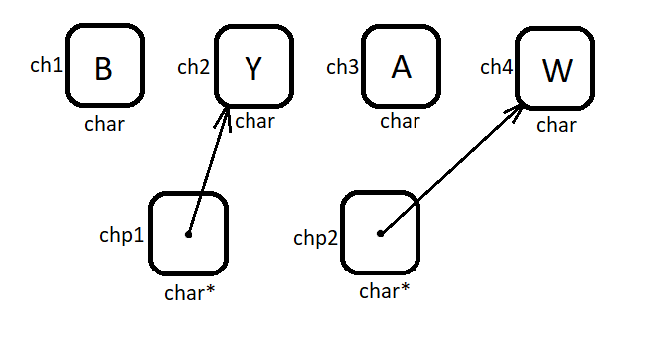

|  |  |
| --- | --- |
| * ch1 = ‘B’ | * chp1 = address ch2 |
| * ch2 = ‘Y’ | * chp2 = address ch4 |
| * ch3 = ‘A’ | * *chp1 = ‘Y’ |
| * ch4 = ‘W’ | * *chp2 = ‘W’ |

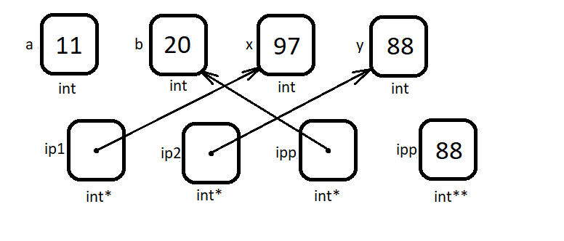

|  |  |
| --- | --- |
| * a = 11 | * ipp = address b |
| * b = 20 | * *ip1 = 97 |
| * x = 97 | * *ip2 = 88 |
| * y = 88 | * *ipp = 20 |
| * ip1 = address x | * **ipp = 88 |
| * ip2 = address y |  |