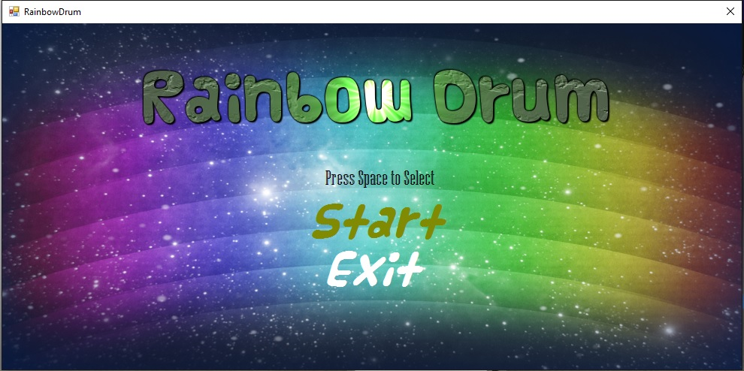

Home:

1. Press “ Space Button” to select
2. Press” ↑ ” ” ↓” to choose

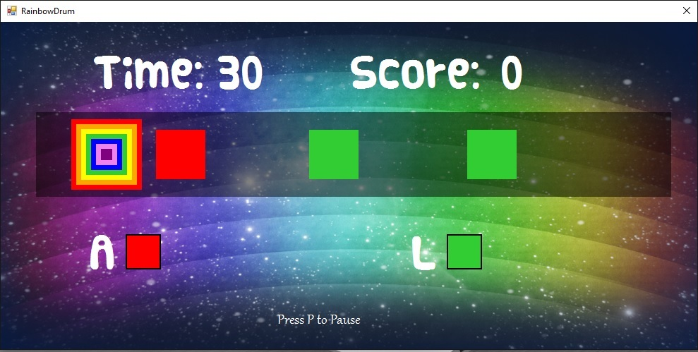

Play area:

1. When the “Red” or “Green” colour box arrive the square rainbow area ,

press “A button “ to get score from red box

press “L button” to get score from green box

1. Press “P button” to pause game.

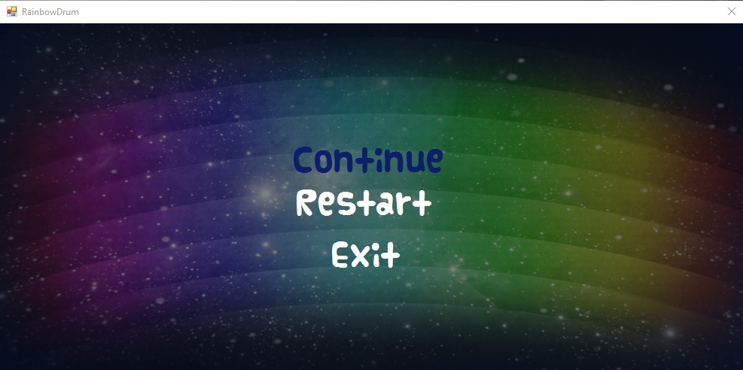

“P button” had pressed:

1. You can continue the game just only press “Space button “ on “Continue “ option.
2. You can play again the game just only press “Space button” on “Restart” option.
3. You can exit the game just only press “Space button “ on “Exit” option.

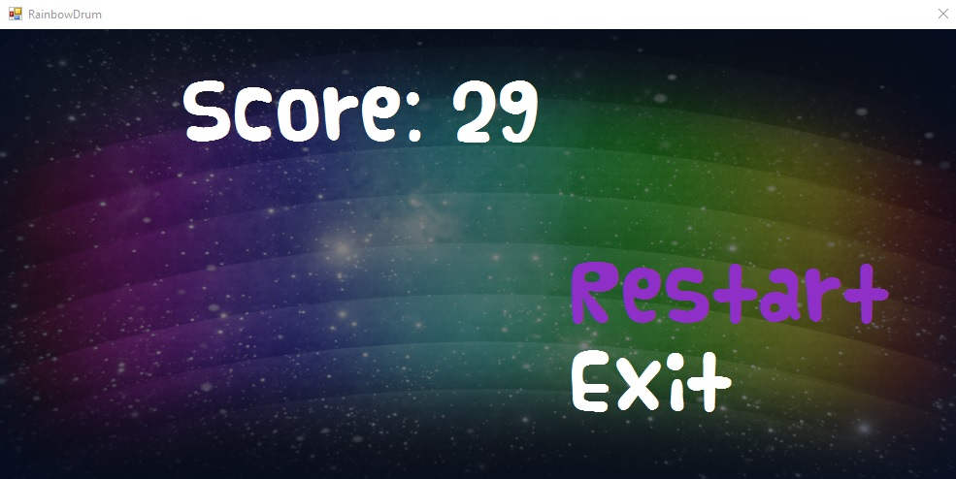

Game Over:

1. You have only 30 second to get high score.
2. You can play again the game just only press “Space button” on “Restart” option.
3. You can exit the game just only press “Space button “ on “Exit” option.