Illustrate the concept of conditional, joint, marginal (relative) frequency using a simple bivariate distribution

JOINT: In a bivariate distribution, given the variables X and Y, the Joint frequency represents the number of statistical units which have Xi value and Yj value at the same time.
To simplify: A joint frequency is how many times a combination of two conditions happens together. For example a dog owner who is also a woman.[^1]

Marginal frequency: Marginal Frequency is the ratio between the frequency of a row total or column total to the total frequency of the data. It is commonly used to analyze general trends in one specific category of data. [^2]
To simplify: A marginal frequency can be calculated by dividing a row total or a column total by the total frequency of the data. [^3]

Given a contingency table, we can observe how the amrginal column at the right and the marginal row at the bottom represent the marginal distribution, while the row/column in the middle are the conditional distirbution.

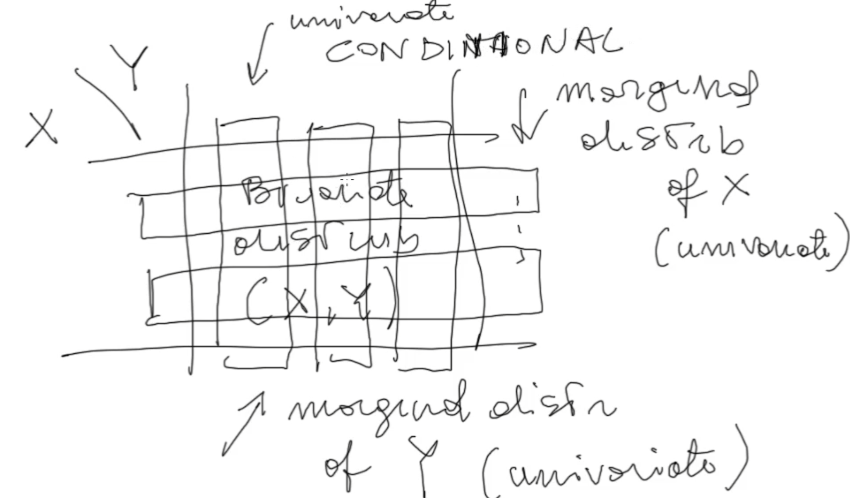

[^1]: Statistics How To , JOINt frqeuncy, https://www.statisticshowto.com/joint-frequency/#:~:text=What%20is%20Joint%20Frequency%3F,of%20two%20conditions%20happens%20together.

[^2: ]Study: https://study.com/learn/lesson/conditional-joint-marginal-relative-frequency-overview-comparison-examples.html
[^3]: onlinemath4all: how to calculate marginal relative frequency: https://www.onlinemath4all.com/how-to-calculate-marginal-relative-frequency.html

