Overall
Welcome to ⁠Barcelona! Staying at the ⁠Catalonia Magdalenes Hotel puts you in the perfect spot to explore. Since you arrive during International Museum Day (May 18th), this 5-night itinerary leverages free cultural access while efficiently grouping Gaudí’s masterpieces.

Transport Strategy: The "Hola ⁠Barcelona" Card
For your 5-day stay, the Hola Barcelona Travel Card (120 hours) is the most efficient choice.
- Unlimited Access: Covers all Metro, TMB buses, trams, and urban trains (FGC).
- Airport Included: It includes the Metro (L9) journey from the airport to the city center.
- Cost-Effective: Typically cheaper than individual tickets if you take 2-3 trips daily.

Day 1 (May 17th): The Medieval Soul
Start with the historic districts right outside your hotel.
- Morning: Walk through the ⁠Gothic Quarter to the ⁠Barcelona Cathedral.
- Afternoon: Explore the artisan shops of ⁠El Born and visit the ⁠Picasso Museum Barcelona.
  - Tip: May 17th is an Open Door Day for the Picasso Museum, but online booking 4 days in advance is strictly required.
- Evening: Enjoy a performance at the ⁠Palau de la Música Catalana, a UNESCO jewel.

Day 2 (May 18th): International Museum Day
Many museums offer free admission today.
- Morning: Take the Metro to ⁠Montjuïc Hill. Visit the ⁠Fundació Joan Miró (free open day) and the ⁠Museu Nacional d'Art de Catalunya (MNAC) for its Romanesque collection.
- Afternoon: Stroll down ⁠Passeig de Gràcia to see the façades of ⁠Casa Batlló and ⁠Casa Milà.

Day 3 (May 19th): The Gaudí Legacy
- Morning: Take Bus 24 from ⁠Plaça de Catalunya (2 mins from your hotel) directly to the entrance of ⁠Park Güell.
- Afternoon: Head to your booked visit at the ⁠Basílica de la Sagrada Família.
  - Note: 2026 marks the targeted completion year for the main towers.
Park Güell
Basílica de la Sagrada Família
Hotel Catalonia Magdalenes to Park Güell

Day 4 (May 20th): Montserrat Day Trip
A dramatic mountain retreat home to a Benedictine monastery.
- The Route: Take the R5 train from ⁠Plaça Espanya (Metro L1/L3) toward ⁠Manresa.
- The Ascent: Transfer at Montserrat-Aeri for the cable car or ⁠Monistrol de Montserrat for the rack railway (⁠Cremallera).
- Highlight: See the Black Madonna and ride the ⁠Sant Joan Funicular for sweeping views.

Day 5 (May 21st): Local Flavors & Departure
- Morning: Visit the ⁠Mercat de la Boqueria on Las Ramblas for a fresh breakfast before checking out.
- Final Stroll: Walk down to Port Vell or the ⁠Barceloneta beach if time permits before heading to the airport.
Overview Map
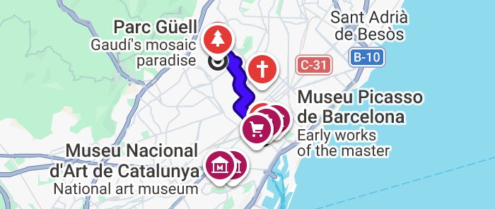

May 17
This walking route for Sunday, May 17, 2026, takes you through the medieval heart of ⁠Barcelona, connecting three world-class cultural landmarks within a compact 1-mile stroll.

Morning: The Spiritual Heart of the ⁠Gothic Quarter
Start your Sunday by wandering through the narrow, stone-paved streets of the Gothic Quarter, which lead you directly to the city's grandest cathedral.
- The Cathedral of Barcelona is a Gothic masterpiece that serves as the neighborhood's focal point. On Sunday mornings, the interior is dedicated to worship and prayer (8:30 AM – 1:45 PM), while cultural and tourist visits generally open in the afternoon from 2:00 PM to 4:30 PM.
- The Route: A 5-minute walk from the center of the Gothic Quarter along Carrer del Bisbe brings you to the cathedral's main square.

Afternoon: Artisan Shopping and Picasso in ⁠El Born
From the cathedral, cross the Via Laietana into El Born, a vibrant district known for its historical charm and creative energy.
- The Picasso Museum Barcelona houses one of the world's most extensive collections of the artist's early works. Conveniently, May 17 is observed as International Museum Day, meaning the museum typically hosts an Open Door day with free entry, though prior reservation is highly recommended.
- Artisan Shops: On your way to the museum, explore the shops in El Born. Look for handmade leather goods at Atelier Madre or traditional ceramics at 1748 Artesania I Coses.
- The Route: This 11-minute walk takes you through the heart of El Born via Carrer de l'Argenteria.

Evening: A UNESCO Jewel of Music
Finish your day at one of the most beautiful concert halls in the world, located just on the edge of the Sant Pere neighborhood.
- The Palau de la Música Catalana is the only music hall in the world recognized as a UNESCO World Heritage Site. On the evening of May 17, 2026, you can experience a spectacular Barcelona Guitar Trio & Dance concert, featuring a tribute to Paco de Lucía with flamenco dance and guitar virtuosity.
- The Route: A final 9-minute walk from the Picasso Museum via Carrer d'En Giralt el Pellicer leads you to the Palau.
Overview Map
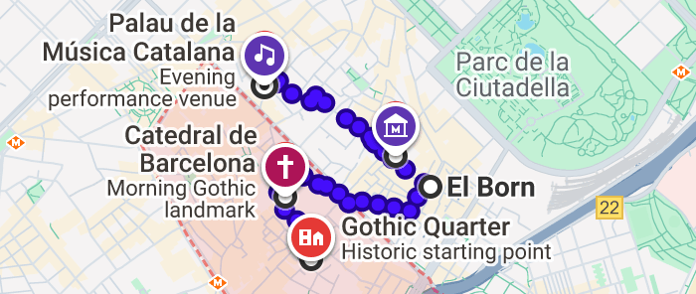

May 18
Monday, May 18, 2026, marks International Museum Day, an annual celebration where Barcelona's top cultural institutions throw open their doors for free. This route maximizes your access to world-class art on Montjuïc Hill before returning to the city center for architectural sightseeing.
Morning: Art and Open Doors on Montjuïc Hill
Start your morning on the scenic heights of Montjuïc. On this special Monday, both major museums on the hill are exceptionally open and offer free admission to the public.
Fundació Joan Miró
The ⁠Fundació Joan Miró is a vibrant space celebrating the surrealist master with a vast collection of paintings and sculptures. For International Museum Day, the foundation hosts an Open Door day from 10:00 AM to 7:00 PM, granting free access to all permanent collections and temporary exhibitions.
Museu Nacional d'Art de Catalunya
A short stroll away sits the ⁠Museu Nacional d'Art de Catalunya (MNAC), housed in the grand Palau Nacional. It is renowned for its Romanesque collection, featuring medieval frescoes saved from Pyrenean churches. It also offers free entry today from 10:00 AM to 8:00 PM.
- Getting to ⁠Montjuïc: From ⁠Plaça de Catalunya, take the 55 Bus for a 27-minute ride directly to the museum. Alternatively, take the L3 Subway to Paral·lel and transfer to the Funicular de Montjuïc.
- Between Museums: The walk from ⁠Fundació Joan Miró to MNAC takes approximately 9 minutes via ⁠Passeig de Santa Madrona.
in 3 & 22 min from Pl. Catalunya - Pg. de GràciaFundació Joan Miró to Museu Nacional d'Art de Catalunya
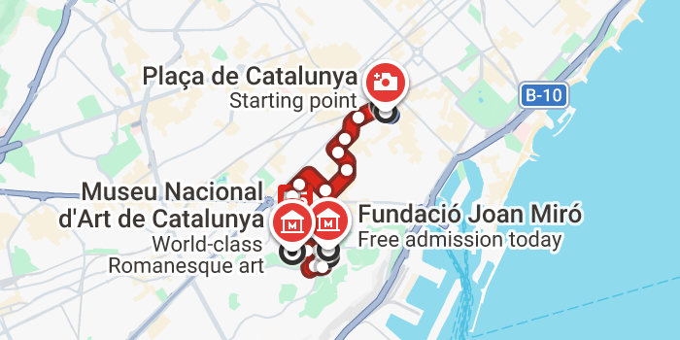
Afternoon: Modernism on ⁠Passeig de Gràcia
Descend from the hill to stroll down Barcelona's most elegant boulevard, Passeig de Gràcia, to admire the visionary façades of Antoni Gaudí.
Casa Batlló
The façade of ⁠Casa Batlló is a kaleidoscopic dream of glass and ceramic, famously resembling a dragon's back. While interior entry requires a ticket, the exterior is a free public masterpiece.
La Pedrera - Casa Milà
Just a short walk up the street is ⁠La Pedrera - Casa Milà, Gaudí's final residential design. Its undulating stone exterior and whimsical chimneys have made it a global icon of Modernism.
- Getting to ⁠Passeig de Gràcia: From ⁠MNAC, walk to the ⁠Poble Sec metro station and take the L3 Subway to Passeig de Gràcia (approx. 23 minutes).
- The Stroll: The walk between ⁠Casa Batlló and Casa Milà takes about 8 minutes along the main boulevard.
in 15 & 20 min from Poble Sec
8 min walk from Casa Batlló to La Pedrera - Casa Milà
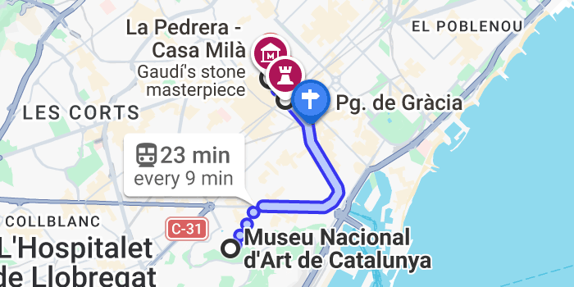
Overview Map
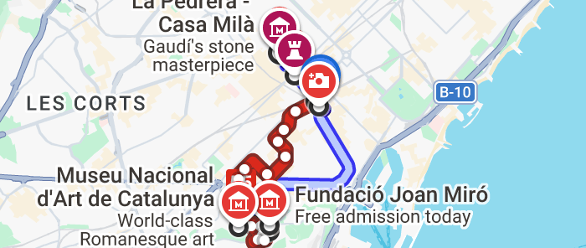

May 19
This navigation guide for Tuesday, May 19, 2026, follows your Gaudí-centric itinerary, taking you from your hotel to the hilltop vistas of ⁠Park Güell and finally to the now-soaring spires of the ⁠Sagrada Família.
Morning: Journey to ⁠Park Güell
Your day begins with a short walk followed by a direct bus ride that climbs the hills of the Gràcia district.
Park Güell
- Departure: From ⁠Hotel Catalonia Magdalenes, a quick 6-minute walk (0.3 miles) brings you to the bustling ⁠Plaça de Catalunya.
- Transit: Board the Bus 24 at the ⁠Pl Catalunya - Rambla Catalunya stop. This bus runs every 6 minutes and takes approximately 32 minutes to reach the C N Catalunya - ⁠Park Güell entrance.
- Visitor Tips: In May, ⁠Park Güell is open from 8:00 AM to 9:30 PM. Booking tickets at least three months in advance is essential for the Monumental Zone, especially for morning slots.
Hotel Catalonia Magdalenes to Plaça de Catalunyaat 11:21 AM & 11:27 AM from Pl Catalunya - Rambla Catalunya - Final trajecte
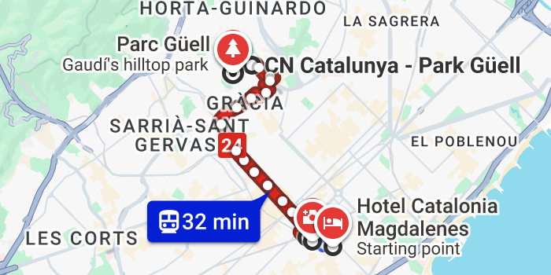
Afternoon: The ⁠Sagrada Família Milestone
After exploring the park, descend back toward the Eixample district for your scheduled visit to Gaudí's magnum opus.
Basílica de la Sagrada Família
- Transit: From the park entrance, catch the V19 Bus (heading toward Barceloneta) and alight at ⁠Pg de Sant Joan - Rosselló. A 10-minute walk from the stop will bring you to the basilica entrance. The total journey takes roughly 27 minutes.
- 2026 Milestone: You are visiting at a historic moment. The central ⁠Tower of Jesus Christ reached its full height of 172.5 meters on February 20, 2026. This completion makes the ⁠Basílica de la Sagrada Família the tallest church in the world. While decorative work on the Glory Façade continues until 2034, the main architectural structure is now realized.
at 4:08 PM & 4:17 PM from Ctra del Carmel - Ptge Josefina Torrens Illas
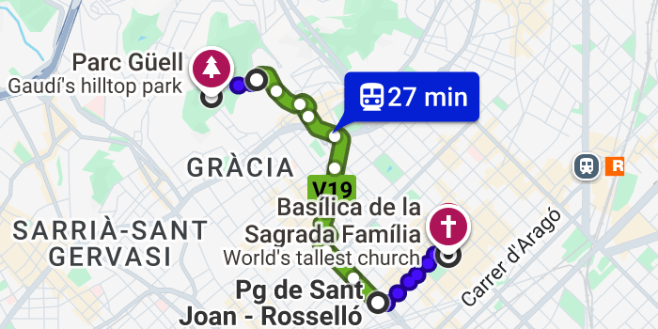
Overview Map
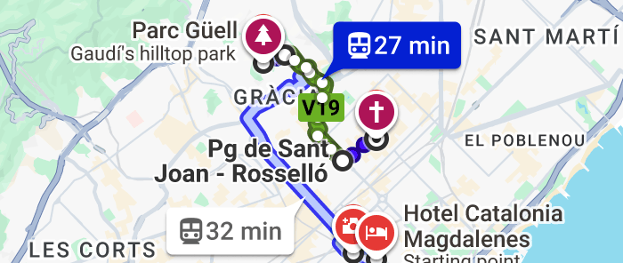

May 20
Your day trip to the jagged peaks of ⁠Montserrat on Wednesday, May 20, 2026, offers a spiritual and scenic retreat just over an hour from Barcelona. This route connects the R5 train with the mountain's iconic ascent options.
The Train Journey (R5 Line)
Begin your journey at the major transit hub of ⁠Plaça d'Espanya.
- Board the R5 Train (FGC) heading towards Manresa-Baixador. Trains typically depart every hour, and the journey to the base of the mountain takes approximately one hour.
- Pro Tip: Sit on the left side of the train during the ride out of Barcelona to catch the best first views of the Montserrat massif as you approach.
The Ascent: Cable Car or Rack Railway
Depending on your preference for speed or comfort, you will choose between two distinct ways to reach the monastery.
- Option 1: Montserrat-Aeri (Cable Car). Alight at the Montserrat-Aeri station for a thrilling 5-minute ride. The yellow cable cars depart every 15 minutes and offer steep, panoramic views as they scale the cliffs.
- Option 2: Monistrol de Montserrat (Rack Railway/Cremallera). Stay on the train for one more stop to Monistrol de Montserrat. The green rack railway provides a smoother, 15-minute seated journey through the mountain landscape.
- Navigation: The total travel time from Plaça d'Espanya to the Abbey is roughly 1 hour and 36 minutes via the Rack Railway.
Highlights: The Black Madonna and Sant Joan Views
Once at the sanctuary, the spiritual and natural highlights are just a short walk from the station.
- Inside the Basilica, you can visit the Black Madonna (La Moreneta), the patron saint of Catalonia. To see the statue up close, it is highly recommended to book a timed entry ticket in advance, as queues can be long. The shrine is typically accessible from 8:00 AM to 10:30 AM and 12:00 PM to 6:25 PM.
- For the most expansive views of the Pyrenees and the Llobregat valley, take the Sant Joan Funicular. It climbs to one of the highest points of the mountain (1,000m) in about 7 minutes. In May, it generally operates from 10:00 AM to 6:00 PM.
Overview Map
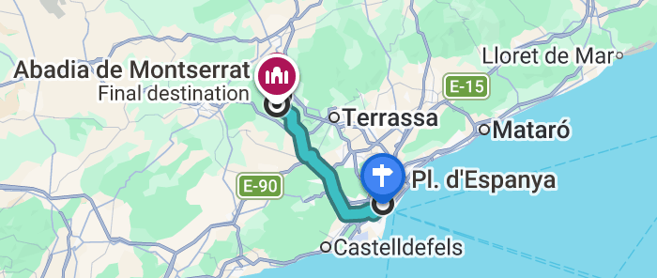

May 21
On your final day in ⁠Barcelona, Thursday, May 21, 2026, you'll savor the city's culinary heart and enjoy a last seaside stroll before departing from ⁠Josep Tarradellas Barcelona-El Prat Airport (BCN).
Morning: Breakfast at ⁠La Boqueria
Start your morning with a sensory feast at ⁠Barcelona’s most famous market, just a short walk from your hotel.
Mercat de la Boqueria
The ⁠Mercat de la Boqueria is a historic iron-framed market packed with over 200 stalls. Arriving early (around 8:00 AM) is recommended to beat the crowds and enjoy a fresh breakfast.
- Dining Highlights: For a legendary market breakfast, try the fried eggs with baby squid at ⁠El Quim de la Boqueria or the chickpeas with black pudding at ⁠Bar Pinotxo.
- The Route: From ⁠Hotel Catalonia Magdalenes, a 10-minute walk through the Gothic Quarter via ⁠Carrer de la Portaferrissa brings you to the market entrance on La Rambla.
Hotel Catalonia Magdalenes to Mercat de la Boqueria
Final Stroll: Port Vell and the Beach
After checking out, follow the historic ⁠La Rambla down to the Mediterranean for one last look at the sea.
- Port Vell: A 17-minute walk down the length of ⁠La Rambla leads you to ⁠Port Vell, the city’s historic harbor. It's a scenic area featuring the Maremàgnun shopping center and the Columbus Monument.
- ⁠Barceloneta Beach: If time permits, continue walking for another 20 minutes along the waterfront to reach ⁠Barceloneta Beach. This is the city's most central beach, perfect for a final coffee by the waves.
Mercat de la Boqueria to Port vell in BarcelonaPort vell in Barcelona to Barceloneta Beach
Departure: Heading to the Airport
Whether you choose a quick taxi or public transit, ensure you allow enough time for check-in—generally 3 hours for non-Schengen flights and 2 hours for domestic or Schengen flights.
- By Taxi (Recommended for Speed): A taxi from the beach area to ⁠Barcelona-El Prat Airport (BCN) takes approximately 15–20 minutes and typically costs between €35 and €45.
- By Public Transit: The most efficient transit route involves taking the D20 Bus to ⁠Plaça d'Espanya and transferring to the Aerobús (A1/A2), which takes roughly 1 hour in total.
Barceloneta Beach to Josep Tarradellas Barcelona-El Prat Airportin 2 & 11 min from Pg Marítim - Pepe Rubianes
Overview Map
