Improved Comparable Sale No. 1
Comparable Sale | Sale No. 1
Property Type | Convenience Store / Gas Station
CAD ID | 48758
Street Address | 8760 Texas Highway 35
City | Van Vleck
State | Texas
County | Matagorda
Land Size (SF) | 20996
Land Size (Acres) | 0.5
Gross Building Area (SF) | 4036
Net Rentable Area (SF) | 4036
Land to Building Ratio | 5.20
Year Built/ Renovated | 1975 / 2007
Date of Sale | 09/6/2024
Sales Price | $1,300,000
Unit Price ($/Net SF) | $322.10
Unit Price ($/Gross SF) | $322.10
Cap Rate | 7.28%
NOI ($/Net SF) | $23.46
Occupancy Rate at Time of Sale | 100.0%
Data Source | Colliers International - Appraisal Document
Recorded Number | 2024-4382
Grantor | Angeles Enterprises Inc.
Grantee | Moprin Enterprises LLC
Terms and Conditions | Cash at Settlement
Property Rights Conveyed | Fee Simple
Transactional Status | Recorded
Additional Comments | The property is currently Philip 66 Branded, with 2 MPDs and 4 fueling position, two USTs (one 12,000-gallon and one 6,000-gallon). A 1,025 SF fueling canopy. Instore features a 22-door walk-in cooler. Sale price includes real estate and FF&E only.

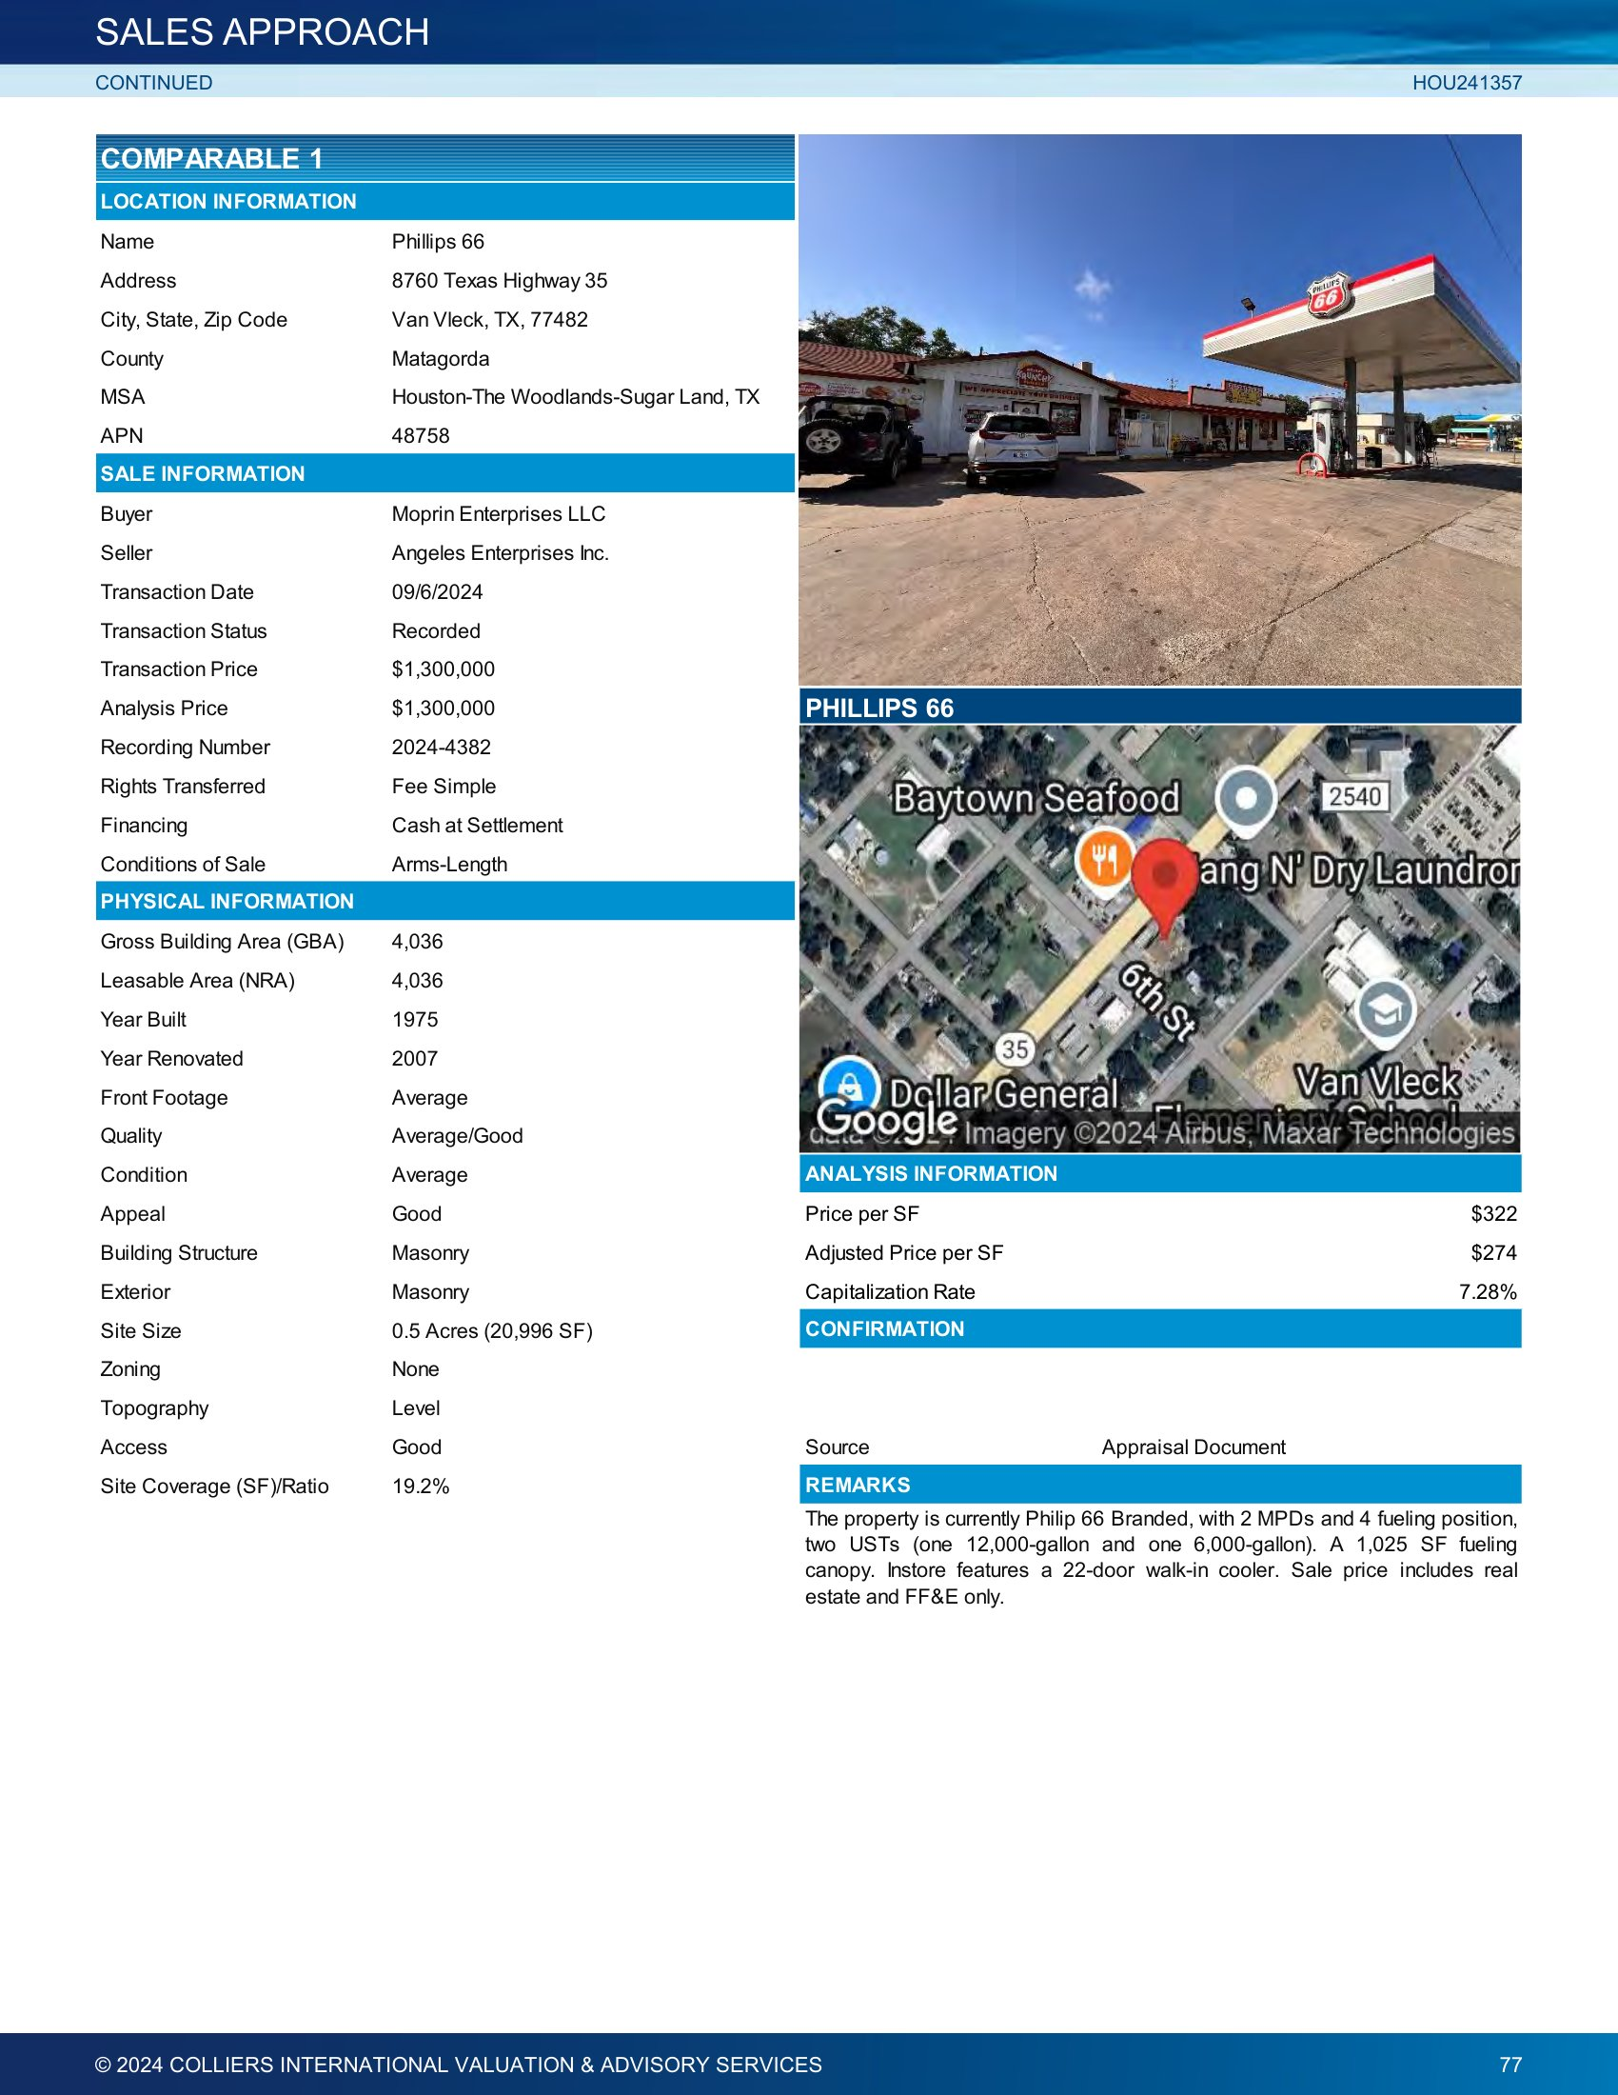

Improved Comparable Sale No. 2
Comparable Sale | Sale No. 2
Property Type | Convenience Store / Gas Station
CAD ID | 034-201-001-0001
Street Address | 3490 Preston Ave.
City | Pasadena
State | Texas
County | Harris
Land Size (SF) | 43691
Land Size (Acres) | 1.0
Gross Building Area (SF) | 5400
Net Rentable Area (SF) | 5400
Land to Building Ratio | 8.09
Year Built/ Renovated | 1996 / 2023
Date of Sale | 05/1/2023
Sales Price | $2,100,000
Unit Price ($/Net SF) | $388.89
Unit Price ($/Gross SF) | $388.89
Cap Rate | 5.64%
NOI ($/Net SF) | $27.18
Occupancy Rate at Time of Sale | 100.0%
Data Source | Colliers International - Appraiser
Recorded Number | RP-2023-154754
Grantor | Ali Roshan, Inc.
Grantee | 3490 Preston Real Estate, LLC
Terms and Conditions | Cash at Settlement
Property Rights Conveyed | Leased Fee
Transactional Status | Recorded

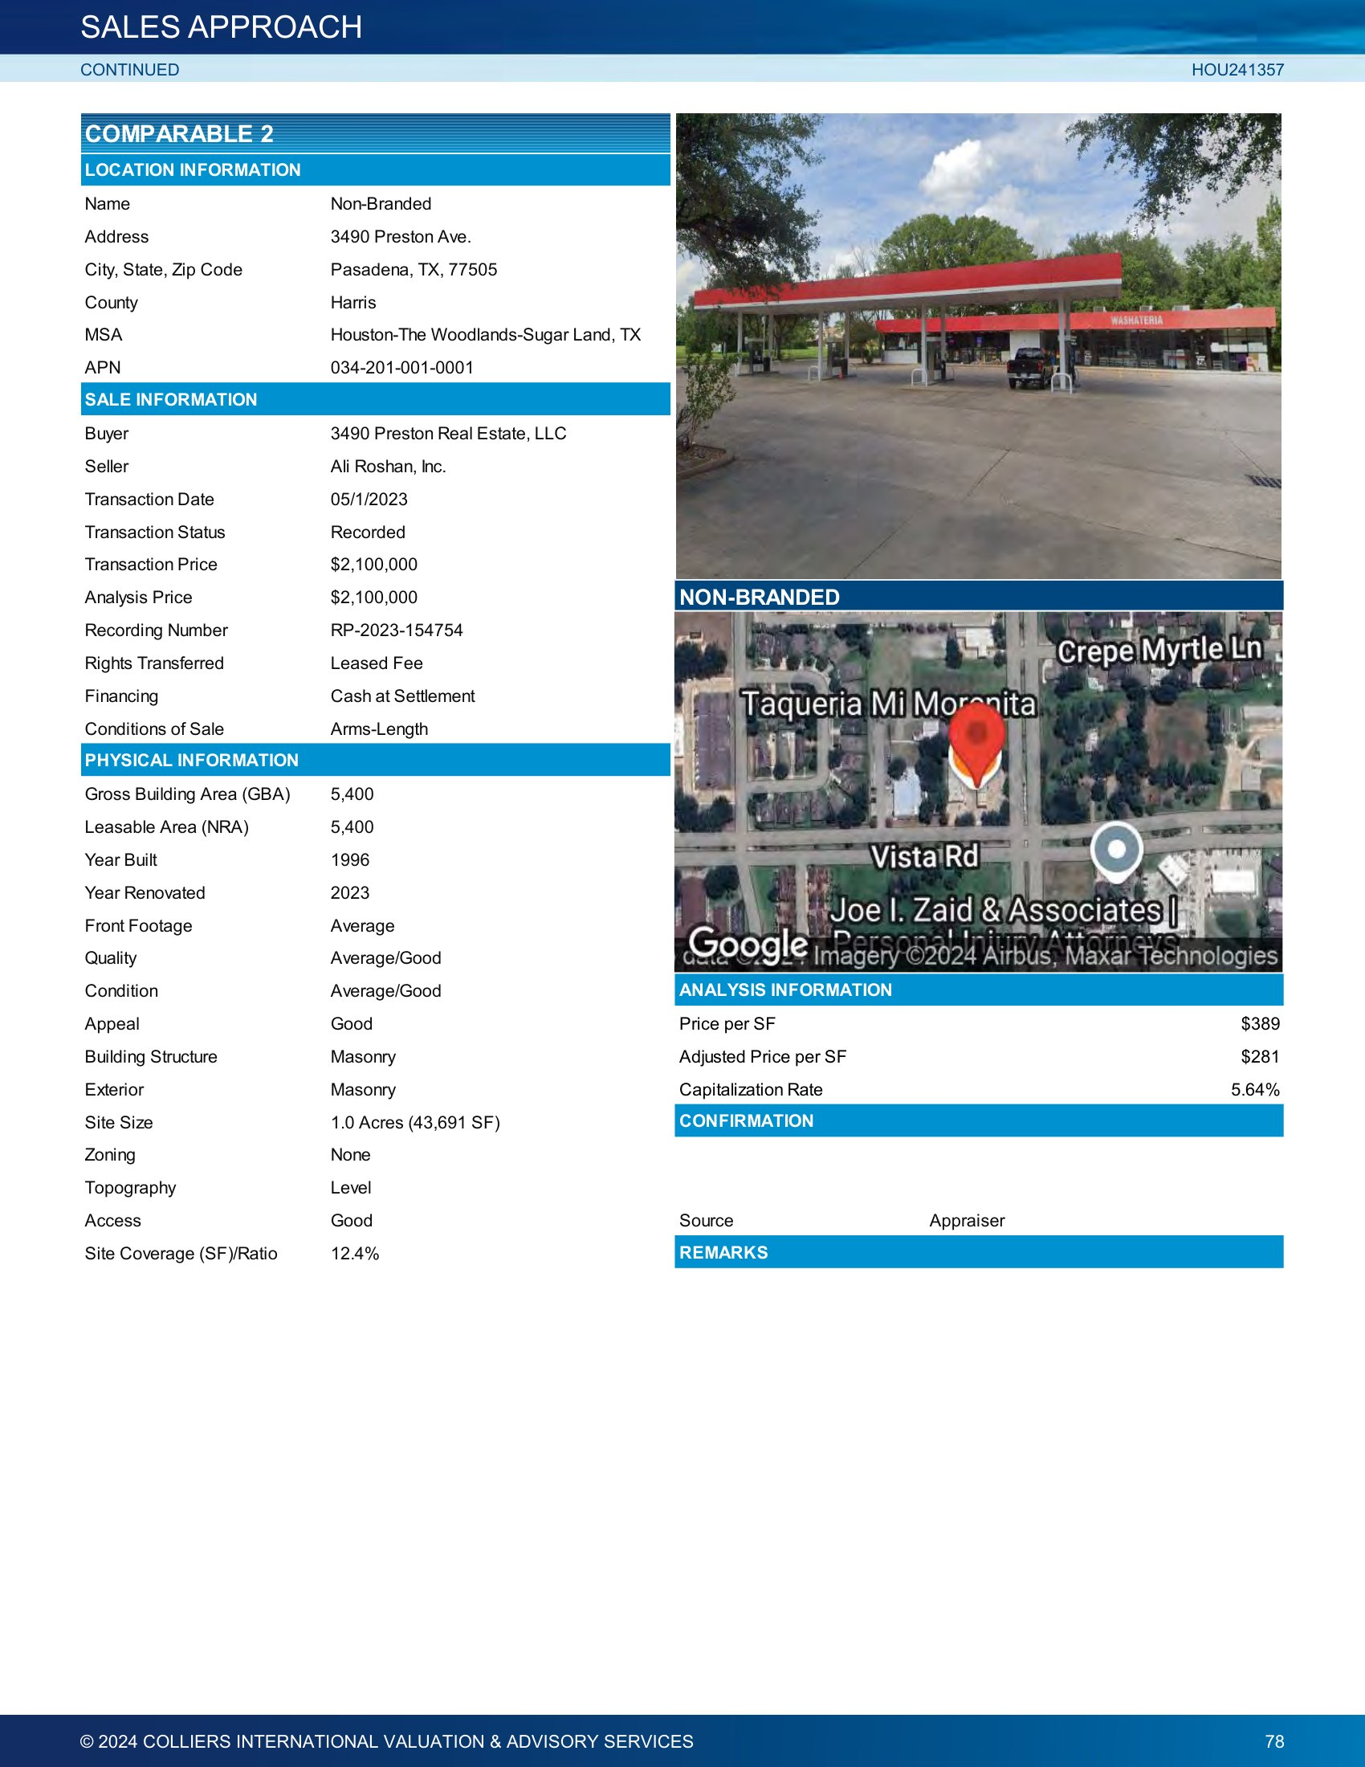

Improved Comparable Sale No. 3
Comparable Sale | Sale No. 3
Property Type | Convenience Store / Gas Station
CAD ID | 047-191-000-0047
Street Address | 12311 Bammel North Houston Rd.
City | Houston
State | Texas
County | Harris
Land Size (SF) | 72698
Land Size (Acres) | 1.7
Gross Building Area (SF) | 11180
Net Rentable Area (SF) | 11180
Land to Building Ratio | 6.50
Year Built/ Renovated | 2019
Date of Sale | 01/10/2023
Sales Price | $5,476,000
Unit Price ($/Net SF) | $489.80
Unit Price ($/Gross SF) | $489.80
Cap Rate | 6.63%
NOI ($/Net SF) | $28.34
Occupancy Rate at Time of Sale | 100.0%
Data Source | Colliers International - Appraiser
Recorded Number | RP-2023-9976
Grantor | Punjabi Sher Investors, LLC
Grantee | GRA-Bammel North LLC
Terms and Conditions | Cash at Settlement
Property Rights Conveyed | Leased Fee
Transactional Status | Recorded
Additional Comments | The facility is currently 75.8% occupied (53.5% owner occupied) and considered to be in excellent overall condition. The property features 5,980 square feet of convenience store space and 5,200 square feet of in-line retail space. The convenience store is operated under the Valero flag and is owner- operated. Two of the retail suites are leased to local tenants. The remaining retail space is vacant and in shell condition. Other features include a deli/kitchen located inside the c-store, 8 multi-product dispensers (MPDs) and a 4,840- square-foot fuel canopy. The property was acquired for a total consideration of $5,328,000 of which $78,000 was allocated to business value. At the time of sale the property was operating at below stabilized occupancy. We have estimated a lease-up cost of $226,000 to achieve stabilized occupancy resulting in an adjusted sale price of $5,476,000, or $489.80 per square foot for the real estate & FF&E.

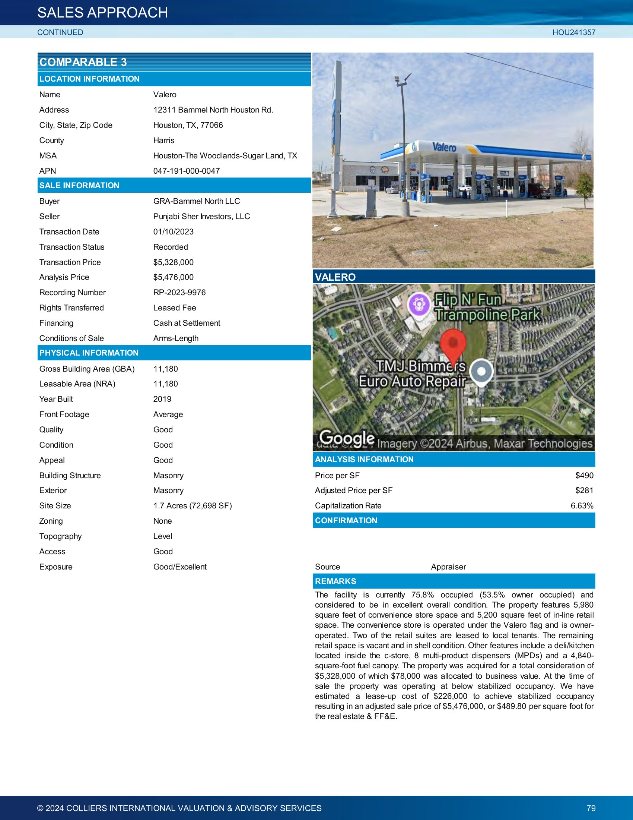

Improved Comparable Sale No. 4
Comparable Sale | Sale No. 4
Property Type | Convenience Store / Gas Station
CAD ID | 139-490-001-0001
Street Address | 5915 Mohawk St.
City | Houston
State | Texas
County | Harris
Land Size (SF) | 64120
Land Size (Acres) | 1.5
Gross Building Area (SF) | 9460
Net Rentable Area (SF) | 9460
Land to Building Ratio | 6.78
Year Built/ Renovated | 2019
Date of Sale | 07/22/2022
Sales Price | $3,600,000
Unit Price ($/Net SF) | $380.55
Unit Price ($/Gross SF) | $380.55
Cap Rate | 7.12%
NOI ($/Net SF) | $27.10
Occupancy Rate at Time of Sale | 100.0%
Data Source | Colliers International - Appraisal Document
Recorded Number | RP-2022-384247
Grantor | SHEIKHANI & MAVANI GROUP LLC-SERIES.
Grantee | RAPS Properties LLC
Terms and Conditions | Cash at Settlement
Property Rights Conveyed | Leased Fee
Transactional Status | Recorded
Additional Comments | This is a multitenant retail center with a Chevron gas station. The property features 4 MPDs, a 3,000 SF fueling canopy, and one 30,000-gallon UST. The building features ±3,960 SF cstore, ±2,750 SF liquor store, and ±2,750 SF nail spa.

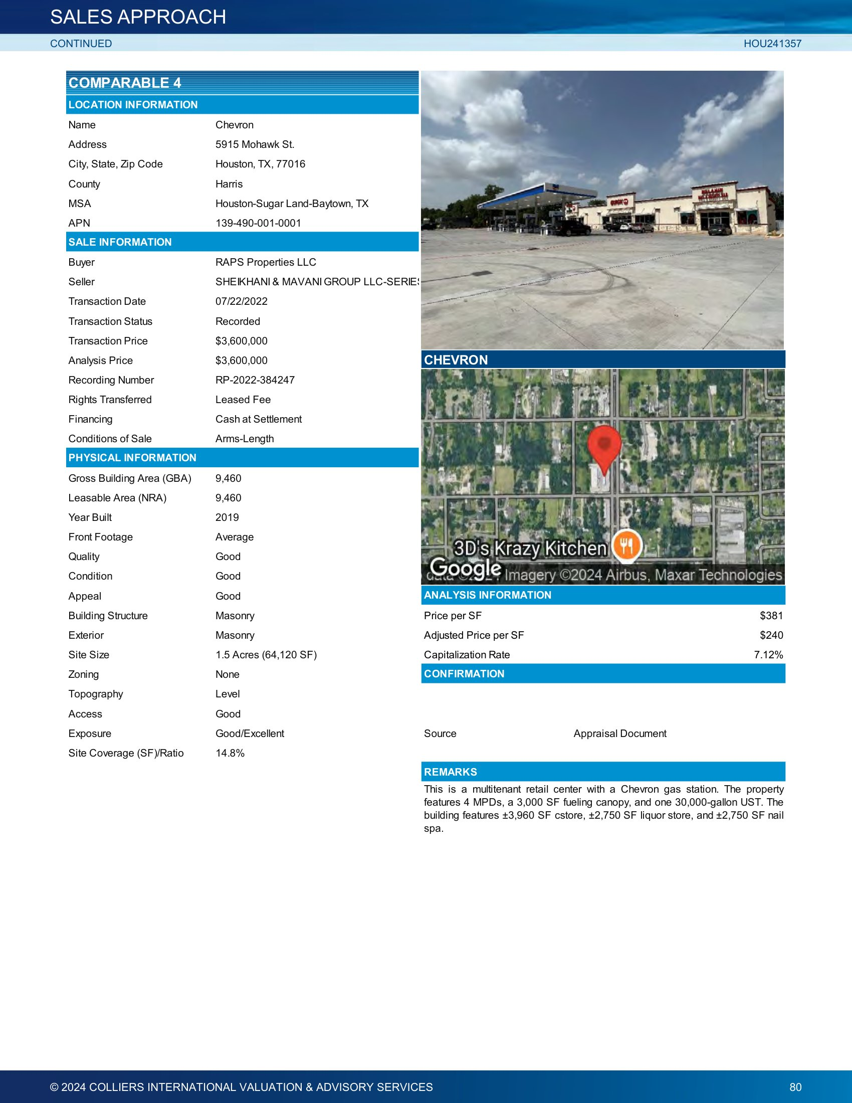

Improved Comparable Sale No. 5
Comparable Sale | Sale No. 5
Property Type | Convenience Store / Gas Station
CAD ID | 02051-007-0140
Street Address | 1822 N Zarzmora St.
City | San Antonio
State | Texas
County | San Antonio
Land Size (SF) | 16117
Land Size (Acres) | 0.4
Gross Building Area (SF) | 4250
Net Rentable Area (SF) | 4250
Land to Building Ratio | 3.79
Year Built/ Renovated | 1980
Date of Sale | 04/6/2022
Sales Price | $799,995
Unit Price ($/Net SF) | $188.23
Unit Price ($/Gross SF) | $188.23
Cap Rate | 8.00%
NOI ($/Net SF) | $15.06
Occupancy Rate at Time of Sale | 100.0%
Data Source | Colliers International - Seller's Broker
Recorded Number | 20220088948
Grantor | Perry Williams
Grantee | Hym Properties, LLC
Terms and Conditions | Cash at Settlement
Property Rights Conveyed | Leased Fee
Transactional Status | Recorded
Additional Comments | The property features a 2-MPD Citgo convenience store/gas station and two other retail spaces.

