6.2 UI Redesign

The new UI will be grounded on our App objective and attempts to facilitate the user journey by improving the old version in the following four dimensions:

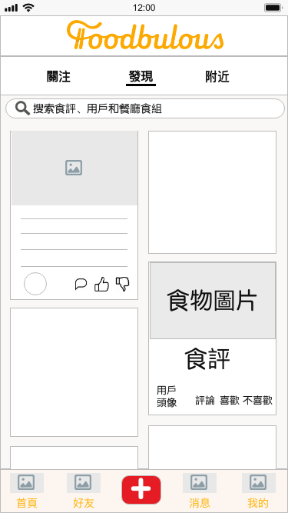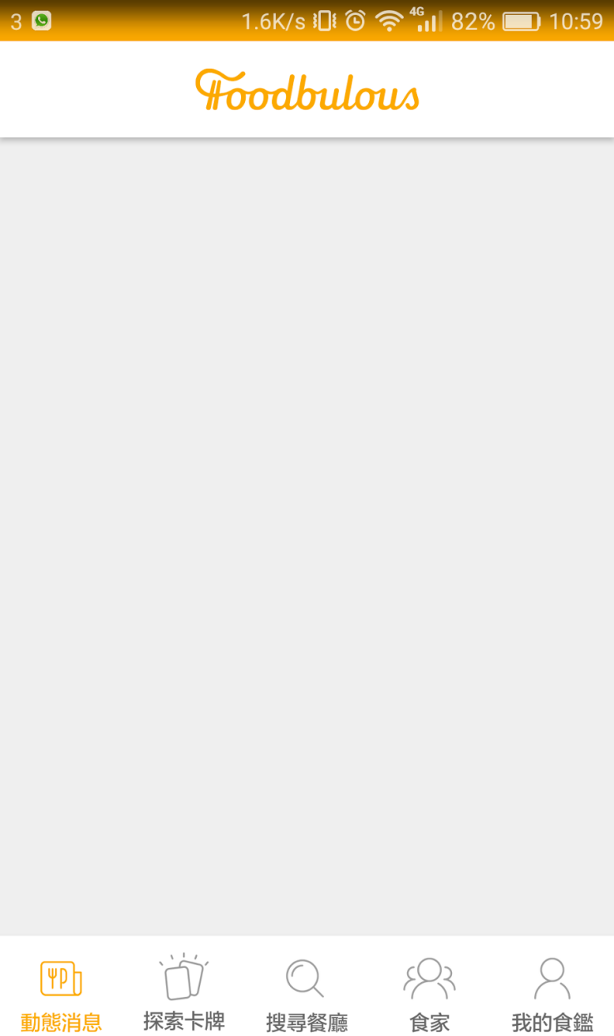

           New UI Sample (Prototype)                                               Current UI

① To enhance the social and community attribute of Foodbulous

           --- By placing user-generated food and/or restaurant Notes (食評) on the Homepage with big and fantastic pictures;

           --- By introducing “comment”, “like” and “dislike” functions to each Food Note to increase interactivity between users;

           --- By enabling users to store, like, comment others’ Decks (食組) and share them to other social media platforms;

           --- By introducing foodie matching system, where users who have the same favourite Food Groups will be recommended to each other.

       ② To improve usability of Foodbulous and increase user’s agency

           --- By showing new users some recommended foodies, who have either written a number of Food Notes, or have received a number of “likes”;

           --- By replacing ambiguous wordings (e.g. “空腹食早餐”, “男人的浪漫”, “偉大的媽媽”...) with more explicit and directed ones to avoid confusion;

           --- By transforming “Discover (搜索餐廳)” tab to a multipurpose search bar, which is fixed at the top of every tab page;

           --- By displaying “Writting Reviews (寫食評)” in a conspicuous place (i.e. navigation bar at the bottom), where users can easily find once they want to post Notes;

           --- By integrating “Popular Themes (探索卡牌)” into search bar as tag suggestions (標籤聯想提示) with reference to 小紅書, and offering Autocomplete Suggestions with reference to Google

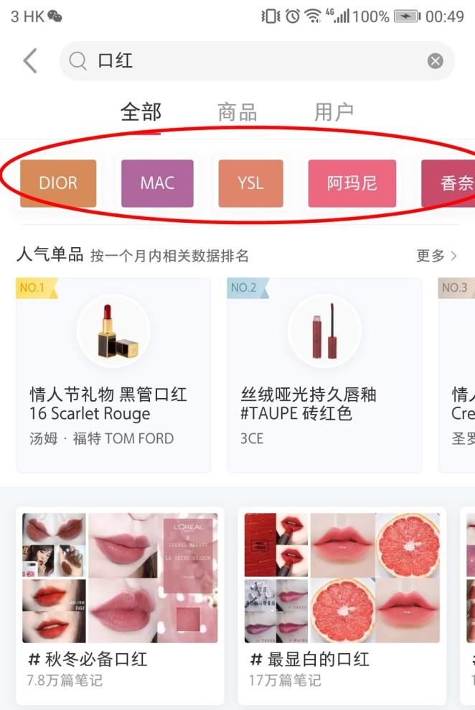

小紅書Tag suggestions

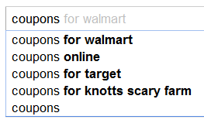

                                                 Google Autocomplete Suggestions

       ③ To strengthen the relationship between product (i.e App) and users

           --- By adding more methods for logging in in addition to Facebook (e.g. Whatsapp, Instagram)

           --- By creating sharable QR code and URL for users to invite their friends