COMM5940 New Media Business Model & Innovation Academic Year 2018/19 Semester 2

Prof. Bernard Suen

**Foodbulous Revamp Proposal**

*(First Milestone Report)*

**X **

# TEAM MEMBERS:

SUN Jianxiang 1155117200

ZHANG Yiming 1155112789

XUE Xuting 1155114866

SUN Guanlin 1155115053

TANG Yedan 1155114685

XIA Congcong 1155119581

ZHOU Tianzi 1155115070

**CONTENT**

1. *INTRODUCTION 3*
2. *SWOT Analytics 3*
3. *PRODUCT ANALYSIS 4*
   1. Mission 4
   2. USP 4
   3. Product Features 4
4. *PROBLEMS 12*
   1. Content 12
   2. With respect of UX elements paradigm 13
5. *OBJECTIVES 15*
6. *USER SEGMENTATION 15*
7. *STRATEGIES&SOLUTIONS 15*
   1. UX Redesign 15
   2. UI Redesign 16
8. *TESTING & EVALUATION 18*
   1. KPIs 18
   2. Usability test; A/B test 18
   3. Qualitative Research: Face-to-face Interview 19
9. *TIMELINE 19*
   1. Breakdown 19

# INTRODUCTION

Foodbulous is a restaurant seeking mobile application developed by Innopage, apps developer and UI/UX consultant, specializing in iOS and Android apps development based in Hong Kong. Unlike other food seeking apps, Foodbulous has created a friend-recommended model to provide users with a more reliable way to find the best food.

Although many efforts have been made to Foodbulous, the app is facing many problems with relatively low usage rate and needs to be revamped. In this situation, it is honored that our team has been given the chance to rejuvenate the app and help accomplish its mission.

All 7 members are from New Media programme of the Chinese University of Hong Kong, including SUN Jianxiang, ZHANG Yiming, XUE Xuting, SUN Guanlin, TANG Yedan, XIA Congcong and ZHOU Tianzi. We will analyze the current market as well as the product, then propose strategies and solutions accordingly. We aim to improve the usability and boot the number of users of Foodbulous.

# SWOT Analytics

**Weaknesses**

* The database is incomplete and the update is slow;
* The app is not user-friendly;
* Lack of customer data;
* Single channel for publicity.

**Strengths**

* Emphasis on the interactions between friends;
* Few fake reviews;
* Has innovation point: "Deck(食組)" function aims to help users better manage and browse their favorite restaurants;
* Support small restaurants, no recommendation fees;
* Passion for exploring the restaurant's story.

**Threats**

* Fierce competition in the industry;
* Similar apps whose main design idea is the same as Foodbulous.

# PRODUCT ANALYSIS

**Opportunities**

* Restaurant finder app market has a lot of room for development;
* Users are tired of Openrice's false reviews;
* The successful experience of the Mainland can be applied to the Hong Kong market.

## Mission

“How to find good food” is a common question in everyone’s daily life. Foodbulous is trying to provide a reliable way to help people explore best dishes and find what they want to eat. Through Foodbulous, foodies will not only find it genuine while interacting with friends, but they may restore beliefs and passions towards delicious food as well.

## USP

1. Recommendations based on friends’ reviews: More reliable and persuasive compared to information provided by restaurants
2. Interactions with other foodies: through likes on food reviews (but currently the engagement is quite weak)
3. Collections of favorite food or restaurants: Decks (but the concept is actually too complicated to understand)

## Product Features

There are five major pages on Foodbulous except Login page and Restaurant single page:

1. News Feed(動態消息)
2. Discover(探索)
3. Restaurant(搜尋餐廳)
4. Foodie(食家)
5. Profile(我的食鑑)

### Login and Sign up

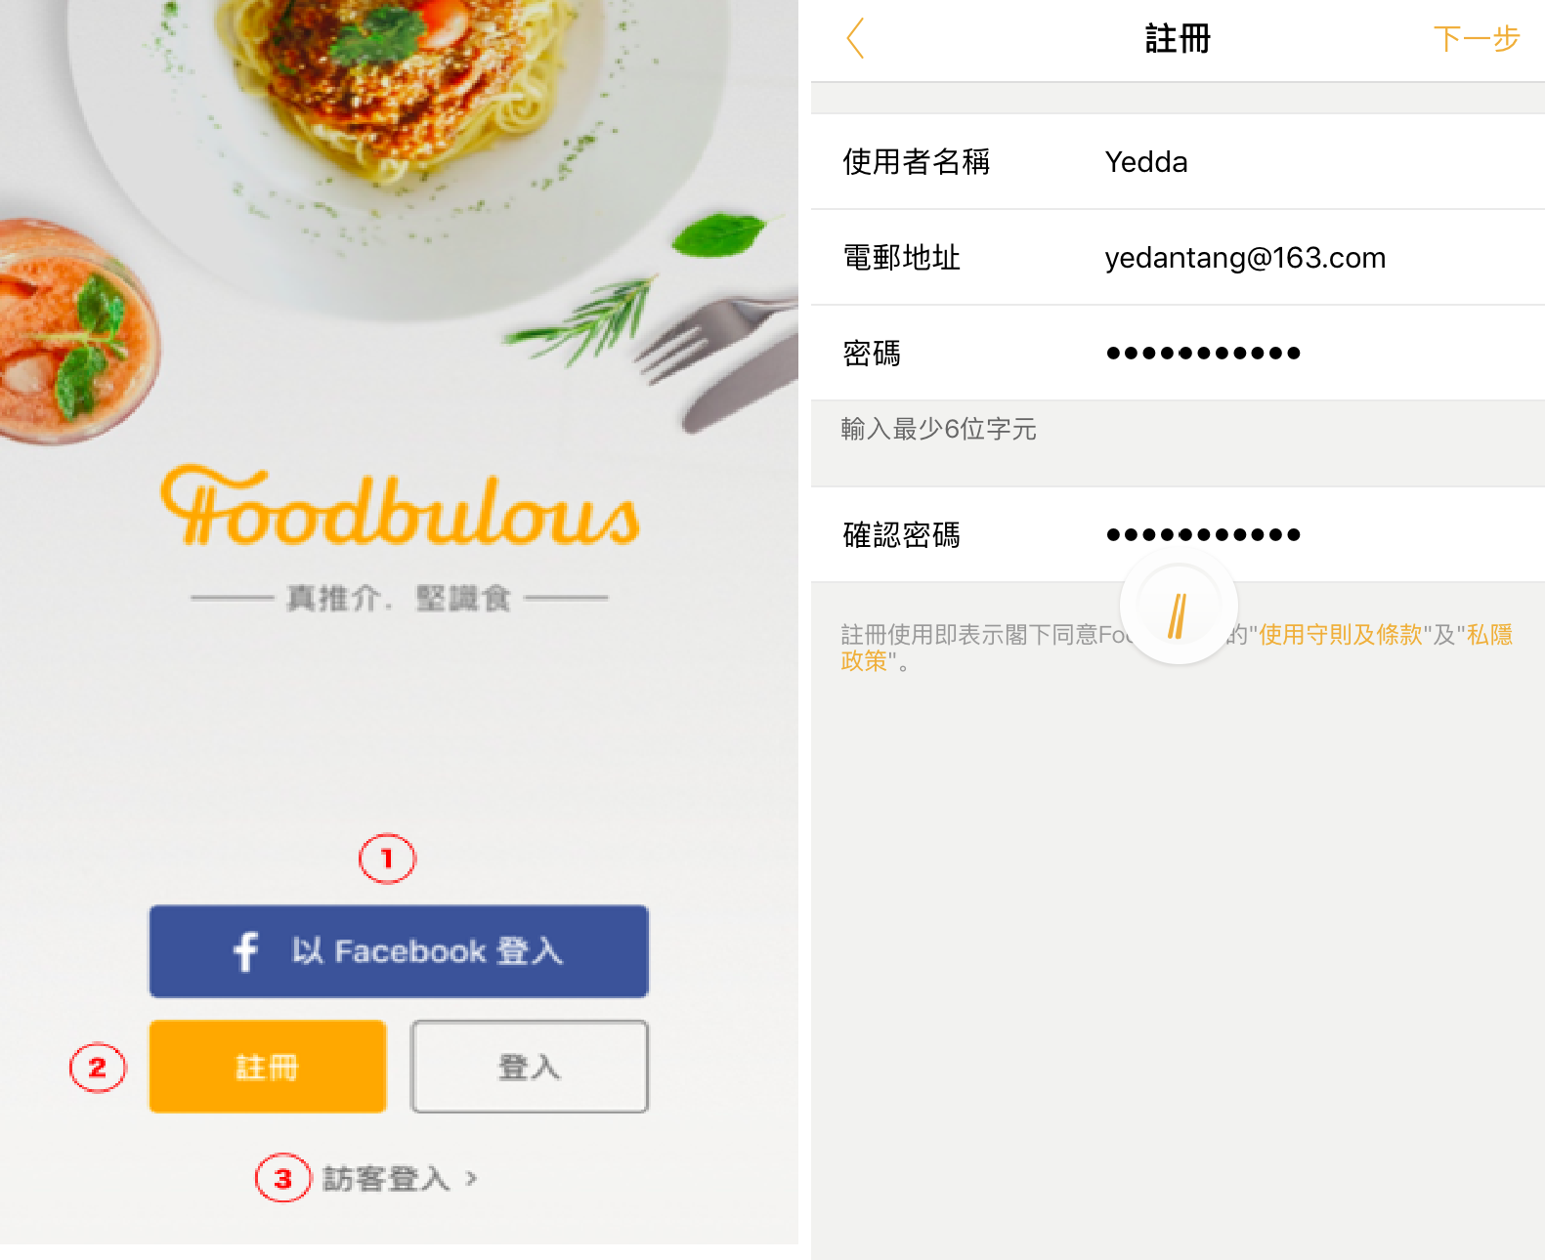

① Login with Facebook: Automated log in with facebook, without requiring filling in emails or other information. User’s Facebook friends list will be copied into the app.

② Link to the sign-up page and need to fill in user’s email.

③ Visitors. In current version, there is no obvious difference between visitor and signed-up users’ experience.

1. **News Feed Page(動態消息):** Food reviews posted by the people one is following

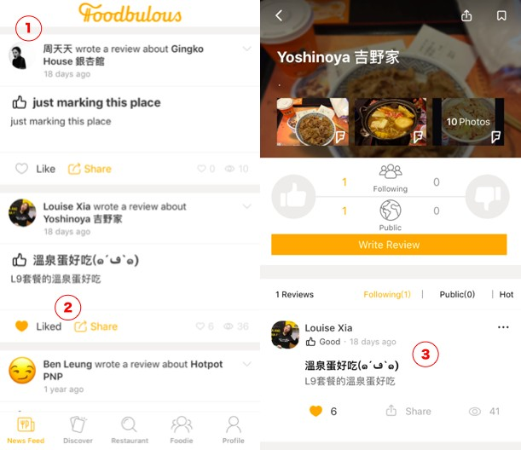

① Reviews of users’ friends will be shown on the top

② In the latest app version, users can like or share others’ posts, but they can’t make comments or reply

③ Each post links to the restaurant’s single page thta contains this piece of food review.

1. **Discover Page(探索):** Theme-based Restaurant Searching System

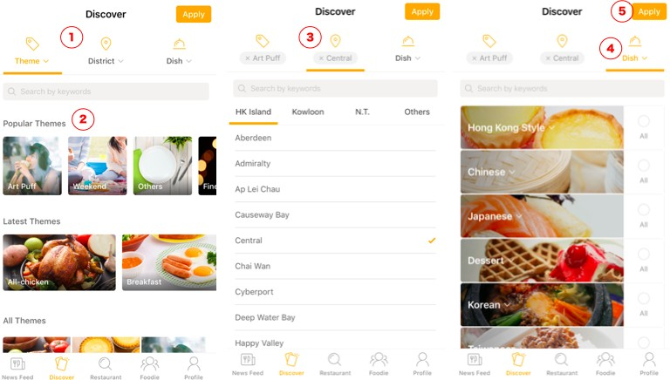

① There are Three filters on this page: theme, district and dish.

② Theme filter contains theme cards for different eating scenarios and restaurant styles, such as: restaurant for dating, for weekend parties and for eating with families.

③ District filter contains restaurants in different district blocks.

④ Dish filter contains restaurants that serve different types of dishes.

⑤ After choosing by the three filters, users can click on the “apply” button to pick out the restaurants that meet all their requirements.

1. **Restaurant Page (搜尋餐廳):** Direct Search of restaurants

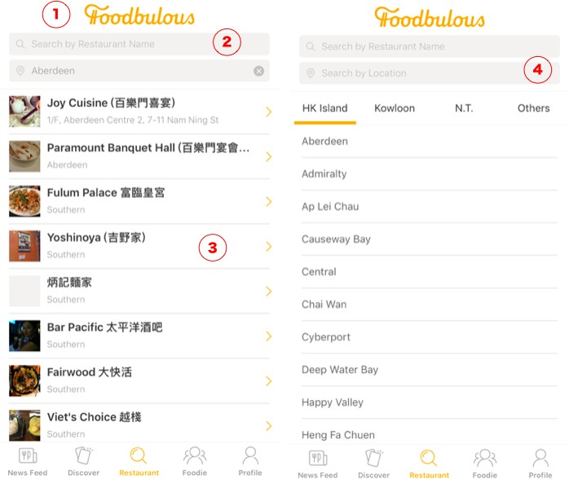

① Two direct search bars: search by restaurant name & search by location

② When searching by restaurant name, all close results will be listed.

③ Each result record contains the restaurant name and address, but there is no information on its price or food type.

④ When searching by location, user can choose restaurants according to their location districts.

1. **Restaurant Single Page:** Single page for one specific restaurant

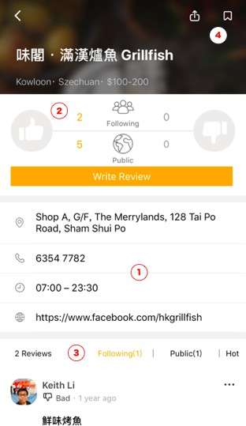

① Basic information of the restaurant

② Rating system:

* Not five-star rating system, only like (thumb up) and dislike (thumb down)
* Two channels: rating from friends and the public

③ Reviews: reviews are displayed in three channels: friends, pubic and hot reviews. Friends’ reviews are shown first.

④ User can click on the stamp button in the top right corner of the screen to collect this restaurant into their decks

1. **Foodie Page(食家):** Showing a list of users one can follow on Foodbulous.

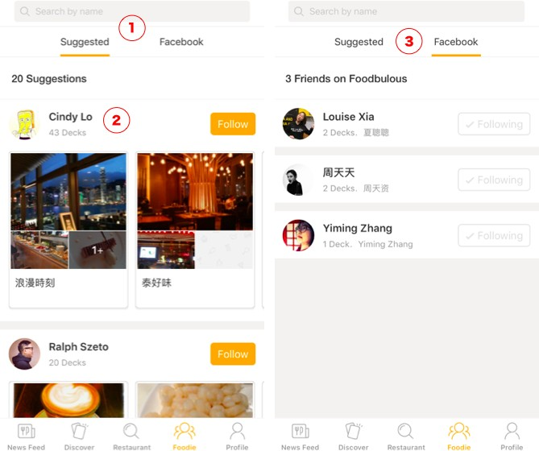

①The foodies(users) are divided in two groups: suggested strangers & automated loaded-in Facebook friends

② A group of Decks（食組）are shown on each user’s record, which is in fact their favorite restaurant collection folder.

③ Users who log in with Facebook will see their Facebook friends that also use Foodbulous.

1. **Profile Page (我的食鑑)：** User’s own profile page

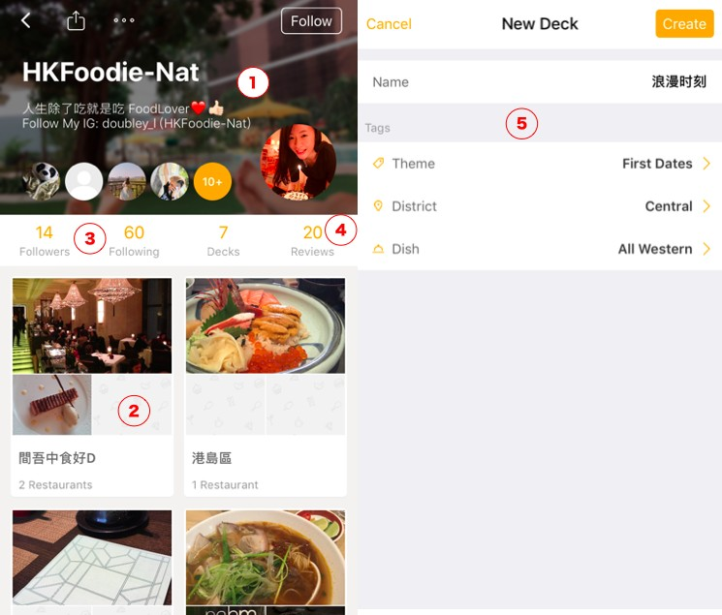

① User’s name and status

② User’s favorite Decks of restaurants

③ Link to User’s following and followers’ lists

④ Link to User’s food review

⑤ User can build, name their desks and tag them with different labels of theme, district and dish.

# PROBLEMS

## With respect of content

|  |  |
| --- | --- |
| **Problems** | **Possible Solutions** |
| 1. Accuracy and updating timeliness of restaurant information | * User reports of outdated and wrong information with support of award system as incentives and review by content moderator; * Content that need continuous update: the locations and menus of the restaurants; the existence of the old and the emergence of the new. |
| 2.Incentive mechanism: why users are willing to post restaurant/food reviews? | Gamification：   * Setting up the points system, users who have reached the certain level can get coupons; * Cultivate KOL in a small area. (e.g. If someone can evaluate all the canteens in CUHK, he can become a KOL in CUHK range). |
| 3. My friend’s taste is not necessarily my taste. How to make sure the restaurants recommended by friends are what I like and are worth trying? | Increase the value of food reviews by matching them to particular users   * Let users select food tags/preferences when they log in for the first time, then the app automatically generates a list of users that you can follow (users can also choose to skip this step); * Based on user's “follow” and “food review”, recommend friends with similar tastes and locations.(Just like Weibo, “You both follow the same 20 beauty bloggers."); * Personalized recommendation system: ensures that the user-generated content can be seen by more people, so as to stimulate users to create more. |

“Deck” can be a valuable feature for those who (1) want to arrange saved restaurants, e.g.: set up several food lists bases on food types or locations;

(2) want to share a feature list with friends, e.g.: send a local Michelin list to a foodie friend traveling in HK via some other social media platforms.

Such user stories are being neglected by Dianping and OpenRice. The potential of Deck feature can probably be exploited to make Foodbulous more useful and attract more traffic.

## With respect of UX elements paradigm

4. How to better exploit the feature of “Deck (食組)” as one of the USPs of Foodbulous?

|  |  |  |
| --- | --- | --- |
| **UX elements** | | **Problems** |
| The Strategy Plane | Site Objectives | * Foodbulous seems to have many functions but none of them is outstanding enough to make the product distinguishable. * Reason: The team members fail to reach a consensus before design the app. |
| User Needs | * Fail to identify the target users before design the app. * Although the team identify the user pain points as mentioned before, they were not clear about what problems they want to solve and how to solve. |
| The Scope Plane | Functional Specifications | * The objectives of each functions are not specific. * Too many functions can distract the users. * The relations between the functions are not very clear. |
| Content Requirements | * Lack of data of the restaurants.   + The app is supposed to contain most of the restaurants in HK, however, many restaurants cannot be founded after our testing.   + After applying all the conditions in the “discovery” functions, it turns out nothing in most cases. It can be implied that the data is not enough to support all the filters. * Lack of data of the users. Sponsor mentioned a great regret that the app did not designed a place to collect the |

|  |  |  |
| --- | --- | --- |
|  |  | data from the users, especially the emails. So, it is hard for Foodbulous backend to analyse the users and develop marketing campaign.   * At the very beginning, an app needs a long time to   precipitate users, so the designers themselves need to provide more content to make the app looks “rich”.  However, the official account just presents a little information, which make the app looks “lean”. |
| The Structure Plane | Interaction Design | * Some interactions are not reasonable.   + Landing page: the default landing page is the “Moments” where show the users’ friends posts. But for the first users (who have not followed any friends), the page is totally blank without any reminders or buttons to call actions.   + Discovery: after clicking the button, the users expect to see the restaurants directly. But in Foodbulous, the users have to click the button on the tight-top to “apply” the conditions. * Usually flashback (suddenly end the program when the user acted frequently) |
| Information Architecture | * The categories of food are unclear and not attractive. It is hard for users to guess the real meaning just for the name such as “是但啦” or “極邪惡”,etc |
| The Skeleton Plane | Interface Design/Navig ation Design | * No “comments” function. According to sponsor, one of the most important features of Foodbulous is to let users share good food with their friends. Now Foodbulous only allow people to “like” and “repost” but we think “reply” is also initial to social networking. * Since the basic logic and user journey behind the app is not clear at the very beginning, without effective navigation, it is harder for users to know their position during the process |
| Information Design | * The secondary list of “菜式” is missing |
| The Surface Plane - Visual Design | * Most of the pictures are low-quality and unattractive. The quality of food pictures is very important for a food app to maintain the users and attract new users. |

1. **OBJECTIVES**
2. To redesign the customer segmentation and product proposition.
3. To improve the usability of Foodbulous, including the UX and UI.

# USER SEGMENTATION

|  |  |  |  |  |  |  |
| --- | --- | --- | --- | --- | --- | --- |
| **Segment** | **Origin** | **Eating Style** | **How to find restaurant** | **Income** | **Gender** | **Age** |
| **1** | Local | eat at home | friend recommend | Low-income | male | below 13 |
| **2** | PRC | eat in | Internet search | Middle-class | female | 13~18 |
| **3** | Foreign | take away | restaurant finding  App | Elite |  | 19~35 |
| **4** |  |  | walk in |  |  | 36~50 |
| **5** |  |  | flyer/menu |  |  | over 50 |

1. **STRATEGIES & SOLUTIONS**

## UX Redesign

To make Foodbulous easy to use, our team plan to redesign the workflow of every section based on user journey.

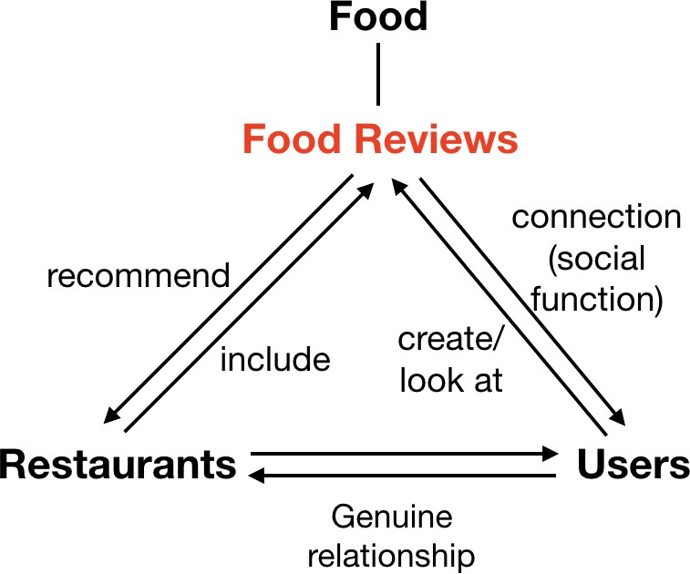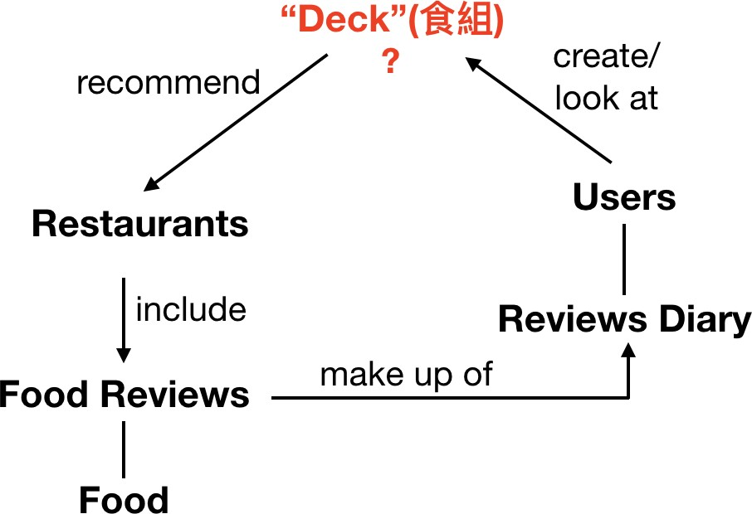

**Current UX**

**Revised UX**

As is shown in figures above, the current design logic (the left UX) is too complicated for users to understand, especially the “Deck” concept—a collection or folder of favorite restaurants.

So, we want to rebuild the bridge between users and food (even restaurants) by focusing on “food review” part (the right UX). , thus making it clear and concise for customers to use Foodbulous.

1. **For food seekers (normal users):**

search for food or restaurant → see food reviews → find relevant food, restaurants, favorites → discover and mark good food → discuss with reviewers and other foodies

1. **For food review writers (potential KOLs):**

write remarks, upload photos, rate the food → publish food reviews → categorize to favorites → discuss with other foodies

## UI Redesign

The new UI will be grounded on our App objective and attempts to facilitate the user journey by improving the old version in the following three dimensions:

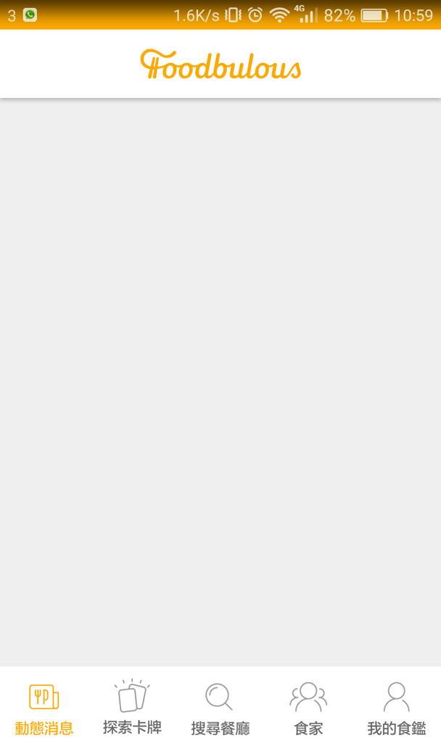 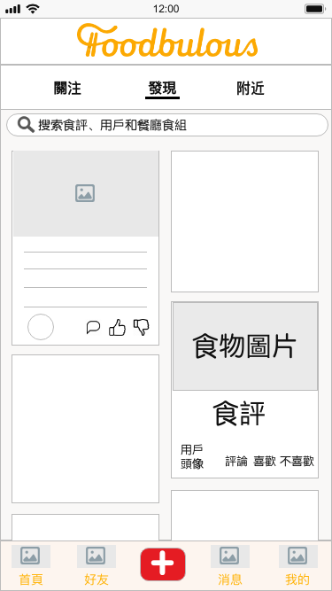

### Current UI New UI Sample (Prototype)

1. To enhance the social and community attribute of Foodbulous

--- By placing user-generated food and/or restaurant Reviews (食評) on the Homepage with big and fantastic pictures;

--- By introducing “comment”, “like” and “dislike” functions to each Food Review to increase interactivity between users;

--- By enabling users to store, like, comment others’ Decks (食組) and share them to other social media platforms;

1. To improve usability of Foodbulous and increase user’s agency

--- By displaying “Writing Reviews (寫食評)” in a conspicuous place (i.e. navigation bar at the bottom), where users can easily find once they want to post Notes;

--- By replacing ambiguous wordings (e.g. “空腹食早餐”, “男人的浪漫”, “偉大的媽媽”) with more explicit and directed ones to avoid confusion;

--- By transforming “Restaurant (搜索餐廳)” tab to a multipurpose search bar, which is fixed at the top of every tab page;

--- By integrating “Popular Themes (卡牌)” into search bar as tag suggestions (標籤

聯想提示) with reference to 小紅書, and offering Autocomplete Suggestions with reference to Google.

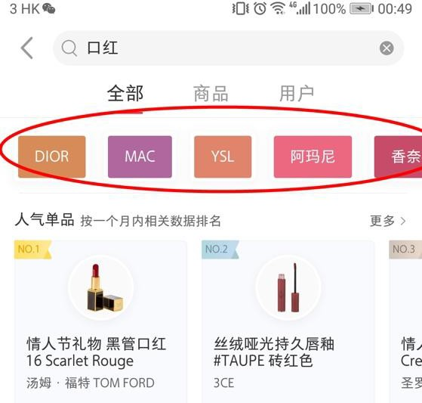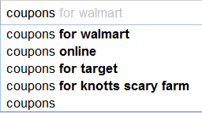

### Tags Suggestions Autocomplete Suggestions

1. To strengthen the relationship between product (i.e App) and users

--- By adding more methods for logging in in addition to Facebook (e.g. Whatsapp, Instagram)

--- By creating sharable QR code and URL for users to invite their friends

# TESTING & EVALUATION

## KPIs

We have set several KPIs to evaluate the success of our UI/UX redesign

1. Downloads
2. Review Scores gained
3. Daily Active User (DAU)

## Usability test; A/B test

Based on current consensus, the redesigned products cannot be online immediately. So large-scale A/B test is difficult to carry out. In the testing phase, we will focus more on usability test.

1. Two measurement methods:
   * scenario metrics
   * experience scorecards
2. Three steps:

Step 1: the wireframe will be printed on paper and the redesigned app will be simulated by cropping, pasting, and coloring.

Step 2: some users will be invited to experience the app. And they will be placed in some scenarios, such as “write a review for Chan Kun Kee” or “find a delicious Italian restaurant”. In the process, their behavior will be recorded by video and will be measured and scored.

Step 3: all the scores will be recorded in scorecards and the scores will be updated as the design is iterated. After the entire project is completed, the trendline can be drawn based on the score.

* 1. **Qualitative Research**: Face-to-face Interview

1. Objectives: understand the attitudes or mind-sets of a user, by asking for the “Why” and “How”.
2. Plan: deliver an interview with 5 people after every version of interactive prototype.

# TIMELINE

## Breakdown

Agile development method will be applied in order to keep moving through

and collect important feedback from the sponsor and user testing as guidance for iterations.

To clarify, the Foodbulous project differs from real agile development processes in that Foodbulous will not be released to real users, and the equivalent of product releases will be our prototype deliverables to the sponsor. It has been confirmed that there will be two more meetings with sponsor during the whole project period, so we decided to divide the whole process into three iteration cycles.

1. In the first sprint, a **lo-fi prototype with interface wireframes of all app sections**

will be built and used to conduct usability test. The goal for the first sprint is to address the usability issues and verify whether our objectives can be achieved with the redesigned and reorganized features of Foodbulous.

1. The second sprint will include a **hi-fi prototype with interactions added and features improved** according to the feedback from the last sprint. A second user test will be conducted during the corresponding review phase for more tweaks in UI/UX of the third sprint.
2. The timescale of the third sprint will be shorter with **final adjustments** to wrap up the revamped UI/UX set.