Docker Containerization Steps

The first step to containerize the app is to create a dockerfile. The Dockerfile established `/app` as the working directory within the container, copy the requirements.txt file first and installing dependencies before copying the application code. All application files were then copied into the container, and the Flask application was configured to expose port 5000 internally. The final CMD instruction specified that the container should execute `python app.py` when started, launching the Flask development server.
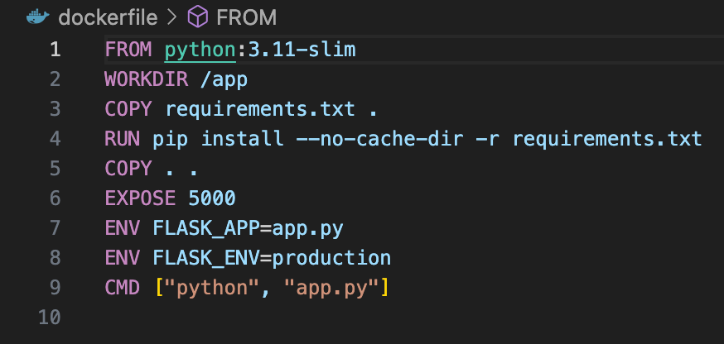

For the next step, the docker-compose.yml file was created to orchestrate both the Flask application container and the MongoDB database container. This configuration defined two services: mongodb and flask-app. The MongoDB service used the official mongo:7.0 image and was configured with port 27017 exposed to the host machine. Critically, a named volume called `mongodb_data` was mounted to `/data/db` within the MongoDB container to ensure data persistence across container restarts and removals.

The Flask application service was configured to build from the local Dockerfile I just created. Environment variables were passed to the container to specify that MongoDB could be reached at the hostname `mongodb` on port 27017. This hostname-based connection works because docker-compose creates a custom bridge network where containers can reference each other by their service names. The depends_on directive ensured that the MongoDB container would be started before the Flask container.

Initially, the Flask application was configured to map port 5000 on the host to port 5000 in the container. However, this caused conflicts with macOS's AirPlay Receiver service, which occupies port 5000 by default on newer macOS versions. The port mapping was changed to `5001:5000`, exposing the application on port 5001 on the host machine while maintaining port 5000 internally within the container.
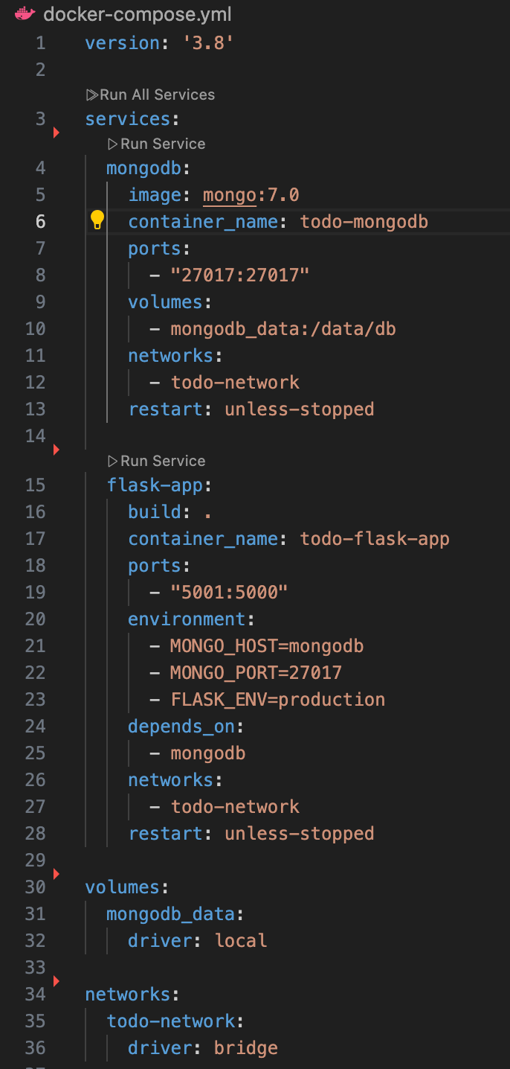
To handle the incompatible version of Werkzeug package and the Flask package, the solution was to explicitly pin Werkzeug to version 2.0.3 in the requirements.txt file. This version was known to be compatible with Flask 2.1.3.
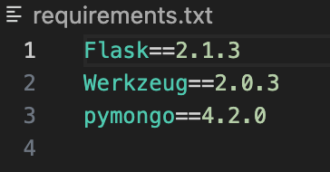
To make the application accessible from outside the container, the code needed to bind to 0.0.0.0 instead of local host. After making this change, the application listens on all network interfaces and the application became accessible at localhost:5001 on the host machine.
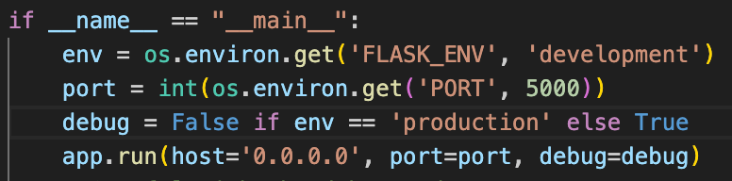

Afterwards, the Flask application image was tagged and pushed to Docker Hub. The image was tagged as `sjxshen/todo-flask-app:latest`, using my Docker Hub username. The image is available at `https://hub.docker.com/r/sjxshen/todo-flask-app` for pulling by any Docker-enabled system.

To validate the application is successfully containerized, we can simply run the command
`docker-compose up -d` and the web application will be available at http://localhost:5001

Kubernetes Deployment Steps

The next step was to deploy the application on Kubernetes using Minikube. First, Minikube was started which created a single-node Kubernetes cluster on the local machine.
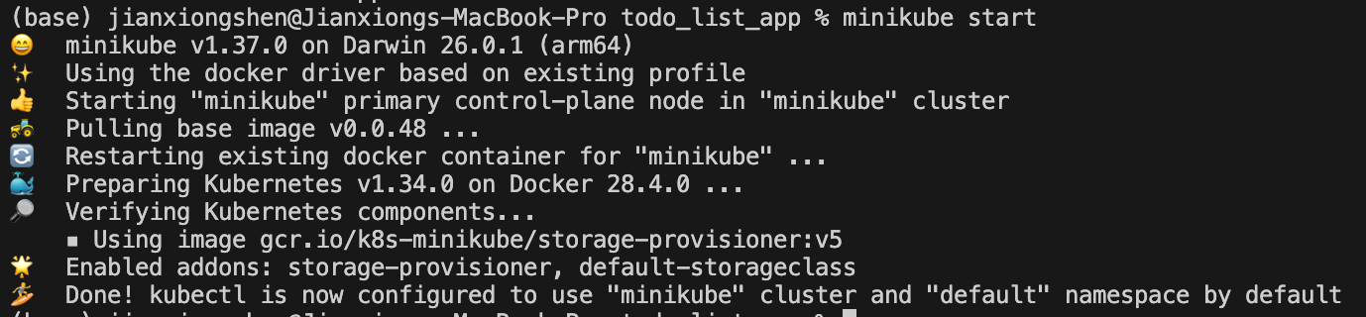
Two Kubernetes deployment files were created in the k8s directory. The mongodb-deployment.yaml file defined three resources: a PersistentVolumeClaim requesting 1Gi of storage for data persistence, a Deployment that creates one MongoDB pod running mongo:7.0, and a ClusterIP Service named `mongodb` that exposes port 27017 for internal cluster communication. The PersistentVolumeClaim ensures that MongoDB data survives pod restarts and deletions.
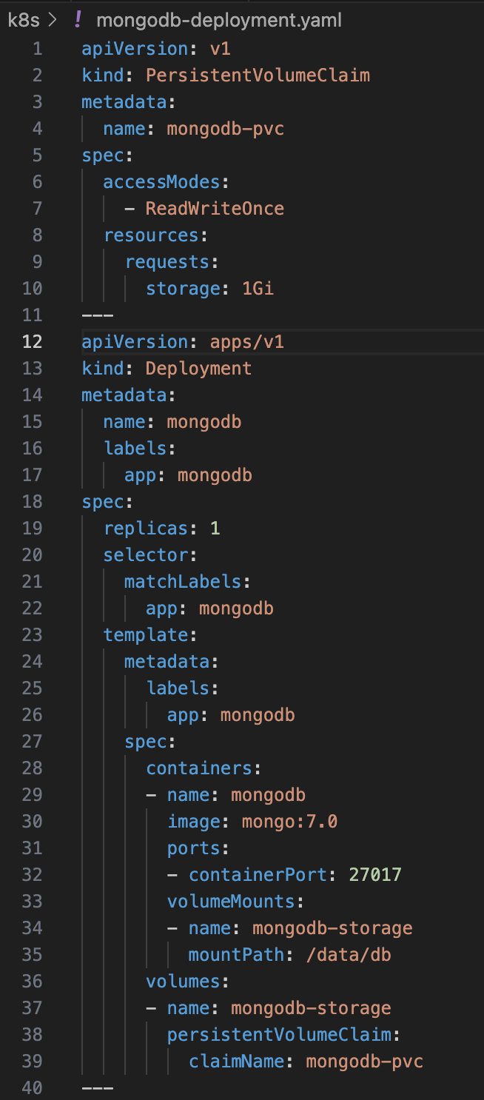
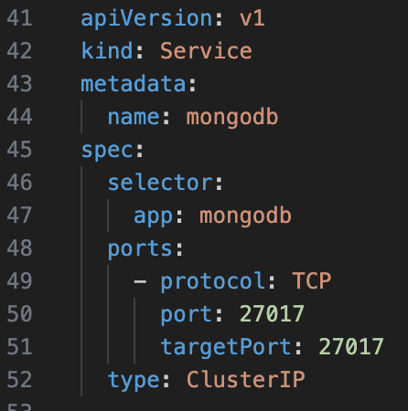
The flask-deployment.yaml file defined the Flask application deployment with two replicas for load balancing and high availability. The deployment pulls the `sjxshen/todo-flask-app:latest` image from Docker Hub and configures each pod with environment variables. The deployment also created a NodePort Service that exposes the application on port 30000, making it accessible from outside the cluster.
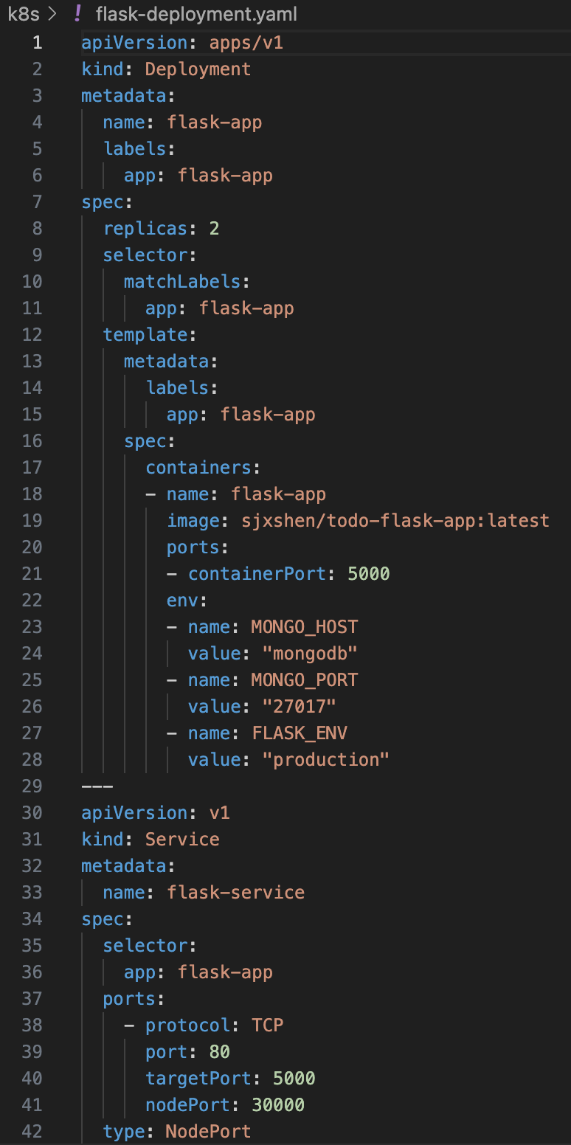
When both deployments were applied using kubectl, Kubernetes created the resources in order. The MongoDB pod started first, followed by two Flask application pods. Kubernetes automatically handles service discovery through its internal DNS system, so when the Flask pods try to connect to `mongodb:27017`, Kubernetes resolves `mongodb` to the MongoDB Service's cluster IP address, enabling communication between the pods.

By running `kubectl get pods`, we can validate that our two flask app pods and one mongo db pods are all running
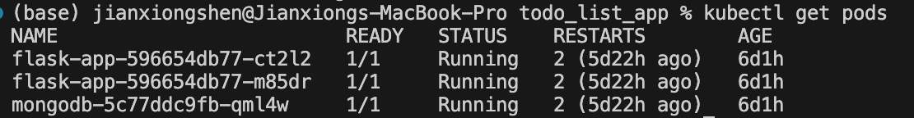

To access the application, the `minikube service flask-service --url` command was used, which creates a tunnel and provides a URL like `http://127.0.0.1:60423`. This tunnel must remain open for the application to be accessible from the host machine. The NodePort Service automatically load balances incoming requests between the two Flask replicas, providing better performance and fault tolerance.
Part 5:
I configured my `k8s/flask-deployment.yaml` file to define the desired number of replicas. In the deployment specification, I set `replicas: 2` under the `spec` section:
This configuration tells Kubernetes to maintain exactly 2 pod replicas of my Flask application at all times. I verified the ReplicaSet was created successfully using:
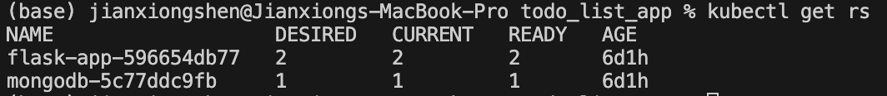
To demonstrate Kubernetes' self-healing capability, I intentionally deleted one of the running pods (pod flask-app-596654db77-ct2l2 is deleted)
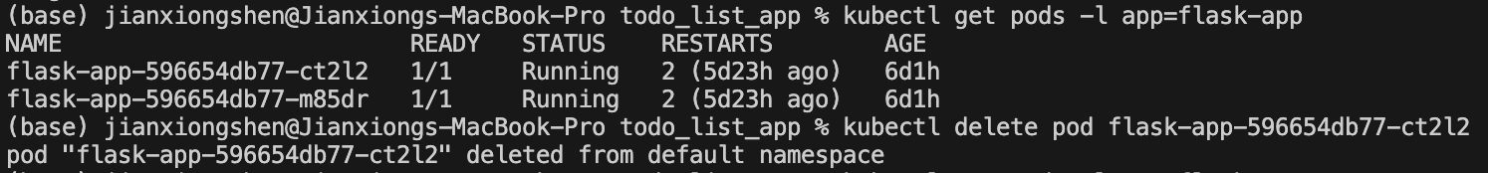
I immediately observed Kubernetes automatically creating a replacement pod to maintain the desired replica count of 2. I verified this by running (new pod flask-app-596654db77-7t6js is created):
To test the automatic scalability of Kubernetes, I scaled the deployment up to 4 replicas using the kubectl scale command:
After a while, the output confirmed that 4 pods were now running. The ReplicaSet automatically created 2 additional pods to reach the desired state.
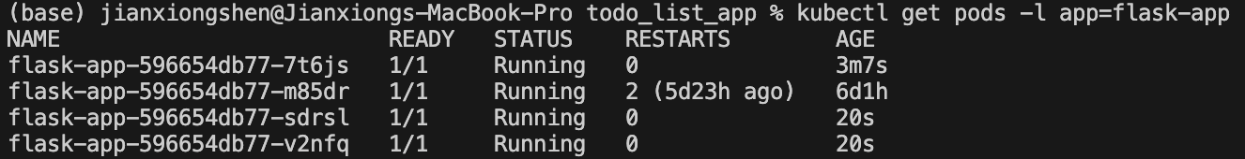
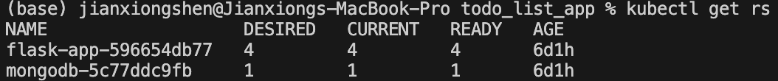

Part 6:
After successfully deploying the Flask–MongoDB To-Do web application on Kubernetes, I implemented a rolling update strategy to upgrade the application from version v1 to v2 without downtime. The deployment configuration (flask-deployment-rolling.yaml) defines a rolling update strategy with maxUnavailable: 1 and maxSurge: 1, ensuring that at most one pod is unavailable while a new one is started during the update. The deployment also specifies three replicas to maintain high availability.
In the environment variables section of the deployment manifest, I introduced an APP_VERSION variable with the value v2, along with configuration for the MongoDB host, port, and the production Flask environment. This environment variable is used by the Flask application to dynamically return its running version number.
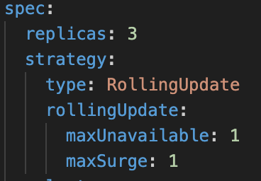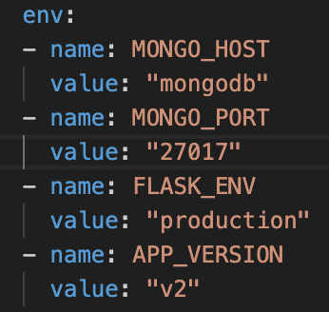
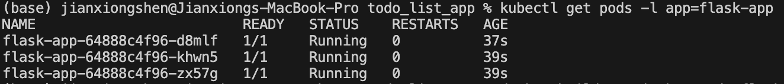
To simulate updating the application code base, I added a new Flask route which reads from the environment variable and show current app version.
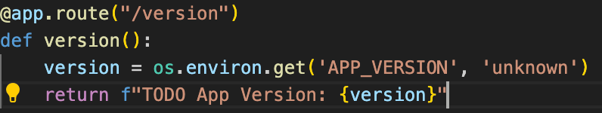

I then updated the Docker image. The image was built and tagged as both sjxshen/todo-flask-app:v2 and sjxshen/todo-flask-app:latest, then pushed to Docker Hub using the following commands:

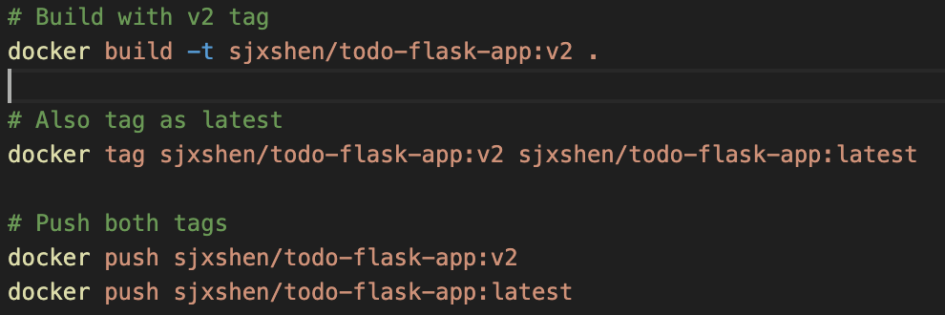
Once the new image was pushed, I set the deployment to use the new image and initiated the rollout. We can verify that the roll out is successful.
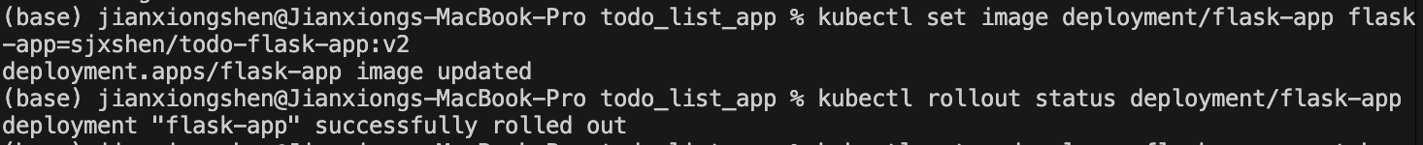
Accessing 127.0.0.1:49935/version returned the message “TODO App Version: v2”, verifying that the container now uses the updated code from the new image.
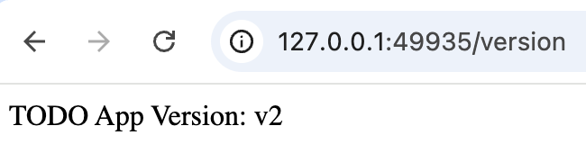

Part 7
In this part, I implemented comprehensive health monitoring by configuring both liveness and readiness probes for the Flask application. The implementation required two main steps: first, adding health check endpoints to the application code, and second, configuring the Kubernetes deployment to use these endpoints for monitoring.

I began by modifying the `app.py` file to add two new routes: `/health/live` for the liveness probe and `/health/ready` for the readiness probe. The liveness endpoint performs a simple check to verify the application is alive and not in a deadlocked state. I implemented a testing mechanism where the presence of a file at `/tmp/fail-liveness` would cause the endpoint to return a 500 status code, simulating an unhealthy application state. Similarly the presence of `/tmp/fail-readiness` would cause the endpoint `/health/ready` to fail.
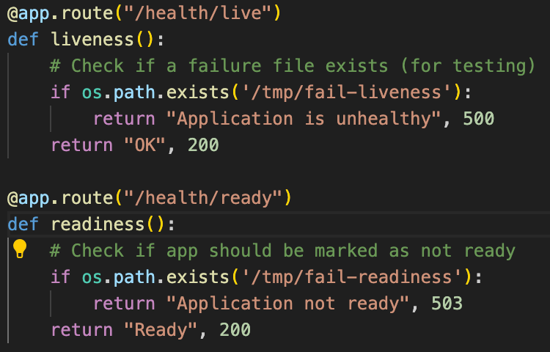
After adding these endpoints, I rebuilt the Docker image to include the new health check functionality and pushed it to Docker Hub. I then created a deployment configuration in `flask-deployment-probes.yaml` that included all features from the previous parts addition with the liveness/readiness probe feature. The liveness probe configuration specified `httpGet` as the probe type, targeting the `/health/live` endpoint on port 5000, with an `initialDelaySeconds` of 10 to allow the application adequate startup time, a `periodSeconds` of 5 for regular health checks, and a `failureThreshold` of 3, meaning Kubernetes would restart the container after three consecutive failed probes. The readiness probe has similar configuration.
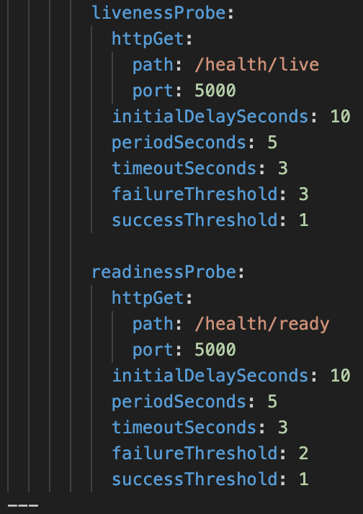
When I applied this deployment using `kubectl apply -f k8s/flask-deployment-probes.yaml`, I observed the pods starting with a "0/1 Ready" status initially. This indicated that while the containers were running, they had not yet passed the readiness probe checks. After the initial delay period and successful probe responses, the pods transitioned to "1/1 Ready" status, signifying they were healthy and ready to receive traffic. Using `kubectl describe pod <pod-name>`, I examined the probe configuration and confirmed that both liveness and readiness probes were correctly configured and actively monitoring the application's health.
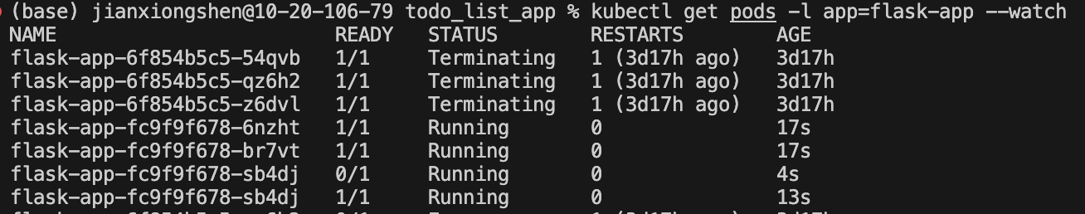
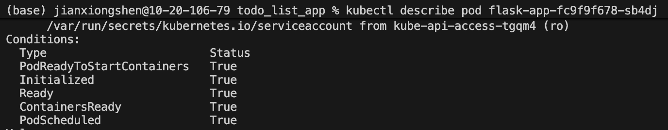
To test the liveness probe functionality, I deliberately triggered a failure condition by creating the `/tmp/fail-liveness` file inside one of the running pods using `kubectl exec $POD -- touch /tmp/fail-liveness`. This caused the liveness endpoint to start returning HTTP 500 errors. I monitored the pod status using `kubectl get pods -l app=flask-app --watch` and observed Kubernetes detecting the failed liveness probes. After three consecutive failures (as specified by the failureThreshold), Kubernetes automatically restarted the container. I then examine the pod events with `kubectl describe pod $POD` revealed "Liveness probe failed" warnings followed by a "Container will be restarted" message. Once restarted, the temporary failure file was gone, the liveness probe succeeded again, and the pod returned to a healthy state.
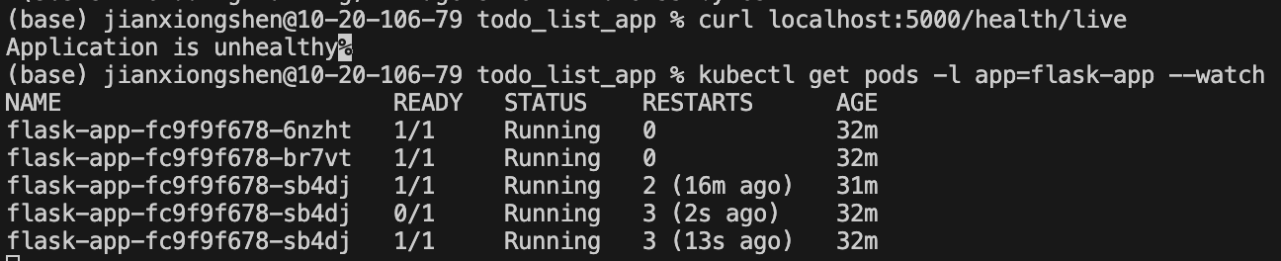
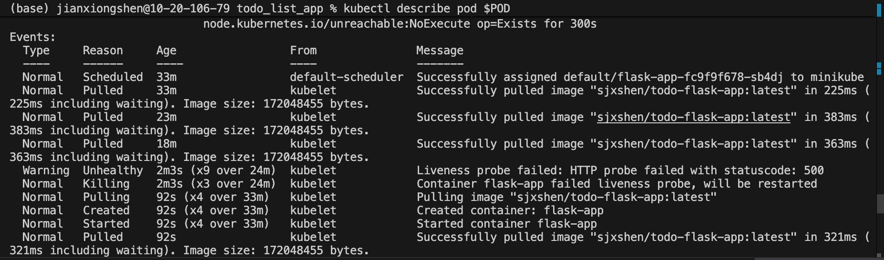
For testing the readiness probe, I created the `/tmp/fail-readiness` file using `kubectl exec $POD -- touch /tmp/fail-readiness`. Unlike the liveness probe failure, this did not restart the container but instead marked the pod as not ready. The pod status changed from "1/1 Ready" to "0/1 Ready" while remaining in "Running" state. Checking the service endpoints with `kubectl get endpoints flask-service` revealed that Kubernetes had removed this pod's IP address from the service endpoint list, ensuring no traffic would be routed to the unhealthy pod while the other healthy pods continued serving requests. 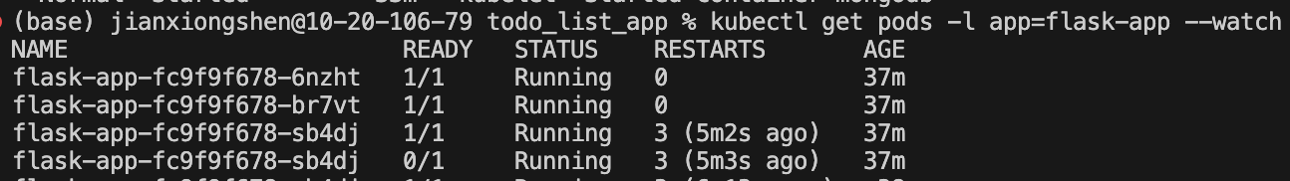
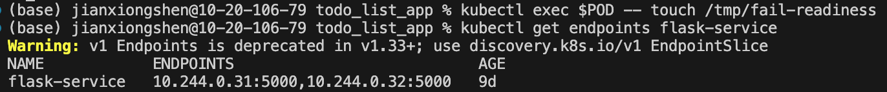
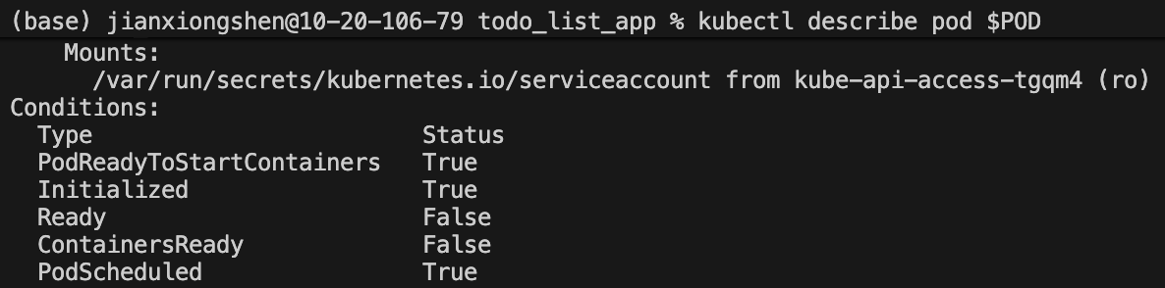
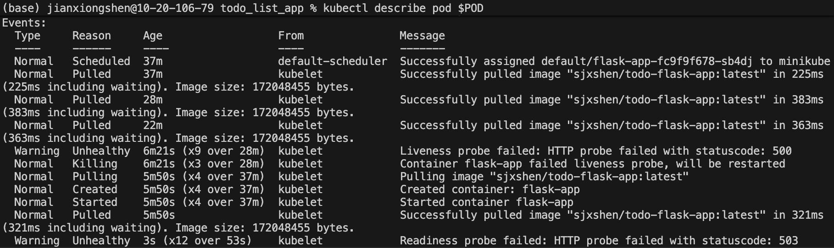
When I removed the failure file using `kubectl exec $POD -- rm /tmp/fail-readiness`, the readiness probe began succeeding again after a few seconds, the pod returned to "1/1 Ready" status, and its IP address was automatically re-added to the service endpoints.
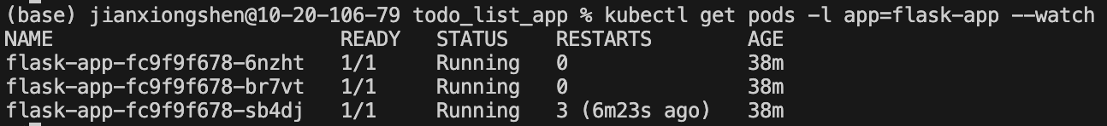
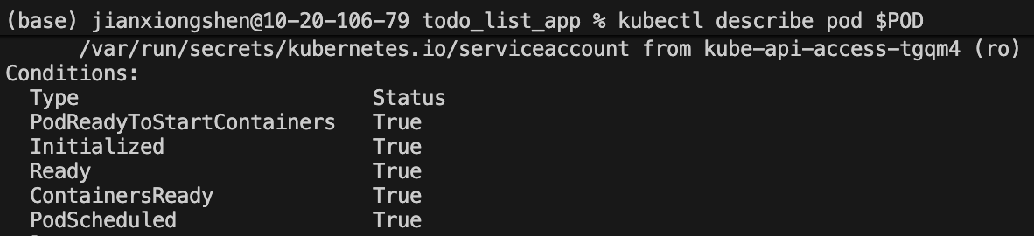
Throughout the testing process, I used `kubectl describe pod $POD` to examine the detailed probe events and status. The Conditions section showed the pod's health state, with "Ready: False" during readiness probe failures and "Ready: True" when healthy. The Events section provided a chronological log of probe failures and state transitions, offering valuable insights into Kubernetes' automated health management actions. These tests conclusively demonstrated that Kubernetes probes provide robust health monitoring capabilities, automatically handling both fatal failures requiring restarts and temporary unavailability requiring traffic rerouting, all without manual intervention.

Part8

I began the Part 8 implementation by installing the Prometheus monitoring stack using Helm, which is the standard package manager for Kubernetes applications. First, I added the Prometheus community Helm repository by executing `helm repo add prometheus-community https://prometheus-community.github.io/helm-charts` followed by `helm repo update` to ensure I had access to the latest chart versions. Before installing Prometheus, I created a dedicated namespace called "monitoring" to isolate all monitoring components from my application workloads using `kubectl create namespace monitoring`.

With the namespace prepared, I installed the complete kube-prometheus-stack using the command `helm install prometheus prometheus-community/kube-prometheus-stack --namespace monitoring --set prometheus.prometheusSpec.serviceMonitorSelectorNilUsesHelmValues=false --set alertmanager.enabled=true`. This comprehensive installation automatically deployed Prometheus for metrics collection and storage, Alertmanager for alert routing and notifications, Grafana for visualization dashboards, node-exporter for collecting node-level system metrics, and kube-state-metrics for monitoring Kubernetes object states. The configuration flag `serviceMonitorSelectorNilUsesHelmValues=false` was crucial as it instructed Prometheus to discover ServiceMonitor resources across all namespaces rather than only those with specific Helm labels.

After initiating the installation, I monitored the deployment progress by repeatedly running `kubectl get pods -n monitoring` until all monitoring components showed a "Running" status. This process took approximately 2-3 minutes as Kubernetes pulled the necessary container images and initialized each component. Once all pods were operational, I verified Prometheus accessibility by creating a port-forward tunnel using `kubectl port-forward -n monitoring svc/prometheus-kube-prometheus-prometheus 9090:9090`, which allowed me to access the Prometheus web interface at http://localhost:9090 from my local browser and confirm the installation was successful.
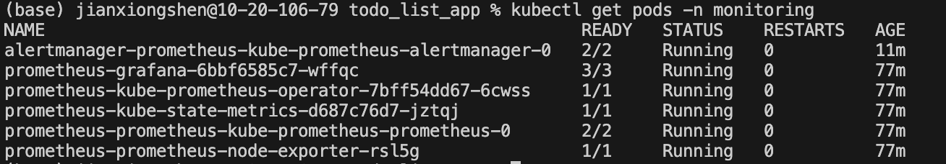
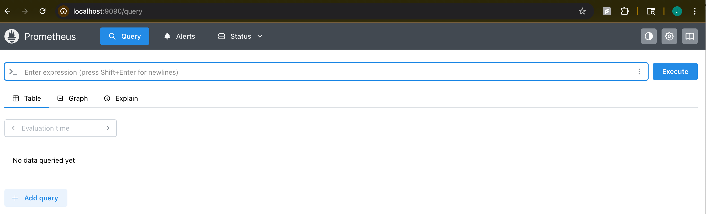
With Prometheus installed, I needed to configure it to collect metrics from my Flask application by adding python supported Prometheus package to my `app.py`. I added Prometheus settings in the annotation section to my part 7 flask app deployment file and create a new file named ` flask-deployment-monitored.yaml `. Then I created a Kubernetes ServiceMonitor custom resource in the file `k8s/flask-servicemonitor.yaml` that instructs Prometheus on how to scrape metrics from the Flask service. The ServiceMonitor specifies that Prometheus should target services with the label `app: flask-app`, scrape metrics from the HTTP port every 30 seconds, and collect data from the `/metrics` endpoint. The ServiceMonitor itself required labels including `release: prometheus` to ensure the Prometheus operator would discover and process it.
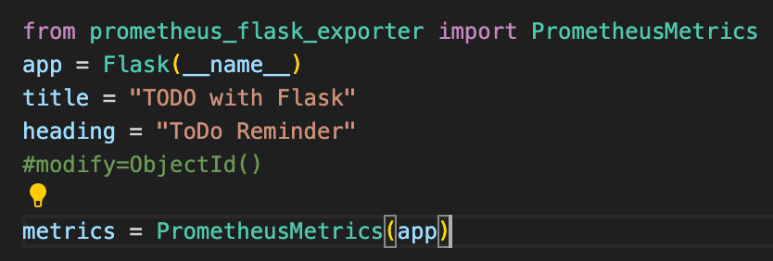
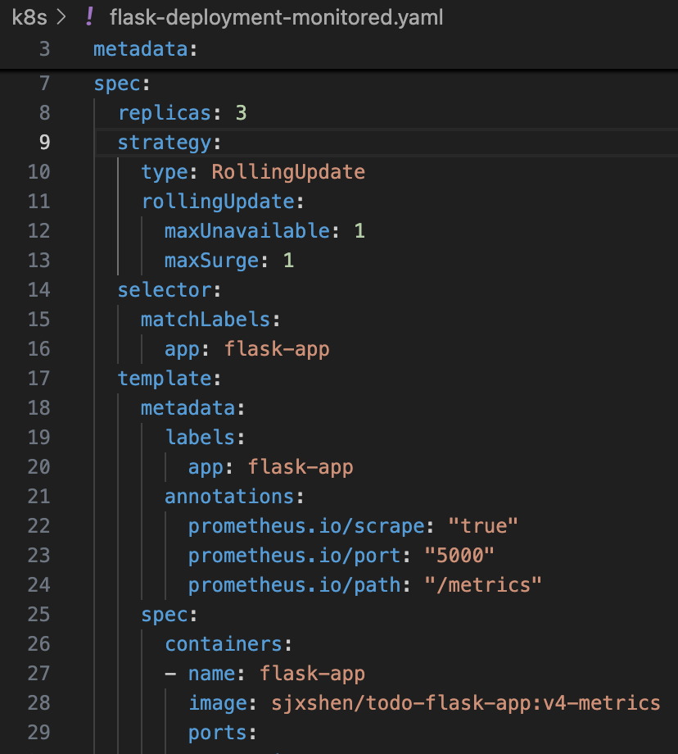
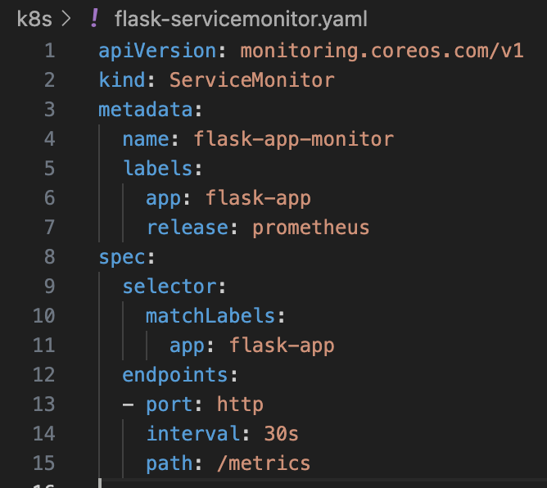
I applied the ServiceMonitor configuration using `kubectl apply -f k8s/flask-servicemonitor.yaml` and verified its creation with `kubectl get servicemonitor`. To confirm that Prometheus was successfully discovering and scraping my Flask application endpoints, I accessed the Prometheus UI at http://localhost:9090, navigated to Status → Target Health, and looked for the flask-app-monitor target. The target showing an "UP" status indicated that Prometheus was successfully collecting metrics from the Flask pods.
