**Reconstruction method of a ptychographic dataset**

**with unknown positions**

1. **Introduction**

Ptychography is a scanning coherent diffraction imaging technique based on the measurement of multiple partially overlapping diffraction patterns during the scanning over a sample. Both the probe function and the complex function of the specimen could be retrieved respectively by the extended ptychographic iterative engine (ePIE) algorithm without a priori probe spatial distribution.[1] This imaging approach has been applied successfully in visible light, X-ray and electron microscopy.[2-4]

In the experiment, the accuracy of the stage and the tilt between the object plane and the detector plane are the two main factors of probe position errors[6], and these errors are almost unavoidable. The influence of positions errors in ptychography was analyzed by Hue et al. in the electron experiments. Even an error of a fraction of the required resolution could cause a significant image quality degradation. Therefore, translation position correction is extremely important for the reconstruction in ptychography.

The nonlinear optimization approach[5] and the diffraction pattern gradient algorithm have limitation in balancing between the position refinement and large initial probe position errors. A trial-and-select based algorithm, pc-PIE, which tests a branch of trial positions for every scan position, can fulfilled the two aforementioned requirements simultaneously but it’s computationally expensive[7]. The two cross-correlation registration based algorithm, proposed by Zhang et al.[6] and by Rong[8] et al., accelerate the computation but still require a rough knowledge of the scan position.

Xu et al. gave a powerful method to solve the position correction problem[9]. In this project, this algorithm will be implemented. The all estimated scan points drift from [0,0] to their correct position during the reconstruction process without a priori position information. In section 2, the algorithm would be explained in detail, and the simulation result of my implementation in Python is shown in section 3. A discussion and conclusion are given at the end in section 4.

1. **The unknown-position algorithm**

In this powerful algorithm, the complex object function, probe function and the scan positions can be reconstructed from the measured diffraction intensity without a priori of positions.

In ptychography, a coherent illumination beam scans the specimen in a sequence of positions and the diffraction patterns are recorded in the near-field Fresnel plane or in the far field Fraunhoffer plan. the distance between two adjacent scan positions must be smaller than the probe size in order to have an overlap area, and the overlap ratio should be larger than 60% to obtain a good quality of reconstruction result[10]. we assume the thin-object approximation, the j-th exit wave field just behind the specimen is formed by the multiplication of the illumination probe P(r) and the object O(r):

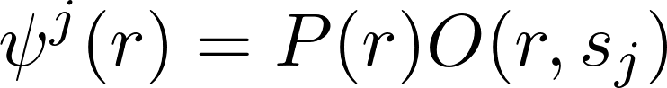

where **r** is the coordinated vector at the object plane and **sj** is the j-th (j = 1,2,...,J) object translation shift. Assuming the diffraction patterns are recorded in the Fraunhoffer plane, the propagation process can be considered as Fourier transform, and the measured intensity is

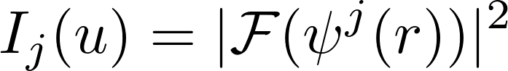

where **u** denotes the coordinate vector at the detector plane.

The task of ptychographic reconstruction algorithm is to search for suitable object and probe function which can fulfill two sets of constraints: the modulus constraint in the detector plane and a consistency requirement in the overlapping regions of the object reconstruction which is referred to overlap constraint.

The procedure step of the unknown-position ePIE algorithm is below. In step 4 we employ the modulus constraint, that replace the the modulus of estimated wave front at the detector plane with the square-root of the j-th measured pattern intensity, and propagate back to object plane

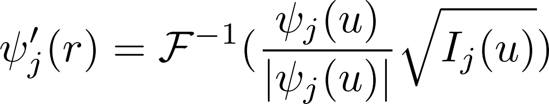

The overlap constraint is then applied to update our estimated object and probe functions. The object function in n-th iteration is



where \* stands for the complex conjugate operator.

The implementation of probe update is straightforward, that simply interchange the appearance of the object function and probe function in the object update function to produce a probe update function.

The above mentioned steps are the conventional ePIE algorithm. The normalized root-mean-square-error(NRMSE) is employed to reveal the difference between the intensity of the estimated diffraction wave and the measured diffraction pattern at each iteration for all object positions after object and probe updates

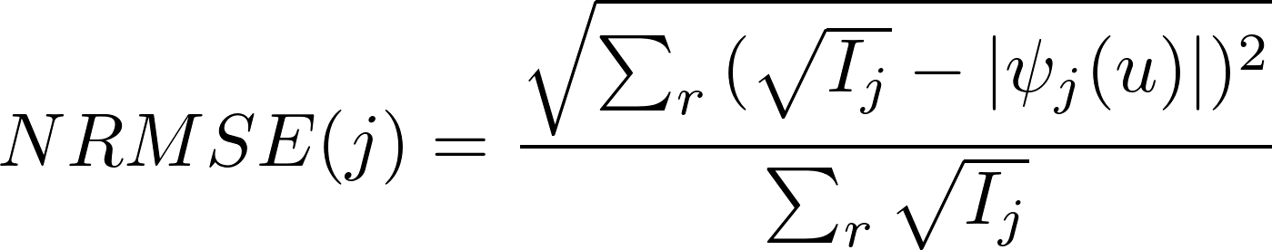

The ePIE algorithm is sensitive to the position errors, even a low position inaccuracy can leads to enormous reconstruction artifacts. However, the revised individual object estimate shifts towards its true position after the applying the modulus and overlap constraints.[6] The relative shift is calculated by locating the peak of the cross correlation between the revised object function and the current estimated object function with the equation

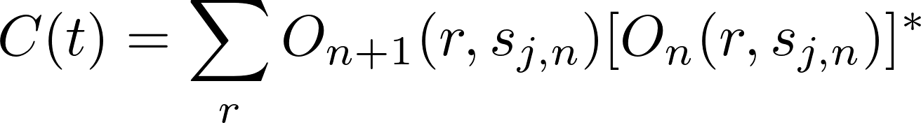

The cross correlation was computed between the objects on two successive iterations at the j-th scan position.Thus the position correction starts from the second iteration. The magnitude of the shift error error is typically in the order of 0,01 pixels or less, a subpixel image registration algorithm, matrix multiplication method[12], was applied to achieved a precision refiner than 0.01 pixel. Compared to FFT with zero-padding algorithm, the proposed method reduces the computation time significantly. Then the shift error are fed back to revise the scan position sj in step 9

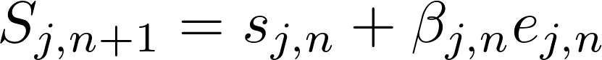

The initial value of β1 is important to the algorithm. If β1 is too small, the scan positions will stay at the initial estimated positions, while if it is too large, the scan positions might have a enormous shifting and escape out of our object space. The optimal β1 is dependent on the overlap ratio(OR), the larger the OR the smaller the β1, and the noise level, the noisy the recorded diffraction pattern the smaller the β1. The βn will be adjusted automatically after each iteration[6]. To adjust the βn**,** the cross-correlation coefficient, wpsoffice, between two set of successive retrieved position errors was calculated(for x and y direction separately). A positive wpsoffice indicates the two position revision shift the the same direction, thus βn should be increased to accelerate the process. In contrast, a negative wpsoffice means the position revision process oscillates and is unstable, so βn should be reduced. When wpsoffice is less than -0.3, βn is reduced by a factor of 0.9, while it is increased by 1.1 times when wpsoffice is larger than 0.3.

To avoid the algorithm stagnates before all the scan positions are correct. We should reposition the incorrect points(IPs) after each 20 or 30 iterations. Incorrect point(IP) refers to the point considered as in the incorrect position, and correct point(CP) refers to the point at the correct position. The stagnation can be detected by calculating the maximum shift step. If the maximum shift is smaller than the threshold δ(normally set to 1 or 2), the correction process is considered as stagnation. We can determine whether the reposition should activate with the following conditions: max. shift < δ, and n > n\_IPs+ν. ν is the least number of iterations being circled before the next round of the reposition process, it often set to 20 or 30. n\_IPs is the iteration sequence number of last reposition process, its initial value is 0.

The incorrect points(IPs) are distinguished from the CPs according to the NRMSE. The NRMSE of IPs are always larger than those of CPs. Here we define that the IPs are the points with NRMSE 0.1 larger than the minimum NRMSE in the n-th iteration. The IPs detection is implement in step 14.

After the IPs was found out, they will be shift to their nearest CP(NPs) in step 16. The correlation coefficient between the diffraction patterns of each IP and the other CPs is applied to search the NP of each IP. The point with the largest correlation coefficient is considered as the NP of each IP. We shift the IPs to their corresponding NP and continue the reconstruction and position correction process from step 2 to step 9.

Besides, we should redefine the parameter β, because when the position correction process stagnates, the value of β is adjusted to a relative small value by the code in step 17. We hope that the βn value keeps large for IPs for a lager shift step to faster shift to the correct position, while it decreases to a relative low value for CPs. We know that the NRMSE of CPs are all close to the minimum value of NRMSE and the NRMSE of IPs are relative large, so the β value can be calculated with

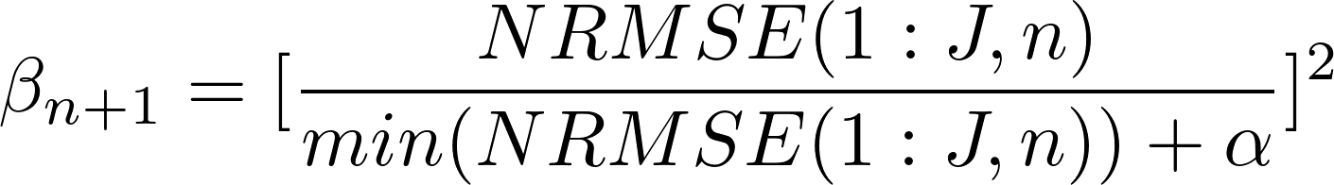

where ɑ is a constant to avoid the possible excessive augmentation of β, it should be set in according to the minimum value of the NRMSE.

**Reconstruction procedure of the unknown-position ePIE algorithm**

|  |  |
| --- | --- |
| **Input:** Diffraction patterns intensity **Ij(j = 1,2,...,J)**, guessed object **O(r),** guessed probe **P(r)**, and guess positions **s(j)**  **Output:** Retrieved object **O(r)**, probe **P(r)**, and scan position **sj** | |
| 1 | **for** n in range(n\_iter): |
| 2 | **for** j in range(J): |
| 3 | /private/var/folders/dq/0b06_dss4971r54wyrbp_63r0000gn/T/com.kingsoft.wpsoffice.mac/wpsoffice.vpfLxcwpsoffice |
| 4 | /private/var/folders/hj/hfh_m4yd2kzg3rg6c0n0_ydw0000gn/T/com.kingsoft.wpsoffice.mac/wpsoffice.uTxFQiwpsoffice  **Apply modulus constraint** |
| 5 | /private/var/folders/dq/0b06_dss4971r54wyrbp_63r0000gn/T/com.kingsoft.wpsoffice.mac/wpsoffice.Nymmdewpsoffice  **Update object function** |
| 6 | /private/var/folders/dq/0b06_dss4971r54wyrbp_63r0000gn/T/com.kingsoft.wpsoffice.mac/wpsoffice.BkQiVDwpsoffice  **Update probe function** |
| 7 | wpsoffice  **Calculate NRMSE for each scan position** |
| 8 | /private/var/folders/hj/hfh_m4yd2kzg3rg6c0n0_ydw0000gn/T/com.kingsoft.wpsoffice.mac/wpsoffice.GhmEaowpsoffice  **Compute the shift error e by locating the cross correlation** |
| 9 | /private/var/folders/hj/hfh_m4yd2kzg3rg6c0n0_ydw0000gn/T/com.kingsoft.wpsoffice.mac/wpsoffice.pGKaPOwpsoffice  **Revise the translation shift** |
| 10 | wpsoffice  **Calculate the maximum shift step of all scan positions** |
| 11 | **Automatically adjust the β for next iteration** |
| 12 | **If** Maxshift(n)<δ & n>n\_IPs+ν: |
| 13 | n\_IPs = n |
| 14 | IPs = positions[NRMSE > min(NRMSE + wpsoffice)]  **find the incorrect points** |
| 15 | **Calculate the correlation coefficient values between the diffraction patterns of each incorrect point and other scan points** |
| 16 | **position[IPs] = position[NPs]** |
| 17 | /private/var/folders/hj/hfh_m4yd2kzg3rg6c0n0_ydw0000gn/T/com.kingsoft.wpsoffice.mac/wpsoffice.YRlgbBwpsoffice  **revise the feedback parameter of each scan points** |

1. **Simulation result**

Two data sets(Lena and Cameraman) are used to create a 256 × 256 pixels’ dummy object spacing(a complex array). As shown in Fig. 1, the images from left to right are the intensity and the phase of our dummy object spacing, and the intensity and phase of illumination beam, respectively. The wavelength of the probe is 632nm. The size of the reconstruction box, 161 pixels, while the diameter of the probe is 50 pixels.

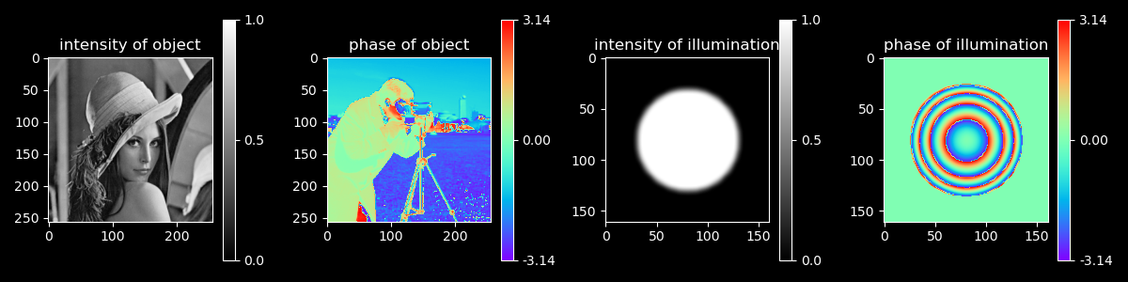

Fig. 1. The ground truth of object and probe

The blue points shown in Fig. 2 are the 7 × 7 scan positions in the simulation, which is a mesh gird with a random offset of 3 pixel size to prevent the raster scan pathology artifact[11]. The yellow points are a gird without offset, it was considered as the input position knowledge for reconstruction to illustrate the importance of the accuracy of the correct position information.

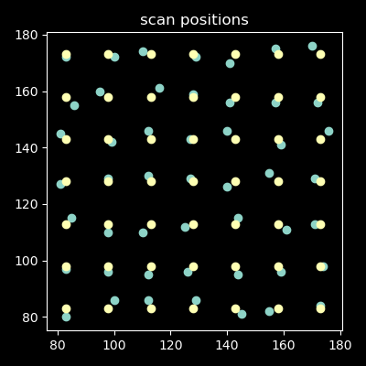

Fig. 2. The scan positions. The yellow points are a 7 × 7 grid, while blue points add a random offset of 3 pixel size additionally.

The reconstruction results are shown in Fig. 3. The reconstructed results in the upper row has a correct scan positions input, while the results in the lower row has a 3 pixels positions errors. The reconstruction quality are significantly degradation with the appearance of the position errors. After 300 iterations, ePIE reconstructed a high-resolution object and probe with correct positions. However, when a small position error appears, the structures of the images are hard to be distinguished. The NRMSE shown in Fig. 4 also reflects the degradation. The error of reconstruction with accurate positions reduced to under 0.025, while with incorrect positions stagnates in the level of 0.8.

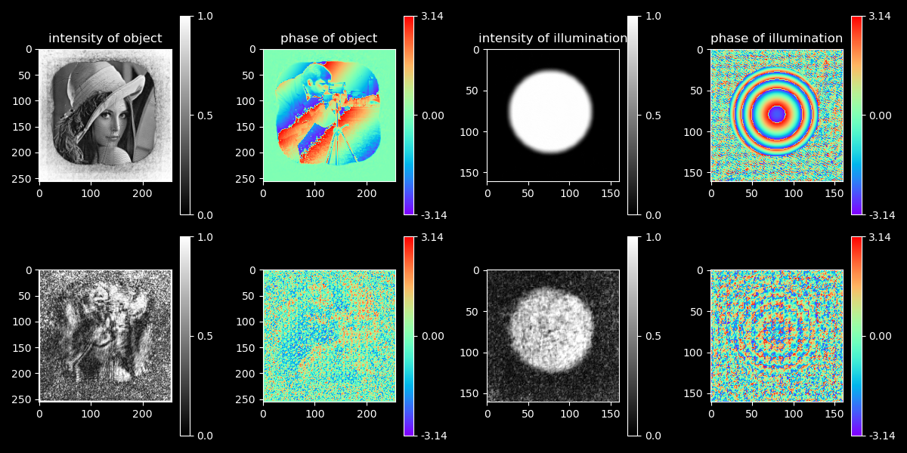

Fig. 3. The reconstructed result of ePIE algorithm. The upper row is reconstructed with an input of accurate position information, while the bottom row inputs a grid position without the 3 pixels random offset. The figures from left to right are the intensity and the phase of our dummy object spacing, and the intensity and phase of illumination beam, respectively.

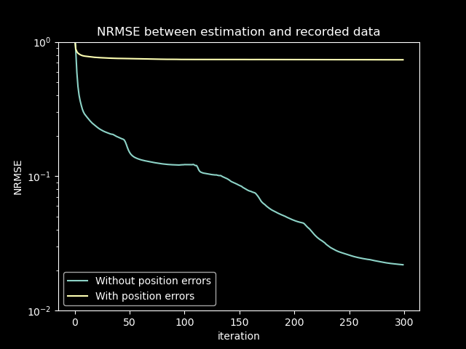

Fig. 4. Effect of position errors on the NRMSE.

My implementation of the position algorithm doesn’t work. The retrieved positions are shown in Fig. 5. The result is divergent, the scanning points spread towards to the edge of the object spacing. The reason can be inferred from the correlation coefficient diagram in Fig. 5. The coefficient between two set of successive retrieved position errors refers to the stability of the position revision process. The negativity indicates that the direction of the position errors in n-th iteration is different from the last iteration. In my implementation, the correlation coefficients in both x and y axis are always negative, which means the position correction process oscillate heavily and so unstable. These may be resulted by the inaccuracy of the subpixel refinement function in the cross-correction peak locating.

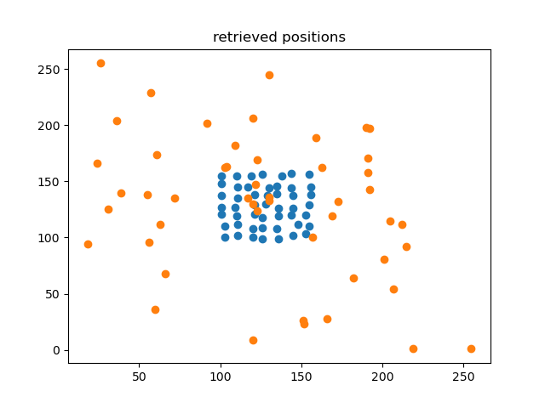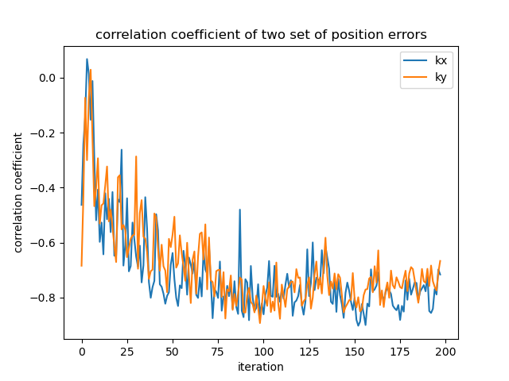

Fig. 5. on the left is the retrieved positions, where orange points are the retrieved positions and the blue points are the ground truth positions. The right is the correlation coefficient of two set of successive retrieved position errors for x and y direction.

1. **Conclusion**

Although I failed to implement the algorithm in Python, I could feel the benefits of this algorithm and found the limitation of it. Profit from the matrix multiplication method, the precision of the positions errors can reach 0.01 pixel or less. The estimated positions start from all-zero guesses, it doesn’t require any priori position input. However, it needs a very high overlap radio. A OR larger than 87.5% is required for the convergence of the correction. The largest difficulty to implement this algorithm is to find an efficient and precise method to locate the peak of cross-correlation.

**Reference**

1. A. M. Maiden and J. M. Rodenburg, “An improved ptychographical phase retrieval algorithm for diffractive imaging,” Ultramicroscopy 109(10), 1256–1262 (2009)
2. J. M. Rodenburg, A. C. Hurst, A. G. Cullis, B. R. Dobson, F. Pfeiffer, O. Bunk, C. David, K. Jefimovs, and I. Johnson, “Hard-x-ray lensless imaging of extended objects,” Phys. Rev. Lett. 98(3), 034801 (2007).
3. K. Giewekemeyer, M. Beckers, T. Gorniak, M. Grunze, T. Salditt, and A. Rosenhahn, “Ptychographic coherent x-ray diffractive imaging in the water window,” Opt. Express 19(2), 1037–1050 (2011).
4. F. Hüe, J. M. Rodenburg, A. M. Maiden, F. Sweeney, and P. A. Midgley, “Wave-front phase retrieval in transmission electron microscopy via ptychography,” Phys. Rev. B 82(12), 121415 (2010).
5. M. Guizar-Sicairos and J. R. Fienup, “Phase retrieval with transverse translation diversity: a nonlinear optimization approach,” Opt. Express 16(10), 7264–7278 (2008).
6. F. Zhang, I. Peterson, J. Vila-Comamala, A. Diaz, F. Berenguer, R. Bean, B. Chen, A. Menzel, I. K. Robinson, and J. M. Rodenburg, “Translation position determination in ptychographic coherent diffraction imaging,” Opt. Express 21(11), 13592–13606 (2013).
7. A. Shenfield and J. M. Rodenburg, “Evolutionary determination of experimental parameters for ptychographical imaging,” J. Appl. Phys. 109(12), 124510 (2011)
8. L. Rong, C. Tang, D. Y. Wang, B. Li, F. R. Tan, Y. X. Wang, and X. Y. Shi, Opt. Express 27, 938 (2019).
9. Wenhui Xu, Huixiang Lin, Hangyu Wang, and Fucai Zhang, "Reconstruction method of a ptychographic dataset with unknown positions," Opt. Lett. 45, 4634-4637 (2020)
10. Oliver Bunk et al. “Influence of the overlap parameter on the convergence of the ptychographical iterative engine”. In: Ultramicroscopy 108.5 (2008), pp. 481–487.
11. M. Dierolf, P. Thibault, A. Menzel, C. M. Kewish, K. Jefimovs, I.Schlichting, K. Von Konig, O. Bunk, and F. Pfeiffer, New J. Phys. 12, 035017 (2010).
12. M. Guizar-Sicairos, S. T. Thurman, and J. R. Fienup, Opt. Lett. 33, 156 (2008)