電通二乙微處理器實驗 實驗結報

實驗名稱 | 藍芽操作設定與遠端控制
組別 | 33 | 組員 | 簡佑霖

- 實驗目的

了解藍芽實際應用，並使用藍芽遠端控制LED

- 實驗步驟

實驗一
下載範例程式 BeaconAdvertisement
修改 configAsIBeacon 中的 Major/Minor為自己學號後四碼
由手機 App 搜尋 7697 Beacon

實驗二
執行範例程式 EddystonURLadvertisement
將 URL 修改為自己的網址
由手機 App 搜尋 7697 Beacon
下載範例程式 SimplePeripheral
將 UUID 前八碼 ”19B10010” 改成自己的學號”
實驗三
將所有 “BLE LED” 字串改成自己的名字;
在 BLE Scanner 畫面找到自己的 7697 並連線
Write value輸入00和01觀察 LED 變化

- 程式碼

實驗一
#include <LBLE.h>
#include <LBLEPeriphral.h>

void setup() {
//Initialize serial and wait for port to open:
Serial.begin(9600);

// Initialize BLE subsystem
Serial.println("BLE begin");
LBLE.begin();
while (!LBLE.ready()) {
delay(100);
}
Serial.println("BLE ready");

LBLEAdvertisementData beaconData;

LBLEUuid uuid("E2C56DB5-DFFB-48D2-B060-D0F5A71096E0");
beaconData.configAsIBeacon(uuid, 04, 65, -40);

Serial.print("Start advertising iBeacon with uuid=");
Serial.println(uuid);

LBLEPeripheral.advertise(beaconData);
}

void loop() {

delay(3000);
}

實驗二
#include <LBLE.h>
#include <LBLEPeriphral.h>

void setup() {
Serial.begin(115200);

Serial.println("BLE begin");
LBLE.begin();
while (!LBLE.ready()) {
delay(100);
}
Serial.println("BLE ready");

LBLEAdvertisementData beaconData;

beaconData.configAsEddystoneURL(EDDY_HTTPS, "google", EDDY_DOT_COM);

Serial.print("Start advertising Eddystone-URL");

LBLEPeripheral.advertiseAsBeacon(beaconData);
}

void loop() {

delay(3000);
}

實驗三
#include <LBLE.h>
#include <LBLEPeriphral.h>

LBLEService ledService("05050465-E8F2-537E-4F6C-D104768A1214");
LBLECharacteristicInt switchCharacteristic("19B10011-E8F2-537E-4F6C-D104768A1214", LBLE_READ | LBLE_WRITE);

void setup() {

pinMode(LED_BUILTIN, OUTPUT);
digitalWrite(LED_BUILTIN, LOW);

Serial.begin(9600);

pinMode(6, INPUT);

LBLE.begin();
while (!LBLE.ready()) {
delay(100);
}
Serial.println("BLE ready");

Serial.print("Device Address = [");
Serial.print(LBLE.getDeviceAddress());
Serial.println("]");

LBLEAdvertisementData advertisement;
advertisement.configAsConnectableDevice("Jian");

LBLEPeripheral.setName("Jian");

ledService.addAttribute(switchCharacteristic);

LBLEPeripheral.addService(ledService);

LBLEPeripheral.begin();

LBLEPeripheral.advertise(advertisement);
}

void loop() {
delay(1000);

Serial.print("conected=");
Serial.println(LBLEPeripheral.connected());

if (digitalRead(6))
{
Serial.println("disconnect all!");
LBLEPeripheral.disconnectAll();
}

if (switchCharacteristic.isWritten()) {
const char value = switchCharacteristic.getValue();
switch (value) {
case 1:
digitalWrite(LED_BUILTIN, HIGH);
break;
case 0:
digitalWrite(LED_BUILTIN, LOW);
break;
default:
Serial.println("Unknown value written");
break;
}
}
}

- 實驗結果及分析

實驗一
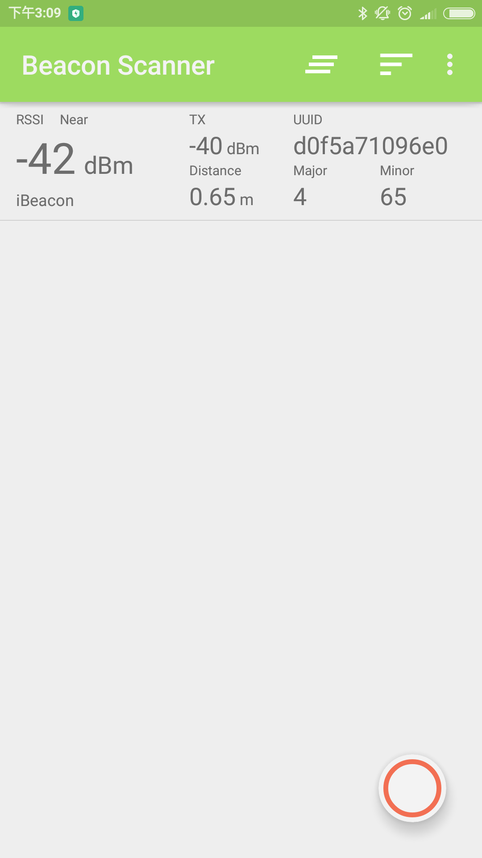

實驗二
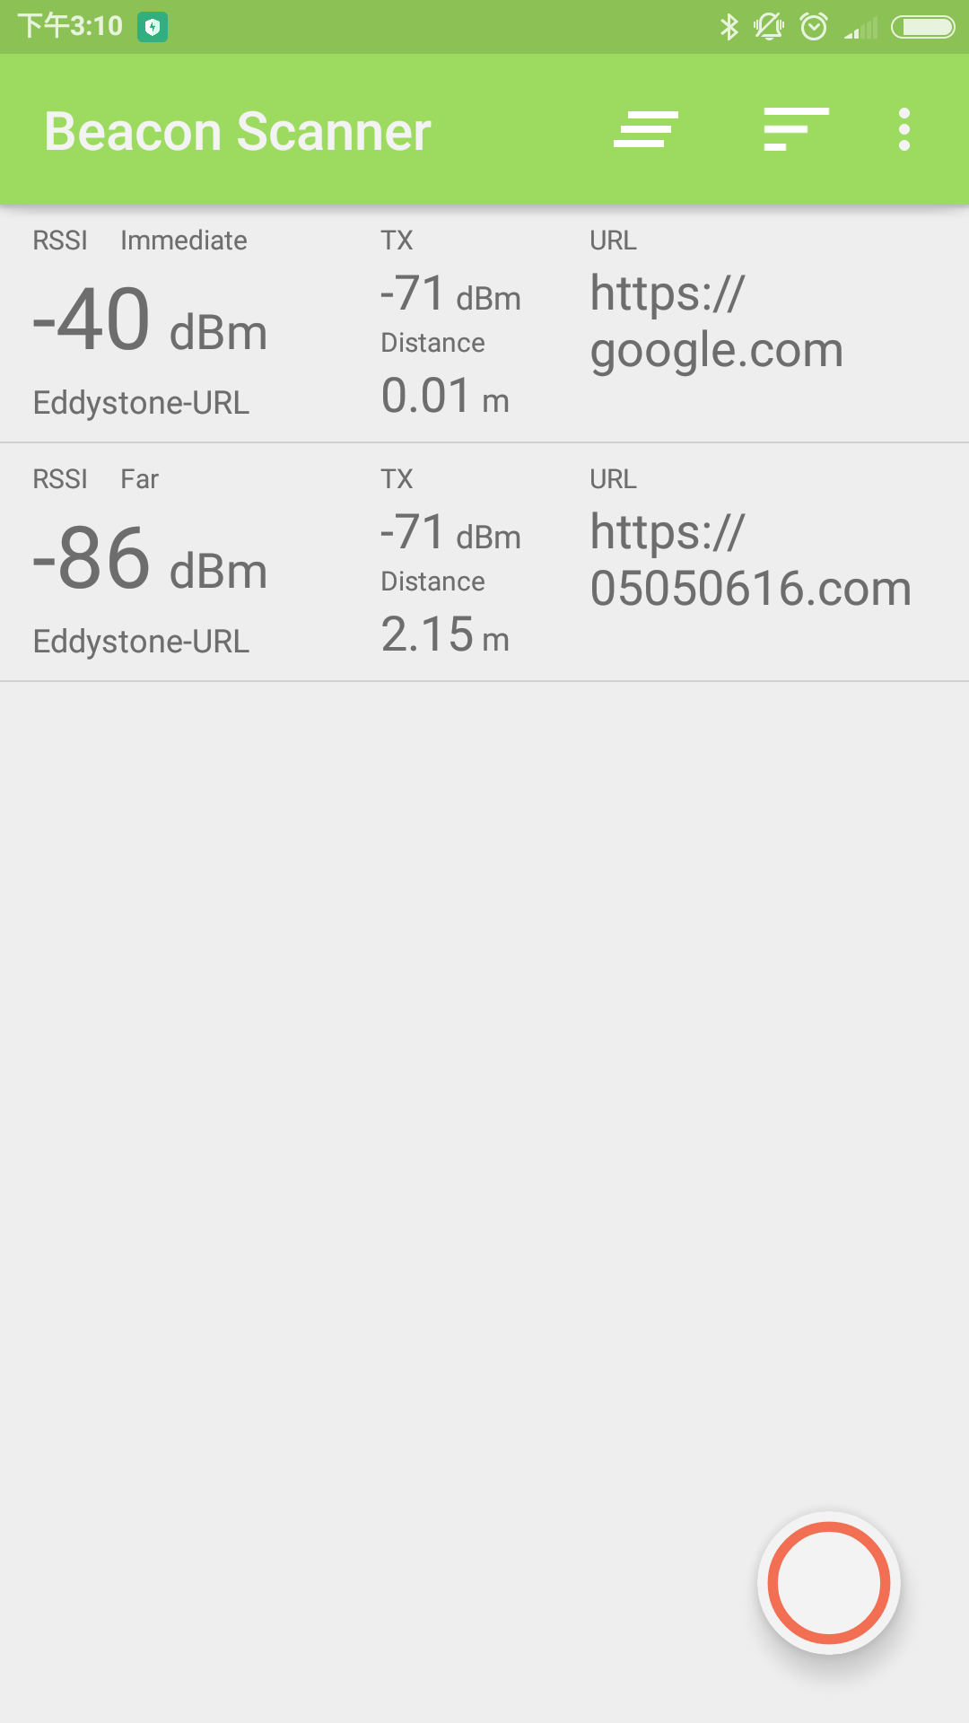

實驗三
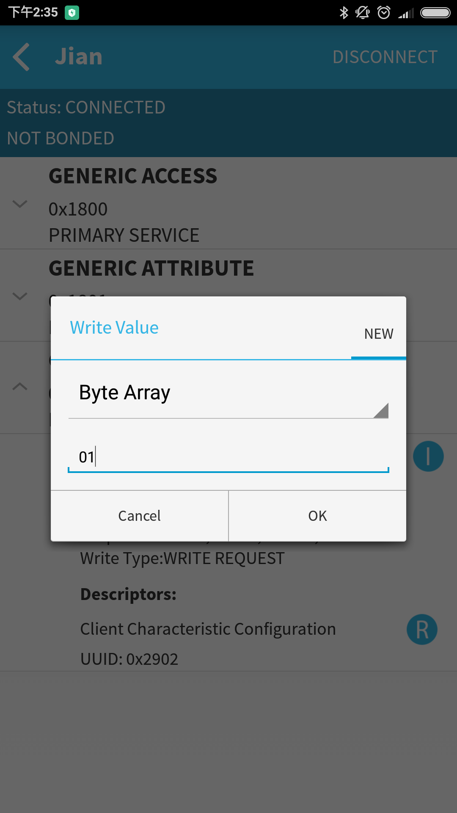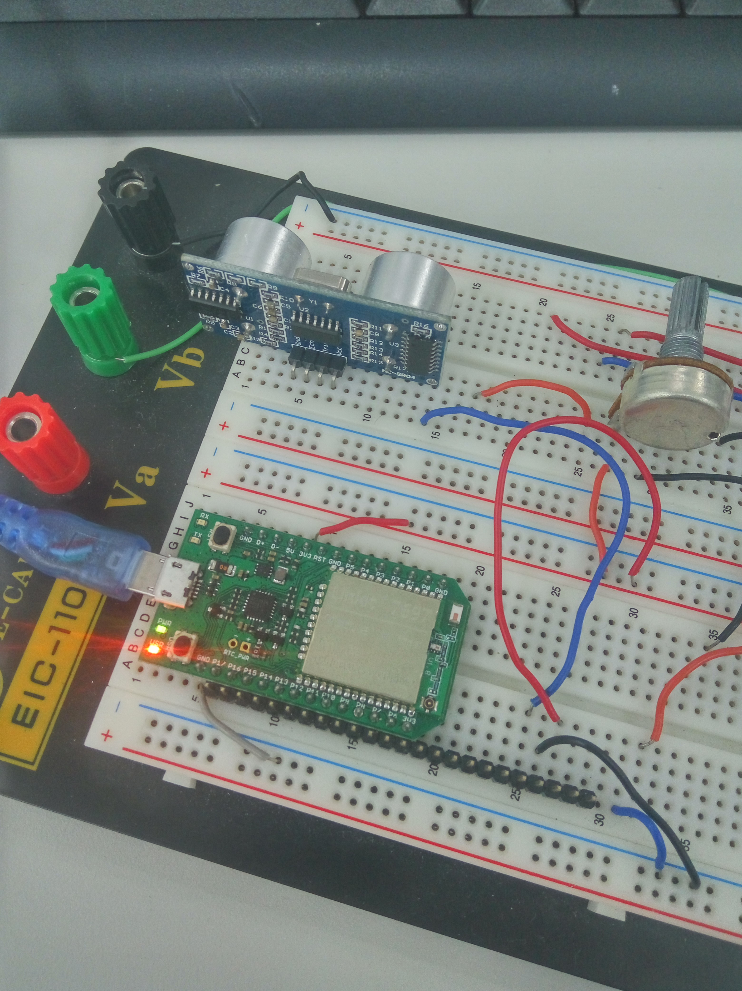

- 心得討論
成功的用藍芽遠端控制LED

