**Security Assignment Report**

**DT228/3**

**Jianyu He**

**cryptography algorithms**

**Vigenere**

Reference: https://en.wikipedia.org/wiki/Vigen%C3%A8re_cipher

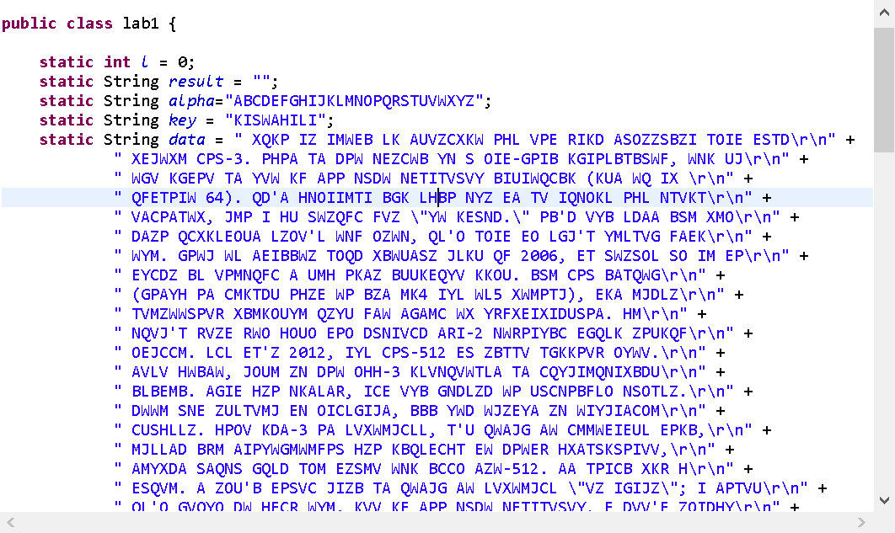



First initialize variable for key, alpha and ciphertext, and delete all symbol.

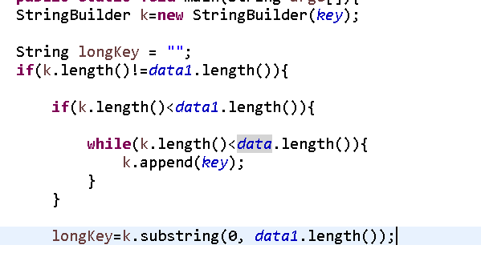

Make key longer, cut it same length with ciphertext without symbol. Make key and ciphertext as table. The column of table is ciphertext and row of table is key.

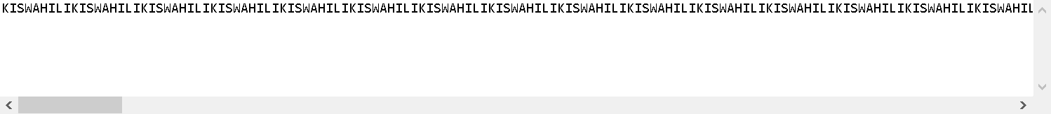

output longKey.

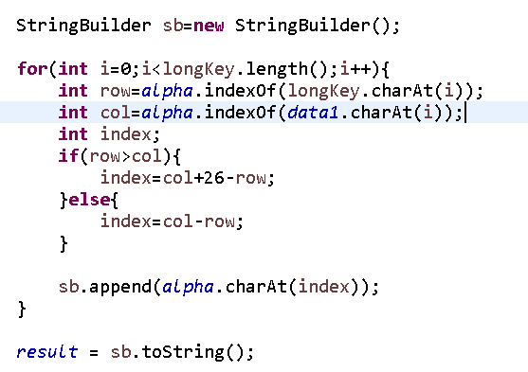

Find location of `letter of key and ciphertext in alpha.



Use this formula to find location of letter of plaintext in alpha.

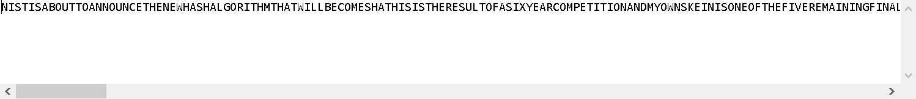

Output result. But the result is without symbol.



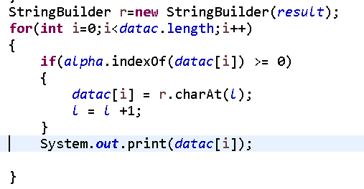

Replace all letters from ciphertext to plaintext, this will keep all symbol. The final result is in the below.



**RSA**

BigInteger introduct and formula ref: <http://www.ruanyifeng.com/blog/2013/07/rsa_algorithm_part_two.html>

BigInteger Multiply Ref：<http://java2s.com/Tutorials/Java/BigDecimal_BigInteger/How_to_add_subtract_multiply_and_divide_a_Java_BigInteger.htm>

BigInterger subtract ref:

<https://stackoverflow.com/questions/15902789/biginteger-in-java>

prime ref: <https://www.tutorialspoint.com/java/math/biginteger_probableprime.htm>

Big Integer compare ref: <https://www.geeksforgeeks.org/biginteger-compareto-method-in-java/>

Euclid’s extended algorithm ref: <https://www.tutorialspoint.com/java/math/biginteger_modinverse.htm>

Modpow ref: <https://www.javatpoint.com/java-biginteger-modpow-method>

String and big integer exchange: <https://stackoverflow.com/questions/50497085/how-can-i-convert-a-biginteger-string-to-an-ascii-string>

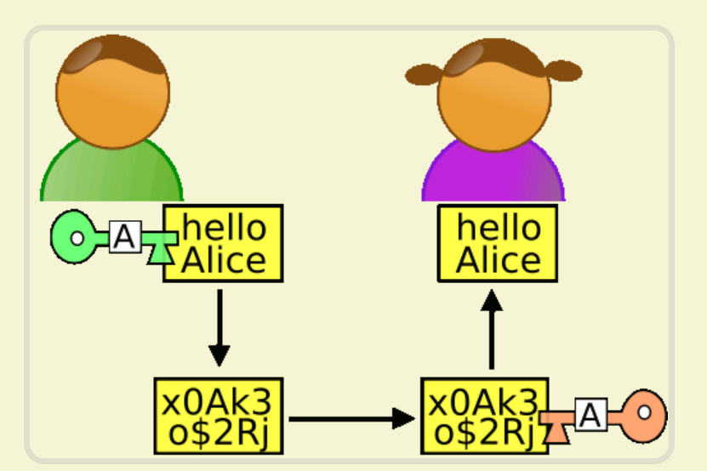

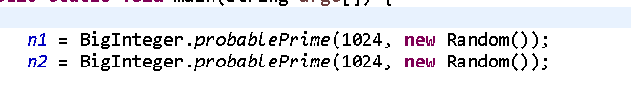

First create 2 big integer and set length is 1024.

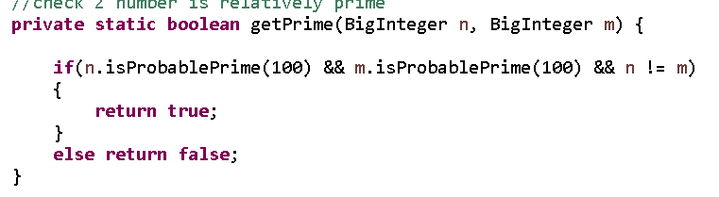

Check 2 big integer is relative prime, if number 1 is prime, number 2 is prime and they are not same, so they are relative prime.

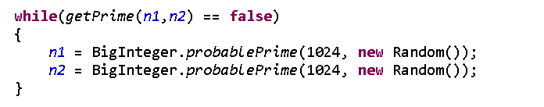

If they not relative prime will use while loop to create new number to make sure they are relative prime. Result as below.



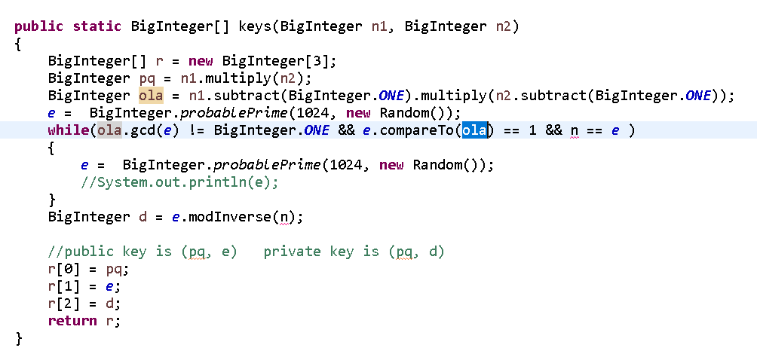

Find public key (pq, e) and private key (pq, d) use below formula. Pq is n of below, ola is φ(n) of below, e is random pick from 1 to ola and e is relative prime with ola, d is ed of below.



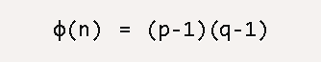

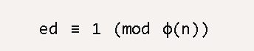

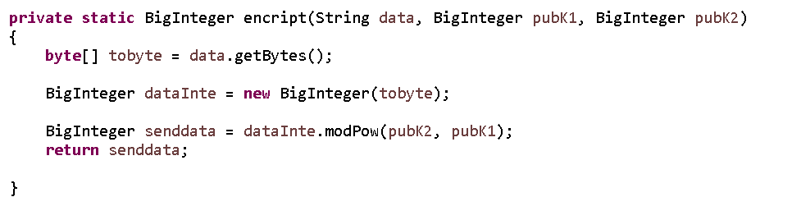

Change data to big integer then use public key follow formula of below to encryption. dataInte is m of below, senddata is c of below, pubK2 is e of below and pubK1 is n of below.





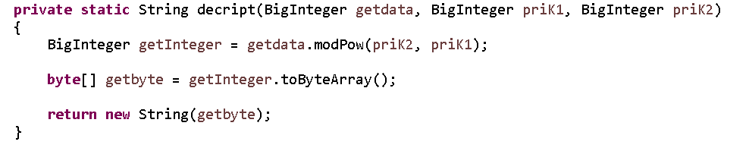

Use private key follow formula of below to decryption, then change big integer to string.

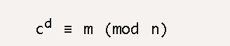

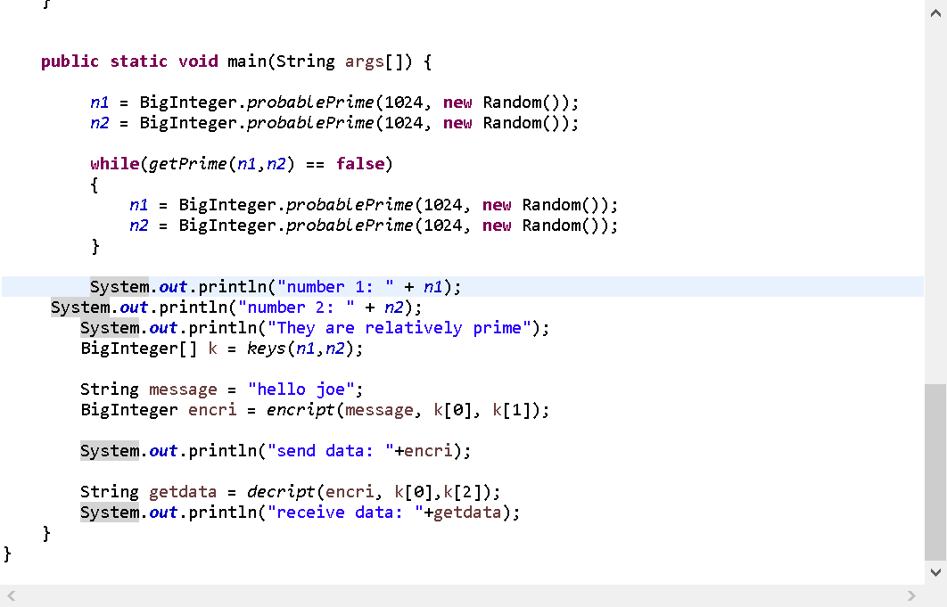

Implement method in the main. Result as below

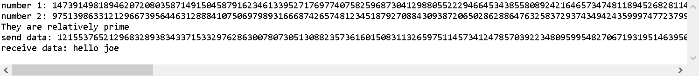

**Cryptographic Tools**

**Sage for RSA**

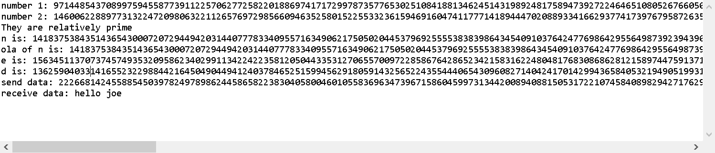

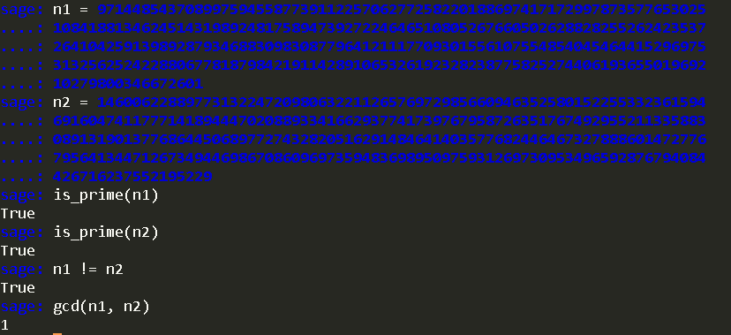

Check 2 random number is prime and not same, so they are relative prime

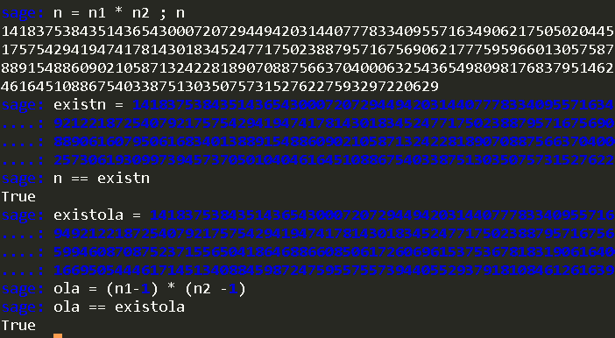

Check n is and euler of n same with coding.

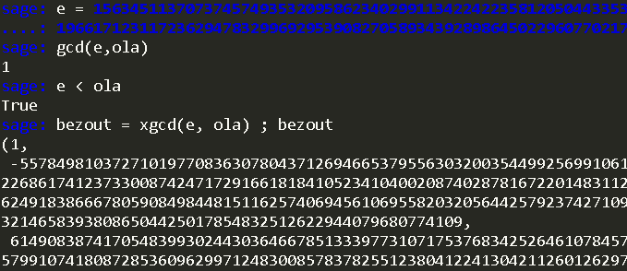

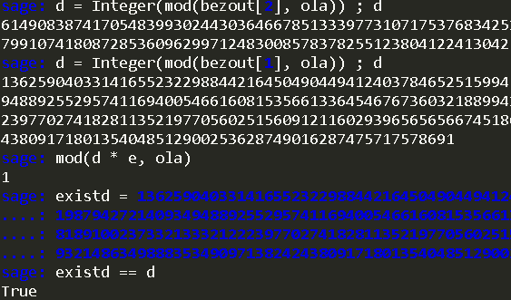

Check e is relative prime with euler of n, e less than euler of n. check d is same with coding.

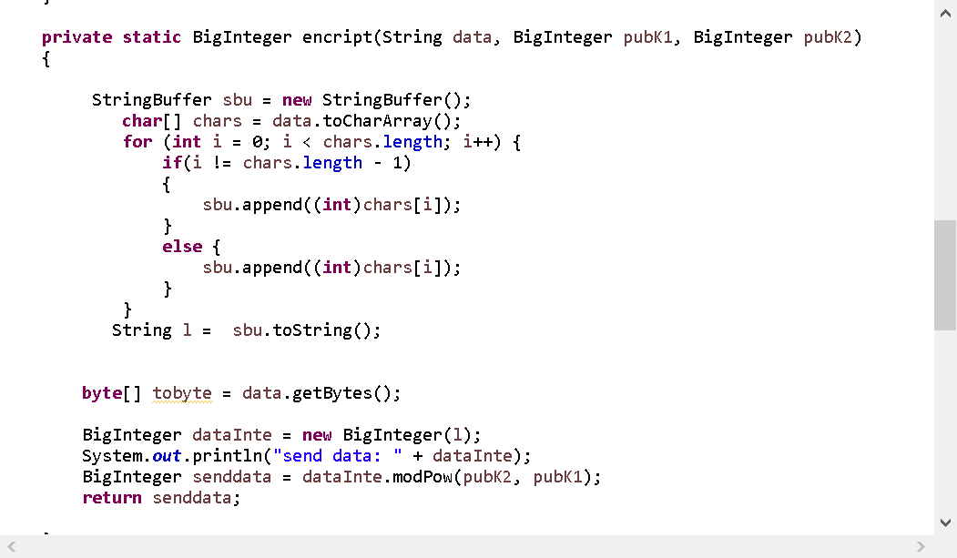



Add string to integer in encrypt.

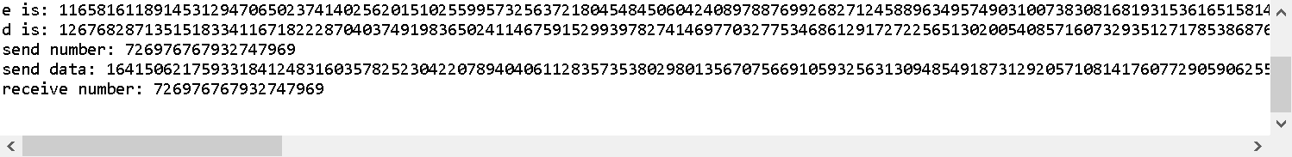

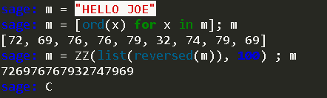

Change string to integer.

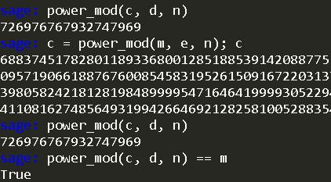

Encrypt and decrypt for integer, is same and same with coding as well.

**Sage for Vigenere**

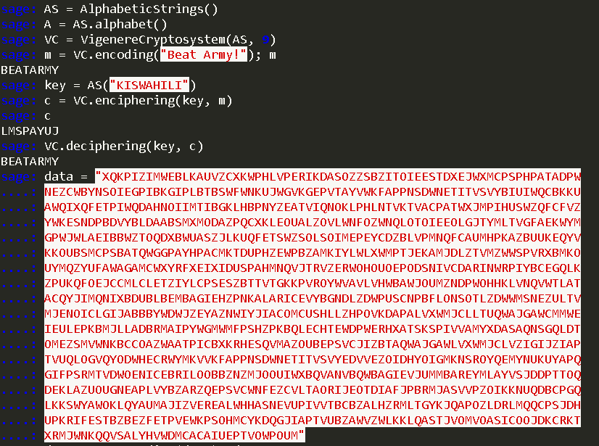

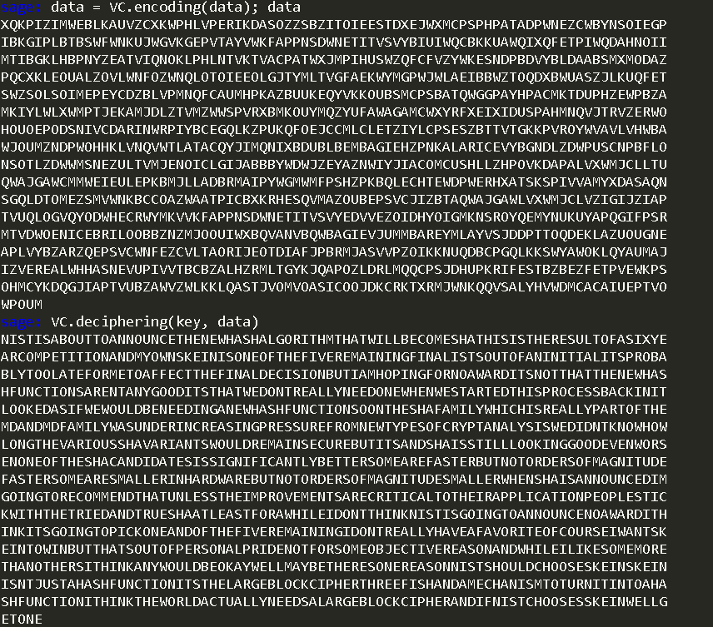

Use sage to decrypt ciphertext for vigenere cipher find reults. Then compare with coding is some.

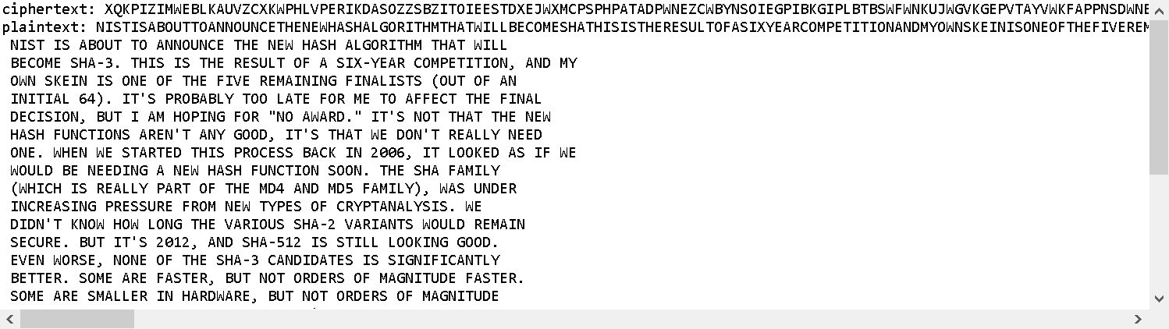

**Openssal for RSA**

Reference:

<https://my.oschina.net/fenying/blog/786238>

<http://fileformats.archiveteam.org/wiki/DER_encoded_RSA_private_key>

<https://stackoverflow.com/questions/19850283/how-to-generate-rsa-keys-using-specific-input-numbers-in-openssl>



Use java to print out p, q, n, e, d ect.

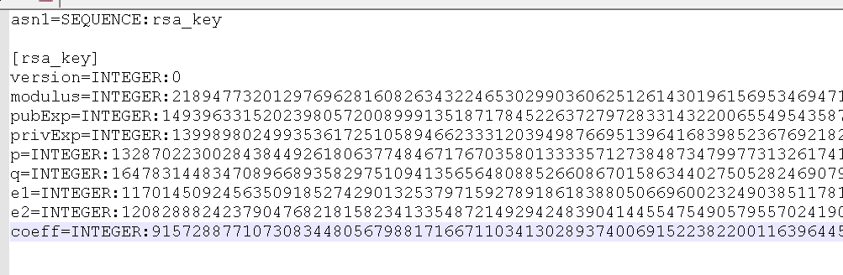

Write those argument in text file.

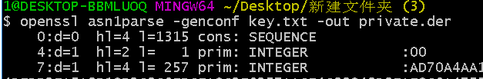

Change text file to der file.

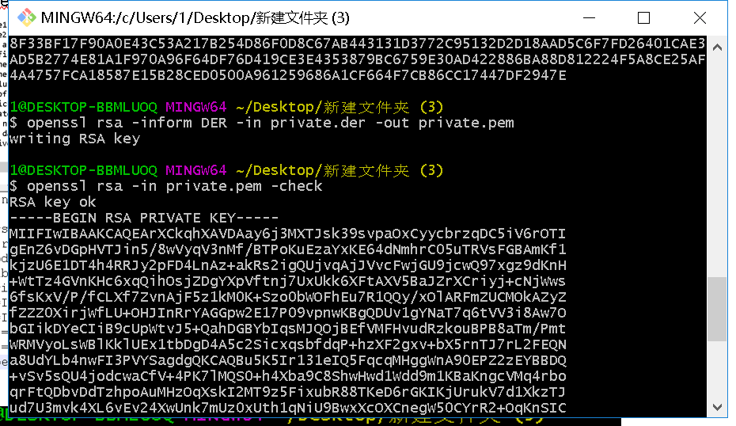

Change primary key der file to pem file. And check as private key.

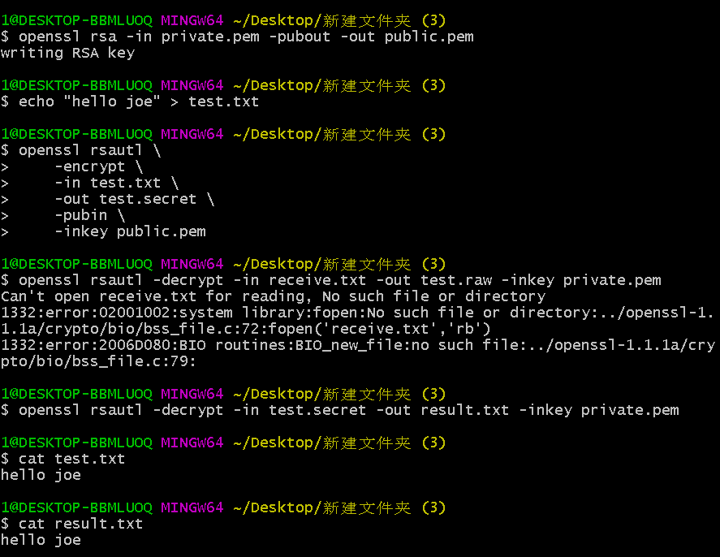

Create public key from private key, then create a test txt file as transform data, use public key to encrypt data, use private key to decrypt data print out result txt is same with test txt. That I can testimonial primary key from eclipse is useful.



**Security Monitoring and Vulnerability**

**Nagios**

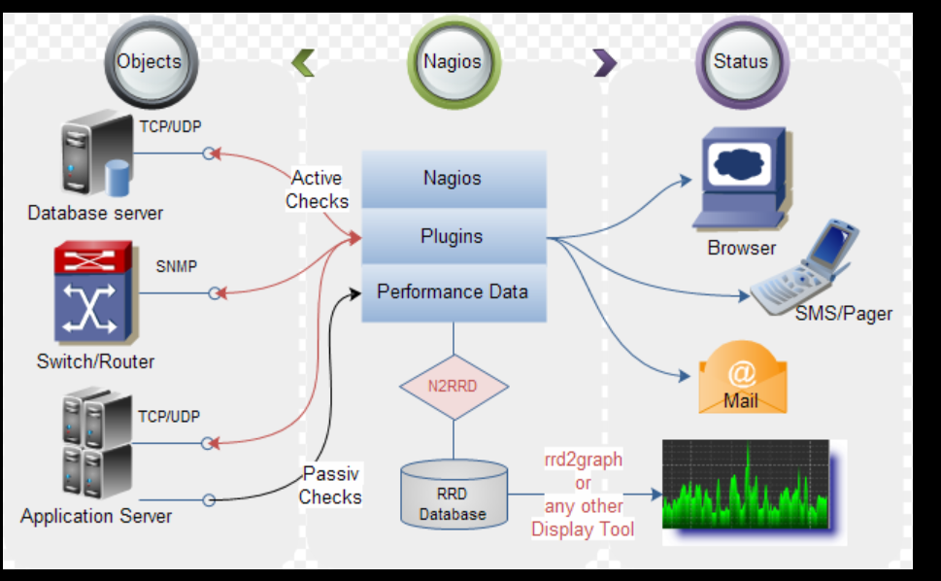

Nagios is open source application use to Monitoring systems and networks. Then client program is deployed on the server to be monitored. That allowed server and client communication to monitoring different source of client.

Nagios can monitor most project.

if Nagios detect Anomaly happens will sent web page to your mobile or email, that you can through open web page to check anomaly of source.

Advantages:

* Increased server, services, process, and application availability
* Fast detection of network and server outages and protocol failures
* Fast detection of failed servers, services, processes and batch jobs

**Ten vulnerabilities**

1. Microsoft Windows HTTP.sys Code Execution Vulnerability

Web server

HTTP.sys in Microsoft Windows 7 SP1, Windows Server 2008 R2 SP1, Windows 8, Windows 8.1, and Windows Server 2012 Gold and R2 allows remote attackers to execute arbitrary code via crafted HTTP requests, aka "HTTP.sys Remote Code Execution Vulnerability."

Successful exploitation will allow remote attackers to cause a buffer overflow and potentially execute arbitrary code with SYSTEM privileges

1. Windows Terminal Service Detection

Backdoors

The Terminal Services are enabled on the remote host. Terminal Services allow a Windows user to remotely obtain a graphical login and therefore act as a local user on the remote host.

If an attacker gains a valid login and password, he may be able to use this service to gain further access on the remote host.

1. Microsoft's SQL TCP/IP Listener

The remote host is running MSSQL, a database server from Microsoft. It is possible to extract the version number of the remote installation from the server pre-login response.

Attackers can gain critical information about the host.

1. Internet Explorer 8 Allows Code Execution (KB2847140)

Category: Policy Checks

as exploited in the wild in May 2013. The remote version of IE reportedly has a use-after-free flaw related to how CGenericElement objects are handled that could result in arbitrary code execution on the remote system.

vulnerability in Internet Explorer 8 Could Allow Remote Code Execution

1. Insecure Library Loading Allows Code Execution (KB2269637)

Category: Policy Checks

working directory when resolving DLL dependencies. If a malicious DLL with the same name as a required DLL is located in the application's current working directory, the malicious DLL will be loaded.

A remote attacker could exploit this issue by tricking a user into accessing a vulnerable application via a network share or WebDAV folder where a malicious DLL resides, resulting in arbitrary code execution.

1. PHP Running Version Prior to 5.2.15

Category: Server Side Scripts

in PHP 5.3.x through 5.3.3 might allow remote attackers to bypass open_basedir restrictions via vectors related to the length of a filename. * Double free vulnerability in the imap_do_open function in the IMAP extension (ext/imap/php_imap.c) in PHP 5.2 before 5.2.15 and 5.3 before 5.3.4 allows attackers to cause a denial of service (memory corruption) or possibly execute arbitrary code via unspecified vectors.

1. Vulnerabilities in Unauthorized Digital Certificates Allow Spoofing (KB2728973)

Category: Policy Checks  
The remote host is missing Microsoft KB2264107, The remote host is missing KB2728973, which updates the system's SSL certificate blacklist.

Unauthorized digital certificates could allow spoofing, phishing, or man in the middle attacks.

1. Vulnerabilities in Server Service Allows Code Execution (MS08-067, Network)

Category: SMB/NetBIOS

The Server service in Microsoft Windows 2000 SP4, XP SP2 and SP3, Server 2003 SP1 and SP2, Vista Gold and SP1, Server 2008, and 7 Pre-Beta allows remote attackers to execute arbitrary code via a crafted RPC request, as exploited in the wild in October 2008, aka Server Service Vulnerability.

An attacker who successfully exploited this vulnerability could take complete control of an affected system remotely.

1. PHP Unsupported Version Detection

Category: Server Side Scripts

According to its version, the installation of PHP on the remote host is no longer supported. As a result, it is likely to contain security vulnerabilities.

Anyone can connect to the NSClient and retrieve sensitive information, such as process and service states, memory usage, etc.

1. NSClient Default Password

|  |  |
| --- | --- |
| Category: | Simple Network services |

The remote host is running an instance of NSClient, an addon for Nagios used to monitor Windows hosts, configured using a default password.

Anyone can connect to the NSClient and retrieve sensitive information, such as process and service states, memory usage, etc.

<https://en.wikipedia.org/wiki/Nagios>

<https://www.nagios.com/solutions/server-monitoring/>

<https://www.beyondsecurity.com/top_network_web_application_vulnerabilities.html>

**Kali Linux**

* 1. What's your computer's IP address for its current Internet connection? (How can you tell the difference between your Ethernet IP and your wireless IP if you have both connections active?)

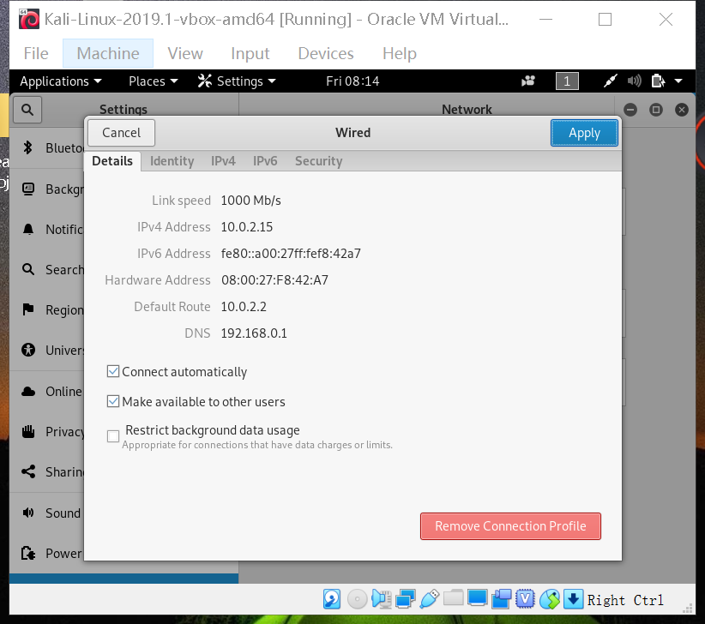



* 1. How can you determine the IP address associated with a given host name?

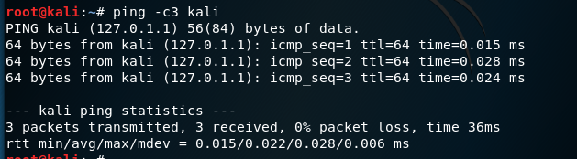

* 1. How can you determine the host name(s) associated with a given IP address?

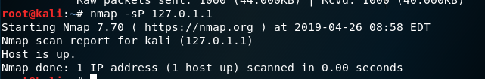

Ref: <https://www.linuxquestions.org/questions/linux-newbie-8/basic-command-to-resolve-ip-to-hostname-582026/>

* 1. How can you copy a file from one computer to another? Or more to the point, if you create a file on the Kali virtual machine and you want to put it someplace where you can save it, how do you go about it from the Kali command-line interface?

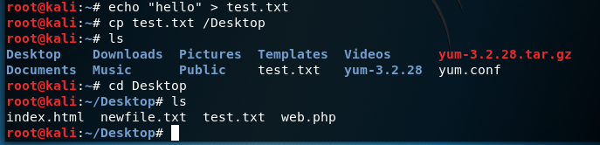

Create test.txt and copy it move to Desktop.

* 1. How can you tell whether there's a process listening on a given port (e.g. port 80 or port 22) on a given host?

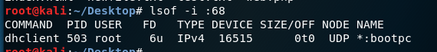

Use given port 68 to find process.

Ref: <https://www.tecmint.com/find-out-which-process-listening-on-a-particular-port/>

* 1. How can you tell which ports have processes listening on them on a given host?

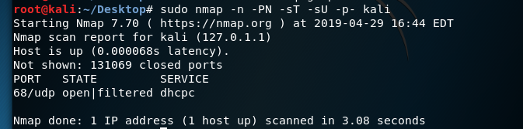

Use given host name to find port is 68.

Ref: <https://www.tecmint.com/find-listening-ports-linux/>

* 1. How can you retrieve and save a given web page (say http://google.com/ in a file on your system?

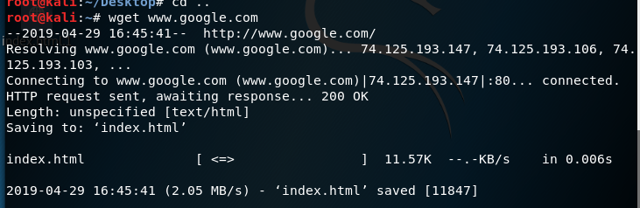

Use wget to download webpage as index.html.

* 1. How can you view the HTTP headers sent back from a specified web server when you request one of its pages?

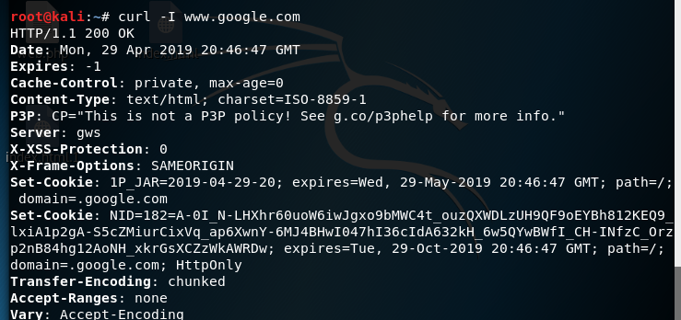

Use curl -I to shows http header of google.com

* 1. [Super bonus question] Is there a command-line-only way to view the HTTP headers that *my* computer sends when I run the commands in the previous two questions?

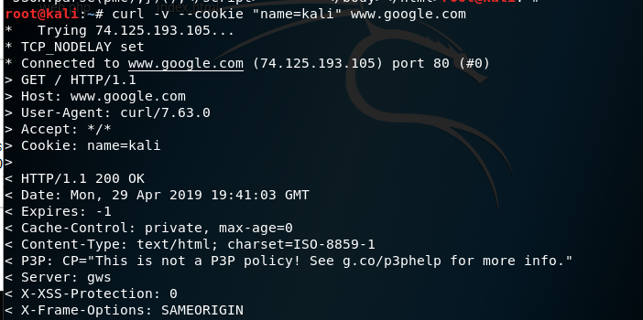

Use curl -v to shows http header of request which name is kali.

Ref: <https://curl.haxx.se/docs/manpage.html>

What is the difference between Kali Linux and other linux distributions? How does it support computer security?

Kali linux has many things in it, like any other flavor of linux it uses the Linux kernal (think game engine to understand) just like Unreal Tournament uses the Unreal Game Engine.

Kali Linux is a Penetration Testing Distribution. This means it is set up to break into things by default (skill of user dependent). It is probably also not what the cool kids use either (they go and build their own versions of a desktop environment using Arch Linux).

The difference between Kali Linux and Linux is this: Kali is a Desktop Environment, Linux is an Operating System Kernel. Its the difference between the engine in your car and the body of your car. The Kernel is the thing everything else you see is built around, and Linux is still necessary to have a functioning installation of Kali Linux.

Kali linux have many security tools can support computer security, such as: AirCrack, Burp Suite, Hydra, John the Ripper, Maltego, Metasploit Framework, Nmap, Zed Attack Proxy, Sqlmap and Wireshark.

**Discussion**

For cryptography algorithms, it is very helpful to use diagrammatize and formula to understand vigenere cipher and RSA cipher. Good logical thinking, mathematics and lots of research from internet can help coding for them.

For crypto tools, they are very useful and helpful for check encryption process and decryption process. They are easy to use for decryption and encryption without coding, but you have to do some research about command line and to understand how command line does.

For security monitoring and vulnerability, With the development of the Internet, security is very important, we have to use monitoring tools to check security of computer. Nagios is very powerful monitoring tool; it can monitor most process of computer includes detect vulnerability. Vulnerability is exist in every computer, Hackers can attack your computer through a vulnerability, so you have to install security tool to detect vulnerability and fix it.

For kali linux, It can use command line to do most command, if you understand most command line of kail linux that you can use computer without mouse to save time with unnecessary actions. Some command line can use check network status it is very helpful to check computer security.

In my previous impressions computer is not very important for me, because I think no hackers will attack my computer. Now I understand computer security not just about hacker, when I use internet may have virus invade my computer, I have to install security tools to protect my computer. cryptography algorithms is getting complexity because internet development will week out obsolete cryptography algorithms.