**Web Development Assignment Report**

**Login.php**

<html>

<h2 align = "center">Library System</h2>

<tr></tr>

<h2 align = "center"> Please Login in or Register</h2>

<tr></tr>

<head>

<title> Login page </title>

</head>

<body bgcolor = "lightgreen">

<form action = "login.php" method = "post">

<table border = "2" align = "center" bgcolor = "lightpink" >

<tr>

<td colspan = "2" align = "center"> login form </td>

</tr>

<tr>

<td>UserName: </td>

<td><input type = "text" name = "userName"></td>

</tr>

<tr>

<td>Password: </td>

<td><input type = "password" name = "Password"></td>

</tr>

<tr>

<td colspan = "2" align = "center"><input type = "submit" name = "Login" ></td>

</tr>

<tr>

<td colspan = "2" align = "center"><input type = "button" value = "Register" onclick="location.href='register.php' "></td>

</tr>

</form>

</body>

</html>

<?php

session_start();

echo "<font size='10'>";

$db = mysqli_connect('localhost', 'root', '') or die(mysqli_error());

mysqli_select_db($db ,"ca") or die(mysqli_error());

if (isset($_POST) && !empty($_POST))

{

$userName = $_POST["userName"];

$password = $_POST["Password"];

$query = "select * from users where userName = '$userName' and Password = '$password'";

$result = mysqli_query($db, $query);

$count = mysqli_num_rows($result);

if($count == 1)

{

$_SESSION['userName'] = $userName;

header('Location: search.php');

return;

}

else

{

$_SESSION["error"] = "invalid username or password";

header('Location: login.php');

return;

}

}

if ( isset($_SESSION["error"]) ) {

echo('<p style="color:red" align = "center">Error:'.

$_SESSION["error"]."</p>\n");

unset($_SESSION["error"]);

}

?>

Login form show below, when user login successful will go to search page.

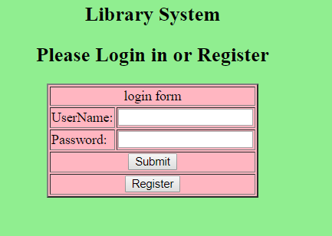

Incorrect username or password happened and click register button go to registration page.

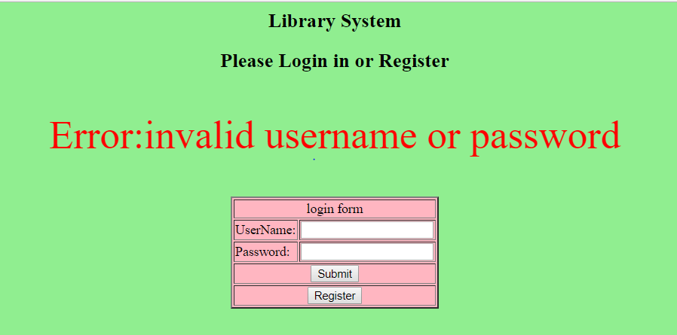

**Register.php**

<html>

<p colspan = "2" align = "center"><input type = "button" value = "search and reserve" onclick="location.href='search.php' ">

<input type="button" value="Logout" onclick="location.href='logout.php'; return false ">

<input type = "button" value = "display" onclick="location.href='display.php' ">

<input type = "button" value = "Reservation and return" onclick="location.href='reservation.php' "></p>

<h1 align = "center"> Registration </h1>

<tr></tr>

<p align = "center" >Mobile phone numbers should be numeric and 10 characters in length and Password should be six characters </p>

<body bgcolor = "lightblue">

<form action = "register.php" method = "post">

<table border = "2" align = "center" bgcolor = "CHARTREUSE">

<tr>

<td colspan = "2" align = "center"> Register form </td>

</tr>

<tr>

<td>UserName: </td>

<td><input type = "text" name = "userName"></td>

</tr>

<tr>

<td>Password: </td>

<td><input type = "password" name = "Password" maxlength = 6 ></td>

</tr>

<tr>

<td> Confirm Password: </td>

<td><input type = "password" name = "CPassword"></td>

</tr>

<tr>

<td>FirstName: </td>

<td><input type = "text" name = "firstName"></td>

</tr>

<tr>

<td>Surname: </td>

<td><input type = "text" name = "surname"></td>

</tr>

<tr>

<td>AddressLine1: </td>

<td><input type = "text" name = "address1"></td>

</tr>

<tr>

<td>AddressLine2: </td>

<td><input type = "text" name = "address2"></td>

</tr>

<tr>

<td>City: </td>

<td><input type = "text" name = "city"></td>

</tr>

<tr>

<td>Telephone: </td>

<td><input type = "text" name = "telephone"></td>

</tr>

<tr>

<td>Mobile: </td>

<td><input type = "text" name = "mobile" maxlength = 10></td>

</tr>

<tr>

<td colspan = "2" align = "center"><input type = "submit" name = "register" ></td>

<tr>

<td colspan = "2" align = "center"><input type = "button" value = "Login" onclick="location.href='login.php' "></td>

<table>

</form>

</body>

</html>

<?php

$db = mysqli_connect('localhost', 'root', '') or die(mysqli_error());

mysqli_select_db($db ,"ca") or die(mysqli_error());

if (isset($_POST) && !empty($_POST))

{

$userName = mysqli_real_escape_string($db,$_POST["userName"]);

$password = ($_POST["Password"]);

$cpassword = ($_POST["CPassword"]);

$firstname = mysqli_real_escape_string($db,$_POST["firstName"]);

$surname = mysqli_real_escape_string($db,$_POST["surname"]);

$address1 = mysqli_real_escape_string($db,$_POST["address1"]);

$address2 = mysqli_real_escape_string($db,$_POST["address2"]);

$city = mysqli_real_escape_string($db,$_POST["city"]);

$telephone = is_numeric($_POST["telephone"]);

$mobile = is_numeric($_POST["mobile"]);

$query = "insert into users (userName,Password,FirstName,Surname, AddressLine1, AddressLine2, City, Telephone, Mobile )

values ('$userName','$password','$firstname','$surname','$address1','$address2','$city','$telephone','$mobile')";

if(empty($_POST["userName"]) || empty($_POST["Password"]) || empty($_POST["CPassword"]) || empty($_POST["firstName"])||empty($_POST["surname"])||empty($_POST["address1"])|| empty($_POST["address2"])||empty($_POST["city"])||empty($_POST["telephone"])||empty($_POST["mobile"]) )

{

echo '<p align = "center" style="color:red"> Please enter all information </p>';

}

else

{

if(($_POST["Password"]) == ($_POST["CPassword"]))

{

if(is_numeric($_POST["mobile"]))

{

if(mysqli_query($db, $query))

{

echo '<p align = "center" style="color:green">your registration is successfull</p>';

}

else

{

echo '<p align = "center" style="color:red"> incorrect information please try again </p>';

}

}

else

{

echo '<p align = "center" style="color:red"> Mobile is not numeric </p>';

}

}

else

{

echo '<p align = "center" style="color:red"> incorrect confirm password</p>';

}

}

}

?>

Register form show below and click login button go back to login page, if already login user can click display go to display page or click reservation and return go to reservation books page or click search and reserve go to search page or click logout go back login page.

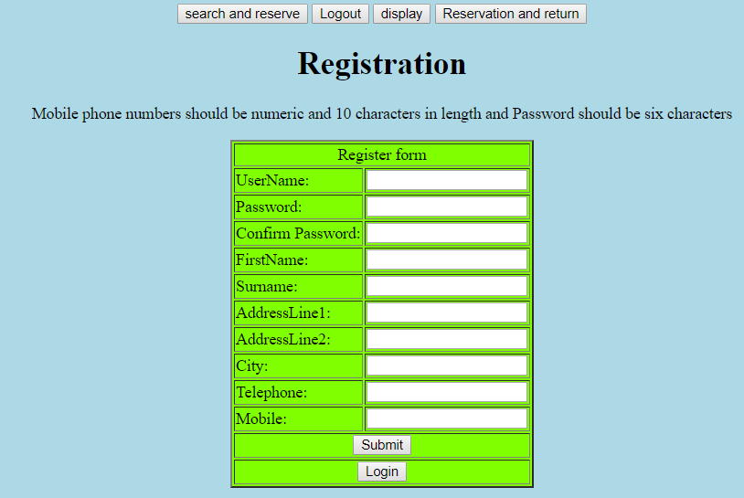

When registration is successful a successful the user’s information will be store in database.

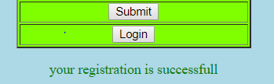

When registration was fairs:

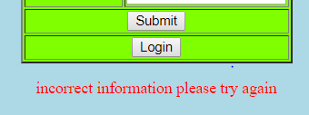

Mobile number must be numeric:



Incorrect confirm password:

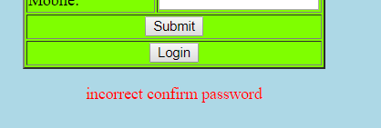

**Search.php**

<html>

<body bgcolor = "LAVENDER">

<p align = "center"><input type="button" value="Register" onclick="location.href='register.php' ">

<input type="button" value="Logout" onclick="location.href='logout.php'; return false ">

<input type = "button" value = "display" onclick="location.href='display.php' ">

<input type = "button" value = "Reservation and return" onclick="location.href='reservation.php' "></p>

<h1 align = "center">Search Page</h1>

<h2 align = "center">Book search</h2>

<form action="search.php" method="GET" align = "center">

<select name="option" >

<option value="0">bookTitle </option>

<option value="1">author </option>

<option value="2">category </option>

</select>

<input type="text" name="search" placeholder = "Search" />

<button type="submit" name = "submit-search" >Search</button>

</form>

<tr></tr>

<?php

session_start();

if(!isset($_SESSION['userName']))

{

header('Location: login.php');

}

$db = mysqli_connect('localhost', 'root', '') or die(mysqli_error());

mysqli_select_db($db ,"ca") or die(mysqli_error());

if( isset($_GET['submit-search']) && isset($_GET['option']) && !empty($_GET['search']) )

{

$search = mysqli_real_escape_string($db, $_GET['search']);

$option = mysqli_real_escape_string($db, $_GET['option']);

$bookTitle = "select * from Books where (bookTitle like '%$search%') and (rese = 'N')";

$author = "select * from Books where (author like '%$search%') and (rese = 'N')";

$category = "select * from Books where (category like '%$search%') and (rese = 'N')";

if($option == 0)

{

$result = mysqli_query($db, $bookTitle);

}

else if($option == 1)

{

$result = mysqli_query($db, $author);

}

else if($option == 2)

{

$result = mysqli_query($db, $category);

}

//paging

echo '<table border="0" align = "center"><tr><td>';

$totalrow=mysqli_num_rows($result);

$rowperpage = 5;

$totalpage = ceil($totalrow / $rowperpage);

if (isset($_GET['currentpage']) && is_numeric($_GET['currentpage'])) {

$currentpage = (int) $_GET['currentpage'];

} else {

$currentpage = 1;

}

if ($currentpage > $totalpage) {

$currentpage = $totalpage;

}

if ($currentpage < 1) {

$currentpage = 1;

}

$offset = ($currentpage -1) * $rowperpage;

$url = "option=".$_GET['option']."&search=".$_GET['search']."&submit-search=".$_GET['submit-search'];

$prevpage = $currentpage - 1;

echo "<a href=\"" . $_SERVER['PHP_SELF'] . "?".$url."&amp;currentpage=$prevpage\">Prevpage</a> ";

echo " [<b>$currentpage</b>] ";

$nextpage = $currentpage + 1;

echo "<a href=\"" . $_SERVER['PHP_SELF'] . "?".$url."&amp;currentpage=$nextpage\">Nextpage</a> ";

echo '</td></tr></table>';

//////////////////////////////////////////////////////////////////////////////////////////////////////////////

echo '<table border = "1" align = "center" bgcolor = "AQUA">'."\n";

$bookTitle1 = "select * from Books where (bookTitle like '%$search%') and (rese = 'N') LIMIT $offset, $rowperpage";

$author1 = "select * from Books where (author like '%$search%') and (rese = 'N') LIMIT $offset, $rowperpage";

$category1 = "select * from Books where (category like '%$search%') and (rese = 'N') LIMIT $offset, $rowperpage";

if($option == 0)

{

$result1 = mysqli_query($db, $bookTitle1);

}

else if($option == 1)

{

$result1 = mysqli_query($db, $author1);

}

else if($option == 2)

{

$result1 = mysqli_query($db, $category1);

}

if($totalrow >0)

{

echo "<th>ISBN</th>";

echo "<th>BookTitle</th>";

echo "<th>Author</th>";

echo "<th>Edition</th>";

echo "<th>Year</th>";

echo "<th>Category</th>";

echo "<th>Rese</th>";

while ($row = mysqli_fetch_row($result1))

{

echo '<tr><td>';

echo($row[0]);

echo('</td><td>');

echo($row[1]);

echo('</td><td>');

echo($row[2]);

echo('</td><td>');

echo($row[3]);

echo('</td><td>');

echo($row[4]);

echo('</td><td>');

echo($row[5]);

echo('</td><td>');

echo($row[6]);

echo('</td></tr>');

}

}

else

{

echo '<p align = "center" style="color:red">There is no such a book or already reserved!</p>';

}

}

echo "</table>\n";

mysqli_close($db);

?>

<h1 align = "center">Reserve books</h1>

<p align = "center">Please insert book title or book author to reserve book </p>

<form action="search.php" method="GET" align = "center">

<input type="text" name="reserve" placeholder = "reserve book" />

<button type="submit" name = "book-reserve" >Reserve</button>

</form>

<?php

$db = mysqli_connect('localhost', 'root', '') or die(mysqli_error());

mysqli_select_db($db ,"ca") or die(mysqli_error());

if ( isset($_GET['book-reserve']) )

{

$reserve = $_GET['reserve'];

$update = "update books set rese = 'Y' where bookTitle ='$reserve' or author like '$reserve'";

$find = "select ISBN from books where (bookTitle ='$reserve' or author like '$reserve') and (rese = 'N')";

$date = date("d-M-Y");

$r = mysqli_query($db, $find);

$e = mysqli_fetch_assoc($r);

if(mysqli_num_rows($r) >0)

{

$insert = "insert into reservations (ISBN,userName,reservedDate)

values ('{$e['ISBN']}','{$_SESSION['userName']}','$date')";

mysqli_query($db, $update);

mysqli_query($db, $insert);

echo '<p align = "center" style="color:green">your book reservation is successfull</p>';

return;

}

else

{

echo '<p align = "center" style="color:red"> incorrect information please try again </p>';

return;

}

}

?>

</body>

</html>

Search and reserve from show below, this page allow user to search books by book title, author or category. User can insert book title or author to reserve a book. User can click display go to display page or click reservation and return go to reservation books page or click register go to registration page or click logout go back login page.

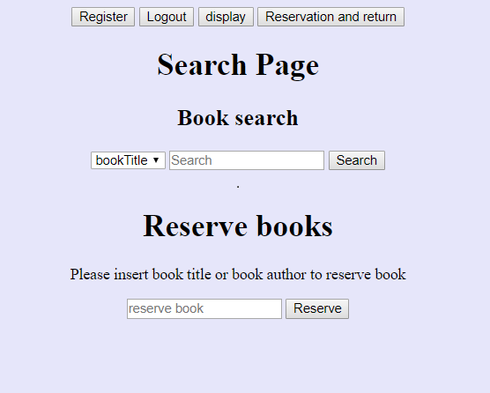

When search was fairs:



Drop down for book title, author and category:

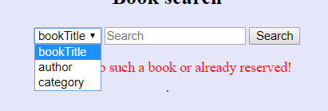

Search by Book title:

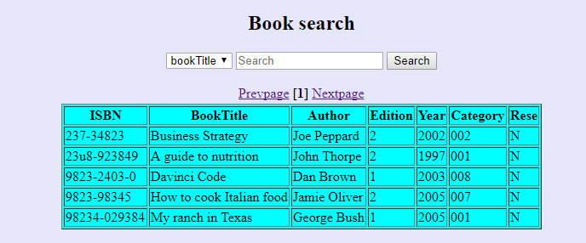

Search by category:

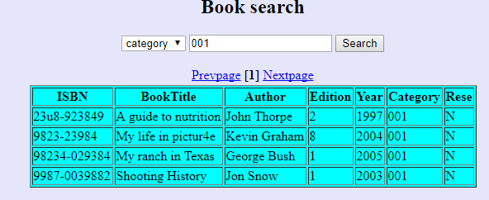

When reservation was successful the ISBN of book , username and date will be store in database.



When reservation was fairs:



**reservation.php**

<body bgcolor = "LIGHTSKYBLUE">

<p align = "center"><input type="button" value="Logout" onclick="location.href='logout.php'; return false ">

<input type = "button" value = "display" onclick="location.href='display.php' ">

<input type = "button" value = "search and reserve" onclick="location.href='search.php' "></p>

<h2 align = "center"> Reservation Books </h2>

<?php

session_start();

if(!isset($_SESSION['userName']))

{

header('Location: login.php');

}

$db = mysqli_connect('localhost', 'root', '') or die(mysqli_error());

mysqli_select_db($db ,"ca") or die(mysqli_error());

//paging

echo '<table border="0" align = "center"><tr><td>';

$sql1 = mysqli_query($db, "select * from books where rese = 'Y'");

$totalrow=mysqli_num_rows($sql1);

$rowperpage = 5;

$totalpage = ceil($totalrow / $rowperpage);

if (isset($_GET['currentpage']) && is_numeric($_GET['currentpage'])) {

$currentpage = (int) $_GET['currentpage'];

} else {

$currentpage = 1;

}

if ($currentpage > $totalpage) {

$currentpage = $totalpage;

}

if ($currentpage < 1) {

$currentpage = 1;

}

$offset = ($currentpage - 1) * $rowperpage;

$prevpage = $currentpage - 1;

echo " <a href='{$_SERVER['PHP_SELF']}?currentpage=$prevpage'>Prevpage</a> ";

echo " [<b>$currentpage</b>] ";

$nextpage = $currentpage + 1;

echo " <a href='{$_SERVER['PHP_SELF']}?currentpage=$nextpage'>Nextpage</a> ";

echo '</td></tr></table>';

//////////////////////////////////////////////////////////////////////////////////////////////////////////////

$resebook = mysqli_query($db, "select * from books where rese = 'Y' LIMIT $offset, $rowperpage");

echo '<table border = "1" align = "center" bgcolor = "AQUA">'."\n";

echo "<th>ISBN</th>";

echo "<th>BookTitle</th>";

echo "<th>Author</th>";

echo "<th>Edition</th>";

echo "<th>Year</th>";

echo "<th>Category</th>";

echo "<th>Rese</th>";

while ($row = mysqli_fetch_row($resebook))

{

echo '<tr><td>';

echo($row[0]);

echo('</td><td>');

echo($row[1]);

echo('</td><td>');

echo($row[2]);

echo('</td><td>');

echo($row[3]);

echo('</td><td>');

echo($row[4]);

echo('</td><td>');

echo($row[5]);

echo('</td><td>');

echo($row[6]);

echo('</td></tr>');

}

echo '</table> ';

?>

<h1 align = "center">Return books</h1>

<p align = "center">Please insert book title or book author to return book </p>

<form action="reservation.php" method="POST" align = "center">

<input type="text" name="return" placeholder = "return book" />

<button type="submit" name = "book-return" >return</button>

</form>

<?php

$db = mysqli_connect('localhost', 'root', '') or die(mysqli_error());

mysqli_select_db($db ,"ca") or die(mysqli_error());

if ( isset($_POST['book-return']) )

{

$return = $_POST['return'];

$update1 = "update books set rese = 'N' where bookTitle ='$return' or author like '$return'";

$find = "select * from books where (bookTitle ='$return' or author like '$return') and (rese = 'Y')";

$e = mysqli_query($db, $find);

if(mysqli_num_rows($e) >0)

{

mysqli_query($db, $update1);

echo '<p align = "center" style="color:green">your book return is successfull</p>';

return;

}

else

{

echo '<p align = "center" style="color:red"> incorrect information please try again </p>';

return;

}

}

?>

</body>

Display reservation books and return books, this page is limit to 5 rows for each page, this is first page. Use can click display go to display page or click search and reserve go to search books page or click logout go back login page.

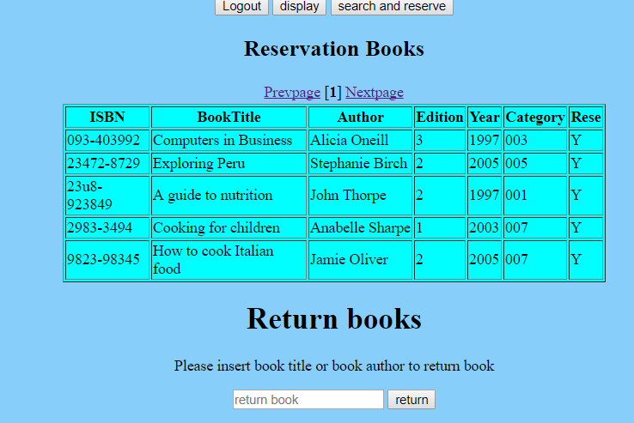

Second page for display reservation books:

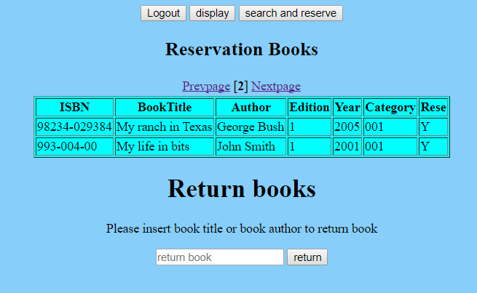

When books return was fairs:



When books return is successful:



**Display.php**

<body bgcolor= "SANDYBROWN">

<p colspan = "2" align = "center"><input type = "button" value = "search and reserve" onclick="location.href='search.php' ">

<input type="button" value="Logout" onclick="location.href='logout.php'; return false ">

<input type = "button" value = "Reservation and return" onclick="location.href='reservation.php' "></p>

<h1 align = "center">Books Display</h1>

<?php

session_start();

if(!isset($_SESSION['userName']))

{

header('Location: login.php');

}

$db = mysqli_connect('localhost', 'root', '') or die(mysqli_error());

mysqli_select_db($db ,"ca") or die(mysqli_error());

//paging

echo '<table border="0" align = "center"><tr><td>';

$sql1 = mysqli_query($db, "select * from books");

$totalrow=mysqli_num_rows($sql1);

$rowperpage = 5;

$totalpage = ceil($totalrow / $rowperpage);

if (isset($_GET['currentpage']) && is_numeric($_GET['currentpage'])) {

$currentpage = (int) $_GET['currentpage'];

} else {

$currentpage = 1;

}

if ($currentpage > $totalpage) {

$currentpage = $totalpage;

}

if ($currentpage < 1) {

$currentpage = 1;

}

$offset = ($currentpage -1) * $rowperpage;

$prevpage = $currentpage - 1;

echo " <a href='{$_SERVER['PHP_SELF']}?currentpage=$prevpage'>Prevpage</a> ";

echo " [<b>$currentpage</b>] ";

$nextpage = $currentpage + 1;

echo " <a href='{$_SERVER['PHP_SELF']}?currentpage=$nextpage'>Nextpage</a> ";

echo '</td></tr></table>';

//////////////////////////////////////////////////////////////////////////////////////////////////////////////

$result = mysqli_query($db, "select * from books LIMIT $offset, $rowperpage");

echo '<table border = "1" align = "center" bgcolor = "AQUA">'."\n";

echo "<th>ISBN</th>";

echo "<th>BookTitle</th>";

echo "<th>Author</th>";

echo "<th>Edition</th>";

echo "<th>Year</th>";

echo "<th>Category</th>";

echo "<th>Rese</th>";

while ($row = mysqli_fetch_row($result))

{

echo '<tr><td>';

echo($row[0]);

echo('</td><td>');

echo($row[1]);

echo('</td><td>');

echo($row[2]);

echo('</td><td>');

echo($row[3]);

echo('</td><td>');

echo($row[4]);

echo('</td><td>');

echo($row[5]);

echo('</td><td>');

echo($row[6]);

echo('</td></tr>');

}

echo '</table> ';

?>

</body>

Display all books and limit to 5 rows for each page, this is first page, user can click reservation and return go to reservation books page or click search and reserve go to search page or click logout go back login page.

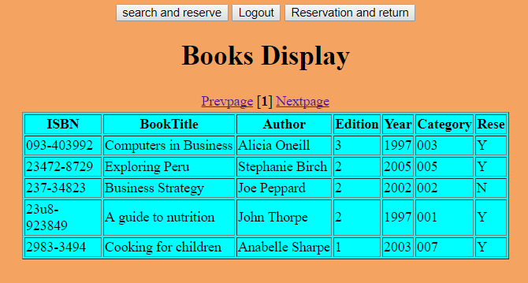

Second page:

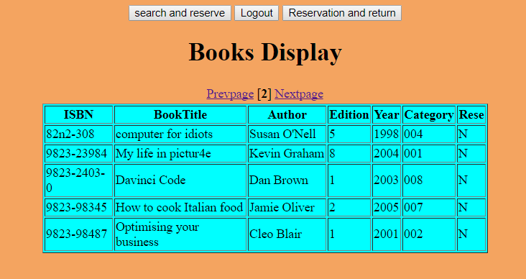

Third page:

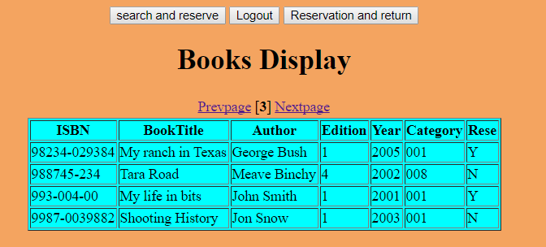

**Table created**

create table categories(

category varchar(3) primary key,

categoryDescription varchar(20)

);

create table books(

ISBN varchar(20) primary key,

bookTitle varchar(50),

author varchar(20),

edition int(5),

year int(4),

category varchar(3),

rese char(1),

index (ISBN),

foreign key (category) references categories(category)

);

create table users(

userName varchar(50) primary key not null,

Password varchar(6) not null,

FirstName varchar(10) not null,

Surname varchar(10) not null,

AddressLine1 varchar(20),

AddressLine2 varchar(20),

City varchar(20),

Telephone int(20),

Mobile int(10)

);

create table reservations(

ISBN varchar(20),

userName varchar(50),

reservedDate varchar(20),

foreign key (ISBN) references books(ISBN),

foreign key (userName) references users(userName)

);

insert into categories (category,categoryDescription) values

(001, 'Health');

insert into categories (category,categoryDescription) values

(002, 'Business');

insert into categories (category,categoryDescription) values

(003, 'Biography');

insert into categories (category,categoryDescription) values

(004, 'Technology');

insert into categories (category,categoryDescription) values

(005, 'Travel');

insert into categories (category,categoryDescription) values

(006, 'Self-Help');

insert into categories (category,categoryDescription) values

(007, 'Cookery');

insert into categories (category,categoryDescription) values

(008, 'Fiction');

insert into books (ISBN, bookTitle, author, edition, year, category, rese) values

('093-403992', 'Computers in Business', 'Alicia Oneill', 3, 1997, 003, 'N');

insert into books (ISBN, bookTitle, author, edition, year, category, rese) values

('23472-8729', 'Exploring Peru', 'Stephanie Birch', 2, 2005, 005, 'N');

insert into books (ISBN, bookTitle, author, edition, year, category, rese) values

('237-34823', 'Business Strategy', 'Joe Peppard', 2, 2002, 002, 'N');

insert into books (ISBN, bookTitle, author, edition, year, category, rese) values

('23u8-923849', 'A guide to nutrition', 'John Thorpe', 2, 1997, 001, 'N');

insert into books (ISBN, bookTitle, author, edition, year, category, rese) values

('2983=3494', 'Cooking for children', 'Anabelle Sharpe', 1, 2003, 007, 'N');

insert into books (ISBN, bookTitle, author, edition, year, category, rese) values

('82n2-308', 'computer for idiots', 'Susan ONell', 5, 1998, 004, 'N');

insert into books (ISBN, bookTitle, author, edition, year, category, rese) values

('9823-23984', 'My life in pictur4e', 'Kevin Graham', 8, 2004, 001, 'N');

insert into books (ISBN, bookTitle, author, edition, year, category, rese) values

('9823-2403-0', 'Davinci Code', 'Dan Brown', 1, 2003, 008, 'N');

insert into books (ISBN, bookTitle, author, edition, year, category, rese) values

('9823-98345', 'How to cook Italian food', 'Jamie Oliver', 2, 2005, 007, 'Y');

insert into books (ISBN, bookTitle, author, edition, year, category, rese) values

('9823-98487', 'Optimising your business', 'Cleo Blair', 1, 2001, 002, 'N');

insert into books (ISBN, bookTitle, author, edition, year, category, rese) values

('98234-029384', 'My ranch in Texas', 'George Bush', 1, 2005, 001, 'Y');

insert into books (ISBN, bookTitle, author, edition, year, category, rese) values

('988745-234', 'Tara Road', 'Meave Binchy', 4, 2002, 008, 'N');

insert into books (ISBN, bookTitle, author, edition, year, category, rese) values

('993-004-00', 'My life in bits', 'John Smith', 1, 2001, 001, 'N');

insert into books (ISBN, bookTitle, author, edition, year, category, rese) values

('9987-0039882', 'Shooting History', 'Jon Snow', 1, 2003, 001, 'N');

insert into users (userName,Password,FirstName,Surname,AddressLine1,AddressLine2,City,Telephone,Mobile) values

('alanjmckenna', 't1234s','Alan','Mckenna','38 Cranley Road' ,'Fairview','Dublin',9998377,856625567);

insert into users (userName,Password,FirstName,Surname,AddressLine1,AddressLine2,City,Telephone,Mobile) values

('joecrotty', 'kj7899','Joseph','Crotty','Apt 5 Clyde Road','Donnybrook','Dublin',8887889,876654456);

insert into users (userName,Password,FirstName,Surname,AddressLine1,AddressLine2,City,Telephone,Mobile) values

('tommy100', '12345','tom','behan','14 hyde road','dalkey','Dublin',9983747,876738782);

insert into reservations (ISBN,userName,reservedDate)

values ('98234-029384','joecrotty','11-Oct-2008');

insert into reservations (ISBN,userName,reservedDate)

values ('9823-98345','tommy100','11-Oct-2008');

**Database**

When book has been reserved, the ISBN, username and reserved date will be store in database.

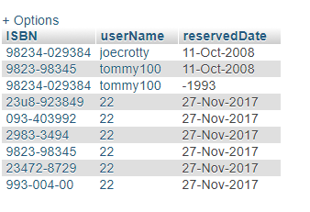

When user register was successful, their information will store in database.

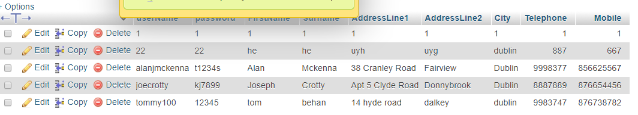

The code use for stop user view search page, reservation page and display when user logout.

