Android Lab Assignment #5

Simple Contact Book

JianyuShen

JIS77@pitt.edu

**1.Introduction**

SQL can be implemented within SQLite inside the Android system and many kinds of skills and experience from SQL development can be implement through Android SQLite, the most typical kinds of operation included insert, delete, display, update data.

**2.Essential Section Design**

**2.1 Create Database**

Add a java class named "DatabaseHelper" and create database name and content:

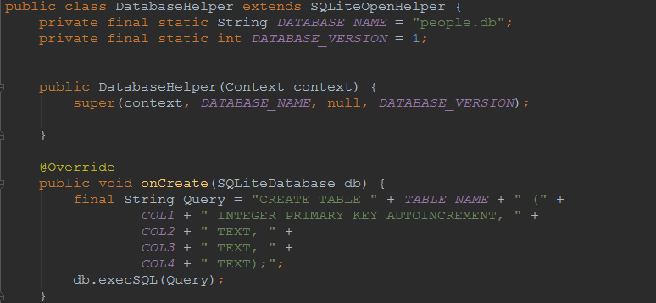

Then create a interface named "DbContent" to identify the content.

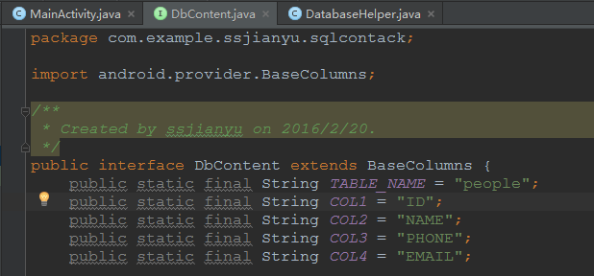

Finally, define a database named "myDb" to use the database.



**Check: Open the Android Device Monitor to check whether the database has been**

**created:**

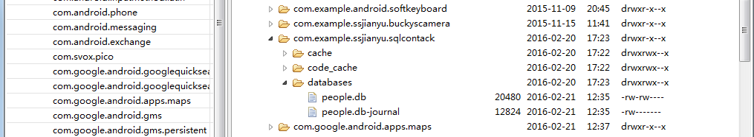

**2.2 Add "Insert " function**

**2.2.1 Add "Insert " Button on layout and set on ClickListener.**

**2.2.2 Java code for Insert funtion**

Codeing the "Insert " function:

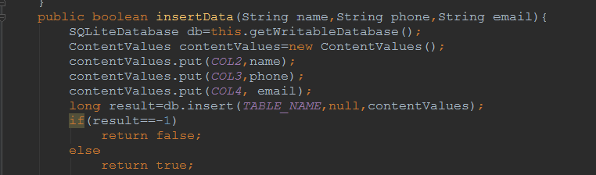

Declare the "Insert" function in Mainactivity:



**2.2.3 "Insert" function test**

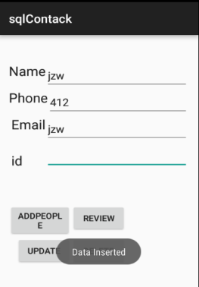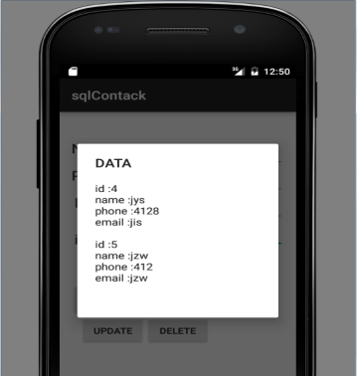

**2.3 Add "ViewAll" function**

**2.3.1 Add "ViewAll " Button on layout and set on ClickListener.**

**2.3.2 Java code for Insert funtion**

Codeing the "ViewAll " function:

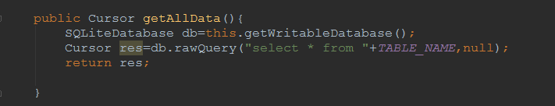

Declare the "ViewAll" function in Mainactivity:

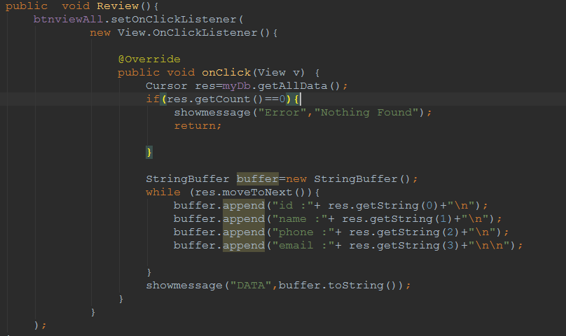

**2.3.3 "ViewAll" function test**

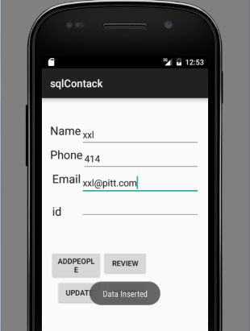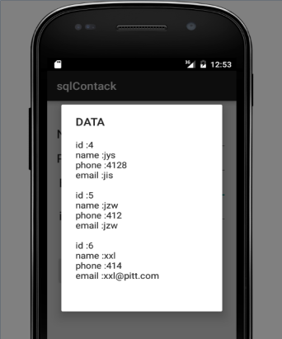

**2.4 Add "Update" function**

**2.4.1 Add "Update " Button on layout and set on ClickListener.**

**2.4.2 Java code for Insert funtion**

Codeing the "Update " function:

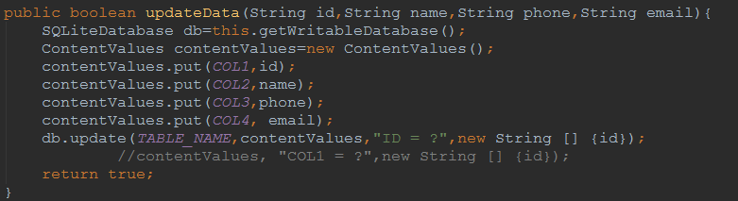

Declare the "Update" function in Mainactivity:

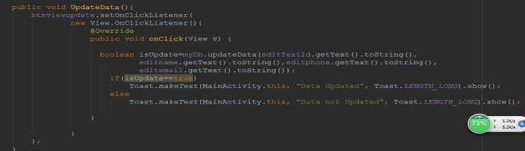

**2.4.3 "Update" function test**

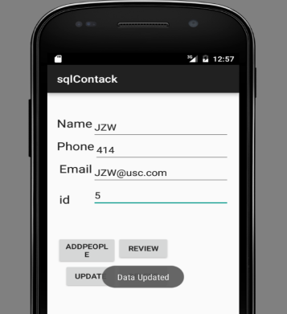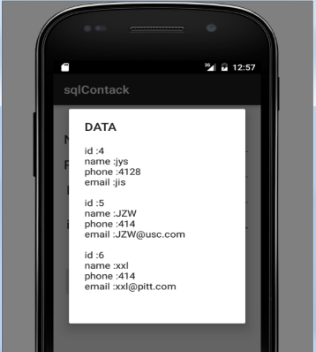

**2.5 Add "Delete" function**

**2.5.1 Add "Delete " Button on layout and set on ClickListener.**

**2.5.2 Java code for Insert funtion**

Codeing the "Delete " function:

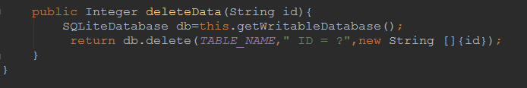

Declare the "Delete" function in Mainactivity:

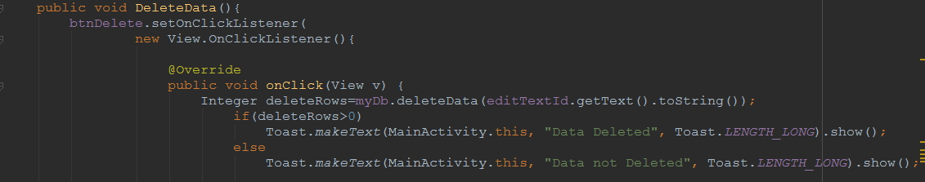

**2.5.3 "Delete" function test**

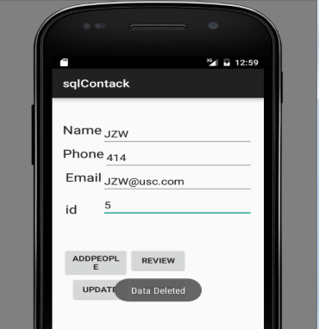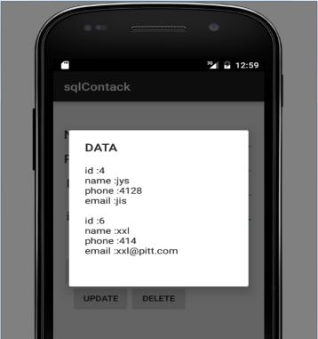

**3.Conclusion**

Android SQLite is a excellent database to manage data, by adopting some basic concepts of the storage solutions in the Android system, some more complex application can be built in the Android system with storage content.

**4.Reference**

**https://www.youtube.com/watch?v=cp2rL3sAFmI**

**https://www.youtube.com/watch?v=LZ8kJg4Pg4Y**

**https://www.youtube.com/watch?v=5_-knAoiVMI**

**https://www.youtube.com/watch?v=38DOncHIazs**