**ECE 2390 Final Computer Project Fall 2015-16**

Two retina images (fundus images) are given as attached, each is in color and of 3900 x3072 pixels. The yellow bright circular spot is the optical disk. Centered around the optical disk, crop out 1024 x 1024 pixels, and take the green channel for study.

(1) Use whatever method that you choose to segment out the optical disk and main vessels as much as possible in each image.

* **Matlab code**

*Local Adaptive Thresholding method* is adopted in this project to segment the two images: *RetinaFD-L12.jpg* and *RetinaFD-R6.jpg.* Firstly, two images *RetinaFD-L12-1024.png* and *RetinaFD-R6-1024.png* centered around the optical disk with 1024 x 1024 pixels are cropped out, which are shown as follows.

RetinaFD-L12-1024.png RetinaFD-R6-1024.png

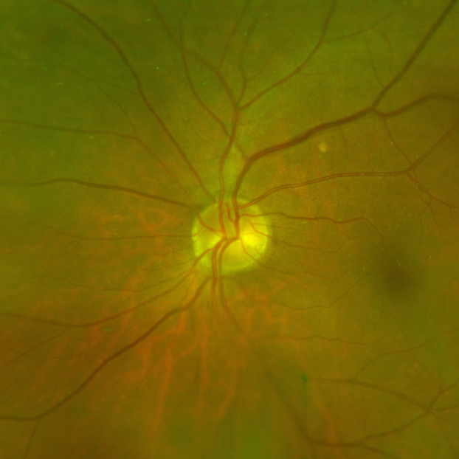 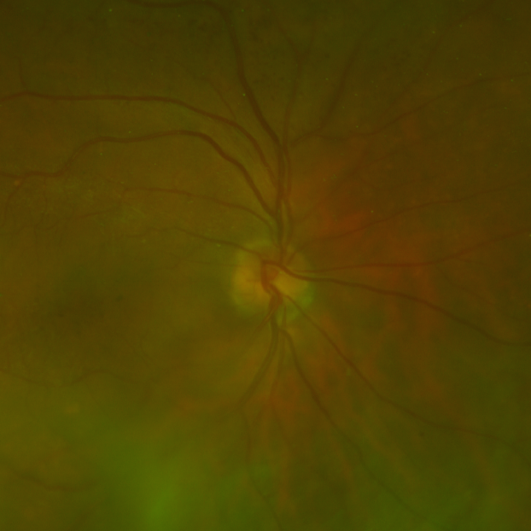

Adaptive thresholding method is an adaptive thresholding algorithm to seperate the foreground from the background with nonuniform illumination. In this project, function *bw=* *adaptivethreshold (IM,ws,C)* outputs a binary image bw with the local threshold mean-C or median-C to the image IM.

* Parameter *IM*: Input image
* Parameter *ws*: the local window size
* Parameter tm: 0 or 1, a switch between mean and median. tm=0 mean(default); tm=1 median.

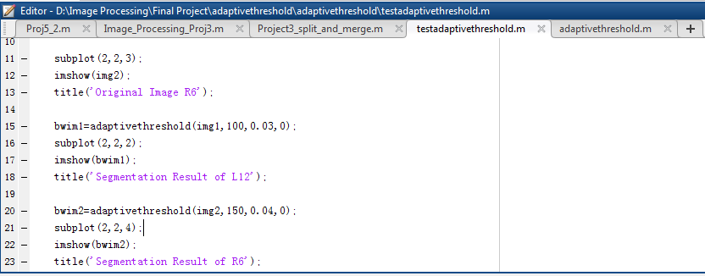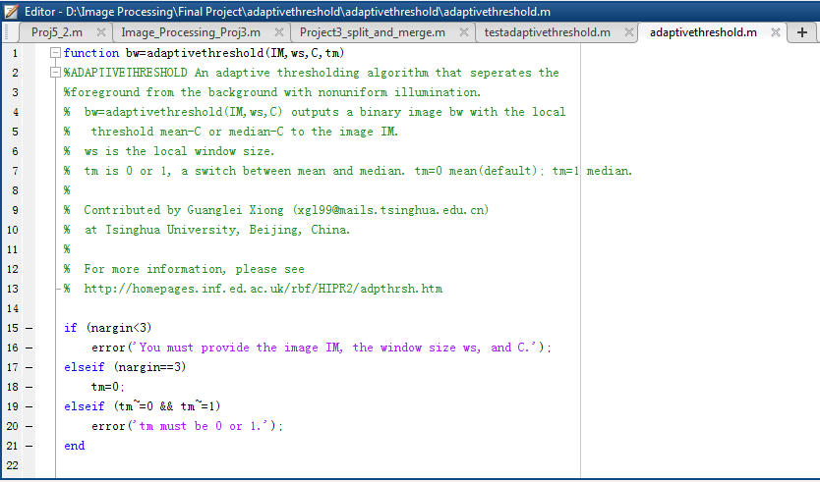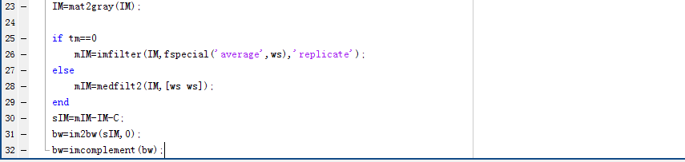

* **Segmentation results**

From the segmentation result images, we can see that optical disk and main vessels can be obviously segmented by adopting adaptive thresholding method.

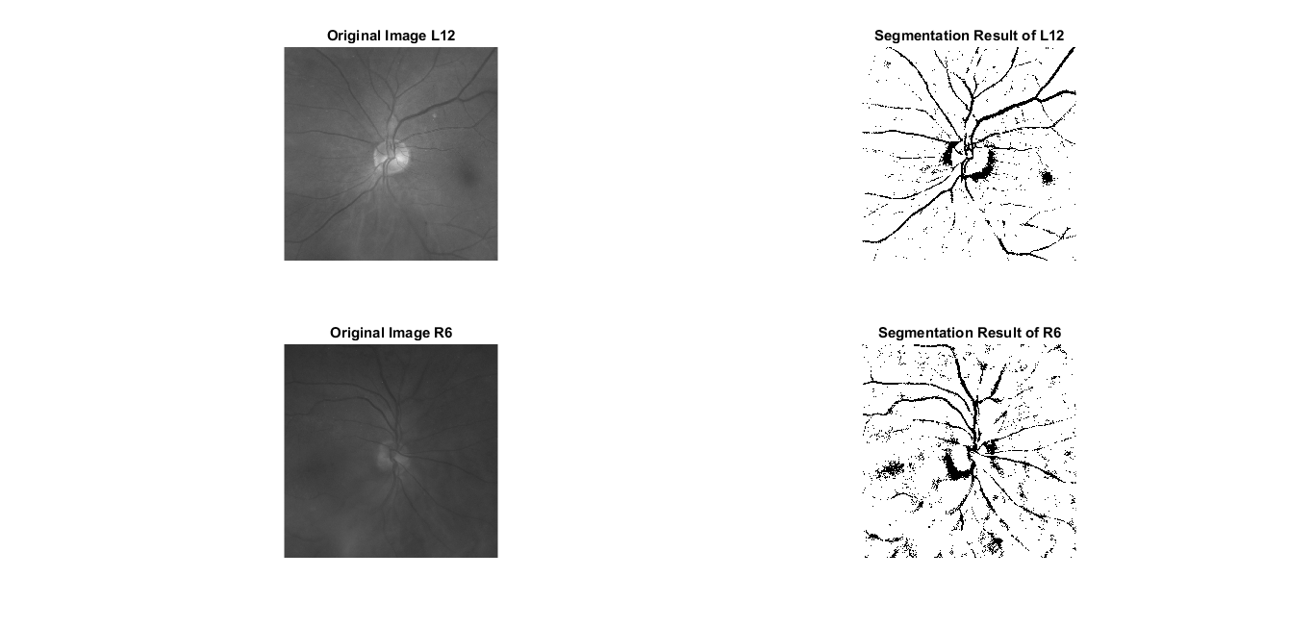

(2)Evaluate statistical texture in each image (choose texture features that you like to study) by use of either Gabor method or Laws texture energy method, can you say any difference in textures between these two images.

* **Matlab code**

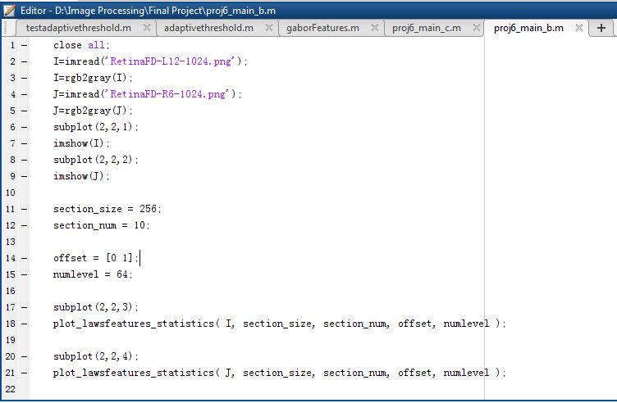

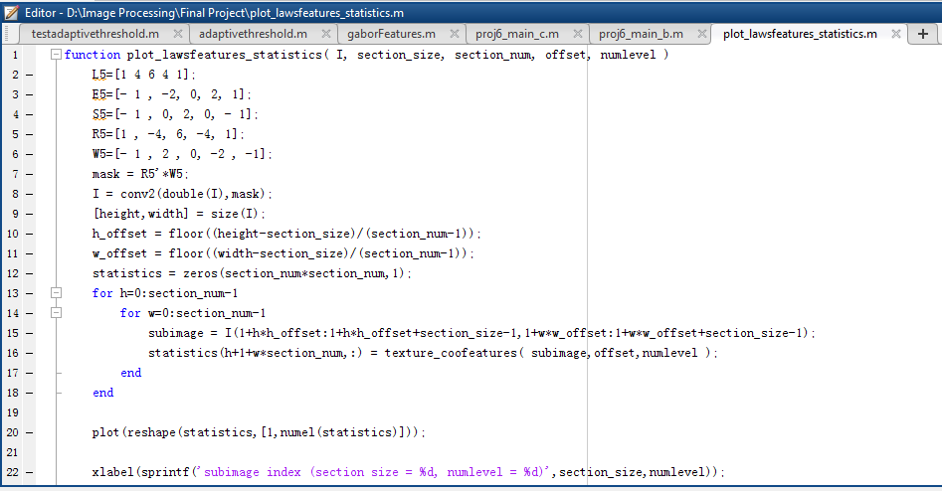



* **Results**

The two result images show that the energy is almost the same for the same kind of feature. The energy of right image is larger than the left image.

